Supplemental Figures

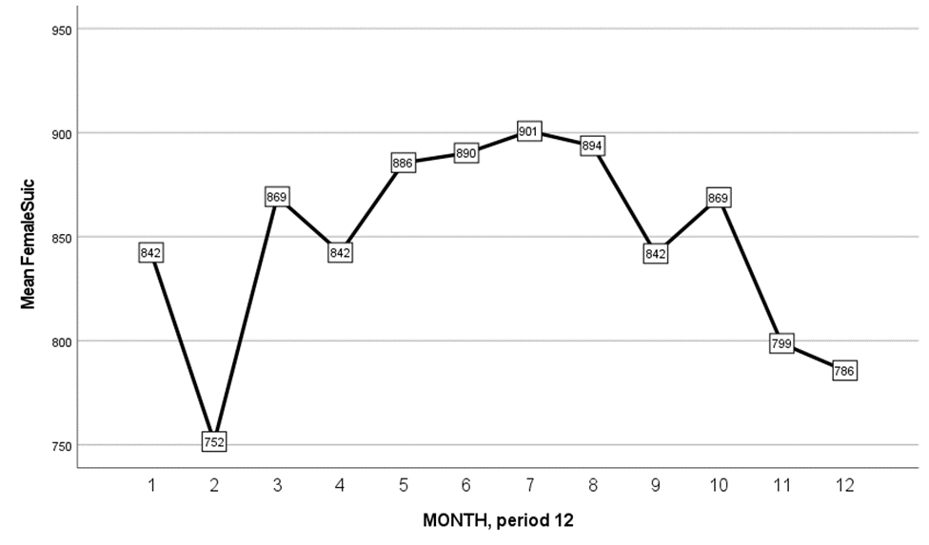
Figure 2: Average Female Suicides from 2015-2020

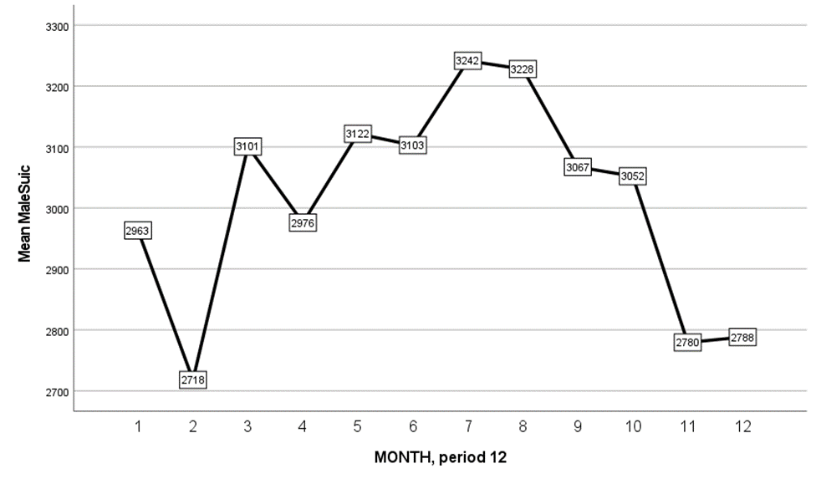
Figure 3: Average Male Suicides from 2015-2020

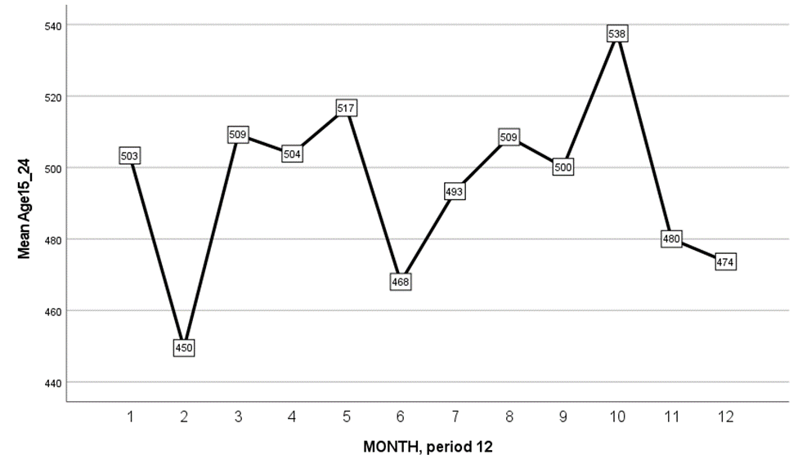
Figure 4: Average Suicides for Ages 15-24 from 2015-2020

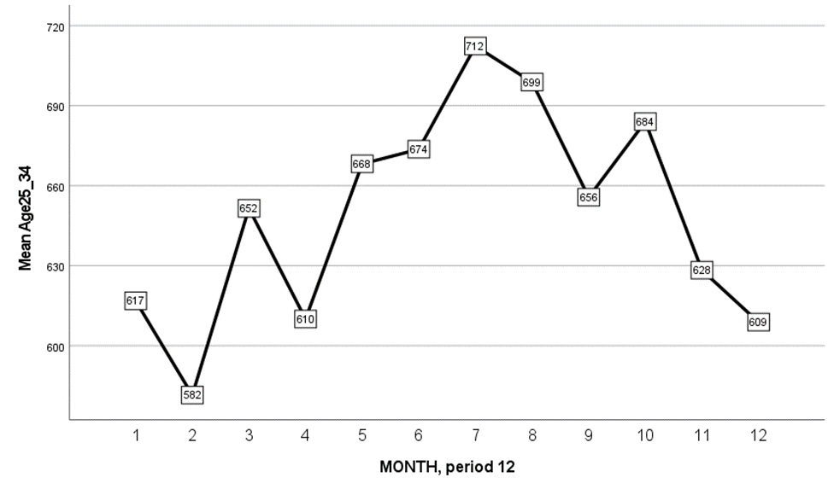
Figure 5: Average Suicides for Ages 25-34 from 2015-2020

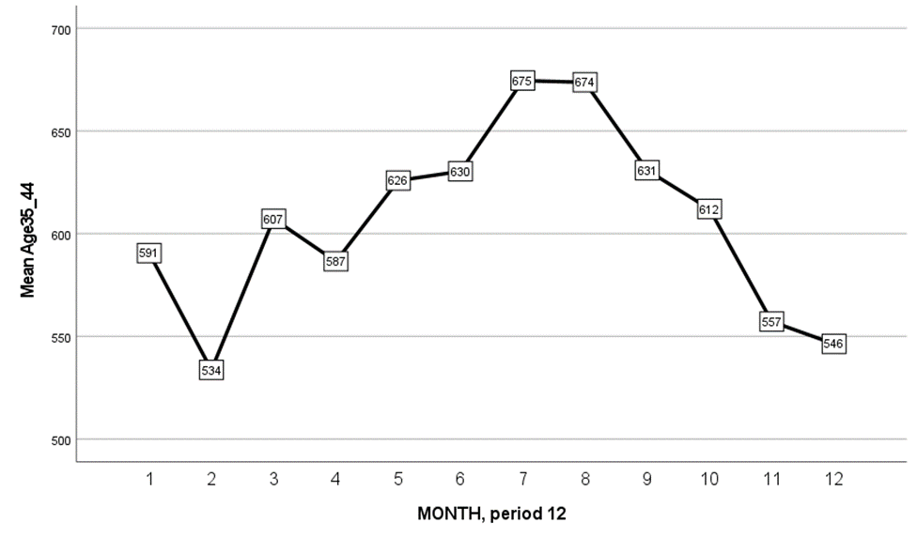
Figure 6: Average Suicides for Ages 35-44 from 2015-2020

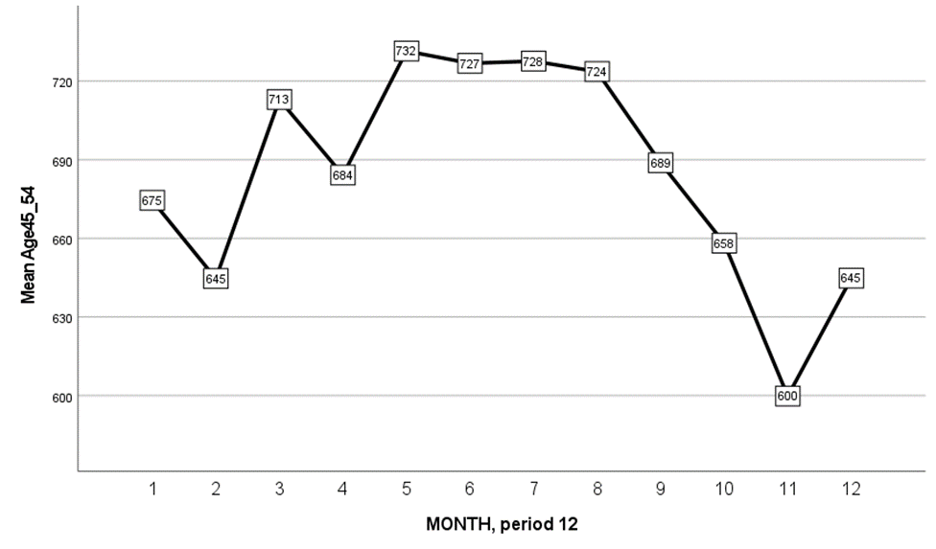
Figure 7: Average Suicides for Ages 45-54 from 2015-2020

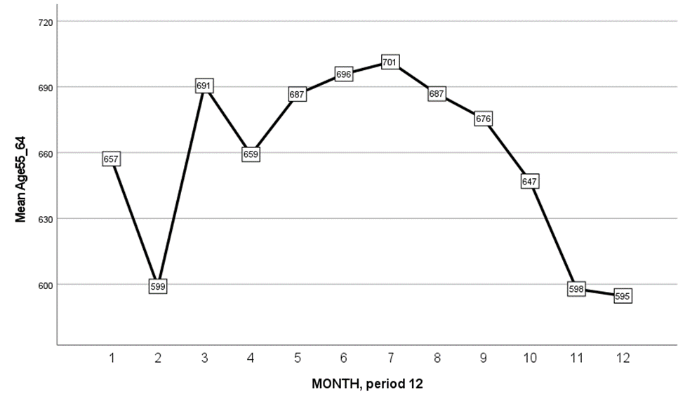
Figure 8: Average Suicides for Ages 55-64 from 2015-2020

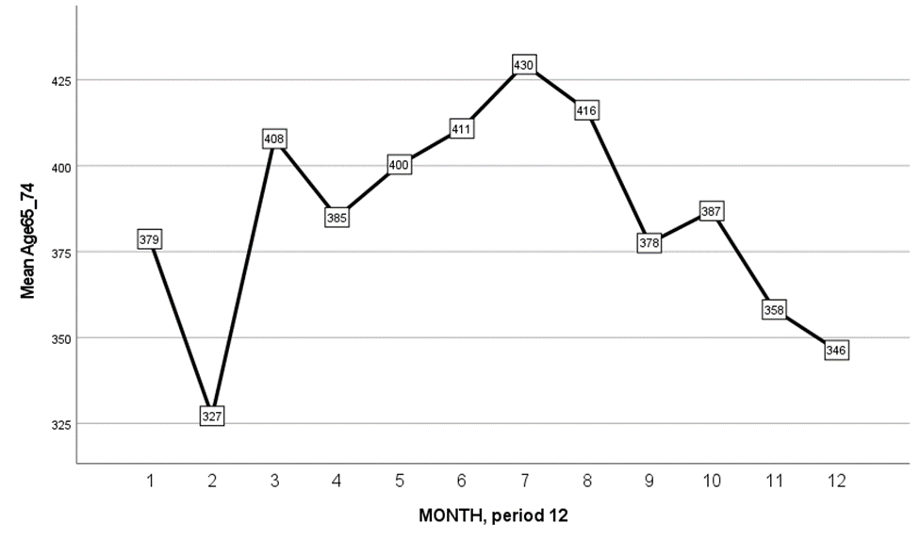
Figure 9: Average Suicides for Ages 65-74 from 2015-2020

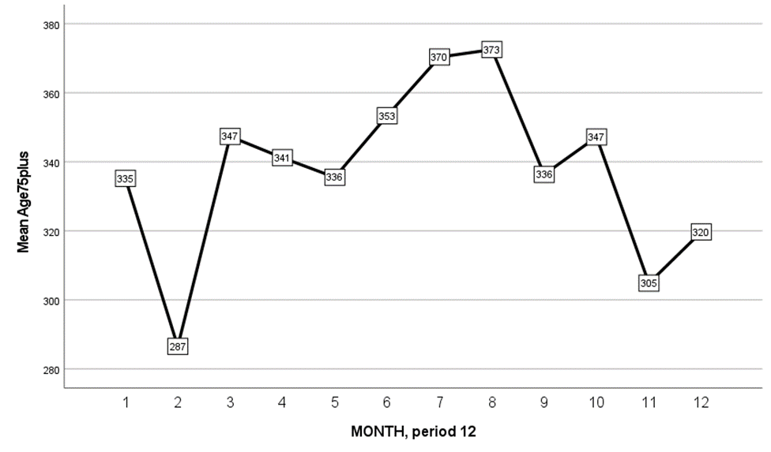
Figure 10: Average Suicides for Ages 75+ from 2015-2020

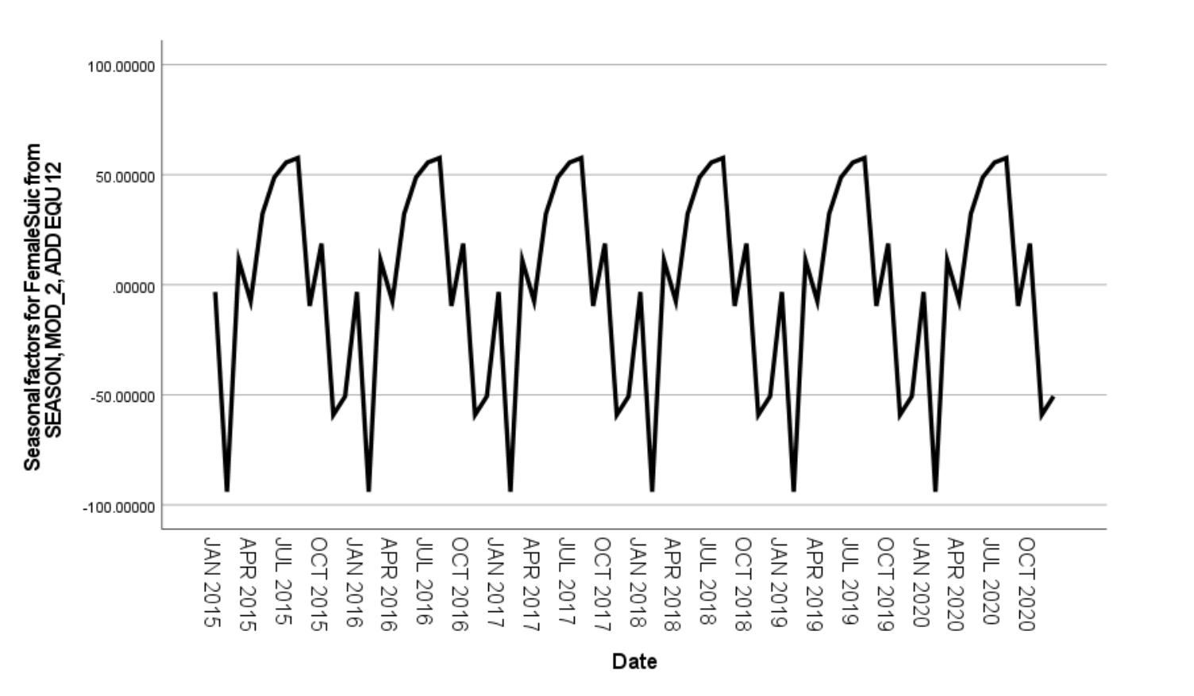
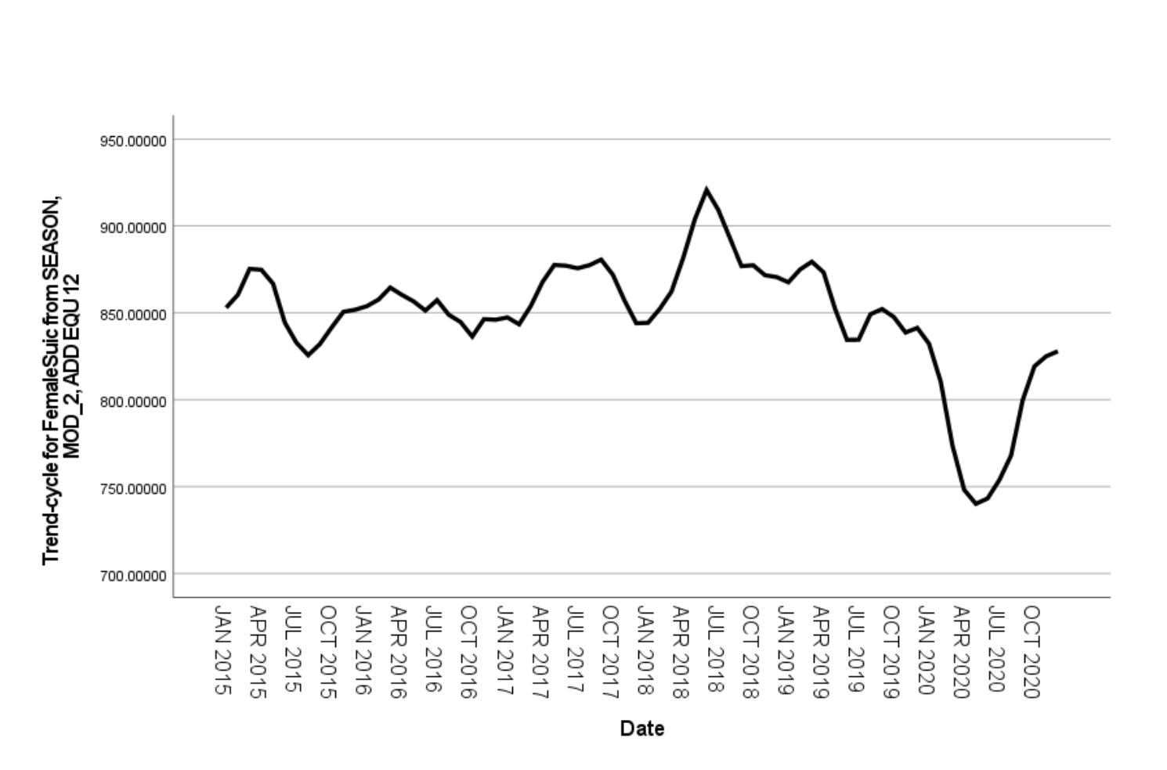
A C

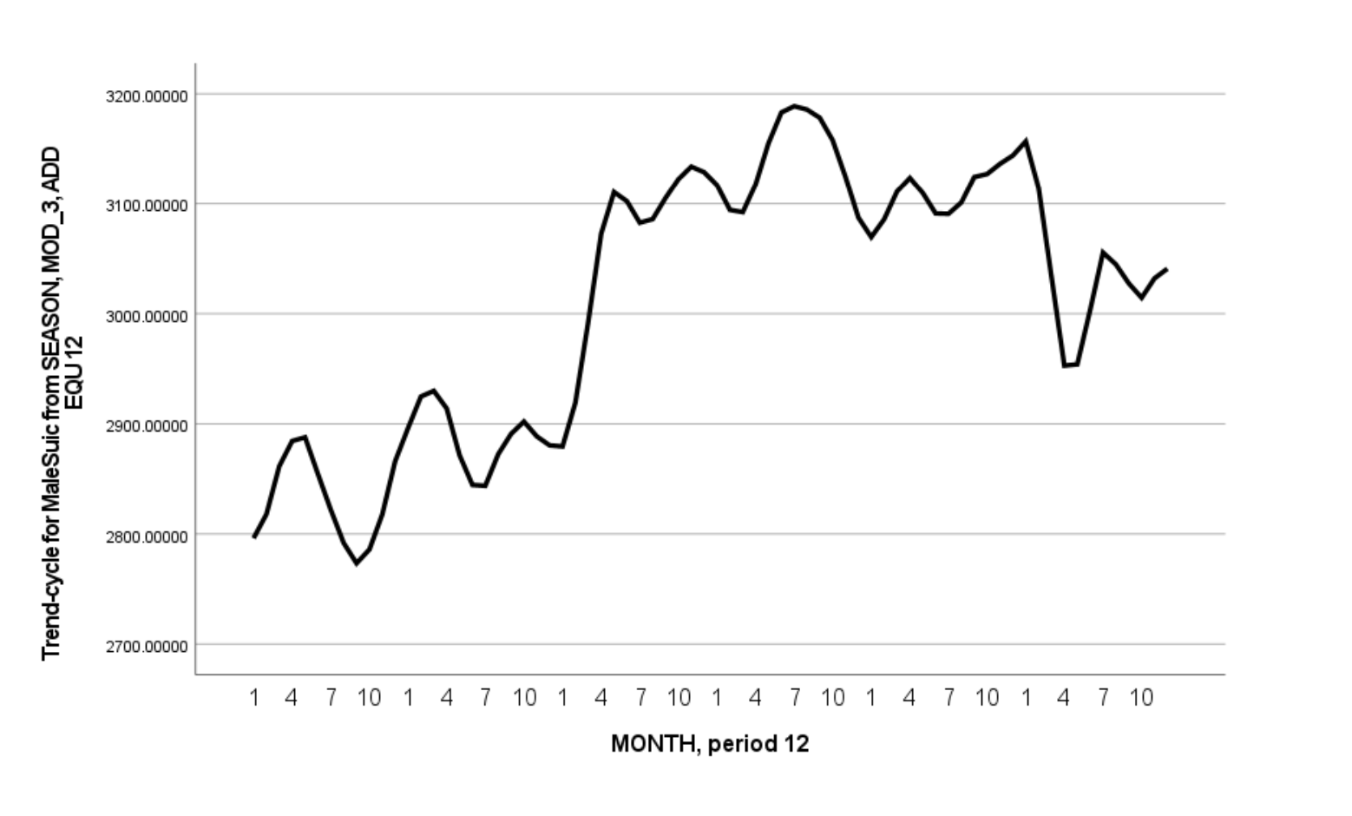
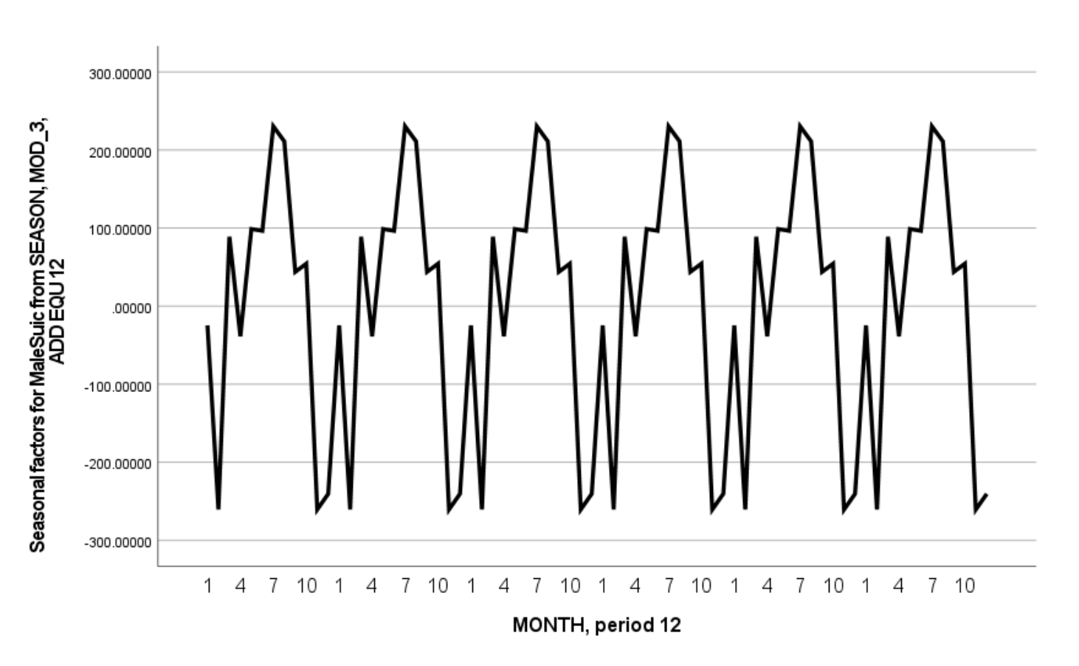
B D

Figure 11. A: Trend of All Female Suicides. B: Trend of All Male Suicides C. Seasonality of All Female Suicides D. Seasonality of all Male Suicides

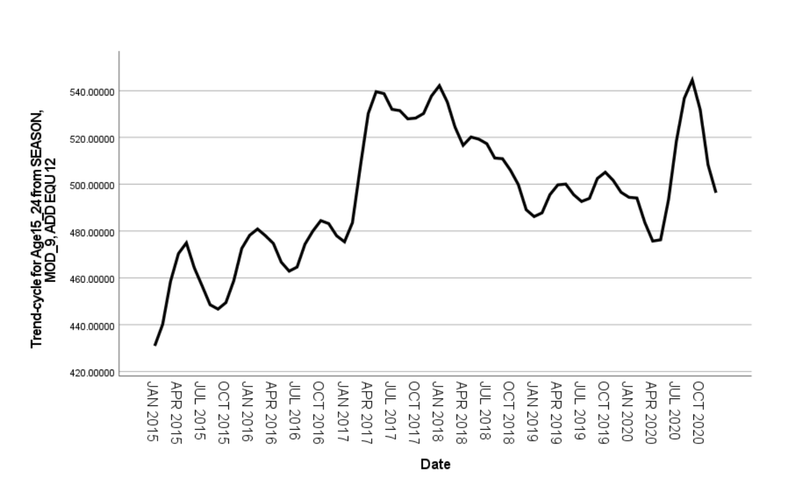
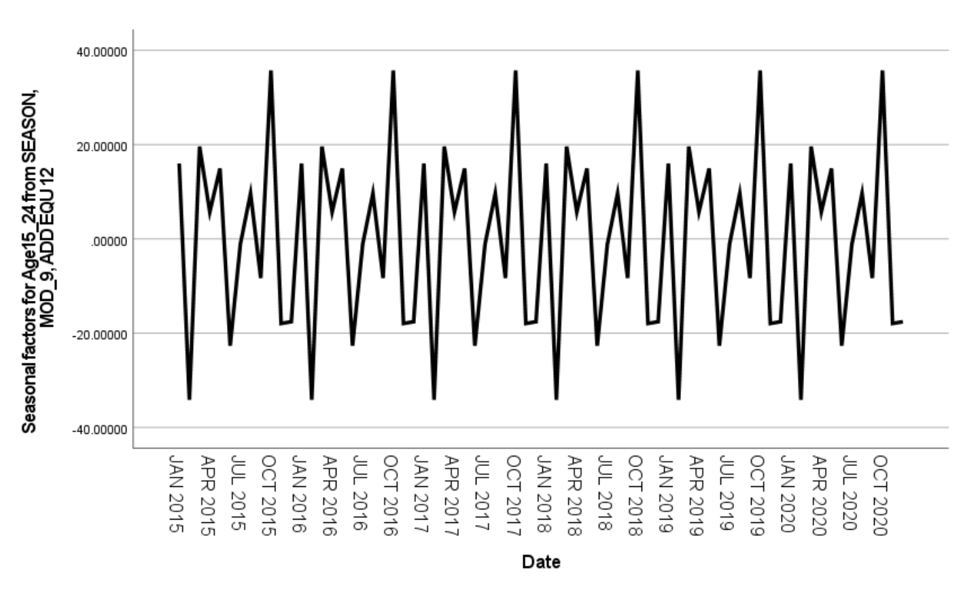
A B

Figure 12: A: Trend for Suicides Ages 15-24 B: Seasonality of Suicides For Ages 15-24

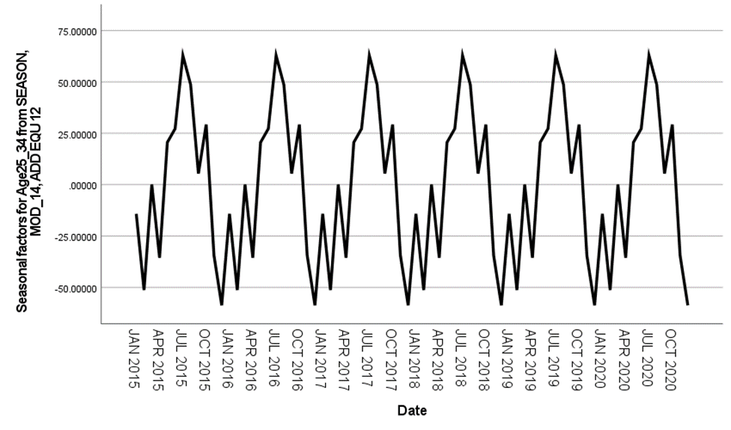
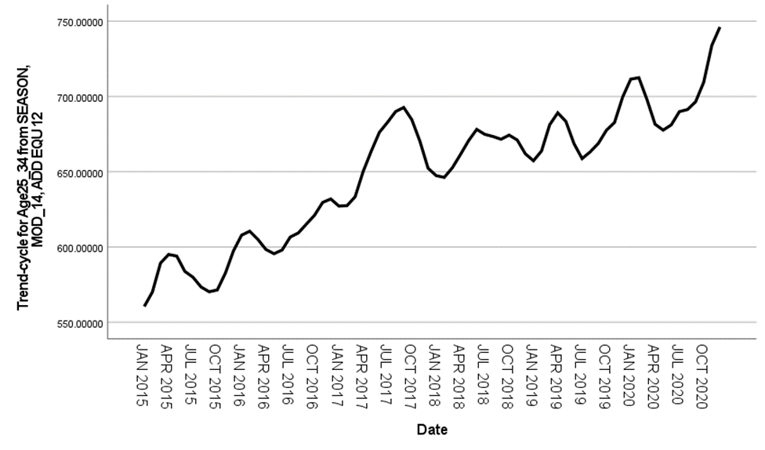
A B

Figure 13: A: Trend for Suicides Ages 25-34 B: Seasonality of Suicides For Ages 25-34

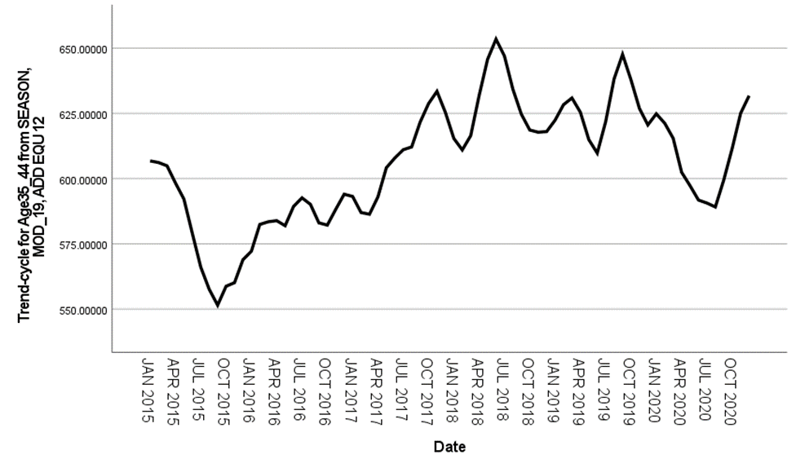
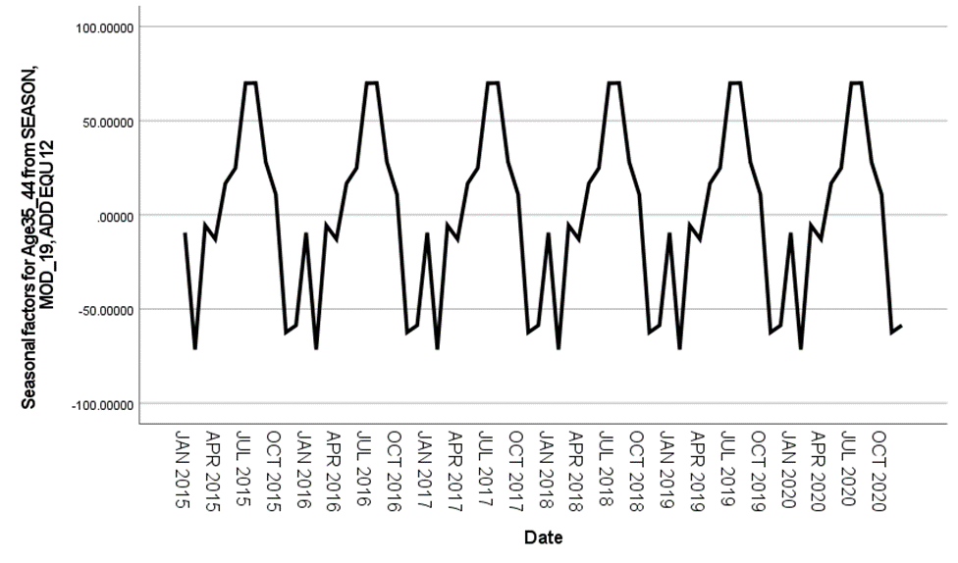
A B

Figure 14: A: Trend for Suicides Ages 35-44 B: Seasonality of Suicides For Ages 35-44

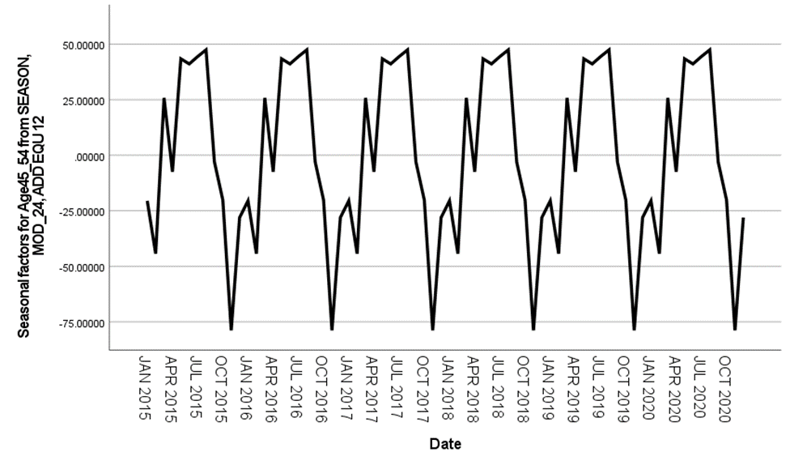
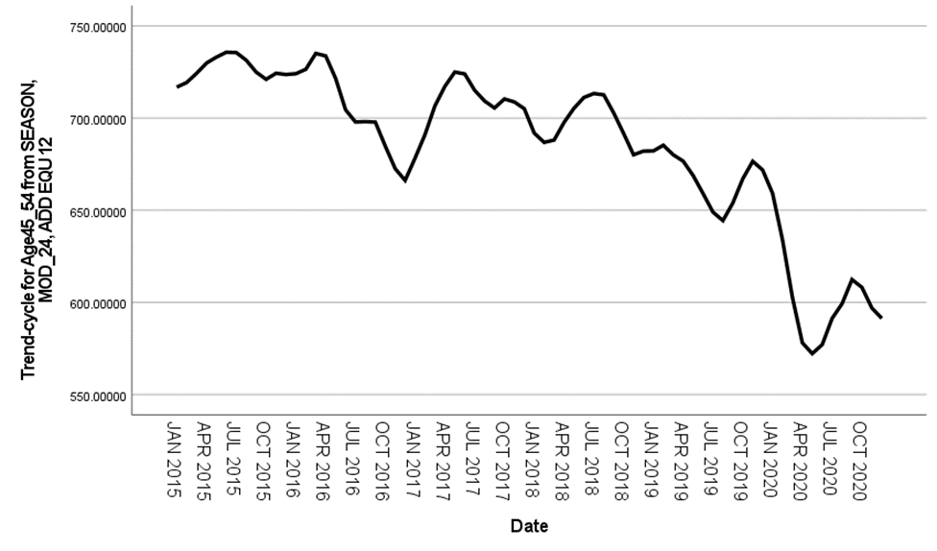
A B

Figure 15: A: Trend for Suicides Ages 45-54 B: Seasonality of Suicides For Ages 45-54

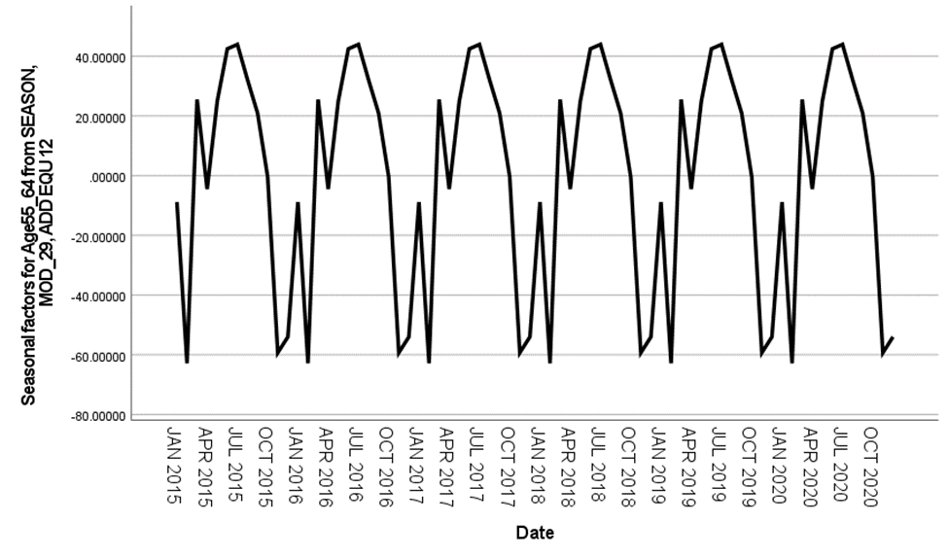
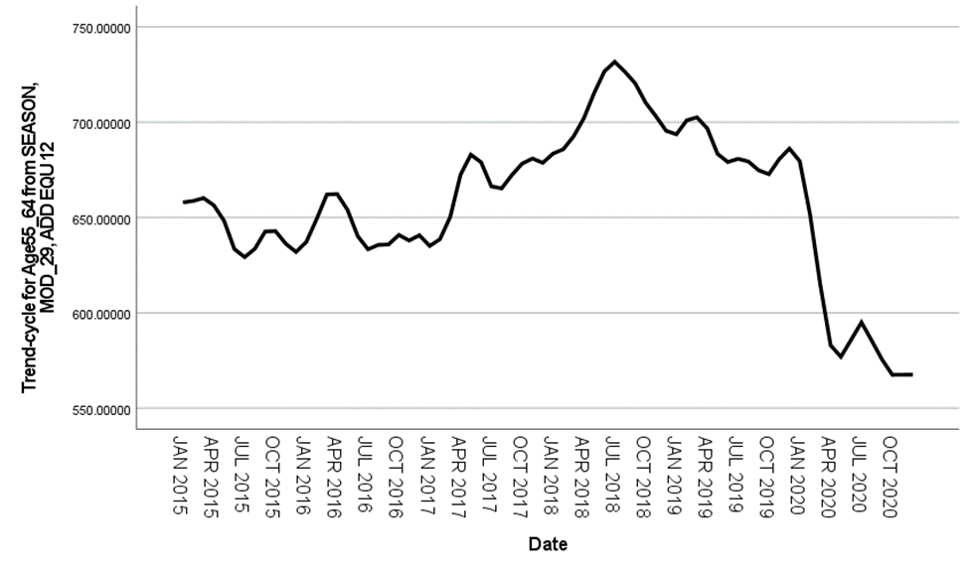
A B

Figure 16: A: Trend for Suicides Ages 55-64 B: Seasonality of Suicides for Ages 55-64

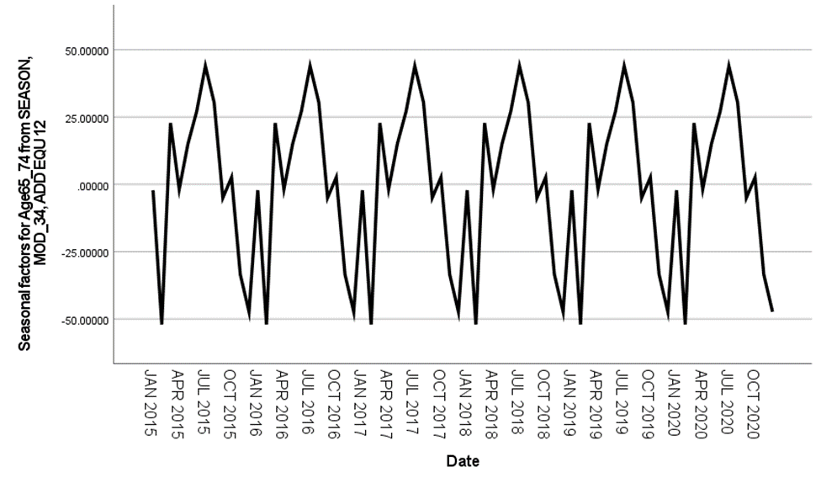
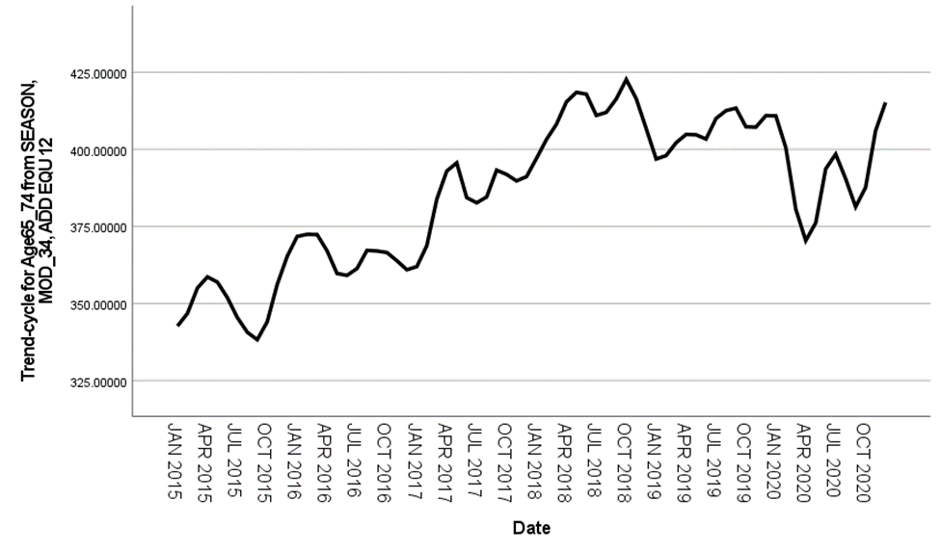
A B

Figure 17: A: Trend for Suicides Ages 65-74 B: Seasonality of Suicides For Ages 65-74

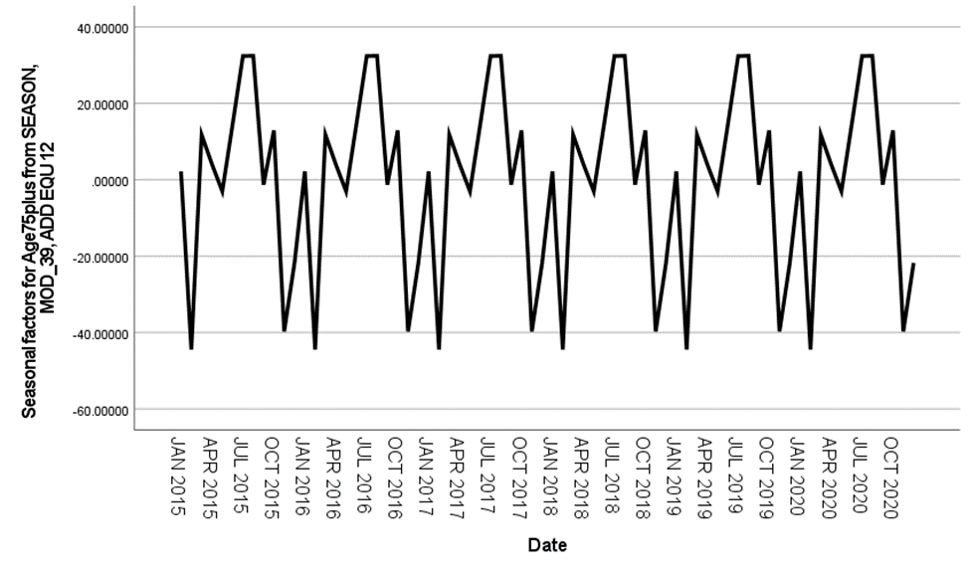
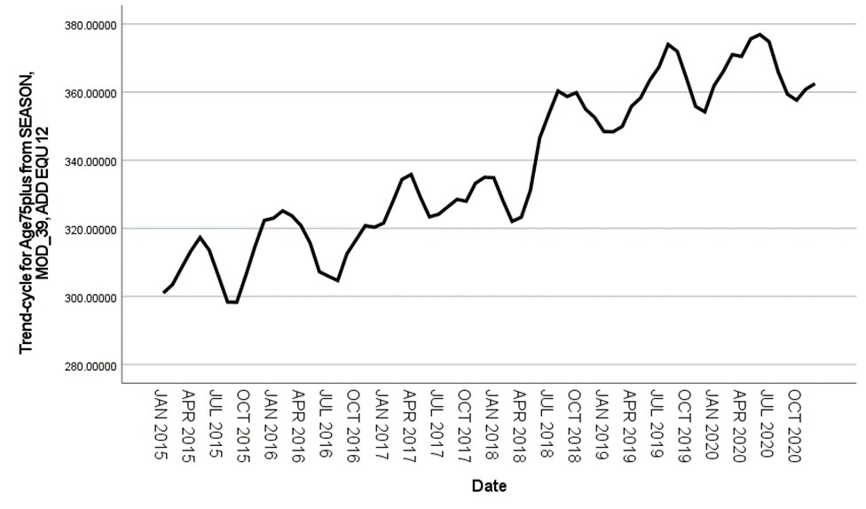
A B

Figure 18: A: Trend for Suicides Ages 75+ B: Seasonality of Suicides For Ages 75+

