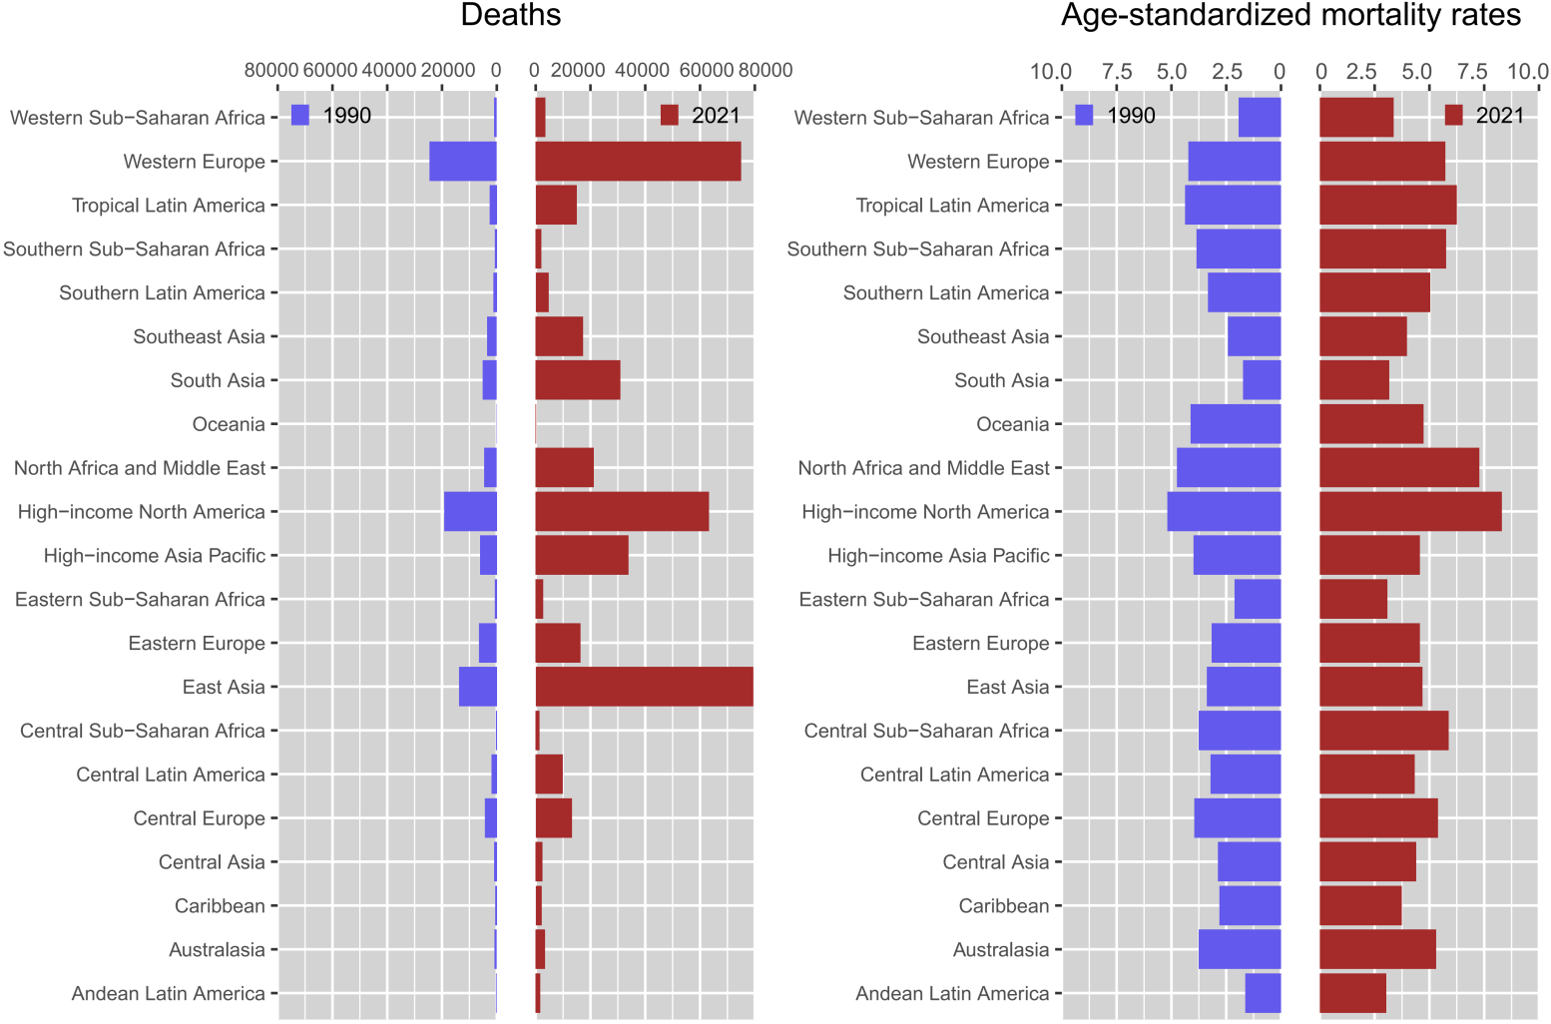
Fig. S2 The deaths and age-standardized mortality rates for metabolism-related Alzheimer’s disease and other dementias in 1990 and 2021 across 21 GBD regions. GBD, Global Burden of Disease

