Supplementary Table S1. Samples of the REST meta MDD project, consortium sites, sample size data acquisition parameters. MDD, major depressive disorder; HC, healthy control.
Number | Sites | Scanner | MDD | HC | Parameters | Ethics Committee or Institutional Review Boards
7 | Sir Run Run Shaw Hospital, Zhejiang University School of  Medicine | GE  discovery MR750  3T | 11 | 37 | 8 channel, TR=2s, TE=30ms, Flip Angle = 90º, Slice number=37,Time points=184, Voxel size=2.29×2.29×3.20, FOV=220×220 | the Ethics Committee of the Sir Run Run Shaw Hospital, School of Medicine, Zhejiang University, and the Affiliated Hospital of Hangzhou Normal University.
8 | Department of  Psychiatry, First  Affiliated Hospital,  China Medical  University | GE  Signa 3T | 41 | 62 | 8 channel, TR=2s, TE=30ms, Flip Angle = 90º, Slice number=35,Time points=200, Voxel size=3.75×3.75×3.00, FOV=240×240 | the Institutional Review Board of China Medical University
9 | The First Affiliated  Hospital of Jinan  University | GE  Discovery MR750  3T | 48 | 124 | 8 channel, TR=2s, TE=25ms, Flip Angle = 90º, Slice number=35,Time points=200, Voxel size=3.75×3.75×3.00, FOV=240×240 | the ethics committee of The First Affiliated Hospital of Jinan University
11 | Department of  Psychiatry, The First  Affiliated Hospital of Chongqing Medical  University | GE  Signa 3T | 18 | 17 | 8 channel, TR=2s, TE=30ms, Flip Angle = 90º, Slice number=33,Time points=200, Voxel size=3.75×3.75×5.00, FOV=240×240 | the ethics committee of The First  Affiliated Hospital of Chongqing Medical University
14 | The Second Xiangya  Hospital of Central South  University | Siemens  Tim Trio  3T | 61 | 32 | 32 channel, TR=2.5s, TE=25ms, Flip Angle = 90º, Slice number=39,Time points=200, Voxel size=3.75×3.75×3.50, FOV=240×240 | the Institutional Review Board of the Central South University.
19 | Anhui Medical  University | GE  Signa 3T | 12 | 31 | 8 channel, TR=2s, TE=22.5ms, Flip Angle = 30º, Slice number=33,Time points=240, Voxel size=3.44×3.44×4.60, FOV=220×220 | the local ethics committees of the Anhui Medical University
20 | Faculty of Psychology,  Southwest University | Siemens  Tim Trio  3T | 143 | 229 | 12 channel, TR=2s, TE=30ms, Flip Angle = 90º, Slice number=32,Time points=242, Voxel size=3.44×3.44×4.00, FOV=220×220 | the Research Ethics Committee of the Brain Imaging Center of Southwest University and First Affiliated Hospital of Chongqing Medical School; the Institutional Review Board of Taipei Veterans General Hospital; the Institutional Review Board of China Medical University
21 | Beijing Anding Hospital,  Capital Medical  University | Siemens  Tim Trio  3T | 76 | 65 | 32 channel, TR=2s, TE=30ms, Flip Angle = 90º, Slice number=33,Time points=240, Voxel size=3.12×3.12×4.20, FOV=220×220 | the Imaging Center for Brain Research, Beijing Normal University and the Institutional Review Board of Anding Hospital, Capital Medical University.
23 | Mental Health Center,  West China Hospital,  Sichuan University | Philips  Achieva  3T TX | 11 | 23 | 8 channel, TR=2s, TE=30ms, Flip Angle = 90º, Slice number=38,Time points=240, Voxel size=3.75×3.75×4.00, FOV=240×240 | the Ethics Committee of Sichuan University

Supplementary Table S2. Demographic characteristics for participants included in subgroup analysis

 |  |  | FEDN vs.NC |  | Mann-Whitney |  |  |  | recurrent vs.NC |  | Mann-Whitncy  Z P |  |  |  | FEDN vs.recurrent
 | FEDN(N=232)  mean SD |  | NC(N=394)  mean SD |  |  |  | recurrent (N= 189) |  | NC (N=427) mean SD |  |  |  | FEDN(N=119)  mean SD |  | recurrent (N=72)  mean SD |  | Mann-Whitney
 |  |  |  |  | Z P |  | mean SD |  |  |  |  |  |  |  |  |  | Z P
Age | 32.7 | 10.4 | 35.7 | 14.2 | -1.424 | 0. 154 | 35.4 | 12.5 | 37.1 | 14.1 | -0.968 | 0.333 | 35.4 | 11.3 | 36.3 | 12.7 | -0. 170 | 0.865
Education | 12.2 | 3.4 | 13.6 | 3.6 | 5.702 | <0.001 | 11.7 | 3.2 | 13.4 | 3.8 | - 6 | <0.001 | 11.5 | 3.4 | 12.0 | 3.5 | -1. 104 | 0.270
HAMD | 22.5 | 5.4 |  |  |  |  | 17.7 | 7.8 |  |  |  |  | 22.1 | 4.2 | 21.3 | 5.8 | 0.894 | 0.371
HAMA | 21.7 | 9.5 |  |  |  |  | 16.9 | 9.1 |  |  |  |  | 22.0 | 9.0 | 19.0 | 9.6 | 2.223 | 0.027
Duration (month) | 17.7 | 30.8 |  |  |  |  | 92.7 | 86.1 |  |  |  |  | 27.0 | 39.5 | 88.7 | 80.1 | -6.419 | <0.001
Episodes |  |  |  |  |  |  | 3.0 | 1.3 |  |  |  |  |  |  | 2.7 | 1.3
Sex | Male | Female | Male | Female | x² | P | Male | Female | Male | Female | x² | P | Male | Female | Male | Female | x² | P
 | 78 | 154 | 152 | 242 | 1.544 | 0.214 | 78 | 111 | 167 | 260 | 0.255 | 0.613 | 40 | 79 | 30 | 42 | 1.253 | 0.263
Abbreviations:FEDN,first episode drug naive;NC,normal control.

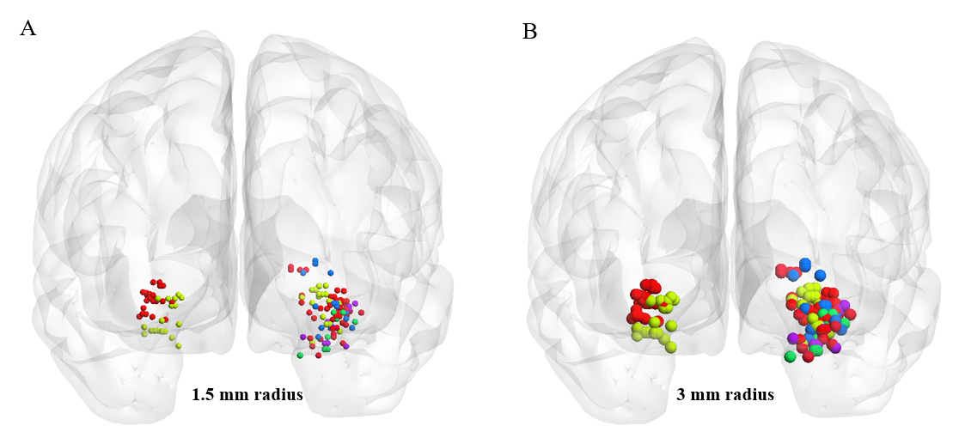
Fig. S1. The displayed of spherical ROI with 1.5 mm (A) and 3mm (B) radius for 188 hippocampal tissues.

Fig. S2. Hippocampal segmentation along the long axis using a group-level independent component analysis method. Red, blue and green represent the head, body and tail of hippocampus, respectively. HP: hippocampus; L: Left; R: Right.

