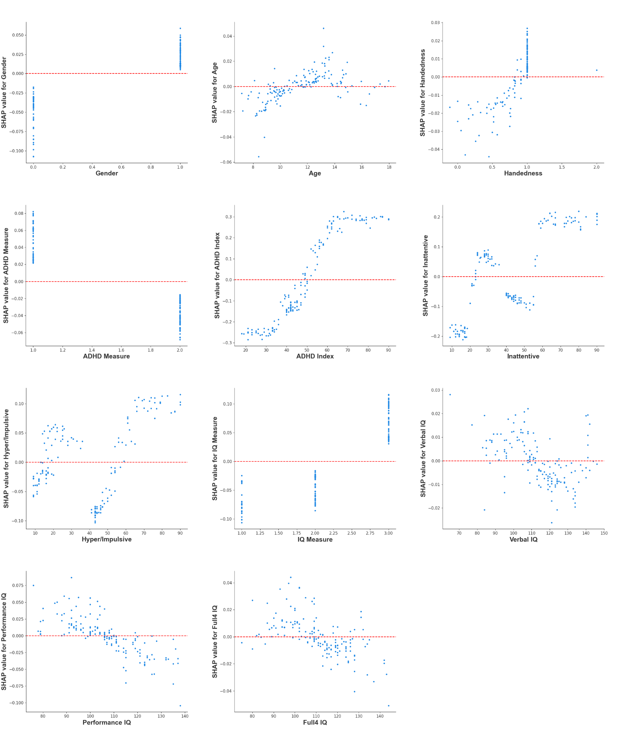
Supplemental Material 4: SHAP dependence plots in the external validation. Each dependence plot shows how a single feature affects the output of the prediction model, and each dot represents a single patient.

