APPENDIX

APPENDIX A：LITERATURE SEARCH STRATEGIES

1. CNKI
SU=('delirium'+'fuzzy consciousness') AND SU=('scale'+'questionnaire') AND SU=('survey'+'assessment'+'instrument'+'measurement') AND FT=('Chinese'+'translation')
Type=Journal, degree thesis/dissertation
Language=Chinese
RESULTS:
259 hits

2. Wanfang
Title or Key words:(delirium OR fuzzy consciousness) and Title or Key words:(scale OR questionnaire) and Title or Key words:(survey OR assessment OR instrument OR measurement) and 全部:(Chinese OR translation)
Type=Journal, degree thesis/dissertation
Language=Chinese
RESULTS:
19hits

3.VIP
(((Title or Key words=delirium OR Title or Key words= fuzzy consciousness) AND (((Title or Key words= assessment OR Title or Key words=survey) OR Title or Key words=instrument) OR Title or Key words=measurement)) AND (Title or Key words=scales OR Title or Key words=questionnaire))
Type=Literature
Language=Chinese
RESULTS:
15hits

- CBMdisc
( "delirium " OR "fuzzy consciousness") AND( "assessment " OR "survey") AND( "instrument" OR "measurement" OR "scales " OR "questionnaire") AND( "Chinese" OR "translation")
Type=Literature
Language=Chinese
RESULTS:
75hits

5.PUBMED
Set | Terms | Results
#1 | (((((((((delirium[MeSH Terms]) OR (Subacute Delirium[Title/Abstract])) OR (Delirium, Subacute[Title/Abstract])) OR (Deliriums, Subacute[Title/Abstract])) OR (Subacute Deliriums[Title/Abstract])) OR (Delirium of Mixed Origin[Title/Abstract])) OR (Mixed Origin Delirium[Title/Abstract])) OR (Mixed Origin Deliriums[Title/Abstract])) OR (fuzzy consciousness[Title/Abstract])) OR (Blurred consciousness[Title/Abstract]) | 13269
#2 | (((((Questionnaire[Title/Abstract]) OR (scale[Title/Abstract])) OR (Assessment[Title/Abstract])) OR (Measurement[Title/Abstract])) OR (Survey[Title/Abstract])) OR (Instrument[Title/Abstract]) | 3609473
#3 | (((measure[Title/Abstract]) OR (Assessment[Title/Abstract])) OR (evaluate[Title/Abstract])) OR (screen[Title/Abstract]) | 3428815
#4 | (((Chinese localization) OR (localize)) OR (Adaptation)) OR (Translation and cultural adaptation) | 2705605
#5 | #1 AND #2 AND #3 AND #4 | 155

6.Web Of Science
Set | Terms | Results
#1 | TS=(delirium or Subacute Delirium or Delirium, Subacute or Deliriums, Subacute or Subacute Deliriums or Delirium of Mixed Origin or Mixed Origin Delirium or Mixed Origin Deliriums or fuzzy consciousness or Blurred consciousness) | 26555
#2 | TS=(Questionnaire or scale or Assessment or Measurement or Survey or Instrument) | 10,121,066
#3 | TS=(measure or Assessment or evaluate or Screen) | 12,371,798
#4 | TS=(Chinese localization or localize or Adaptation or Translation and cultural adaptation) | 1,110,832
#5 | #1 AND #2 AND #3 AND #4 | 91

7. Embase
Set | Terms | Results
#1 | 'deliriuml':ab,ti OR 'Subacute Delirium':ab,ti OR 'Delirium, Subacute':ab,ti OR 'Deliriums, Subacute':ab,ti OR 'Subacute Deliriums':ab,ti OR 'Delirium of Mixed Origin':ab,ti OR 'Mixed Origin Delirium':ab,ti OR 'Mixed Origin Deliriums':ab,ti OR 'fuzzy consciousness':ab,ti OR 'Blurred consciousness':ab,ti | 43
#2 | 'Questionnaire':ab,ti OR 'scale':ab,ti OR 'Assessment':ab,ti OR 'Measurement':ab,ti OR 'Survey':ab,ti OR 'Instrument':ab,ti | 4,793,004
#3 | 'measure':ab,ti OR 'Assessment':ab,ti OR 'evaluate':ab,ti OR 'Screen':ab,ti | 4,813,749
#4 | 'Chinese localization':ab,ti OR 'localize':ab,ti OR 'Adaptation':ab,ti OR 'Translation and cultural adaptation':ab,ti | 294,141
#5 | #1 AND #2 AND #3 AND #4 | 0

Appendix B：QUADAS-2 DIAGNOSTIC TEST RISK OF BIAS EVALUATION CHECKLIST
Phase 1: State the review question:
Patients (setting, intended use of index test, presentation, prior testing):
Index test(s):
Reference standard and target condition:
Phase 2: Draw a flow diagram for the primary study

Phase 3: Risk of bias and applicability judgments
QUADAS-2 is structured so that 4 key domains are each rated in terms of the risk of bias and the concern regarding applicability to the research question (as defined above). Each key
domain has a set of signalling questions to help reach the judgments regarding bias and applicability.

DOMAIN 1: PATIENT SELECTION
A. Risk of Bias

Describe methods of patient selection:

❖ Was a consecutive or random sample of patients enrolled?  Was a case-control design avoided?   Did the study avoid inappropriate exclusions? | Yes/No/Unclear Yes/No/Unclear Yes/No/Unclear
Could the selection of patients have introduced bias?  B. Concerns regarding applicability | RISK: LOW/HIGH/UNCLEAR
Describe included patients (prior testing, presentation, intended use of index test and setting):
Is there concern that the included patients do not match CONCERN: LOW/HIGH/UNCLEAR
the review question?
DOMAIN 2: INDEX TEST(S)
If more than one index test was used, please complete for each test.
A. Risk of Bias

Describe the index test and how it was conducted and interpreted:

❖ Were the index test results interpreted without  knowledge of the results of the reference standard? | Yes/No/Unclear
❖ If a threshold was used, was it pre-specified?  Could the conductor interpretation of the index test have introduced bias? | Yes/No/Unclear  RISK: LOW /HIGH/UNCLEAR
B. Concerns regarding applicability  Is there concern that the index test, its conduct, or interpretation differ from the review question? | CONCERN:  LOW /HIGH/UNCLEAR

DOMAIN 3: REFERENCE STANDARD
A. Risk of Bias

Describe the reference standard and how it was conducted and interpreted:

Is the reference standard likely to correctly classify the target condition?  Were the reference standard results interpreted without | Yes/No/Unclear  Yes/No/Unclear
knowledge of the results of the index test?  Could the reference standard, its conduct, or its interpretation have introduced bias?  B. Concerns regarding applicability  Is there concern that the target condition as defined by the reference standard does not match the review  question? | RISK: LOW /HIGH/UNCLEAR  CONCERN: LOW /HIGH/UNCLEAR
DOMAIN 4: FLOW AND TIMING
A. Risk of Bias

Describe any patients who did not receive the index test(s) and/or reference standard or who were excluded from the 2x2 table (refer to flow diagram):
Describe the time interval and any interventions between index test(s) and reference standard:

❖ Was there an appropriate interval between index test(s) and reference standard? |  | Yes/No/Unclear
❖ Did all patients receive a reference standard? Yes/No/Unclear
❖ Did patients receive the same reference standard? Yes/No/Unclear
❖ Were all patients included in the analysis? Yes/No/Unclear
Could the patient flow have introduced bias? RISK: LOW /HIGH/UNCLEAR

APPENDIX C：GRADE QUALITY RATING TOOL

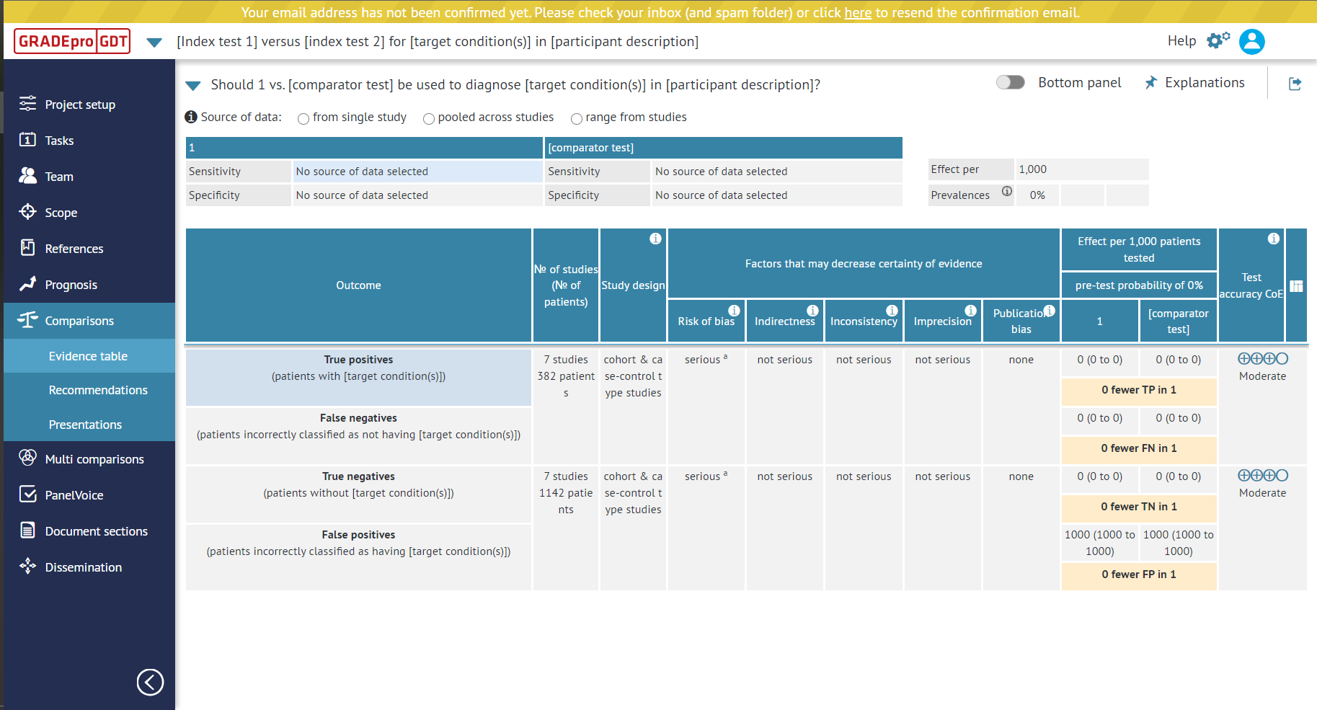
From: https://www.gradepro.org/

