Table S1. Feature selection: Lasso Regression
 | Selected features | Best Lambda | Min MSE | Intersection (descriptions)ª
BACS: Symbol Coding | 21 edges | 0.6057 | 77 | A8m_L- A20cv_L
Animal naming Fluency | 29 edges | 0.4054 | 72 | A1/2/3ll_L- cTtha_R
Speed of Processing | 29 edges | 0.1979 | 67 | aSTS_R- vmPu_L
 |  |  |  | A37vl_R- A23c_R
 |  |  |  | A1/2/3ulhf_L- mAmyg_R
 |  |  |  | G_R- mAmyg_R
 |  |  |  | cLinG_R- A2_R
 |  |  |  | rHipp_R- A24rv_R
 |  |  |  | rHipp_R- rTtha_L
BACS: Brief Assessment of Cognition in Schizophrenia, MSE: mean squared error.
ª: Anatomical and modified Cyto-architectonic descriptions by Brainnetome Atlas, A8m: medial area 8 in superior frontal gyrus, A20cv: caudoventral of area 20 in inferior temporal gyrus, A1/2/3ll: area1/2/3 (lower limb region) in paracentral lobule, cTtha: caudal temporal thalamus, aSTS: anterior superior temporal sulcus, vmPu: ventromedial putamen, A37vl: ventrolateral area 37 in inferior temporal gyrus, A23c: caudal area 23 in cingulate gyrus, A1/2/3ulhf: area 1/2/3(upper limb, head and face region) in postcentral gyrus, mAmyg: medial amygdala, G: hypergranular insula, cLinG: caudal lingual gyrus, A2: area 2 in postcentral gyrus, rHipp: rostral hippocampus, A24rv: rostroventral area 24 in cingulate gyrus, rTtha: rostral temporal thalamus, L: left, R: right.

Table S2. Differences in seed-based functional connectivity across the three groups.
Cluster location | Peak (MNI) |  |  | Number of voxels | T value
Cluster location | x | y | z | Number of voxels | T value
Seed: Cingulate Gyrus_R_7_6 (A23c_R) | 6 | -20 | 40
FSZ<HC
Right Superior frontal gyrus | 18 | 9 | 48 | 24 | -4.1907
Seed: Amygdala _R_2_1 (mAmyg_R) | 19 | -2 | -19
FSZ<CHR
Left Inferior parietal gyrus | -33 | -57 | 36 | 24 | -4.0004
FSZ: first-episode schizophrenia, CHR: clinical high-risk, HC: healthy controls, MNI = Montreal Neurological Institute, A23c_R: right caudal area 23 in cingulate gyrus, mAmyg_R: right medial amygdala.

Table S3. Differences in eye movements across the three groups.
 |  |  |  |  |  | FSZ vs CHR | FSZ vs HC | CHR vs HC
EM | FSZ | CHR | HC | F | p | p | p | p
HS4_sac_amp | 2.76±1.99 | 2.43±1.32 | 2.42±1.29 | 0.448 | 0.640 | 0.426 | 0.405 | 0.988
HS4_sac_av | 75.86±24.22 | 73.94±17.22 | 74.53±17.05 | 0.073 | 0.930 | 0.713 | 0.793 | 0.910
HS4_sac_pv | 137.73±47.45 | 119.54±38.40 | 130.57±41.35 | 1.331 | 0.269 | 0.108 | 0.514 | 0.324
HS4X_sac_amp | 1.70±0.83 | 1.41±0.52 | 1.31±0.51 | 2.959 | 0.057 | 0.092 | 0.021* | 0.554
HS4X_sac_av | 59.31±17.87 | 61.09±9.33 | 58.78±12.28 | 0.225 | 0.799 | 0.623 | 0.881 | 0.520
HS4X_sac_pv | 112.89±36.75 | 92.04±24.32 | 94.88±23.44 | 4.544 | 0.013* | 0.007* | 0.017* | 0.707
LS2_sac_amp | 1.76±0.69 | 1.59±0.95 | 1.38±0.52 | 2.054 | 0.134 | 0.398 | 0.047 | 0.262
LS2_sac_av | 58.86±12.23 | 56.61±12.05 | 56.34±8.81 | 0.468 | 0.628 | 0.441 | 0.377 | 0.926
LS2_sac_pv | 102.67±30.04 | 85.95±31.78 | 85.87±20.24 | 3.656 | 0.030* | 0.024* | 0.020* | 0.992
LS2B_sac_amp | 1.92±0.68 | 1.66±0.61 | 1.59±0.36 | 2.882 | 0.061 | 0.083 | 0.024* | 0.627
LS2B_sac_av | 64.31±16.57 | 61.50±11.88 | 61.84±7.74 | 0.442 | 0.644 | 0.397 | 0.444 | 0.918
LS2B_sac_pv | 111.28±33.25 | 95.42±25.76 | 95.79±20.33 | 2.986 | 0.056 | 0.028* | 0.054 | 0.736
EM: eye movements, FSZ: first-episode schizophrenia, CHR: clinical high-risk, HC: healthy controls, HS: horizontal smooth pursuit task, LS: Lissajous smooth pursuit task, sac_amp: amplitude of saccades, sac_av: average velocity of saccades, sac_pv: peak velocity of saccades.

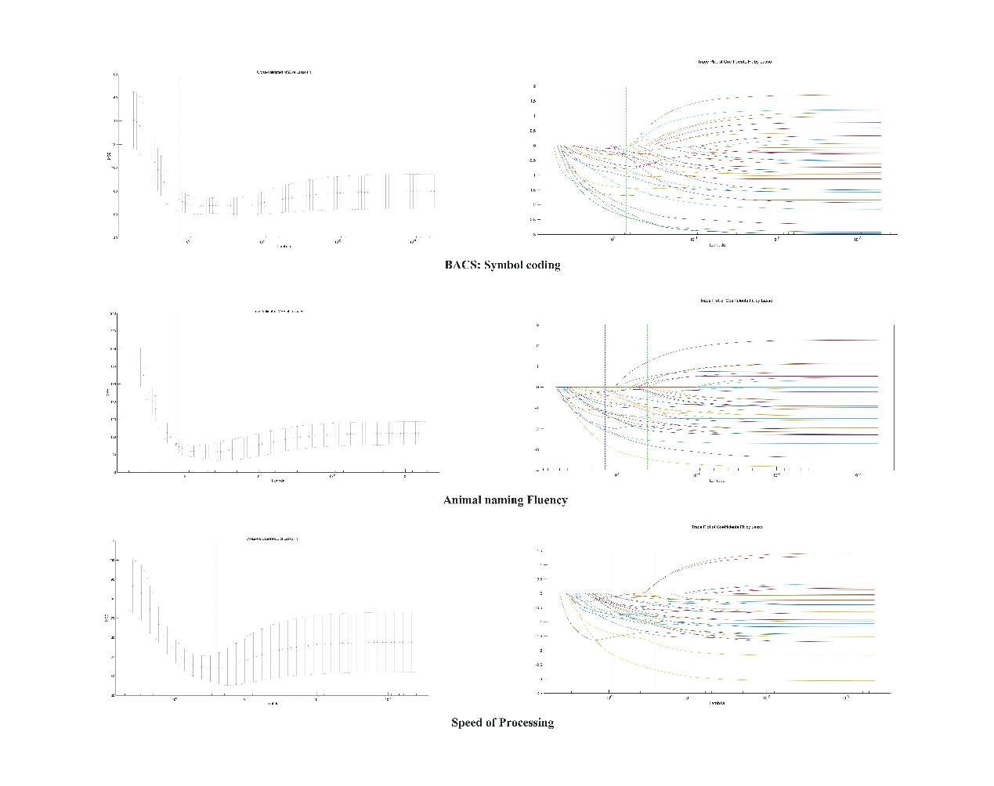
Figure S1. The right Lasso plot visualizes how the coefficients change with different lambda values. The x-axis represents the logarithm of the regularization parameter (lambda) values, and the y-axis represents the coefficients corresponding to each feature in the model. The left Lasso plot helps identify the lambda value that leads to the best-performing Lasso model in terms of cross-validated mean squared error (MSE). In this plot, the x-axis represents the logarithm of the regularization parameter (lambda) values, and the y-axis represents the cross-validated mean squared error (CV-MSE) of the Lasso model for each corresponding lambda value.

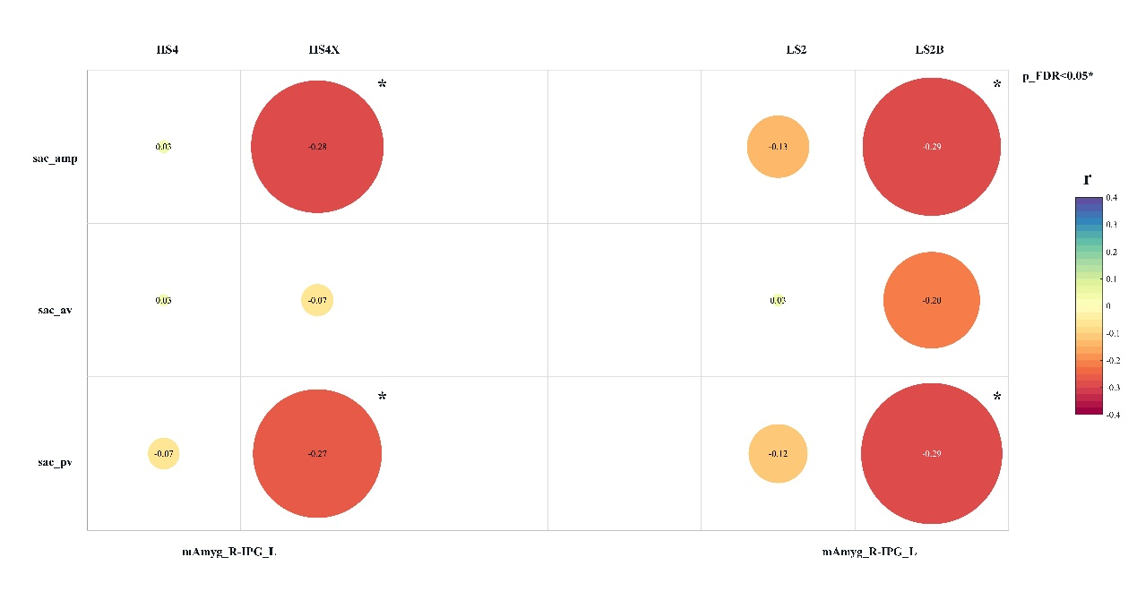
Figure S2. Correlation analysis. In FSZ and CHR patients, FC values between right amygdala and left IPG were negatively correlated with HS4X_sac_amp (r = -0.28, p < 0.05), HS4_sac_pv (r = -0.27, p < 0.05), LS2B_sac_amp (r = -0.29, p < 0.05), and LS2B_sac_pv (r = -0.29, p < 0.05) after FDR correction. sac_amp: amplitude of saccades, sac_av: average velocity of saccades, sac_pv: peak velocity of saccades, HS: horizontal smooth pursuit task, LS: Lissajous smooth pursuit task, FSZ: first-episode schizophrenia, CHR: clinical high-risk, FC: functional connectivity, mAmyg_R: Right Amygdala, IPG_L: Left Inferior parietal gyrus.

