Supplemental Figure 1: A detailed timeline of the experimental session

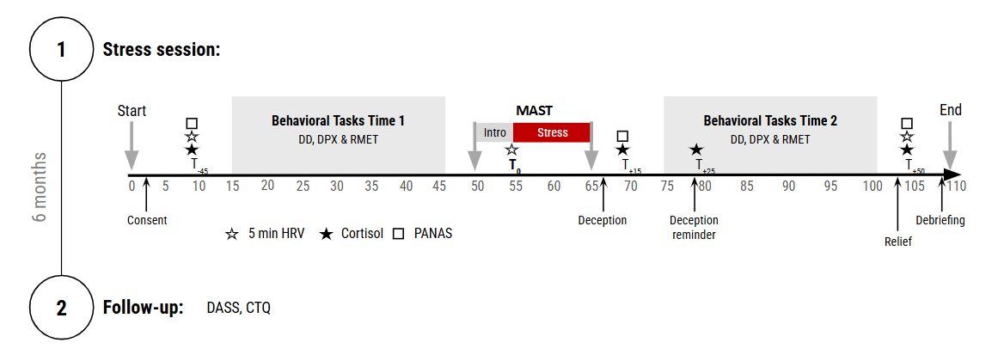
Supplemental Figure 1: A detailed timeline of the experimental session. MAST -Maastricht acute stress test; DD- Delay discounting task; DPX- Dot patternexpectancy task; RMET- Reading the mind in the eyes test; HRV - Heart rate variability; PANAS - Positive and negative affect schedule; CORT - Cortisol; DASS - Depression anxiety and stress scale; CTQ - Childhood trauma questionnaire short form.
See more information at: Rab SL, Simon L, Amit Bar-On R, Richter-Levin G, Admon R. Behavioural profiling following acute stress uncovers associations with future stress sensitivity and past childhood abuse. Eur J Psychotraumatol. 2024;15(1):2420554. doi: 10.1080/20008066.2024.2420554. Epub 2024 Nov 5. PMID: 39498490; PMCID: PMC11539402.

