Supplementary table 1. Traditional pairwise meta- analysis on CDRS-R.
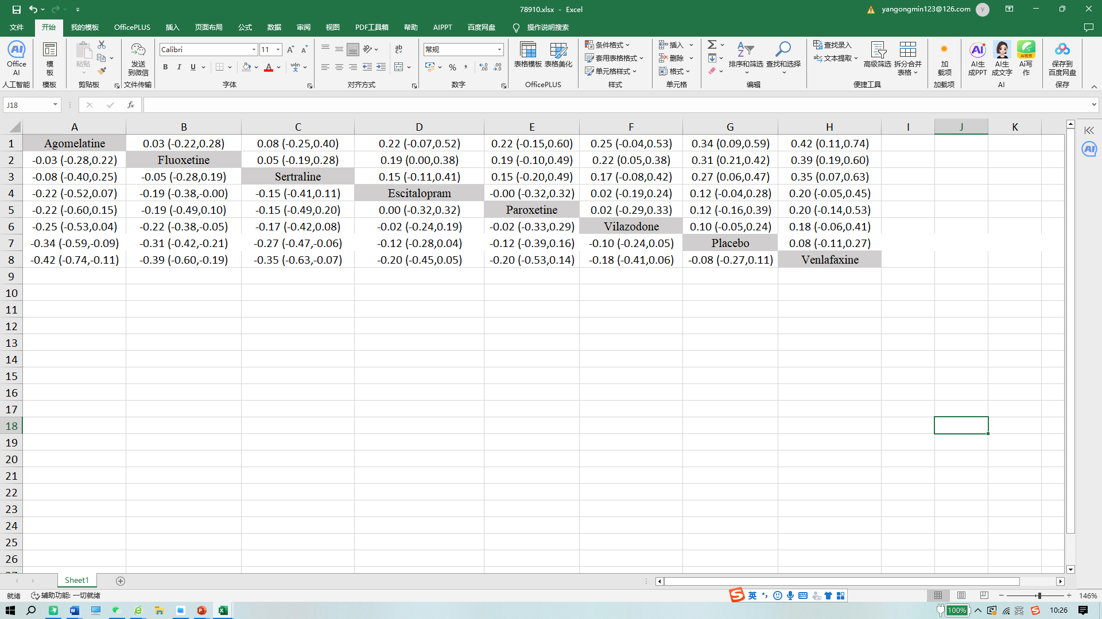
Supplementary table 2. Traditional pairwise meta- analysis on CGI-S.
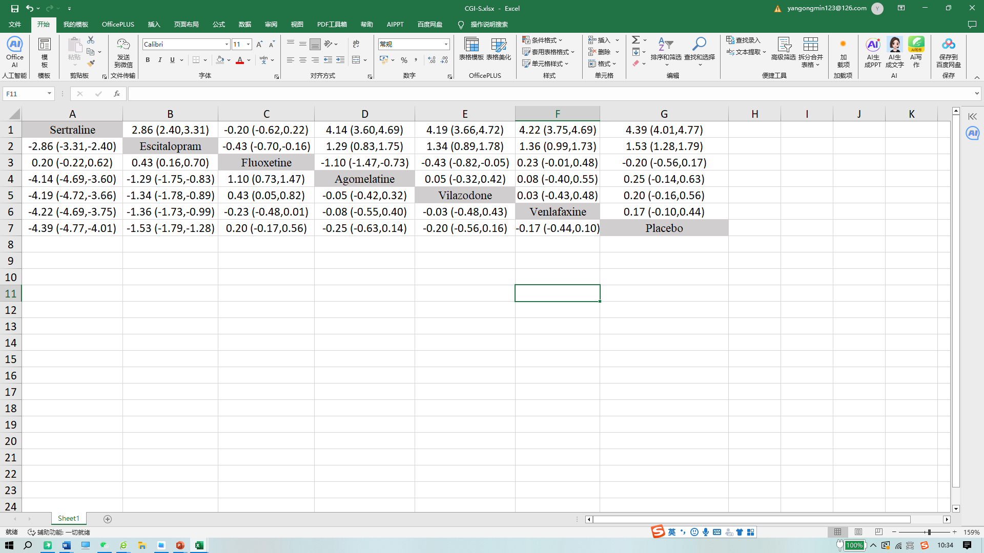
Supplementary table 3. Traditional pairwise meta- analysis on CGAS.
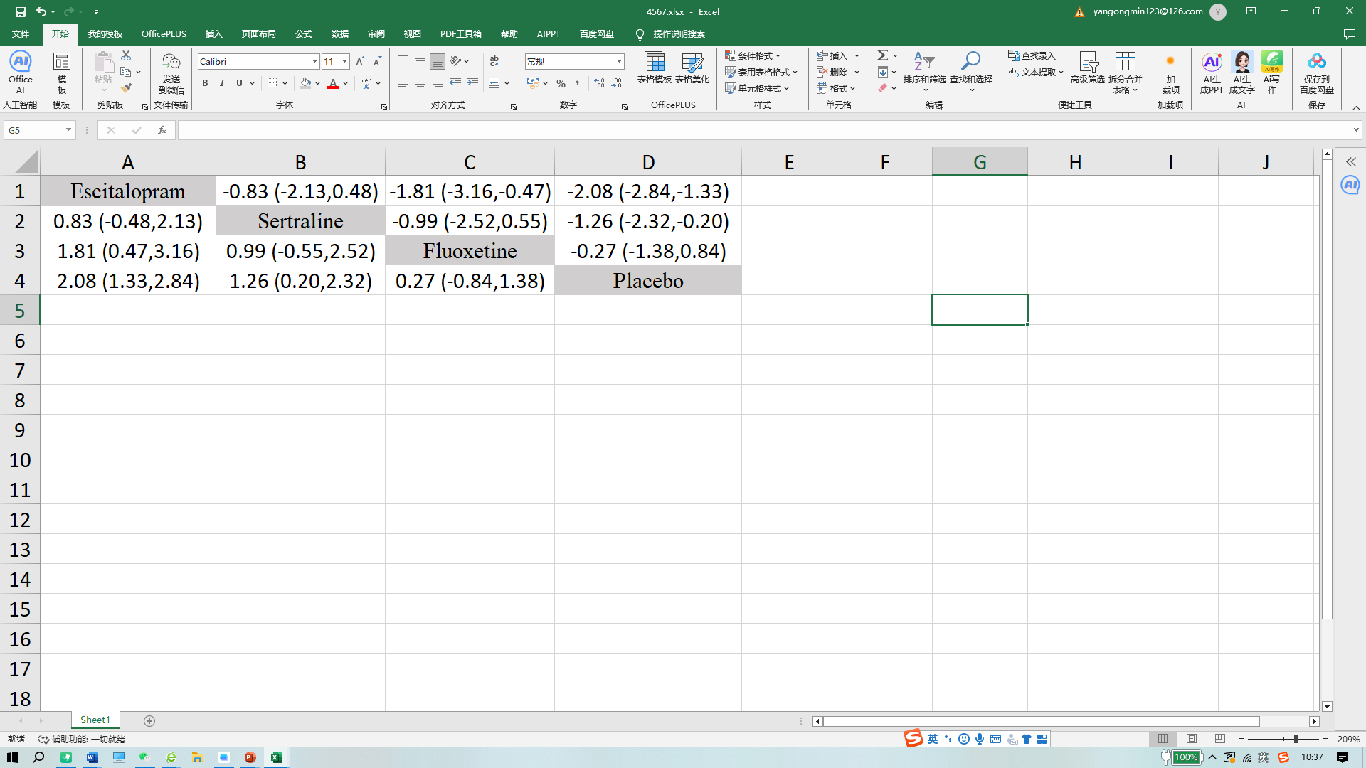
Supplementary table 4. Traditional pairwise meta- analysis on CGI-I.
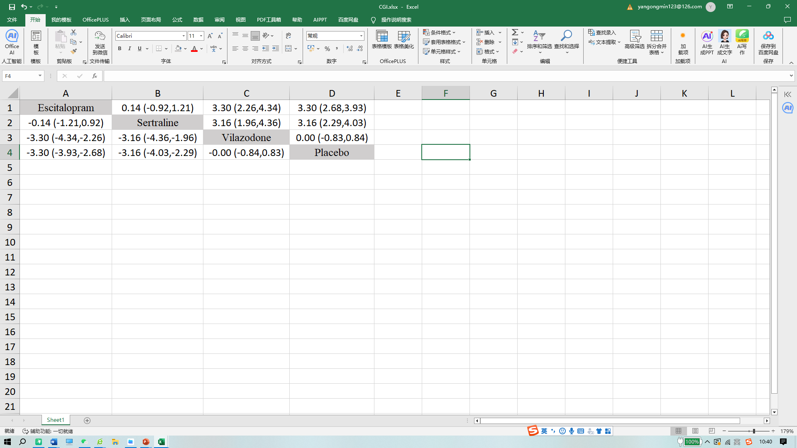
Supplementary table 5. Traditional pairwise meta- analysis on MADRS.
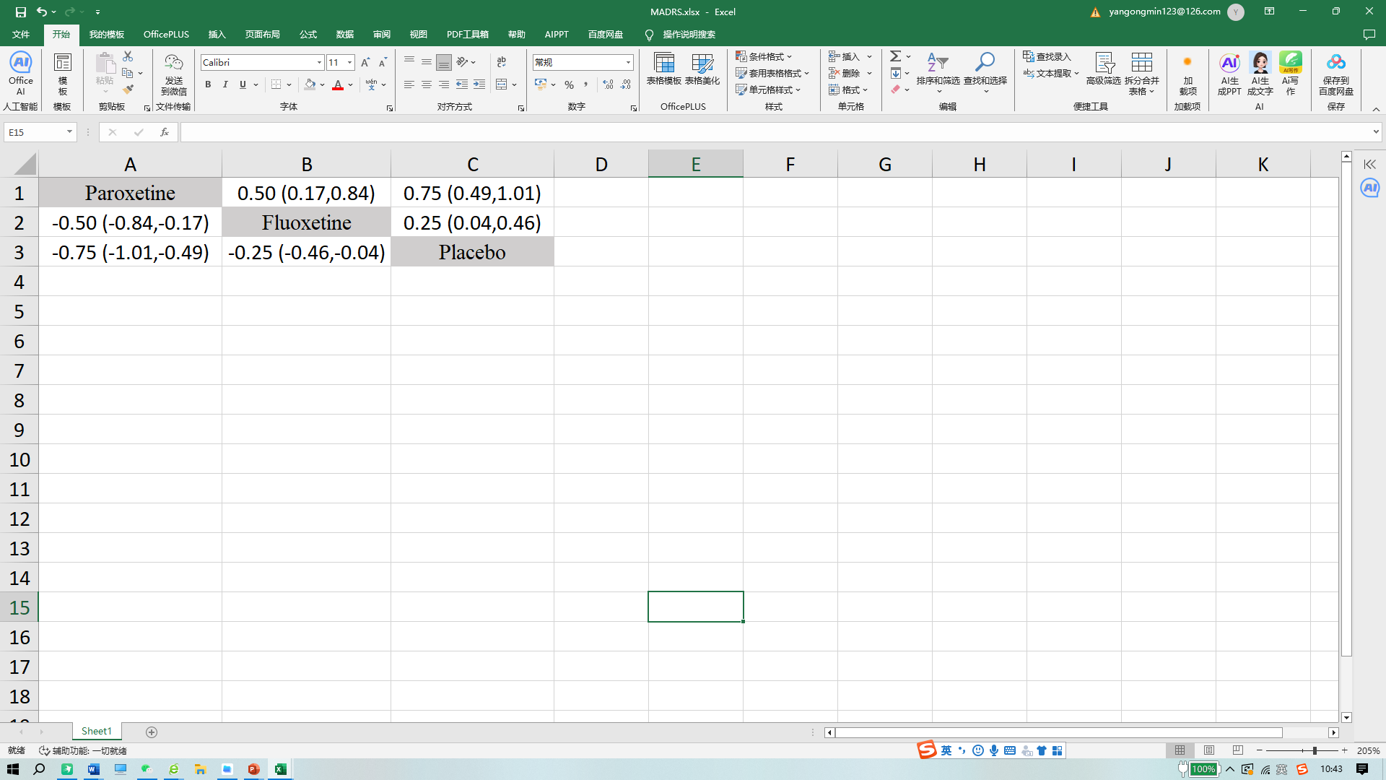
Search strategy
Web of Science
1 | Depression (Topic) or Depressive Disorders (Topic) or Emotional Disorders (Topic) and Preprint Citation Index (Exclude – Database) | 1,193,284
2 | adolescent (Topic) or young adult (Topic) or minors (Topic) and Preprint Citation Index (Exclude – Database) | 4,448,668
3 | fluoxetine (Topic) and Preprint Citation Index (Exclude – Database) | 30,149
4 | sertraline (Topic) and Preprint Citation Index (Exclude – Database) | 11,969
5 | paroxetine (Topic) and Preprint Citation Index (Exclude – Database) | 12,560
6 | agomelatine (Topic) and Preprint Citation Index (Exclude – Database) | 1,795
7 | vilazodone (Topic) and Preprint Citation Index (Exclude – Database) | 438
8 | escitalopram (Topic) and Preprint Citation Index (Exclude – Database) | 6,576
9 | venlafaxine (Topic) and Preprint Citation Index (Exclude – Database) | 9,119
10 | #1 AND #2 AND #3 and Preprint Citation Index (Exclude – Database) | 2,956
11 | #1 AND #2 AND #4 and Preprint Citation Index (Exclude – Database) | 1,386
12 | #1 AND #2 AND #5 and Preprint Citation Index (Exclude – Database) | 1,216
13 | #1 AND #2 AND #6 and Preprint Citation Index (Exclude – Database) | 119
14 | #1 AND #2 AND #7 and Preprint Citation Index (Exclude – Database) | 51
15 | #1 AND #2 AND #8 and Preprint Citation Index (Exclude – Database) | 904
16 | #1 AND #2 AND #9 and Preprint Citation Index (Exclude – Database) | 976

PUBMED
#1 | Search: "Depression"[Mesh] Sort by: Most Recent | 167,624
#2 | Search: (((Depression[Title/Abstract]) ) OR (Emotional Disorders[Title/Abstract])) OR (Depressive Disorders[Title/Abstract]) | 484,240
#3 | Search: ((((Depression[Title/Abstract]) ) OR (Emotional Disorders[Title/Abstract])) OR (Depressive Disorders[Title/Abstract])) OR ("Depression"[Mesh]) | 522,549
#4 | Search: "Adolescent"[Mesh] Sort by: Most Recent | 2,314,132
#5 | Search: ((Adolescent[Title/Abstract]) OR (young adult[Title/Abstract])) OR (minors[Title/Abstract]) | 222,432
#6 | Search: (((Adolescent[Title/Abstract]) OR (young adult[Title/Abstract])) OR (minors[Title/Abstract])) OR ("Adolescent"[Mesh]) | 2,392,265
#7 | Search: fluoxetine[Title/Abstract] | 14,493
#8 | Search: ((fluoxetine[Title/Abstract]) AND ((((Adolescent[Title/Abstract]) OR (young adult[Title/Abstract])) OR (minors[Title/Abstract])) OR ("Adolescent"[Mesh]))) AND (((((Depression[Title/Abstract]) ) OR (Emotional Disorders[Title/Abstract])) OR (Depressive Disorders[Title/Abstract])) OR ("Depression"[Mesh])) | 737
#9 | Search: sertraline[Title/Abstract] | 5,835
#10 | Search: ((sertraline[Title/Abstract]) AND ((((Adolescent[Title/Abstract]) OR (young adult[Title/Abstract])) OR (minors[Title/Abstract])) OR ("Adolescent"[Mesh]))) AND (((((Depression[Title/Abstract]) ) OR (Emotional Disorders[Title/Abstract])) OR (Depressive Disorders[Title/Abstract])) OR ("Depression"[Mesh])) | 344
#11 | Search: paroxetine[Title/Abstract] | 6,264
#12 | Search: ((paroxetine[Title/Abstract]) AND (((((Depression[Title/Abstract]) ) OR (Emotional Disorders[Title/Abstract])) OR (Depressive Disorders[Title/Abstract])) OR ("Depression"[Mesh]))) AND ((((Adolescent[Title/Abstract]) OR (young adult[Title/Abstract])) OR (minors[Title/Abstract])) OR ("Adolescent"[Mesh])) | 270
#13 | Search: agomelatine[Title/Abstract] | 985
#14 | Search: ((agomelatine[Title/Abstract]) AND (((((Depression[Title/Abstract]) ) OR (Emotional Disorders[Title/Abstract])) OR (Depressive Disorders[Title/Abstract])) OR ("Depression"[Mesh]))) AND ((((Adolescent[Title/Abstract]) OR (young adult[Title/Abstract])) OR (minors[Title/Abstract])) OR ("Adolescent"[Mesh])) | 36
#15 | Search: vilazodone[Title/Abstract] | 288
#16 | Search: ((vilazodone[Title/Abstract]) AND (((((Depression[Title/Abstract]) ) OR (Emotional Disorders[Title/Abstract])) OR (Depressive Disorders[Title/Abstract])) OR ("Depression"[Mesh]))) AND ((((Adolescent[Title/Abstract]) OR (young adult[Title/Abstract])) OR (minors[Title/Abstract])) OR ("Adolescent"[Mesh])) | 18
#17 | Search: escitalopram[Title/Abstract] | 3,627
#18 | Search: ((escitalopram[Title/Abstract]) AND ((((Adolescent[Title/Abstract]) OR (young adult[Title/Abstract])) OR (minors[Title/Abstract])) OR ("Adolescent"[Mesh]))) AND (((((Depression[Title/Abstract]) ) OR (Emotional Disorders[Title/Abstract])) OR (Depressive Disorders[Title/Abstract])) OR ("Depression"[Mesh])) | 264
#19 | Search: venlafaxine[Title/Abstract] | 4,928
#20 | Search: ((venlafaxine[Title/Abstract]) AND ((((Adolescent[Title/Abstract]) OR (young adult[Title/Abstract])) OR (minors[Title/Abstract])) OR ("Adolescent"[Mesh]))) AND (((((Depression[Title/Abstract]) ) OR (Emotional Disorders[Title/Abstract])) OR (Depressive Disorders[Title/Abstract])) OR ("Depression"[Mesh])) | 253
Cochrane library
#1 | MeSH descriptor. [Depression] explode all trees | 18820
#2 | (Depression):ti,ab,kw OR (Depressive Disorders):ti,ab,kw OR (Emotional Disorders):ti,ab,kw | 116009
#3 | MeSH descriptor. [Adolescent] explode all trees# | 135760
#4 | (adolescent):ti,ab,kw OR (young adult):ti,ab,kw OR (minors):ti,ab,kw | 237708
#5 | #1 or #2 | 116009
#6 | #3 or #4 | 237708
#7 | fluoxetine | 4061
#8 | #5 and #6 and #7 | 565
#9 | sertraline | 3112
#10 | #5 and #6 and #9 | 293
#11 | paroxetine | 2865
#12 | #5 and #6 and #11 | 222
#13 | agomelatine | 422
#14 | #5 and #6 and #13 | 39
#15 | vilazodone | 163
#16 | #5 and #6 and #15 | 24
#17 | escitalopram | 2294
#18 | #5 and #6 and #17 | 250
#19 | venlafaxine | 2136
#20 | #5 and #6 and #19 | 223

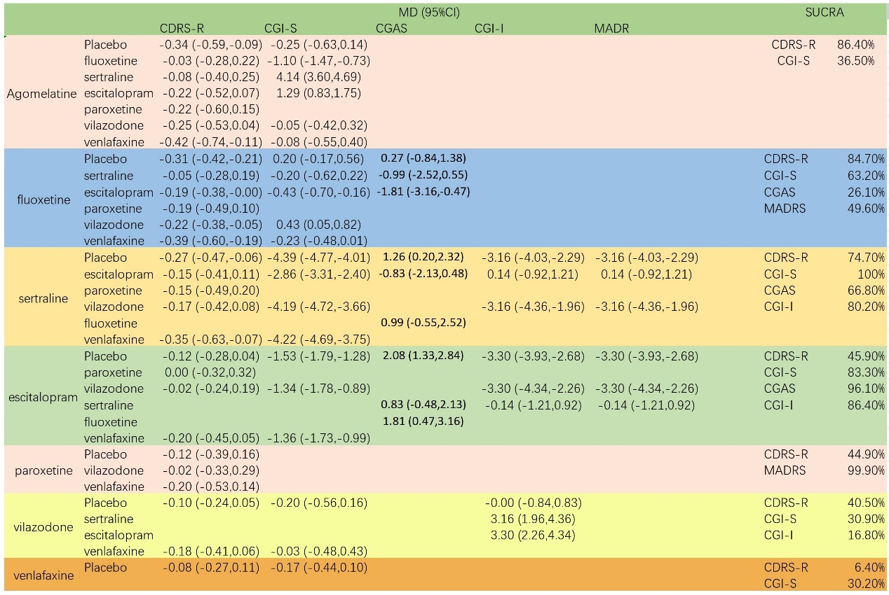
Supplementary diagram of result summary

