Supplementary Figure 4. Number of monthly FMHAs before and during the COVID-19 pandemic. Citizenship.
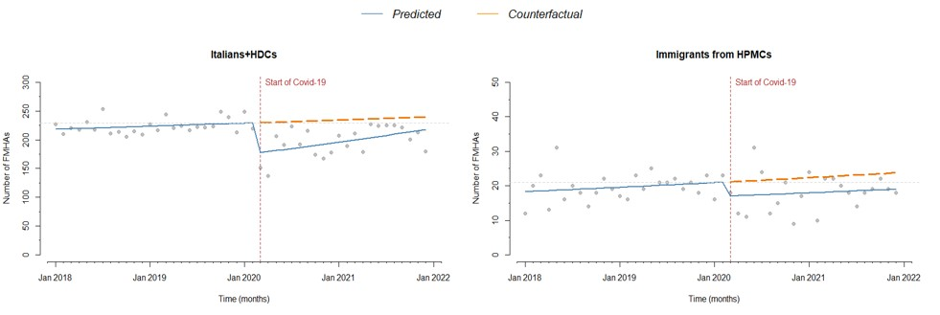
Vertical dashed line: introduction of restrictions. Continuous line: trend over the years. Dashed line: counterfactual scenario. Horizontal dashed line: pre-pandemic level.

