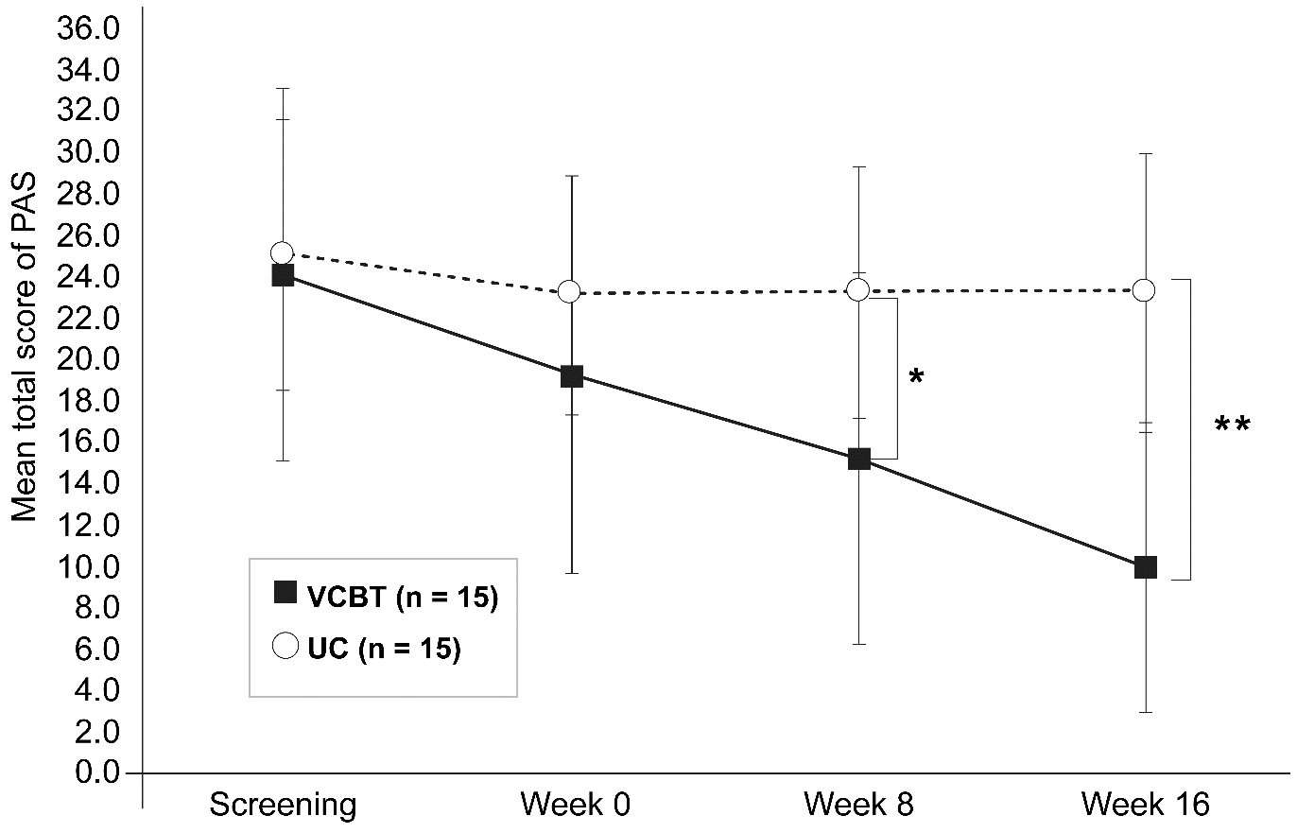
Additional file 3. Mean of Panic and Agoraphobia Scale at each timepoint. Error bars represent 1 standard deviation

