Supplementary material
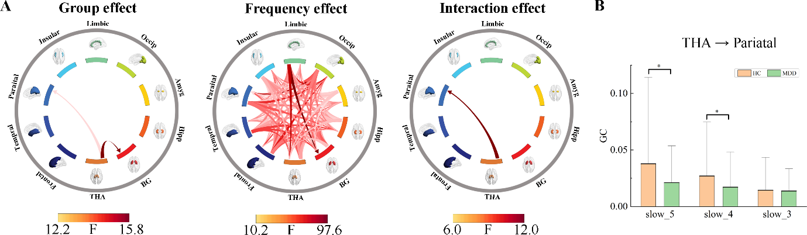
Fig S1. Thalamic EC alterations in patients with MDD were frequency-dependent. A) Main effects of group, frequency, and their interactions. B) Alterations of EC (from thalamus to pariatal) in MDD in each frequency band.

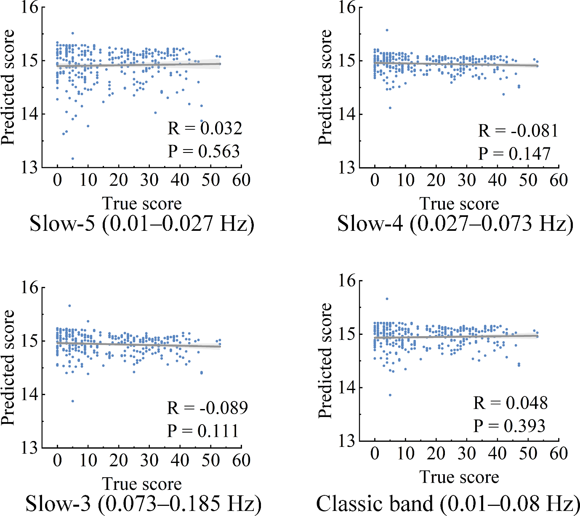
Fig S2. The scatterplots show the correlation between the predicted and observed BDI-II scores in each frequency band, with each dot representing a subject. The thalamic EC in the four bands cannot predict individual BDI-II scores.

