Table S1: Adjusted¶ differences between CSC group and TAU group in mean total costs and health effects by main diagnosis† during 12-month follow up (n=607) – Subgroup analyses
Cost category / Measure of health effect |  | CSC group | TAU group | Difference CSC-TAU | P-value
F30-F39; n=467 | Total costs (PP): mean (SE) | 5874€ (1286€) | 5467€ (1254€) | 407€ (899€) | 0.651
F30-F39; n=467 | Total costs (SP): mean (SE) | 28,593€ (2170€) | 27,243€ (2103€) | 1350€ (3459€) | 0.669
F30-F39; n=467 | QALY (EQ-5D): mean (SE) | 0.86 (0.01) | 0.86 (0.12) | 0.00 (0.02) | 0.786
F30-F39; n=467 | QALY (EQ-VAS): mean (SE) | 0.68 (0.01) | 0.69 (0.01) | −0.01 (0.01) | 0.521
F30-F39; n=467 | QALY (SF-6D): mean (SE) | 0.68 (0.01) | 0.68 (0.01) | −0.01 (0.01) | 0.293
F40, F41; n=93 | Total costs (PP): mean (SE) | 4763€ (938€) | 4144€ (1411€) | 619€ (1699€) | 0.716
F40, F41; n=93 | Total costs (SP): mean (SE) | 23,121€ (2380€) | 27,066€ (6726€) | −3945€ (7806€) | 0.613
F40, F41; n=93 | QALY (EQ-5D): mean (SE) | 0.89 (0.01) | 0.89 (0.05) | −0.01 (0.03) | 0.765
F40, F41; n=93 | QALY (EQ-VAS): mean (SE) | 0.71 (0.02) | 0.72 (0.04) | −0.01 (0.05) | 0.840
F40, F41; n=93 | QALY (SF-6D): mean (SE) | 0.71 (0.01) | 0.71 (0.02) | −0.00 (0.02) | 0.874
F45; n=47 | Total costs (PP): mean (SE) | 4935€ (2248€) | 4532€ (1911€) | 403€ (3253€) | 0.901
F45; n=47 | Total costs (SP): mean (SE) | 25,147€ (7306€) | 24,599€ (6776€) | 548€ (9624€) | 0.955
F45; n=47 | QALY (EQ-5D): mean (SE) | 0.79 (0.05) | 0.86 (0.06) | −0.07 (0.09) | 0.431
F45; n=47 | QALY (EQ-VAS): mean (SE) | 0.68 (0.04) | 0.71 (0.03) | −0.02 (0.05) | 0.647
F45; n=47 | QALY (SF-6D): mean (SE) | 0.69 (0.03) | 0.71 (0.02) | −0.02 (0.04) | 0.592
F30-F39: mood disorders, F40: phobic anxiety disorders, F41: other anxiety disorders, F45: somatoform disorders, PP: payer’s perspective, SP: societal perspective, SE: Standard error, QALY: Quality-adjusted life year, CSC: collaborative and stepped care model, TAU: treatment as usual, VAS: visual analogue scale
¶ Adjusted for sex, age, occupational status, main diagnosis, study inclusion before COVID-19 pandemic, number of comorbidities, MCS and the respective costs / health effect at baseline by a two-part model/generalized linear model with robust standard errors
† F10: Mental and behavioral disorders due to use of alcohol was omitted because this diagnosis was not present in the CSC group

Table S2: Adjusted¶ differences between the CSC group and TAU group in mean total costs and health effects during 12-month follow up – Additional analyses
Cost category / Measure of health effect |  | N | CSC group | TAU group | Difference CSC-TAU | P-value
Complete case analysis | Total costs (PP): mean (SE) | 170 | 4423€ (455€) | 4743€ (734€) | −320€ (937€) | 0.732
Complete case analysis | Total costs (SP): mean (SE) | 148 | 23,281€ (1722€) | 23,336€ (2173€) | −55€ (3272€) | 0.987
Complete case analysis | QALY (EQ-5D-5L): mean (SE) | 253 | 0.86 (0.01) | 0.87 (0.01) | −0.01 (0.02) | 0.725
Complete case analysis | QALY (EQ-VAS): mean (SE) | 243 | 0.69 (0.01) | 0.71 (0.01) | −0.02 (0.02) | 0.265
Complete case analysis | QALY (SF-6D): mean (SE) | 231 | 0.68 (0.01) | 0.70 (0.01) | −0.01 (0.01) | 0.226
Analysis with LOCF | Total costs (PP): mean (SE) | 357 | 4529€ (659€) | 3838€ (689€) | 691€ (644€) | 0.284
Analysis with LOCF | Total costs (SP): mean (SE) | 353 | 29361 (1449€) | 26,767€ (1350€) | 2594€ (2257€) | 0.250
Analysis with LOCF | QALY (EQ-5D-5L): mean (SE) | 446 | 0.84 (0.01) | 0.84 (0.01) | −0.00 (0.01) | 0.839
Analysis with LOCF | QALY (EQ-VAS): mean (SE) | 442 | 0.69 (0.01) | 0.69 (0.01) | −0.01 (0.01) | 0.511
Analysis with LOCF | QALY (SF-6D): mean (SE) | 460 | 0.66 (0.00) | 0.66 (0.00) | −0.00 (0.00) | 0.560
Analysis with only mental health costs | Total costs: mean (SE) | 615 | 2219€ (193€) | 1424€ (166€) | 795€ (225€) | < 0.001
Analysis with winsorized costs† | Total costs (PP): mean (SE) | 615 | 4811€ (336€) | 4171€ (347€) | 640€ (498€) | 0.199
Analysis with winsorized costs† | Total costs (SP): mean (SE) | 615 | 25,845€ (1315€) | 24.813€ (1487€) | 1032€ (2280€) | 0.651
PP: payer’s perspective, SP: societal perspective, SE: Standard error, QALY: Quality-adjusted life year, CSC: collaborative and stepped care model, TAU: treatment as usual
¶ Adjusted for sex, age, occupational status, main diagnosis, study inclusion before COVID-19 pandemic, number of comorbidities, MCS and the respective costs / health effect at baseline by a two-part model/generalized linear model with robust standard errors
† winsorized at the 95th percentile

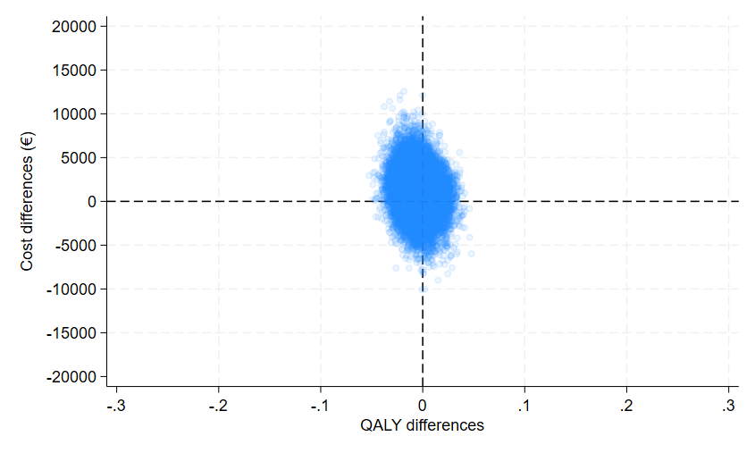
Figure S1: Adjusted¶ cost-effectiveness plane of the CSC model compared with TAU – Analysis from societal perspective†
CSC: collaborative and stepped care model, TAU: treatment as usual, QALY: Quality-adjusted life year
¶ Adjusted for sex, age, occupational status, main diagnosis, study inclusion before COVID-19 pandemic, number of comorbidities, MCS and the EQ-5D-5L index at baseline / total costs up to 6 months before baseline by a seemingly unrelated regression model with bootstrapped standard errors; † QALYs based on the EQ-5D-5L index

Figure S2: Probability of cost-effectiveness¶ of the CSC model compared with TAU for different thresholds for maximum willingness-to-pay per additional QALY – Subgroup analyses (Persons with affective disorders, persons with anxiety disorders, persons with somatoform disorders)
QALY: Quality-adjusted life year
¶ Adjusted for sex, age, occupational status, main diagnosis, study inclusion before COVID-19 pandemic, number of comorbidities, MCS and the respective costs / health effect at baseline by a linear regression model with robust standard errors

Figure S3: Probability of cost-effectiveness¶ of the CSC model compared with TAU for different thresholds for maximum willingness-to-pay per additional QALY – Secondary analyses (Analyses with response to treatment and remission from symptoms as measure of health effect)
QALY: Quality-adjusted life year
¶ Adjusted for sex, age, occupational status, main diagnosis, study inclusion before COVID-19 pandemic, number of comorbidities, MCS and the respective costs / health effect at baseline by a linear regression model with robust standard errors

Figure S4: Probability of cost-effectiveness¶ of the CSC model compared with TAU for different thresholds for maximum willingness-to-pay per additional QALY – Sensitivity analyses (Analysis with winsorized costs, analysis with last observation carried forward, complete case analysis, analysis with psychiatric costs)
QALY: Quality-adjusted life year, LOCF: last observation carried forward
¶ Adjusted for sex, age, occupational status, main diagnosis, study inclusion before COVID-19 pandemic, number of comorbidities, MCS and the respective costs / health effect at baseline by a linear regression model with robust standard errors

