Supplementary Appendix

The list of abbreviations:
- AC, avoidance coping
- ANX, anxiety symptoms
- CogR, cognitive reappraisal
- DEP, depressive symptoms
- DIS, dissociation symptoms
- EMP, empathy
- ES, expressive suppression
- EFC, emotion-focused coping
- EMP, empathy
- IMP, impulsiveness
- INS, insomnia
- PFC, problem-focused coping
- PLEs, psychotic-like experiences
- SR, suicide risk
- VENT, venturesomeness

Table S1. Weights matrix.
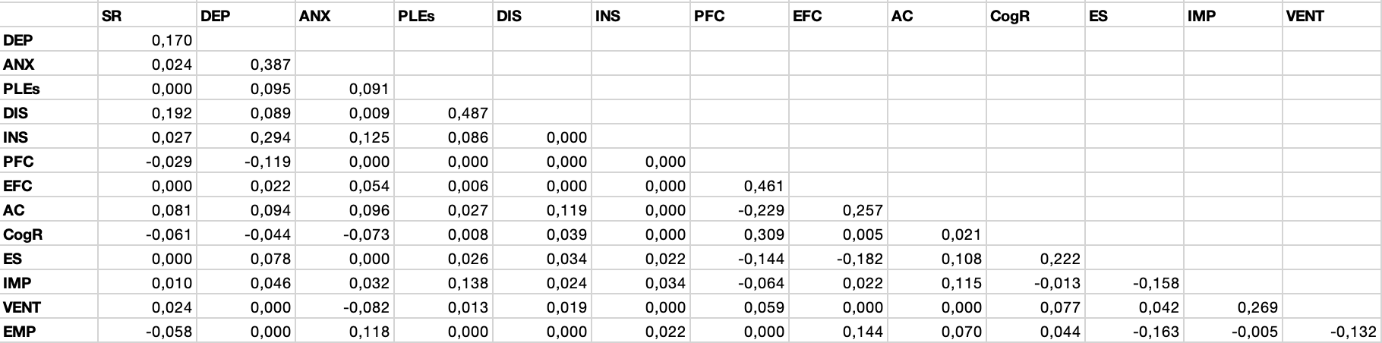

Table S2. Node predictabilities.
Node | Predictability
SR | 0.244
DEP | 0.566
ANX | 0.455
PLEs | 0.482
DIS | 0.480
INS | 0.315
PFC | 0.486
AC | 0.359
CogR | 0.237
ES | 0.278
IMP | 0.249
VENT | 0.140
EMP | 0.167

Figure S1. The comparison of edge weights in the network. Black boxes refer to significant differences, while grey boxes mark differences that appeared to be not significant.
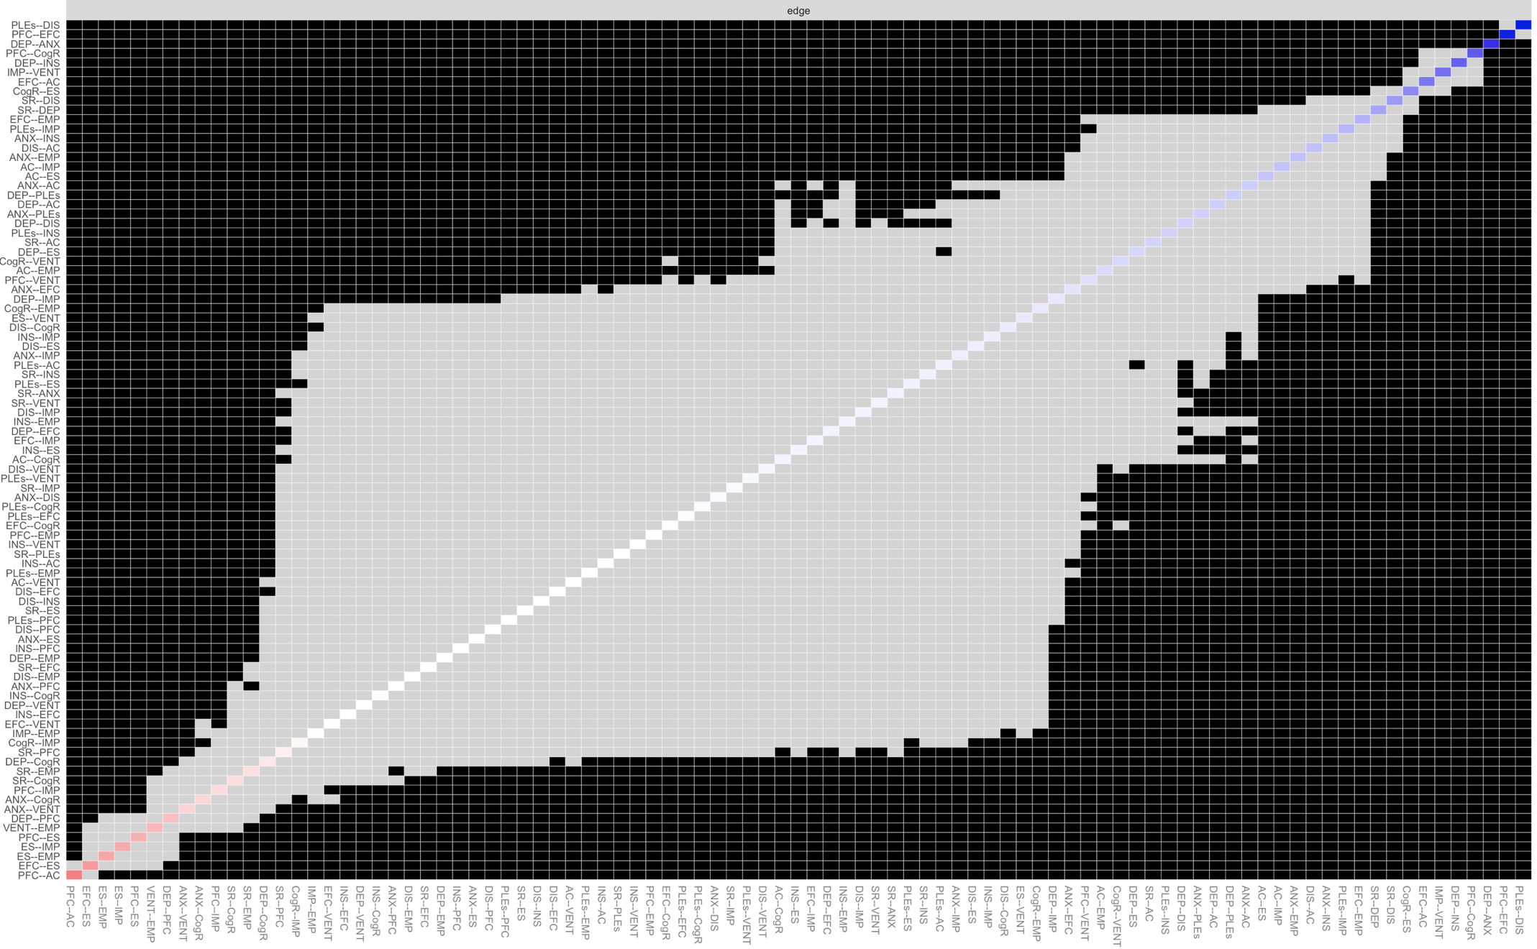

Figure S2. Stability of the bridge expected influence index. The red line shows changes of the centrality index after dropping various proportions of data.
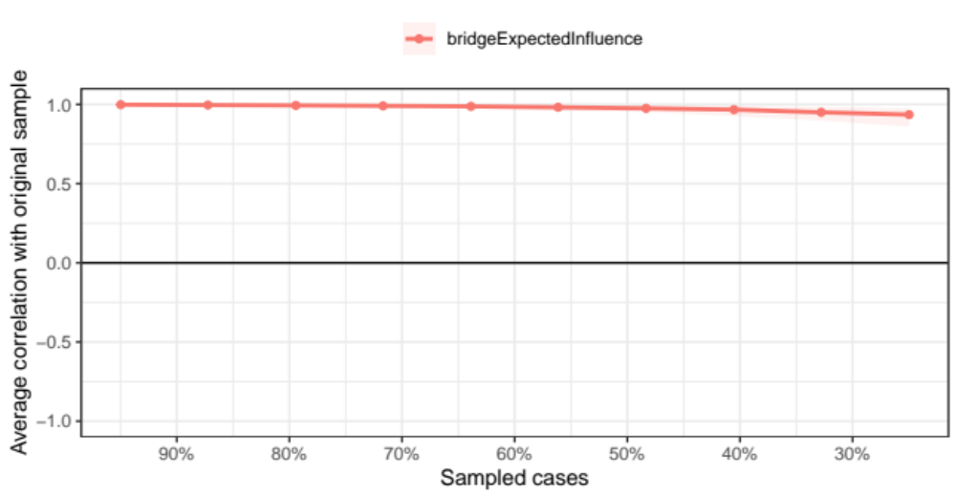
Figure 3. Bootstrapped 95% confidence intervals of edge weights. The sample values are illustrated using a red line. The bootstrapped 95% confidence intervals are depicted within the grey area.
