a)

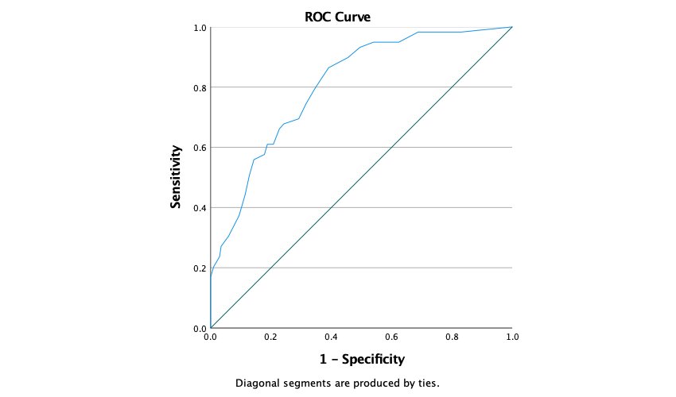
b)
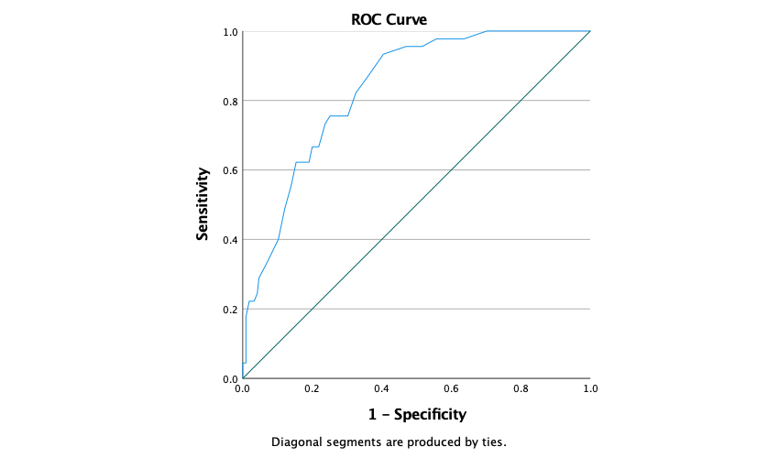

Supplemental Figure 1 Receiver Operating Characteristic (ROC) curves demonstrating the predictive ability of the Autism- Tics, ADHD, and other Comorbidities inventory (A-TAC) for the detection of a) ADHD diagnosis, and b) autism spectrum disorder (ASD).

