Association Between Nicotine-Dependent Patients and Delirium in Intensive Care Units: A Retrospective Cohort Study Using a Large Clinical Database
Mengqing Yang¹, Zhengxin Hu¹, Yun Huang¹, Guohao Zhang², Fengguang Kang³* and Dezhu Chen¹*

- Department of Emergency and Critical Care Medicine, ShunDe Hospital of Guangzhou University of Chinese Medicine, Foshan, Guangdong, People's Republic of China.
- Department of Cardiology, Shunde District Integrated Traditional Chinese and Western Medicine Hospital (Jun'an Hospital, Shunde District), Foshan, Guangdong, People's Republic of China.
- Department of Emergency, ShunDe Hospital of Guangzhou University of Chinese Medicine, Foshan, Guangdong, People's Republic of China.
*Equally contributed as Corresponding author

Address for Correspondence:
Fengguang Kang
Department of Emergency, ShunDe Hospital of Guangzhou University of Chinese Medicine, No.12, Jinsha Road, Daliang Town, Shunde District, Foshan, Guangdong, China, 528000.
Email: kmonmon@163.com
Dezhu Chen
Department of Emergency and Critical Care Medicine, ShunDe Hospital of Guangzhou University of Chinese Medicine. No.12, Jinsha Road, Daliang Town, Shunde District, Foshan, Guangdong, China, 528000.
Email: chendezhu@gzucm.edu.cn

TableS1 Univariate and Multivariate Cox Regression Analysis of Delirium Risk in ICU Patients before PSM
Variables |  | Univariate analysis |  | Multivariate analysis
 |  | HR (95% CI) | P | HR (95% CI) | P
Male | 1.02 (0.97-1.07) |  | 0.450 | 0.99 (0.94-1.04) | 0.636
White | 0.84 (0.80-0.88) |  | <0.001 | 0.88 (0.83-0.94) | <0.001
Black | 1.02 (0.94-1.12) |  | 0.603 | 0.98 (0.89-1.08) | 0.681
Asian | 0.70 (0.60-0.82) |  | <0.001 | 0.72 (0.62-0.85) | <0.001
Age | 1.00 (1.00-1.00) |  | 0.002 | 1.00 (1.00-1.01) | 0.003
Anion gap | 1.06 (1.05-1.06) |  | <0.001 | 0.95 (0.94-0.96) | <0.001
Bicarbonate | 0.96 (0.96-0.97) |  | <0.001 | 0.92 (0.91-0.93) | <0.001
BUN | 1.01 (1.01-1.01) |  | <0.001 | 1.00 (1.00-1.00) | 0.863
Chloride | 0.99 (0.98-0.99) |  | <0.001 | 0.91 (0.90-0.92) | <0.001
Creatinine | 1.07 (1.05-1.08) |  | <0.001 | 0.97 (0.95-0.99) | 0.009
Sodium | 1.01 (1.00-1.01) |  | 0.039 | 1.11 (1.09-1.12) | <0.001
Potassium | 1.12 (1.09-1.16) |  | <0.001 | 1.04 (1.00-1.07) | 0.052
WBC | 1.00 (1.00-1.01) |  | <0.001 | 1.00 (1.00-1.00) | 0.127
Hemoglobin | 0.98 (0.97-0.99) |  | <0.001 | 1.00 (0.99-1.01) | 0.589
Platelet | 1.00 (1.00-1.00) |  | <0.001 | 1.00 (1.00-1.00) | 0.225
Ventilation | 2.06 (1.90-2.23) |  | <0.001 | 1.04 (0.95-1.14) | 0.439
Vasopressor | 2.24 (2.08-2.41) |  | <0.001 | 0.95 (0.87-1.03) | 0.193
Benzodiazepines | 1.95 (1.85-2.05) |  | <0.001 | 1.43 (1.34-1.52) | <0.001
Propofol | 2.37 (2.24-2.50) |  | <0.001 | 1.81 (1.69-1.93) | <0.001
Midazolam | 2.26 (2.14-2.39) |  | <0.001 | 0.99 (0.93-1.07) | 0.863
NRT | 0.51 (0.41-0.64) |  | <0.001 | 0.49 (0.39-0.62) | <0.001
Sepsis | 2.63 (2.49-2.79) |  | <0.001 | 1.58 (1.48-1.68) | <0.001
AKI | 1.89 (1.76-2.03) |  | <0.001 | 1.11 (1.03-1.20) | 0.009
ARF | 2.59 (2.46-2.73) |  | <0.001 | 1.51 (1.42-1.60) | <0.001
Hypertension | 0.97 (0.92-1.02) |  | 0.294 | 0.92 (0.87-0.98) | 0.008
Diabetes | 1.11 (1.05-1.17) |  | <0.001 | 1.06 (1.00-1.13) | 0.071
CHF | 1.07 (1.01-1.13) |  | 0.021 | 0.92 (0.86-0.98) | 0.011
Chronic Pulmonary Disease | 1.12 (1.05-1.18) |  | <0.001 | 1.01 (0.95-1.07) | 0.782
Severe Liver Disease | 2.22 (2.04-2.42) |  | <0.001 | 1.30 (1.17-1.44) | <0.001
Malignant Cancer | 1.00 (0.93-1.07) |  | 0.989 | 0.91 (0.84-1.00) | 0.047
PNA | 1.90 (1.80-2.00) |  | <0.001 | 1.19 (1.13-1.26) | <0.001
SOFA | 1.11 (1.10-1.12) |  | <0.001 | 1.02 (1.01-1.03) | 0.002
SAPS II | 1.03 (1.03-1.03) |  | <0.001 | 1.01 (1.01-1.02) | <0.001
CCI | 1.04 (1.03-1.05) |  | <0.001 | 0.99 (0.97-1.00) | 0.107
Nicotine Dependence | 1.26 (1.17-1.36) |  | <0.001 | 1.27 (1.18-1.37) | <0.001
Abbreviations: BUN, blood urea nitrogen; WBC, white blood cell count; NRT, nicotine replacement therapy; AKI, acute kidney injury; ARF, acute respiratory failure; CHF, congestive heart failure; PNA, pneumonia; SOFA, Sequential Organ Failure Assessment; SAPS II, Simplified Acute Physiology Score II; CCI, Charlson Comorbidity Index；HR, hazard ratio；CI, confidence interval.

TableS2 Univariate and Multivariate Cox Regression Analysis of Delirium Risk in ICU Patients After PSM
Variables | Univariate analysis |  | Multivariate analysis
Variables | HR (95% CI) | P | HR (95% CI) | P
Male | 0.98 (0.88-1.09) | 0.683 | 0.96 (0.86-1.08) | 0.518
White | 0.81 (0.73-0.90) | <0.001 | 0.84 (0.75-0.95) | 0.004
Black | 0.91 (0.77-1.09) | 0.322 | 0.90 (0.74-1.10) | 0.298
Asian | 0.73 (0.52-1.04) | 0.084 | 0.83 (0.58-1.19) | 0.304
Age | 1.00 (1.00-1.00) | 0.320 | 1.00 (1.00-1.01) | 0.882
Anion gap | 1.05 (1.04-1.06) | <0.001 | 0.95 (0.93-0.97) | <0.001
Bicarbonate | 0.96 (0.95-0.97) | <0.001 | 0.92 (0.90-0.95) | <0.001
BUN | 1.01 (1.00-1.01) | <0.001 | 1.00 (1.00-1.00) | 0.947
Chloride | 0.98 (0.98-0.99) | <0.001 | 0.91 (0.88-0.93) | <0.001
Creatinine | 1.05 (1.03-1.08) | <0.001 | 0.95 (0.91-1.00) | 0.073
Sodium | 1.00 (0.99-1.01) | 0.662 | 1.11 (1.08-1.13) | <0.001
Potassium | 1.14 (1.07-1.22) | <0.001 | 1.08 (1.00-1.16) | 0.039
WBC | 1.00 (1.00-1.01) | 0.026 | 1.00 (0.99-1.00) | 0.557
Hemoglobin | 0.97 (0.95-0.99) | 0.008 | 0.99 (0.97-1.01) | 0.414
Platelet | 1.00 (1.00-1.00) | <0.001 | 1.00 (1.00-1.00) | 0.134
Ventilation | 1.89 (1.61-2.22) | <0.001 | 0.87 (0.73-1.05) | 0.144
Vasopressor | 2.07 (1.77-2.42) | <0.001 | 0.93 (0.78-1.10) | 0.400
Benzodiazepines | 1.98 (1.78-2.21) | <0.001 | 1.47 (1.30-1.68) | <0.001
Propofol | 2.72 (2.43-3.04) | <0.001 | 2.04 (1.78-2.33) | <0.001
Midazolam | 2.08 (1.87-2.32) | <0.001 | 0.95 (0.83-1.08) | 0.451
Sepsis | 2.76 (2.46-3.09) | <0.001 | 1.55 (1.36-1.77) | <0.001
AKI | 1.84 (1.61-2.11) | <0.001 | 1.04 (0.90-1.21) | 0.581
ARF | 2.47 (2.23-2.73) | <0.001 | 1.49 (1.33-1.68) | <0.001
Hypertension | 0.94 (0.85-1.04) | 0.221 | 0.95 (0.85-1.07) | 0.409
Diabetes | 0.98 (0.87-1.10) | 0.712 | 0.94 (0.82-1.07) | 0.321
CHF | 0.93 (0.83-1.05) | 0.257 | 0.82 (0.72-0.94) | 0.005
Chronic Pulmonary Disease | 1.02 (0.92-1.13) | 0.696 | 0.96 (0.85-1.08) | 0.478
Severe Liver Disease | 2.23 (1.93-2.58) | <0.001 | 1.28 (1.05-1.56) | 0.014
Malignant Cancer | 0.94 (0.82-1.08) | 0.386 | 0.79 (0.66-0.96) | 0.015
PNA | 1.85 (1.67-2.06) | <0.001 | 1.22 (1.09-1.37) | <0.001
SOFA | 1.11 (1.09-1.13) | <0.001 | 1.01 (0.99-1.03) | 0.405
SAPS II | 1.03 (1.03-1.03) | <0.001 | 1.01 (1.01-1.02) | <0.001
CCI | 1.03 (1.01-1.04) | 0.003 | 1.01 (0.97-1.04) | 0.696
Nicotine Dependence | 1.20 (1.09-1.33) | <0.001 | 1.17 (1.06-1.30) | 0.002
Abbreviations: BUN, blood urea nitrogen; WBC, white blood cell count; NRT, nicotine replacement therapy; AKI, acute kidney injury; ARF, acute respiratory failure; CHF, congestive heart failure; PNA, pneumonia; SOFA, Sequential Organ Failure Assessment; SAPS II, Simplified Acute Physiology Score II; CCI, Charlson Comorbidity Index；HR, hazard ratio；CI, confidence interval.

TableS3 Demographic characteristics of the ICD-encoded version
Variables | ICD9 | ICD10 | p
Age | 59.0(49.0, 67.0) | 60.0 (49.0, 68.0) | 0.33
Sex Male, n (%) | 693.0 (39.5) | 1,062.0 (60.5) | 0.98
Race
White, n (%) | 679 (40.0%) | 1,018 (60.0%) | 0.45
Asian, n (%) | 20 (40.8%) | 29 (59.2%) | 0.96
Black, n (%) | 112 (41.9%) | 155 (58.1%) | 0.41
Other, n (%) | 239 (36.8%) | 410 (63.2%) | 0.13

TableS4 Comparison of baseline characteristics and delirium subgroups in patients
with nicotine dependence
 | ND patients  (n = 2662） | Non-delirium patients  (n = 1841) | Delirium patients  (n = 821) | p
Age | 59.0(49.0, 67.0) | 59.0 (49.0, 67.0) | 59.0 (49.0, 68.0) | 0.6
Sex Male, n (%) | 1,755.0 (65.9) | 1,211.0 (65.8) | 544.0 (66.3) | 0.8
Race
White, n (%) | 1,697.0 (63.7) | 1,210 (65.7) | 487 (59.3) | 0.002
Asian, n (%) | 49 (1.8) | 36 (2.0) | 13 (1.6) | 0.6
Black, n (%) | 267.0 (10.0) | 189 (10.3) | 78.0 (9.5) | 0.6
Other, n (%) | 649 (24.4) | 406 (22.1) | 243 (29.6) | <0.001
Laboratory tests
WBC,(K/uL) | 11.0 (7.8, 15.1) | 11.5 (8.2, 15.7) | 12.3 (8.6, 16.9) | 0.011
Hemoglobin, (g/dL) | 10.5 (8.9, 12.1) | 11.1 (9.3, 12.8) | 11.0 (9.1, 12.7) | 0.2
Platelet, (K/ul) | 176.0 (127.0, 239.0) | 190.0(138.0, 259.0) | 183.0(121.0, 250.0) | 0.002
Creatinine, (mg/d) | 0.9 (0.7, 1.3) | 0.8 (0.7, 1.1) | 0.9 (0.7, 1.5) | <0.001
Bun, (mg/dl) | 18.0 (13.0, 28.0) | 16.0 (11.0, 23.0) | 18.0 (12.0, 32.0) | <0.001
Sodium, (mEg/L) | 139.0 (136.0, 141.0) | 138.0 (136.0, 140.0) | 138.0 (135.0, 141.0) | 0.9
Chloride, (mEq/L) | 105.0 (101.0, 108.0) | 104.0 (101.0, 108.0) | 103.0 (98.0, 107.0) | <0.001
Potassium, (mEq/L) | 4.1 (3.8, 4.5) | 4.1 (3.8, 4.5) | 4.2 (3.7, 4.7) | 0.030
Bicarbonate, (mEg/L) | 23.0 (20.0, 25.0) | 23.0 (21.0, 25.0) | 22.0 (20.0, 25.0) | <0.001
Anion gap, (mEq/L) | 13.0 (11.0, 16.0) | 13.0 (11.0, 15.0) | 14.0 (12.0, 17.0) | <0.001
Treatment measures
Ventilation, n (%) | 2,101.0 (78.9) | 1,369.0 (74.4) | 732.0 (89.2) | <0.001
Vasopressor, n (%) | 131.0 (4.9) | 29.0 (1.6) | 102 .0(12.4) | <0.001
Midazolam, n (%) | 470.0 (17.7) | 197.0 (10.7) | 273.0 (33.3) | <0.001
Propofol, n (%) | 1.314.0 (49.4) | 719.0 (39.1) | 595.0 (72.5) | <0.001
NRT, n (%) | 385.0 (14.5) | 329.0 (17.9) | 56.0 (6.8) | <0.001
Benzodiazepines, n (%) | 1,400.0 (52.6) | 826.0 (44.9) | 574.0 (69.9) | <0.001
ICU-acquired complications
Acute respiratory failure, n (%) | 617.0 (23.2) | 262.0 (14.2) | 355.0 (43.2) | <0.001
Sepsis, n (%) | 1,251.0 (47.0) | 654.0 (35.5) | 597.0 (72.7) | <0.001
AKI, n (%) | 1,808.0 (67.9) | 1,128.0 (61.3) | 680.0 (82.8) | <0.001
Past medical history
Hypertension, n (%) | 1,471.0 (55.3) | 1,027.0 (55.8) | 444.0 (54.1) | 0.4
Diabetes, n (%) | 644.0 (24.2) | 440.0 (23.9) | 204.0 (24.8) | 0.6
CHF, n (%) | 589.0 (22.1) | 406.0 (22.1) | 183.0 (22.3) | >0.9
Severe liver Disease, n (%) | 216.0 (8.1) | 105.0 (5.7) | 111.0 (13.5) | <0.001
Malignant tumor, n (%) | 403.0 (15.1) | 283.0 (15.4) | 120.0 (14.6) | 0.7
Chronic pulmory disease, n (%) | 936.0 (35.2) | 624.0 (33.9) | 312.0 (38.0) | 0.045
PNA, n (%) | 652.0 (24.5) | 334,0 (18.1) | 318.0 (38.7) | <0.001
Severity score
SOFA | 2.0 (1.0, 4.0) | 2.0 (1.0, 3.0) | 2.0 (1.0, 5.0) | <0.001
SAPS II | 34.0 (27.0, 43.0) | 29.0 (22.0, 37.0) | 37.0 (29.0, 47.0) | <0.001
CCI | 4.0 (3.0, 7.0) | 4.0 (2.0, 6.0) | 4.0 (2.0, 6.0) | 0.008
Event
ICU mortality, n (%) | 562.0 (2.6) | 12.0 (0.7) | 42.0 (5.1) | <0.001
Length of lCU stay, (hour) | 54.0 (35.3, 95.8) | 47.3 (32.4, 73.2) | 117.8 (62.6, 211.0) | <0.001
In hospital mortality | 1.309.0 (6.1) | 47.0 (2.6) | 79.0 (9.6) | <0.001
Length of hospital stay, (hour) | 183.1 (119.8, 305.8) | 166.3 (109.2, 261.8) | 314.9 (189.4, 524.6) | <0.001
Abbreviations: WBC, white blood cell count; BUN, blood urea nitrogen; NRT, nicotine replacement therapy; AKI, acute kidney injury; CHF, congestive heart failure; PNA, pneumonia; SOFA, Sequential Organ Failure Assessment; SAPS II, Simplified Acute Physiology Score II; CCI, Charlson Comorbidity Index; ND, nicotine dependence; HR, hazard ratio; CI, confidence interval; ICU, intensive care unit.

TableS5 Association Between Nicotine Replacement Therapy and Delirium Risk, and Its Interaction With Nicotine Dependence
Abbreviations: ND, nicotine dependence; PSM, propensity score matching; HR, hazard ratio; CI, confidence interval.
Model | HR (95% CI) | P
ND Subgroup (Pre-PSM) | 0.365 (0.278-0.479) | <0.001
ND Subgroup (Post-PSM) | 0.367 (0.280-0.481) | <0.001
Full Sample (Interaction) | 0.633 (0.395-1.014) | 0.057
Matched Sample (Interaction) | 0.950 (0.343-2.634) | 0.922

TableS6 Comprehensive List of ICD-9 and ICD-10 Codes for Nicotine Dependence
Version | ICD Code | Description
9 | 305.1 | Tobacco use disorder
10 | F17 | Nicotine dependence
10 | F17.2 | Nicotine dependence
10 | F172.0 | Nicotine dependence, unspecified
10 | F172.00 | Nicotine dependence, unspecified, uncomplicated
10 | F172.01 | Nicotine dependence, unspecified, in remission
10 | F172.03 | Nicotine dependence unspecified, with withdrawal
10 | F172.08 | Nicotine dependence, unspecified, with other nicotine-induced disorders
10 | F172.09 | Nicotine dependence, unspecified, with unspecified nicotine-induced disorders
10 | F172.1 | Nicotine dependence, cigarettes
10 | F172.10 | Nicotine dependence, cigarettes, uncomplicated
10 | F172.11 | Nicotine dependence, cigarettes, in remission
10 | F172.13 | Nicotine dependence, cigarettes, with withdrawal
10 | F172.18 | Nicotine dependence, cigarettes, with other nicotine-induced disorders
10 | F172.19 | Nicotine dependence, cigarettes, with unspecified nicotine-induced disorders
10 | F172.2 | Nicotine dependence, chewing tobacco
10 | F172.20 | Nicotine dependence, chewing tobacco, uncomplicated
10 | F172.21 | Nicotine dependence, chewing tobacco, in remission
10 | F172.23 | Nicotine dependence, chewing tobacco, with withdrawal
10 | F172.28 | Nicotine dependence, chewing tobacco, with other nicotine-induced disorders
10 | F172.29 | Nicotine dependence, chewing tobacco, with unspecified nicotine-induced disorders
10 | F172.9 | Nicotine dependence, other tobacco product
10 | F172.90 | Nicotine dependence, other tobacco product, uncomplicated
10 | F172.91 | Nicotine dependence, other tobacco product, in remission
10 | F172.93 | Nicotine dependence, other tobacco product, with withdrawal
10 | F172.98 | Nicotine dependence, other tobacco product, with other nicotine-induced disorders
10 | F172.99 | Nicotine dependence, other tobacco product, with unspecified nicotine-induced disorders

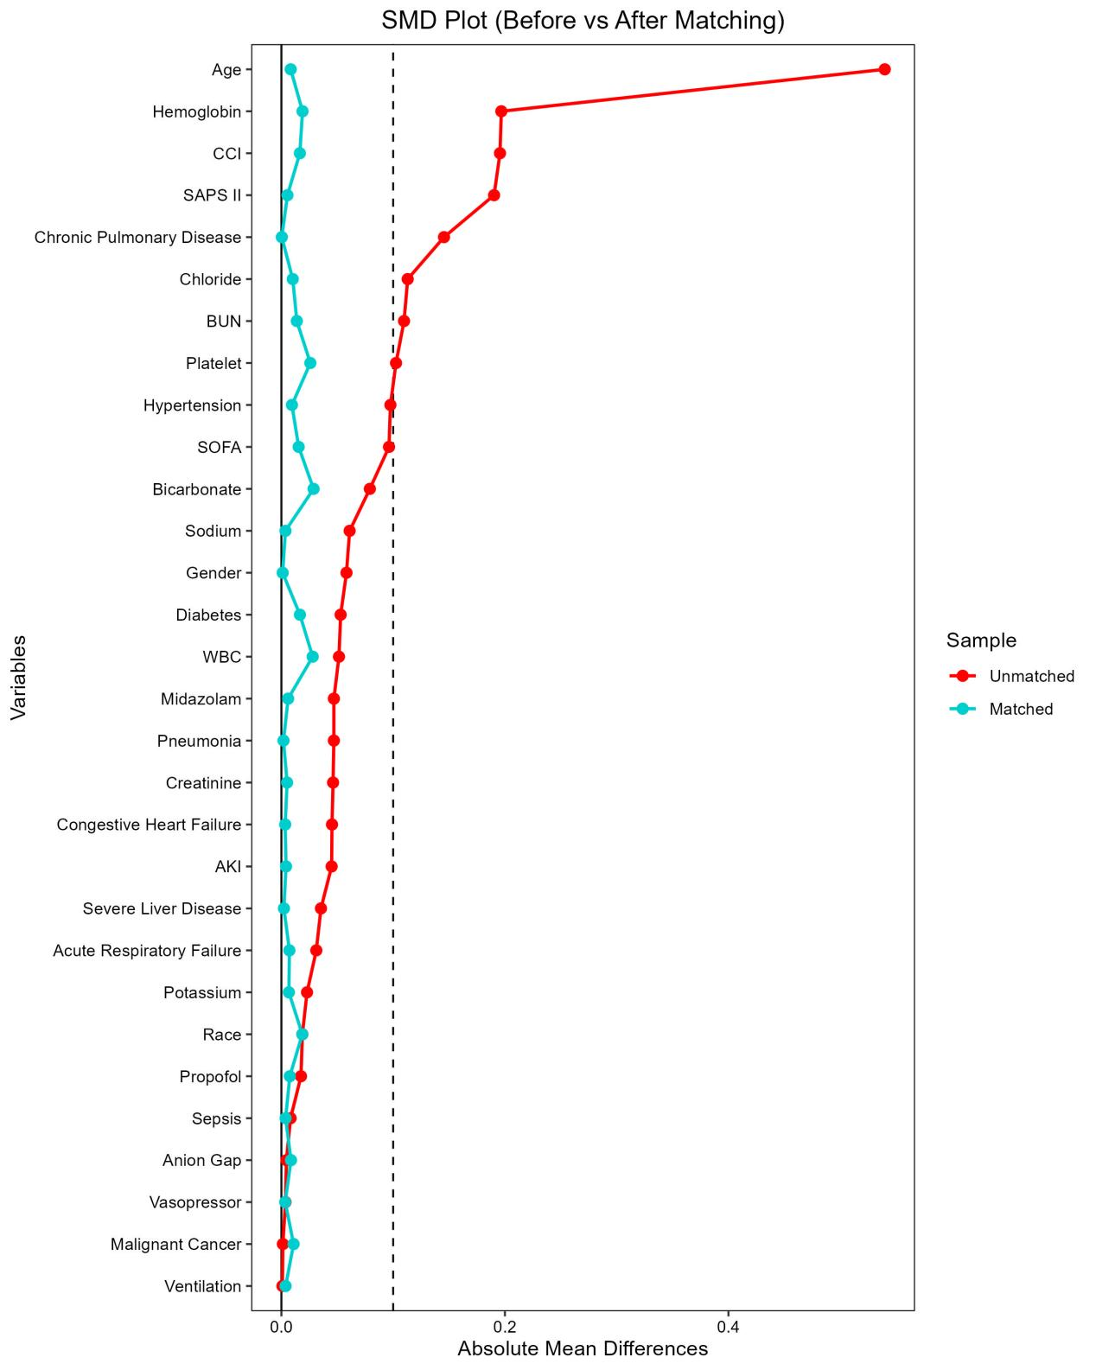
Fig.S1 Standardized mean differences for all covariates between ND and non-ND groups before and after propensity score matching.
Abbreviations: SMD, standardized mean difference; CCI, Charlson Comorbidity Index; SAPS II, Simplified Acute Physiology Score II; BUN, blood urea nitrogen; SOFA, Sequential Organ Failure Assessment; WBC, white blood cell count; AKI, acute kidney injury; PNA, pneumonia.

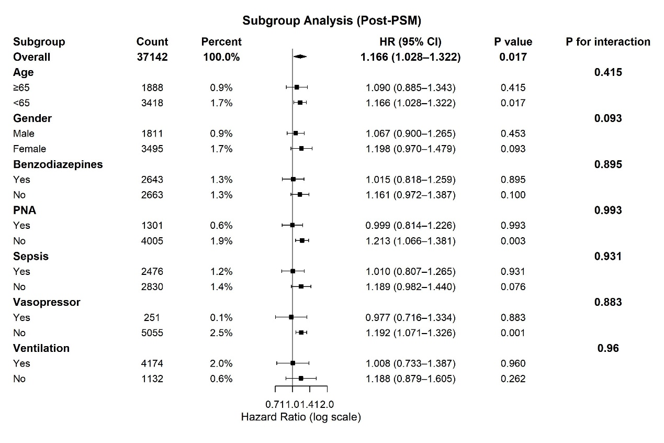
Fig.S2 Forest plot of the subgroup analysis of the association between nicotine dependence and the incidence of delirium after propensity score matching.
Abbreviations: PSM, propensity score matching; HR, hazard ratio; CI, confidence interval; PNA, pneumonia.

