Appendix A: databases were used to search for articles related to the following key words:

Databases | Search Strategy | Results
Pubmed | ("sulforaphane" OR "broccoli sprout extract" OR "isothiocyanate*" OR "sulforafan" OR "1-isothiocyanato-4-(methylsulfinyl)butane" OR "4-(methylsulfinyl)butyl isothiocyanate" OR "cruciferous vegetable extract" OR "brassica extract" OR "glucoraphanin" OR "myrosinase") AND ("Schizophrenia" OR "Schizophrenic Disorders" OR "Paranoid Schizophrenia" OR "Hebephrenic Schizophrenia" OR "Catatonic Schizophrenia" OR "Schizophrenia, Disorganized" OR "Psychotic Disorders" OR "Hallucinations" OR "Delusions" OR "Cognitive Dysfunction" OR "Negative Symptoms" OR "Positive Symptoms" OR "Psychotic Features" OR "Schizoaffective Disorder" OR "First-Episode Psychosis" OR "Early-Onset Schizophrenia" OR "Schizophreniform Disorder" OR "Psychosis Spectrum Disorders" OR "Brief Psychotic Disorder" OR "Thought Disorder" OR "Prodromal Symptoms" OR "Acute Psychotic Episodes" OR "Chronic Psychosis") | 65
Scopus | TITLE-ABS-KEY ( "sulforaphane" OR "broccoli sprout extract" OR "glucoraphanin" OR "myrosinase" OR "cruciferous vegetable extract" OR "brassica extract") AND ("Schizophrenia" OR "Schizophrenic Disorders" OR "Paranoid Schizophrenia" OR "Hebephrenic Schizophrenia" OR "Catatonic Schizophrenia" OR "Schizophrenia, Disorganized" OR "Psychotic Disorders" OR "Hallucinations" OR "Delusions" OR "Cognitive Dysfunction" OR "Negative Symptoms" OR "Positive Symptoms" OR "Psychotic Features" OR "Schizoaffective Disorder" OR "First-Episode Psychosis" OR "Early-Onset Schizophrenia" OR "Schizophreniform Disorder" OR "Psychosis Spectrum Disorders" OR "Brief Psychotic Disorder" OR "Thought Disorder" OR "Prodromal Symptoms" OR "Acute Psychotic Episodes" OR "Chronic Psychosis")) | 93
Web of science | ((ALL=(("sulforaphane" OR "broccoli sprout extract" OR "glucoraphanin" OR "myrosinase" OR "cruciferous vegetable extract" OR "brassica extract")) AND ALL=(("Schizophrenia" OR "Schizophrenic Disorders" OR "Paranoid Schizophrenia" OR "Hebephrenic Schizophrenia" OR "Catatonic Schizophrenia" OR "Schizophrenia, Disorganized" OR "Psychotic Disorders" OR "Hallucinations" OR "Delusions" OR "Cognitive Dysfunction" OR "Negative Symptoms" OR "Positive Symptoms" OR "Psychotic Features" OR "Schizoaffective Disorder" OR "First-Episode Psychosis" OR "Early-Onset Schizophrenia" OR "Schizophreniform Disorder" OR "Psychosis Spectrum Disorders" OR "Brief Psychotic Disorder" OR "Thought Disorder" OR "Prodromal Symptoms" OR "Acute Psychotic Episodes" OR "Chronic Psychosis")) | 51
Cochrane library | ("sulforaphane" OR "broccoli sprout extract" OR "glucoraphanin" OR "myrosinase" OR "cruciferous vegetable extract" OR "brassica extract") AND ("Schizophrenia" OR "Schizophrenic Disorders" OR "Paranoid Schizophrenia" OR "Hebephrenic Schizophrenia" OR "Catatonic Schizophrenia" OR "Schizophrenia, Disorganized" OR "Psychotic Disorders" OR "Hallucinations" OR "Delusions" OR "Cognitive Dysfunction" OR "Negative Symptoms" OR "Positive Symptoms" OR "Psychotic Features" OR "Schizoaffective Disorder" OR "First-Episode Psychosis" OR "Early-Onset Schizophrenia" OR "Schizophreniform Disorder" OR "Psychosis Spectrum Disorders" OR "Brief Psychotic Disorder" OR "Thought Disorder" OR "Prodromal Symptoms" OR "Acute Psychotic Episodes" OR "Chronic Psychosis") | 15
Clinicaltrials.gov | Sulforaphane AND Schizophrenia | 6
The total from the four databases: |  | 230
Number of duplicates: |  | 56
Number after removing duplication:  (By Endnote): |  | 174

Supplementary Table 1: Search strategies and results for each database.

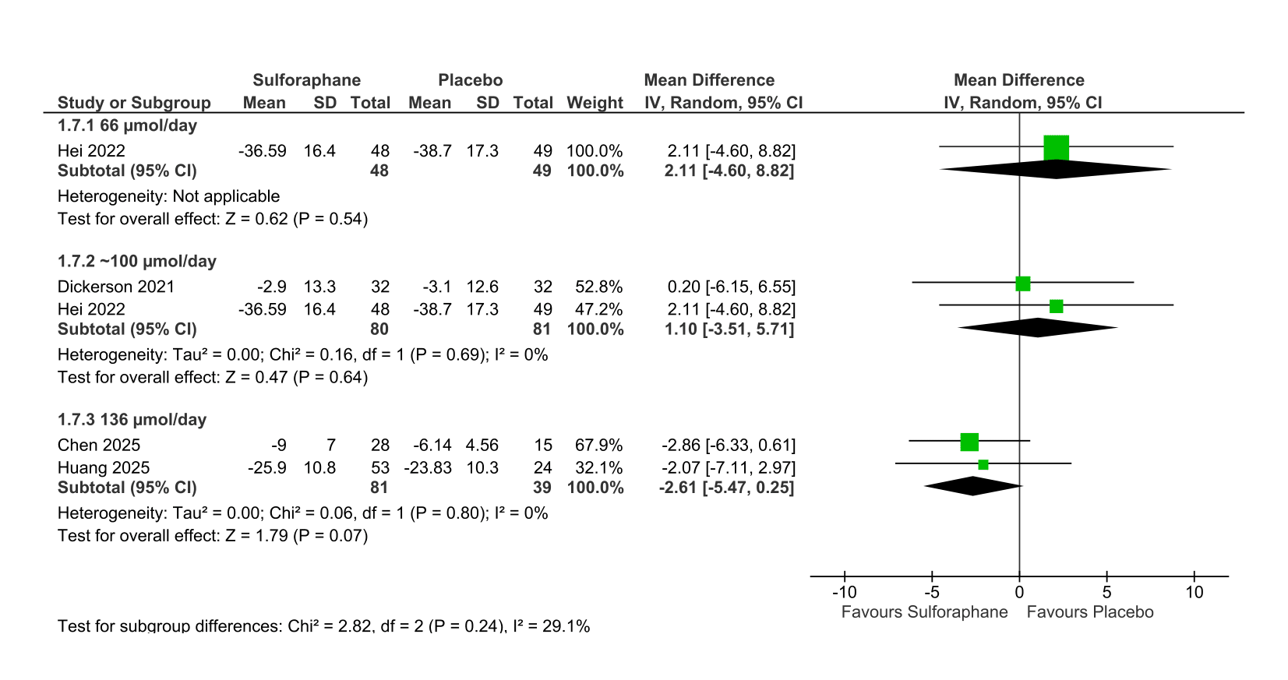
Supplementary Figure 1: Dose-based subgroup analysis of PANSS total score according to sulforaphane dose at the primary endpoint. SD: Standard deviation; CI: Confidence interval; IV: Inverse-variance.
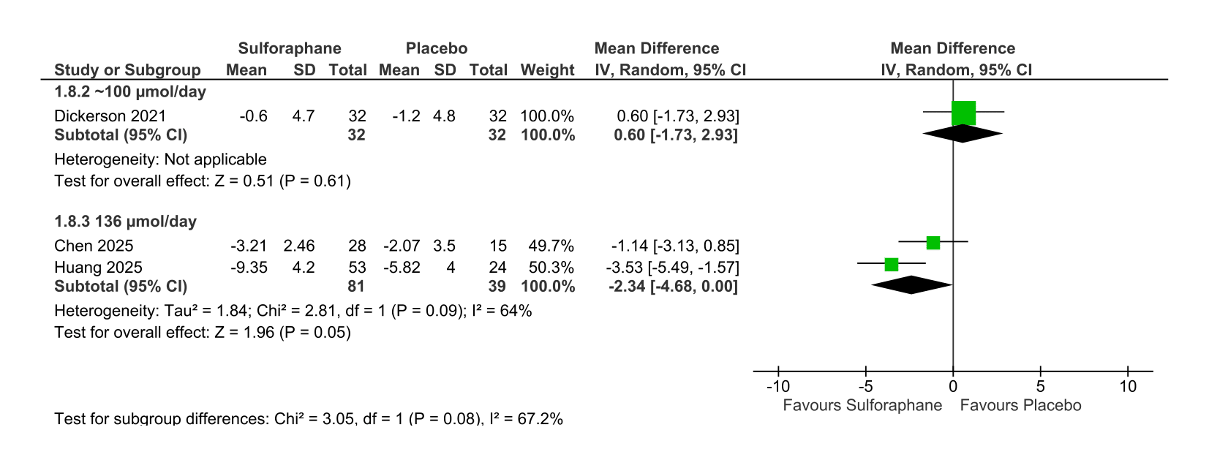 Supplementary Figure 2: Dose-based subgroup analysis of PANSS negative subscale according to sulforaphane dose at the primary endpoint. SD: Standard deviation; CI: Confidence interval; IV: Inverse-variance.

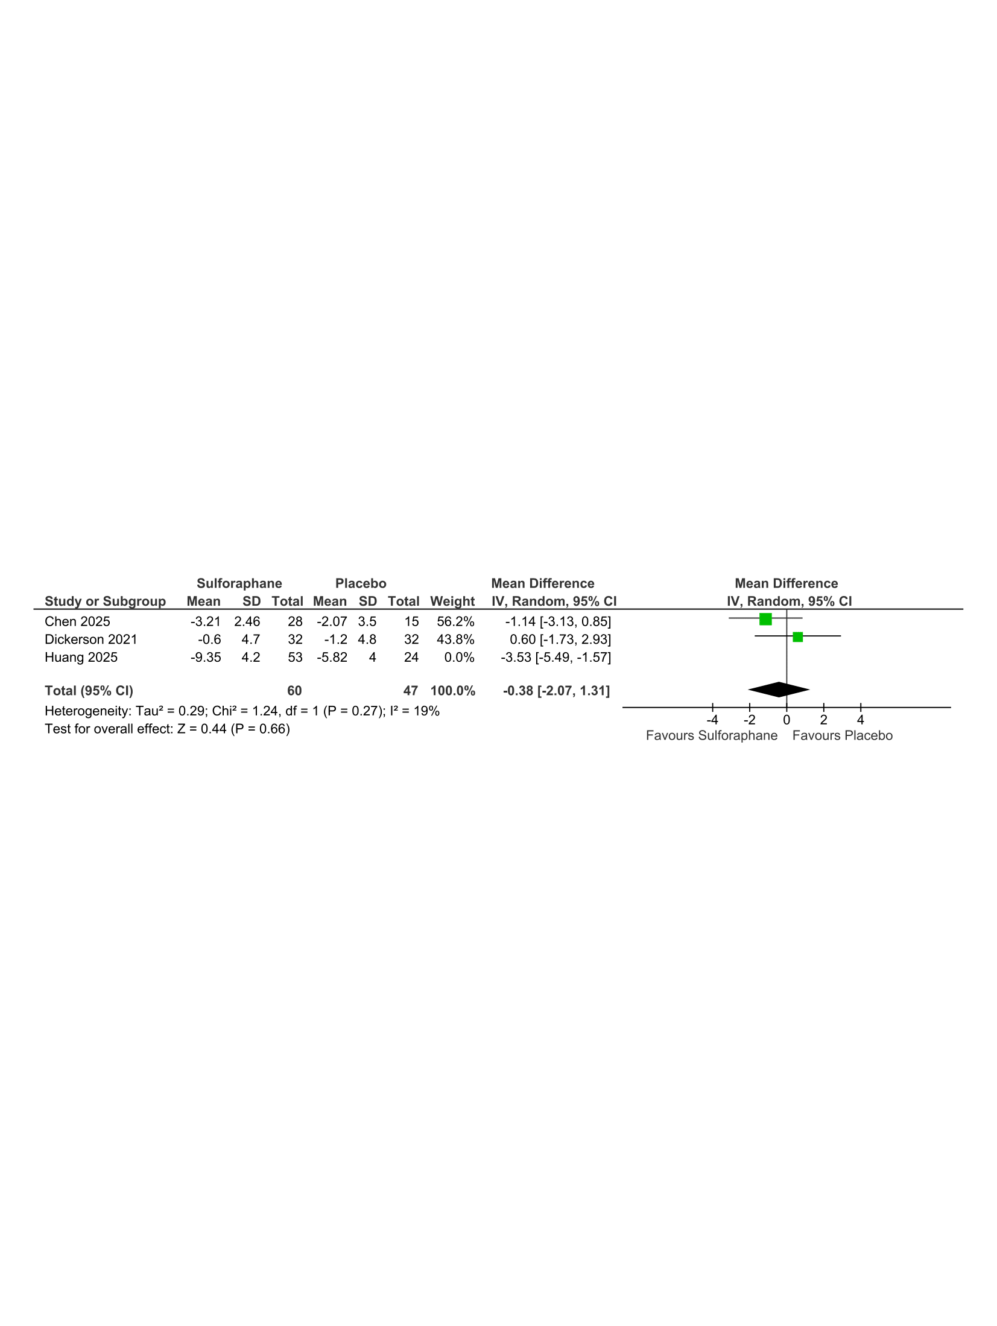
Supplementary Figure 3: Sensitivity analysis for PANSS negative score at the latest follow-up point. SD: Standard deviation; CI: Confidence interval; IV: Inverse-variance.
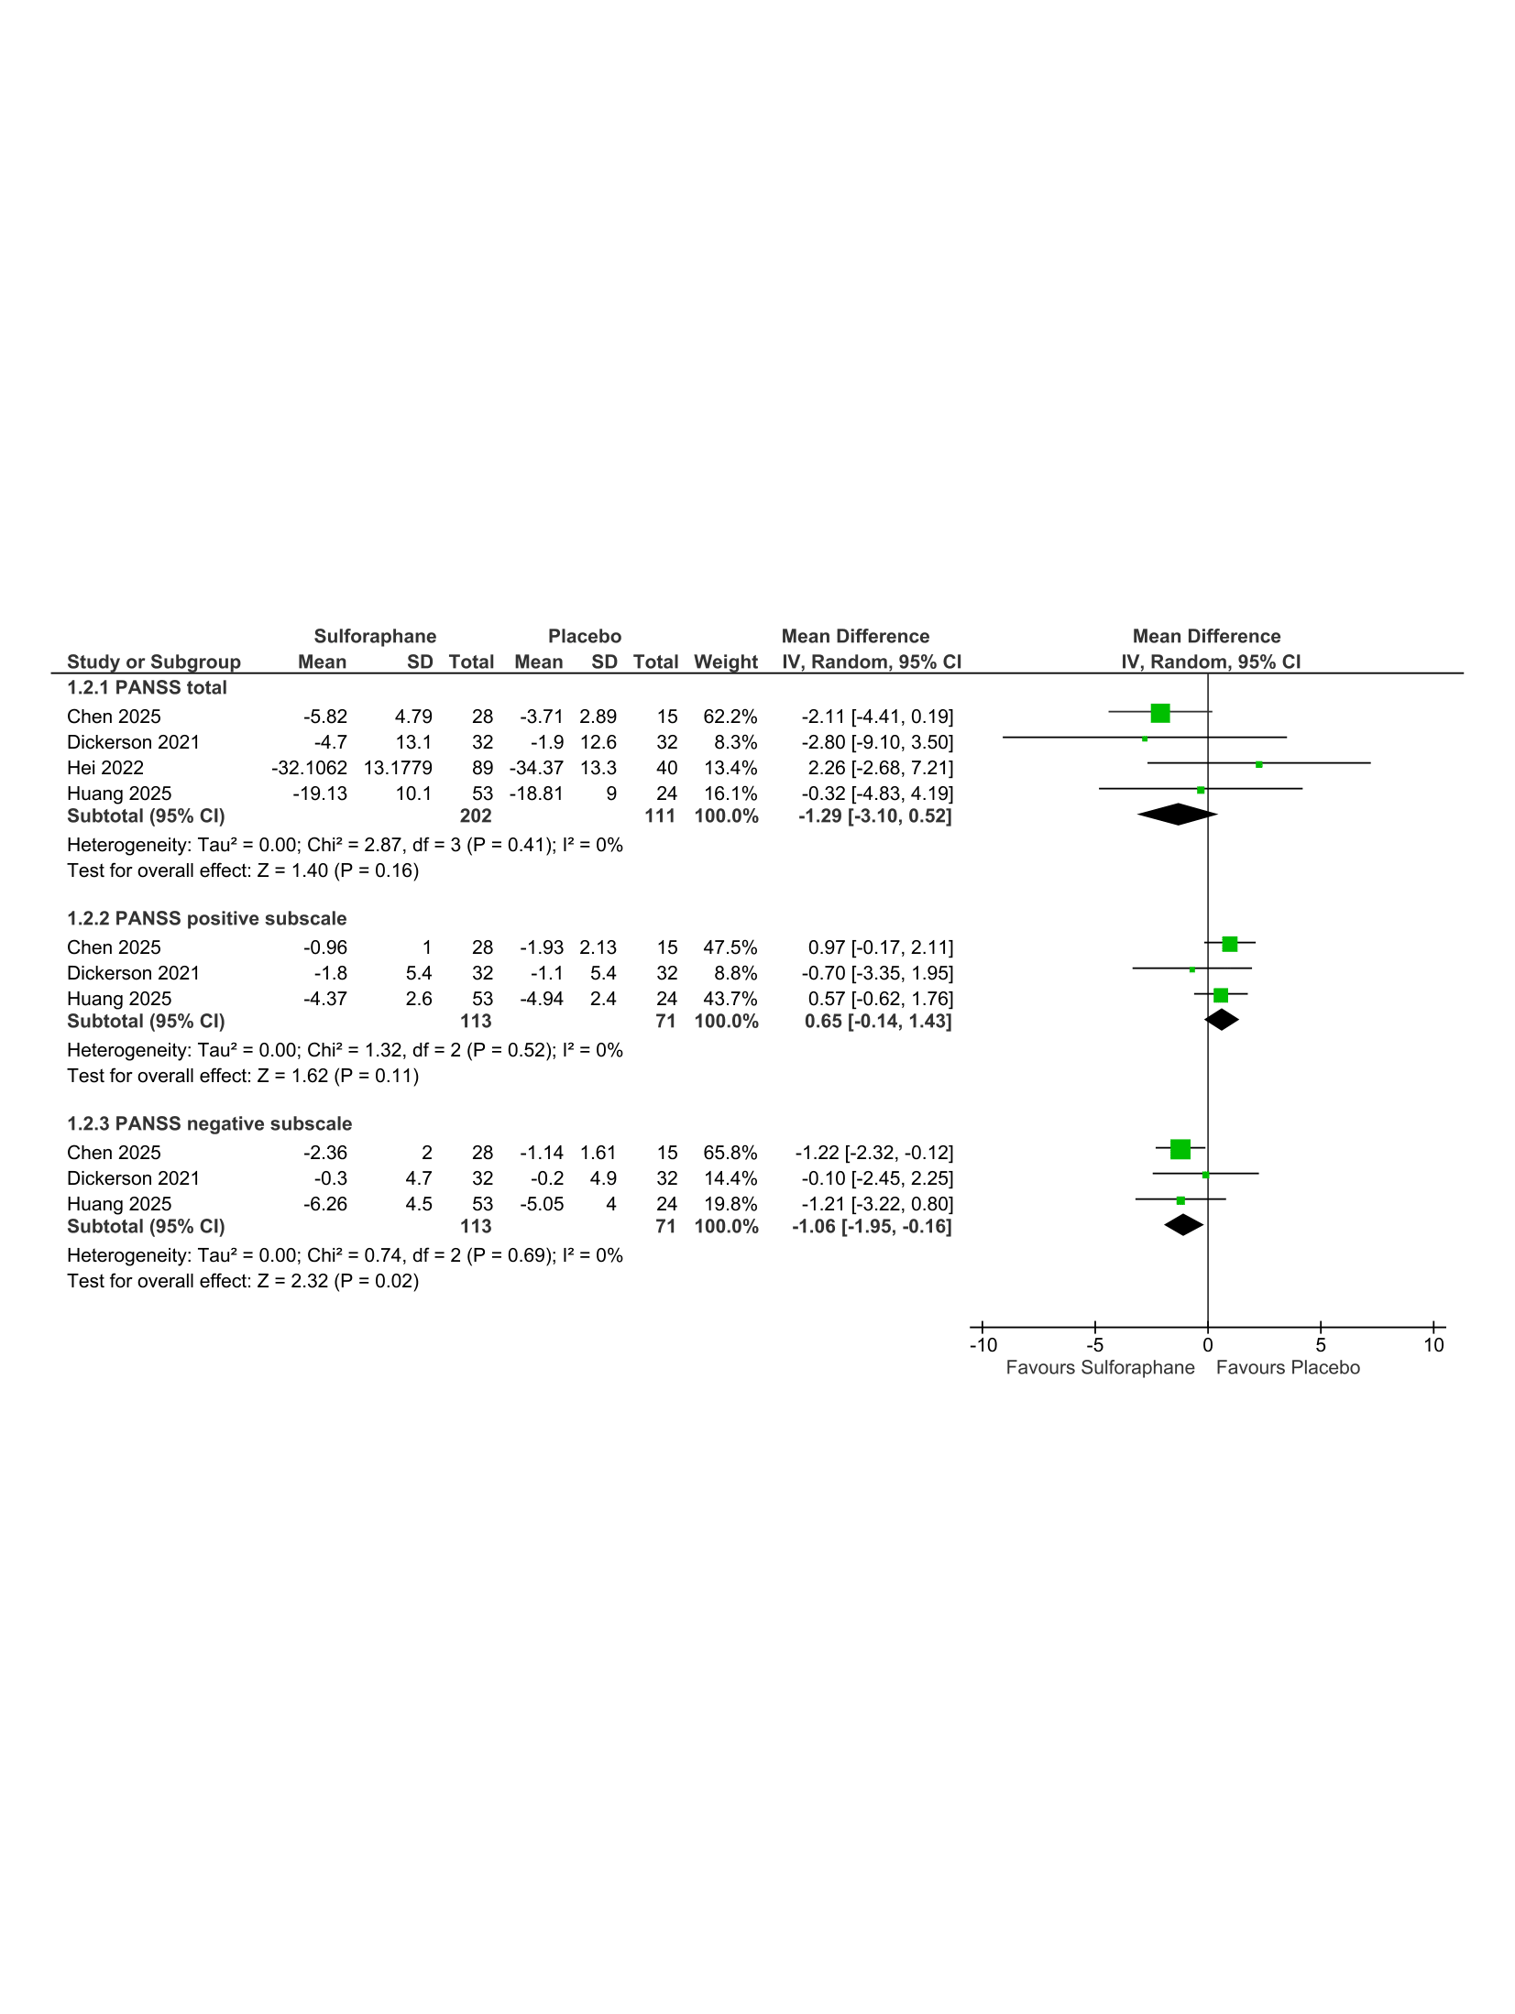
Supplementary Figure 4: Forest plot of the psychiatric outcomes at 12 weeks. 1) PANSS total score, 2) PANSS Positive subscale, 3) PANSS negative subscale at 12 weeks. IV: Inverse-variance; CI: Confidence interval.
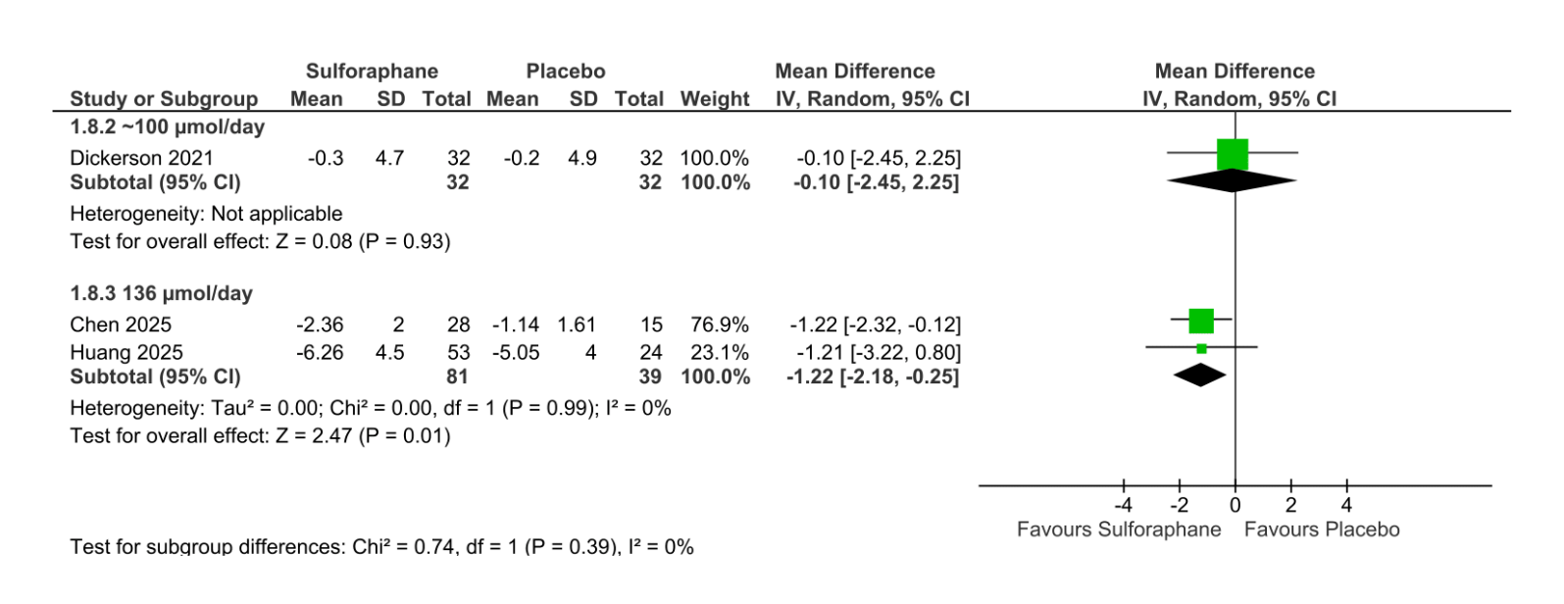Supplementary Figure 5: Dose-based subgroup analysis of PANSS negative subscale at the 12-week time point. SD: Standard deviation; CI: Confidence interval; IV: Inverse-variance.
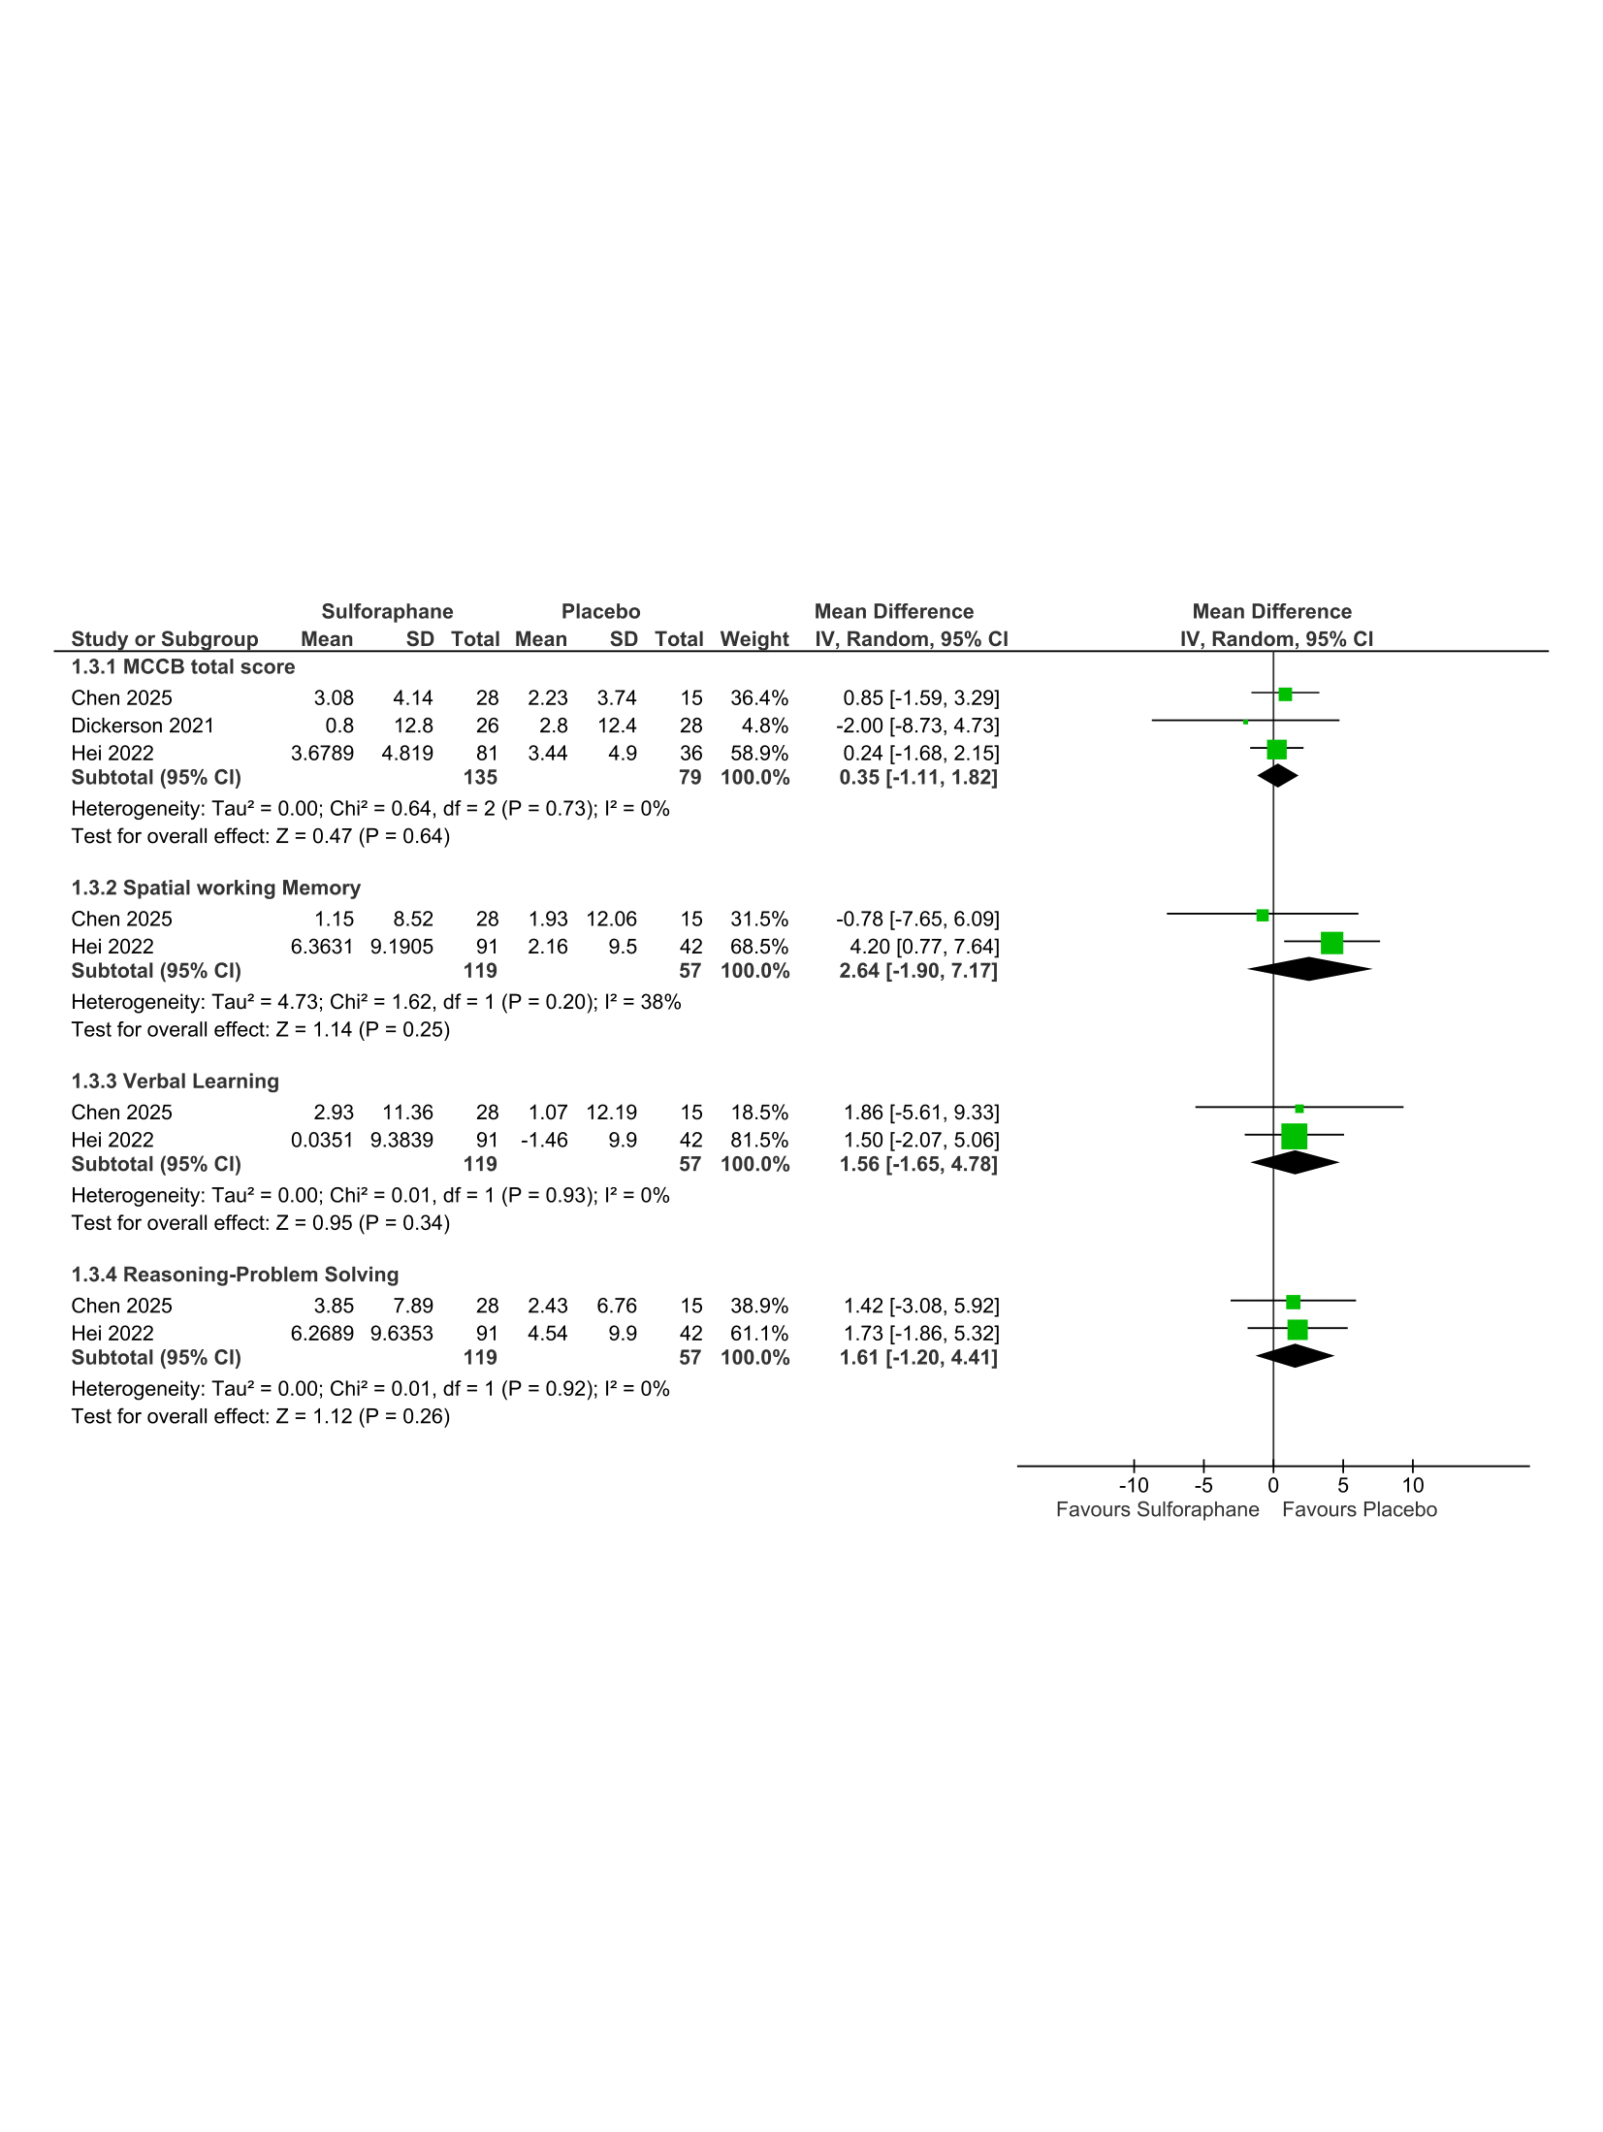
Supplementary Figure 6: Forest plot of sulforaphane effect on cognition. IV: Inverse-variance; SD: Standard deviation; CI: Confidence interval.

