Supplementary materials

S1.
Interview guide – therapist informants

Themes
- How did you experience implementing PROMS and PREMs and use of the outcomes from patient's?
- at what point do you go through the answers?
- the same day that the user has an appointment
- in a meeting with the patient
- I don't always have time
- what do you feel is the most useful for you? And why?
- do the answers provide better insight into what the patient's problems are?
- what was most useful - least useful for you?

- Collaboration with patient
- What are your experiences with patients?
- Have the patients gained better insight into their own problems? In what way?
- Is it easier or more demanding to talk to the patient about the answers?
- Do the responses from the user have any significance for the content of the conversations? Or other offers?
- In what way do you prepare a meeting with the patient, based on the answers from the questionnaire?
- Is there a match between what the user perceives as problems and what you as the therapist perceive?
- What is done if there are major differences in understanding of what the problem is?
- Experiences without and with mapping questionnaire
- What is your experience with the use of submitted answers - does it result in a shorter course of treatment, a longer course, no change and why?
- Any other experiences you would like to share?
- can the use of data from mapping questionnaires be a useful tool for use at system level?

S2.
Interview guide - patient informants

Themes
- How did you experience answering questionnaires electronically?
- In questionnaires on mobile, tablet or PC?

- How was it to read and understand the questions? (easy, medium, hard?)
- Have you completed such questionnaires on paper before? - if so, was it more difficult, just as easy or better (easier) with the use of a mobile phone, tablet or PC?
- What was better/more difficult?
- Did you get a reminder on your mobile about filling in the questionnaire?
- Did you complete the questionnaire right away? Or did you wait later?
- Were there any problems with ticking the answer options? Were the rubrics sufficiently large?
- Approximately how long did it take you (in total) to complete five questionnaires?

After completing the questionnaire - did you gain more insight or understanding of your problems?
- Can you say something about this?
- Do you think it was useful to fill in five questionnaires?
- What was most useful - least useful?

- In a meeting with the therapist
- What experiences have you had in meeting with the therapist?
- Did the therapists go through the answers that you had completed in advance?
- Did you get a better understanding of your problems? Or was there no change?
- Did you change the assistance/other assistance measures after you and the therapist went through your answers?

- Completing the questionnaire after treatment
What made you fill in the questionnaire when you received an SMS message?
- I want to participate in the study
- It gives me better insight into my own problems
- I think there was too much information and too many questions to answer
- It did not provide any new insight
Would you recommend such an arrangement to others - filling in a questionnaire before and after treatment?

Any other experiences you would like to share?

S3.
Illustration of the web-based self-report portal

Figure S1.
Example of Patient Health Questionnaire 9 items as presented to patients for self-report.

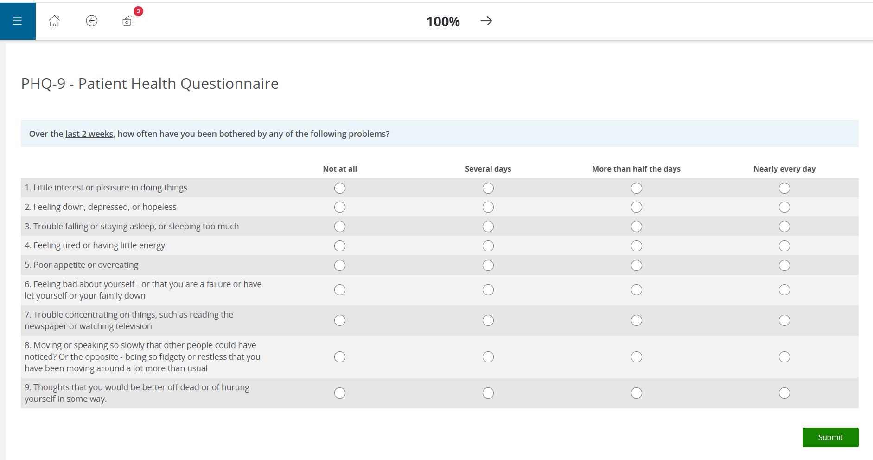

Figure S2.
Example of Patient Health Questionnaire 9 scores on two assessment points for a patient. Note: Fictitious data for illustration purposes.