Supplementary Materials
Supplementary Table 1. Word frequency of the word cloud. 1
Supplementary Table 2. Assignment of items to dimensions in the Self-Rating Depression Scale. 2
Supplementary Table 3. Assignment of items to dimensions in the Self-Rating Anxiety Scale. 3
Supplementary Table 4. The z-scored centrality of nodes in the 12-node regularized partial correlation network. 4
Supplementary Figure 1. Illustration of key elements in network analysis. 5
Supplementary Figure 2. The full network weight matrix of the 12-node regularized partial correlation network. 6
Supplementary Figure 3. Bootstrapped confidence intervals of estimated edge-weights for the 12-node regularized partial correlation network. 7
Supplementary Figure 4. Stability of centrality indices in the 12-node network (case-dropping analysis). 8

Supplementary Table 1. Word frequency of the word cloud.

Feature Word (translated into English) | Original Feature Word (in Chinese) | Record Count
Poor sleep | 睡眠不好 | 39
Depressed | 情绪低落 | 36
Living is meaningless | 活着没意思 | 33
Negative thoughts | 消极观念 | 28
Worrying | 担心 | 16
Panic | 心慌 | 17
Difficulty concentrating | 注意力难以集中 | 16
Want to do nothing | 什么都不想做 | 15
Nervousness | 紧张 | 13
Suicide thoughts | 轻生想法 | 11
Loss of appetite | 食欲减退 | 11
Impulse to jump off a building | 想跳楼 | 10
Irritability | 易激惹 | 9
Thoughts of cutting oneself | 想用锐器伤害自己 | 9
Chest tightness | 胸闷 | 9
Easy to wake up | 易醒 | 7
Self-harm behavior | 自伤行为 | 6
Thoughts of not wanting to live | 不想活的想法 | 6
Cry for no reason | 无故哭泣 | 3
Bumping head against the wall | 用头撞墙 | 2

Supplementary Table 2. Assignment of items to dimensions in the Self-Rating Depression Scale.
Dimension | Item content
depressed mood | 1. I feel down-hearted and blue.
depressed mood | 3. I have crying spells or feel like it.
rhythmic disturbances | 2. Morning is when I feel the best.
rhythmic disturbances | 4. I have trouble sleeping at night.
rhythmic disturbances | 5. I eat as much as I used to.
rhythmic disturbances | 6. I still enjoy sex.
rhythmic disturbances | 7. I notice that I am losing weight.
somatic disturbances | 8. I have trouble with constipation.
somatic disturbances | 9. My heart beats faster than usual.
somatic disturbances | 10. I get tired for no reason.
psychomotor activities | 12. I find it easy to do the things I used to.
psychomotor activities | 13. I am restless and can’t keep still.
ideational suffering | 11. My mind is as clear as it used to be.
ideational suffering | 14. I feel hopeful about the future.
ideational suffering | 15. I am more irritable than usual.
ideational suffering | 16. I find it easy to make decisions.
ideational suffering | 17. I feel that I am useful and needed.
ideational suffering | 18. My life is pretty full.
ideational suffering | 19. I feel that others would be better off if I were dead.
ideational suffering | 20. I still enjoy the things I used to do.

Supplementary Table 3. Assignment of items to dimensions in the Self-Rating Anxiety Scale.
Dimension | Item content
anxiety and panic | 1. I feel more nervous and anxious than usual
anxiety and panic | 2. I feel afraid for no reason at all
anxiety and panic | 3. I get upset easily or feel panicky
anxiety and panic | 4. I feel like I’m falling apart and going to pieces
anxiety and panic | 18. My face gets hot and blushes
somatic control | 5. I feel that everything is all right and nothing bad will happen
somatic control | 9. I feel calm and can sit still easily
somatic control | 13. I can breathe in and out easily
somatic control | 17. My hands are usually dry and warm
somatic control | 19. I fall asleep easily and get a good night's rest
vestibular sensations | 6. My arms and legs shake and tremble
vestibular sensations | 10. I can feel my heart beating fast
vestibular sensations | 11. I am bothered by dizzy spells
vestibular sensations | 12. I have fainting spells or feel like it
vestibular sensations | 14. I get feelings of numbness and tingling in my fingers and toes
gastrointestinal/muscle sensations | 7. I am bothered by headaches neck and back pain
gastrointestinal/muscle sensations | 8. I feel weak and get tired easily
gastrointestinal/muscle sensations | 15. I am bothered by stomachaches or indigestion
gastrointestinal/muscle sensations | 16. I have to empty my bladder often
gastrointestinal/muscle sensations | 20. I have nightmares

Supplementary Table 4. The z-scored centrality of nodes in the 12-node regularized partial correlation network.
Nodes | Strength | Betweenness
SAS1 (anxiety and panic) | 1.43 | 1.44
SDS5 (ideational suffering) | 0.97 | 1.44
SAS3 (vestibular sensations) | 0.92 | 0.33
SAS2 (somatic control) | 0.50 | 0.88
SAS4 (gastrointestinal/muscle sensations) | 0.41 | 0.05
SDS1 (depressed mood) | 0.31 | 0.88
SDS4 (psychomotor activities) | 0.03 | -0.79
SDS3 (somatic disturbances) | -0.06 | -1.07
SDS2 (rhythmic disturbances) | -0.29 | 0.05
Age | -1.06 | -1.07
SI | -1.12 | -1.07
Gender | -2.04 | -1.07

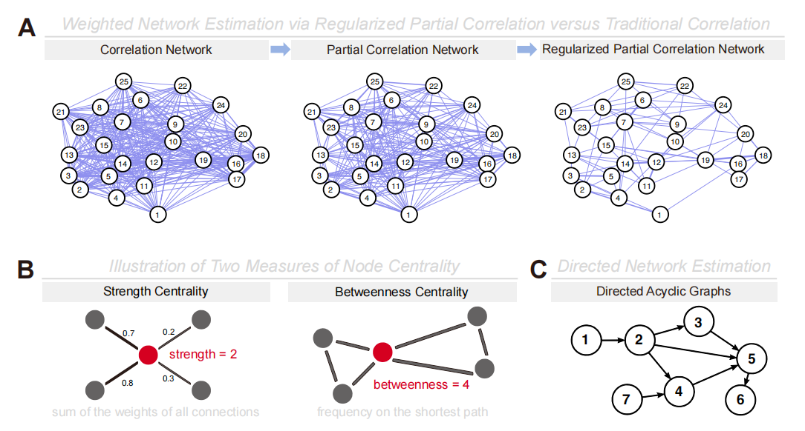

Supplementary Figure 1. Illustration of key elements in network analysis. (A) Schematic illustration of weighted networks estimated using different approaches, with the regularized partial correlation network producing a sparse structure. (B) Visualization of the measures of node centrality. (C) A schematic illustration of the directed acyclic graph illustrates the directional influence flow between nodes.

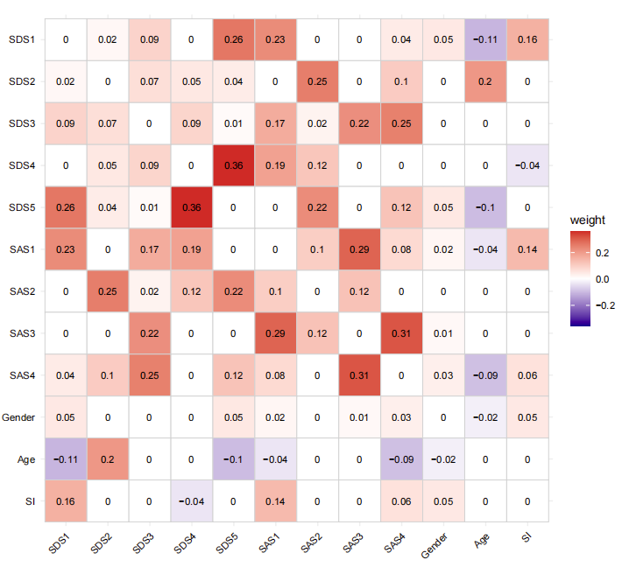

Supplementary Figure 2. The full network weight matrix of the 12-node regularized partial correlation network.
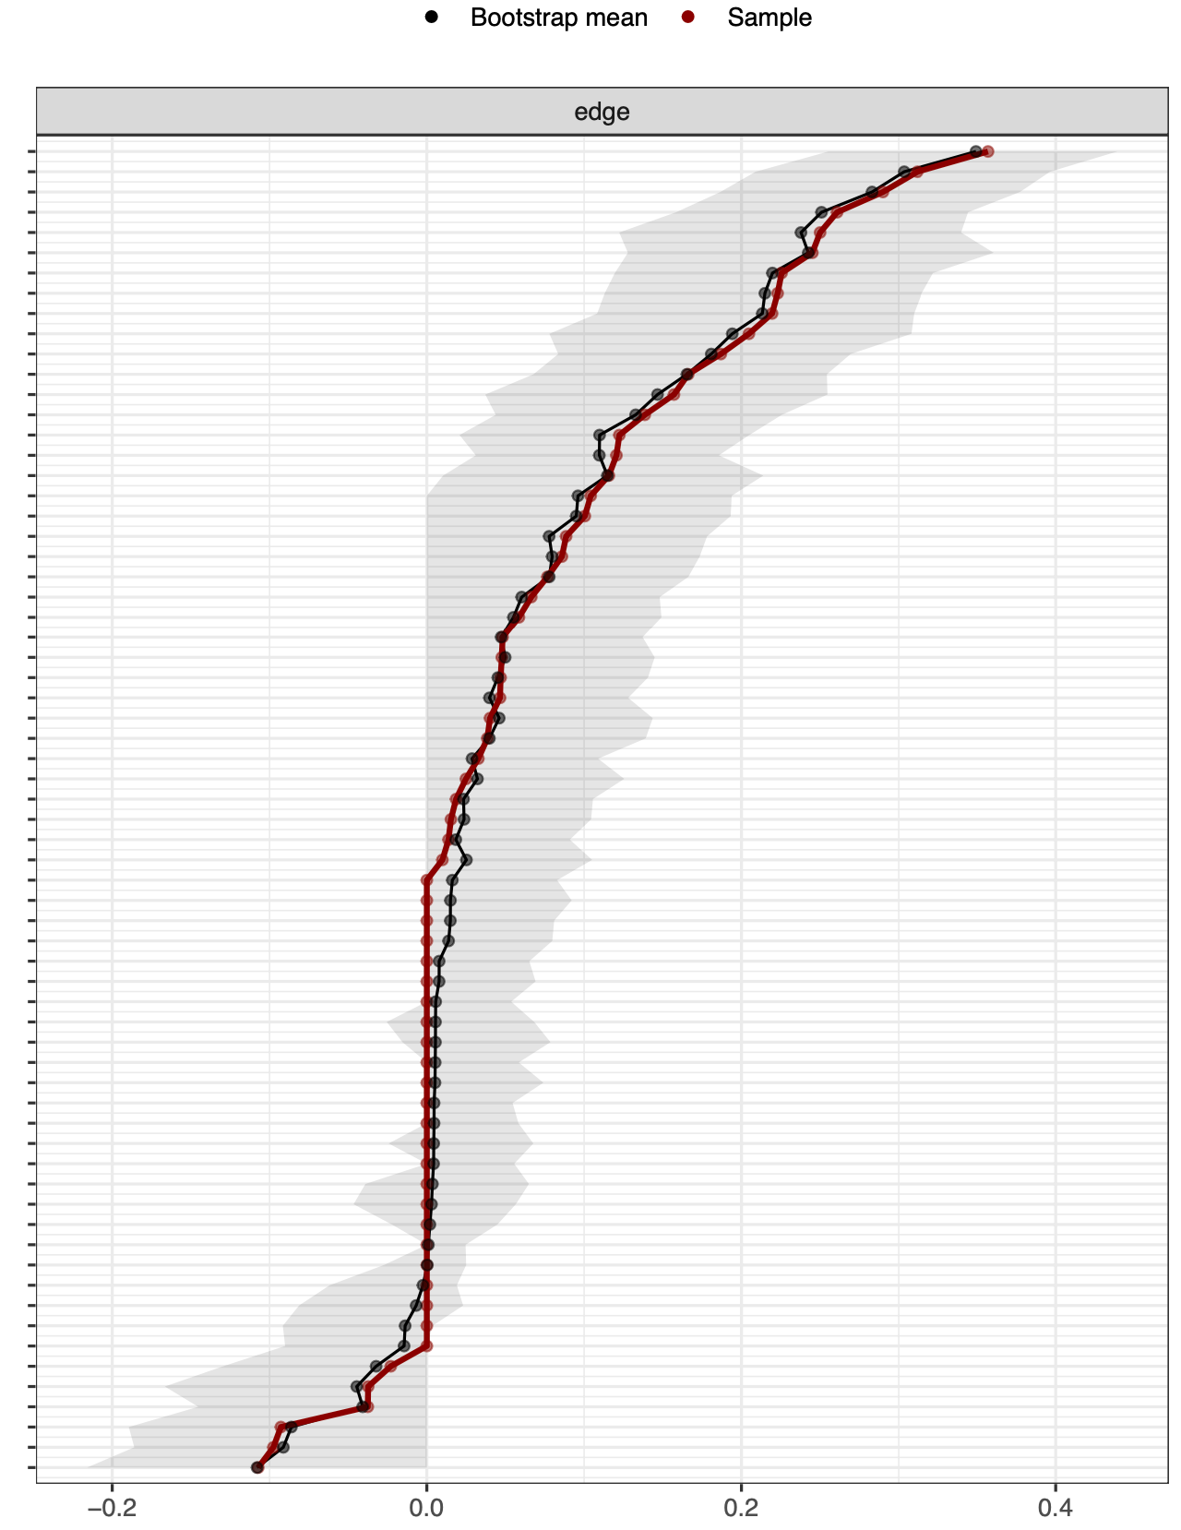

Supplementary Figure 3. Bootstrapped confidence intervals of estimated edge-weights for the 12-node regularized partial correlation network. The red line indicates the sample values and the gray area the bootstrapped CIs. Each horizontal line represents one edge of the network, ordered from the edge with the highest edge-weight to the edge with the lowest edge-weight. The y-axis labels have been removed to avoid cluttering.
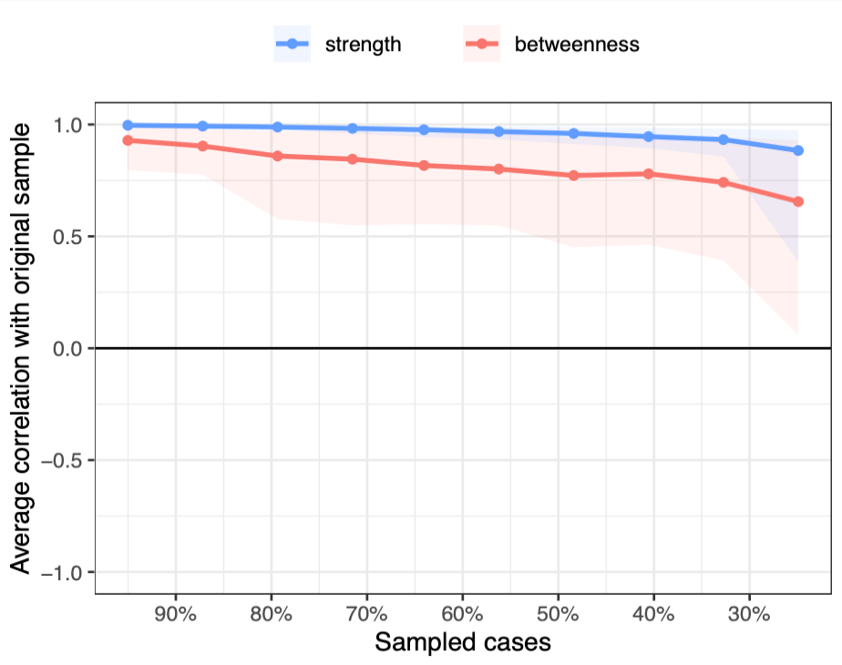

Supplementary Figure 4. Stability of centrality indices in the 12-node network (case-dropping analysis). Here shows the average correlations between centrality indices of the 12-node regularized partial correlation network computed from subsets of participants (with cases dropped) and those from the full sample. Lines indicate the means, and areas indicate the range from the 2.5th quantile to the 97.5th quantile.

