Artical title: The relationship of sensory processing with ADHD and its co-occurred behavioral symptoms based on both undirected and directed network analysis
Journal name: European Child & Adolescent Psychiatry
Author names, affiliation and e-mail address of the corresponding author:
Jing Li ^{1, #}, Yuan Gao ^{2,3 #}, Min Dong ^{2,3 #}, Wenchen Wang ⁴, Haimei Li ^{2,3} , Meirong Pan ^{2,3}, Xinxin Yue ^{2,3}, Ningning Liu^{2,3}, Qiuqjin Qian^{2,3} , Yufeng Wang^{2,3} , Lu Liu^{2,3 *}
¹ Shanxi Bethune Hospital, Shanxi Academy of Medical Sciences, Third Hospital of Shanxi Medical University, Tongji Shanxi Hospital, Taiyuan, 030032, China
² Peking University Sixth Hospital/Institute of Mental Health, Beijing 100191, China
³ NHC Key Laboratory of Mental Health (Peking University), National Clinical Research Center for Mental Disorders (Peking University Sixth Hospital), Beijing 100191, China
^{4.}Department of Psychological Medicine, Beijing Chao-Yang Hospital, Capital Medical University, Beijing, China.
#.Jing Li, Yuan Gao, Min Dong contributed equally to this work.
* Corresponding authors: Lu Liu, liulupku@bjmu.edu.cn

Table S1 Childhood behavior checklist Items used to compute the withdrawn/depressed, social, and thought problems raw scores
Withdrawn/depressed | Social Problems | Thought Problems
Would rather be alone than with others | Clings to adults or too dependent | Cannot get his/he mind off certain thoughts; obsessions
Refuses to talk | Complains of loneliness | Deliberately harms self or attempts suicide
Secretive, keeps things to self | Does not get along with other kids | Hears sounds or voices that are not there
Too shy or timid | Easily jealous | Nervous movement or twitching
Underactive, slow moving, or lacks energy | Feels others are out to get him/her | Picks nose, skin, or  other parts of body
Unhappy, sad, or depressed | Gets hurt a lot, accident prone | Plays with own sex parts in public
Withdrawn, does not get involved with others | Gets teased a lot | Plays with own sex parts too much
 | Not liked by other kids | Repeats certain act over and over; compulsions
 | Poorly coordinated or clumsy | Sees things that are not there
 | Prefers being with younger kids | Sleeps less than most kids
 | Speech problems | Stores up too many things he/she does not need
 |  | Strange behavior
 |  | Strange ideas
 |  | Talks or walks in sleep
 |  | Trouble sleeping

Table S2 The weight adjacency matrix of the symptom network.
 | ADHD_IA | ADHD_HY | ADHD_IM | ODD_AIM | ODD_ADB | ODD_VIN | ATs_WD | ATs_S | ATs_TP | SP_VB | SP_HS | SP_P
ADHD_IA | 0.00 | 0.14 | 0.11 | 0.00 | 0.00 | -0.02 | 0.05 | 0.05 | 0.00 | 0.01 | 0.01 | 0.15
ADHD_HY | 0.14 | 0.00 | 0.54 | 0.00 | 0.03 | 0.00 | -0.03 | 0.00 | 0.03 | 0.20 | 0.00 | -0.11
ADHD_IM | 0.11 | 0.54 | 0 | 0.01 | 0.07 | 0.03 | -0.21 | 0.18 | 0.06 | 0.07 | 0.00 | 0.00
ODD_AIM | 0.00 | 0.00 | 0.01 | 0.00 | 0.51 | 0.15 | 0 | 0.06 | 0.03 | -0.02 | 0.09 | 0.00
ODD_ADB | 0.00 | 0.03 | 0.07 | 0.51 | 0.00 | 0.15 | -0.02 | 0.02 | 0.04 | 0.01 | 0.02 | -0.02
ODD_VIN | -0.02 | 0.00 | 0.03 | 0.15 | 0.15 | 0.00 | 0.00 | 0.04 | 0.03 | 0.01 | 0.04 | -0.01
ATs_WD | 0.05 | -0.03 | -0.21 | 0 | -0.02 | 0.00 | 0.00 | 0.33 | 0.16 | -0.06 | 0.20 | 0.15
ATs_S | 0.05 | 0.00 | 0.18 | 0.06 | 0.02 | 0.04 | 0.33 | 0.00 | 0.20 | 0.16 | 0.03 | 0.17
ATs_TP | 0.00 | 0.03 | 0.06 | 0.03 | 0.04 | 0.03 | 0.16 | 0.20 | 0.00 | 0.08 | 0.19 | 0
SP_VB | 0.01 | 0.20 | 0.07 | -0.02 | 0.01 | 0.01 | -0.06 | 0.16 | 0.08 | 0.00 | 0.17 | 0.17
SP_HS | 0.01 | 0.00 | 0.00 | 0.09 | 0.02 | 0.04 | 0.20 | 0.03 | 0.19 | 0.17 | 0.00 | 0.20
SP_P | 0.15 | -0.11 | 0.00 | 0.00 | -0.02 | -0.01 | 0.15 | 0.17 | 0.00 | 0.17 | 0.20 | 0.00
NOTE. ADHD, attention-deficit/hyperactivity disorder; ADHD-IA, ADHD inattention; ADHD-HI, ADHD hyperactivity, ADHD-IM, ADHD impulsivity; ODD, oppositional defiant disorder; ODD_AIM, ODD angry and irritable mood, ODD_ADB, ODD argumentative and defiant behaviour, ODD_VIN, ODD vindictive, ATs, autistic traits, ATs_WD, ATs withdrawn/depressed, ATs_S, ATs social problems, ATs_TP, ATs thought problems, SP, sensory processing, SP_VB, SP vestibular-balance, SP_HS, SP hyper-sensory, SP_P, SP proprioception.

A B 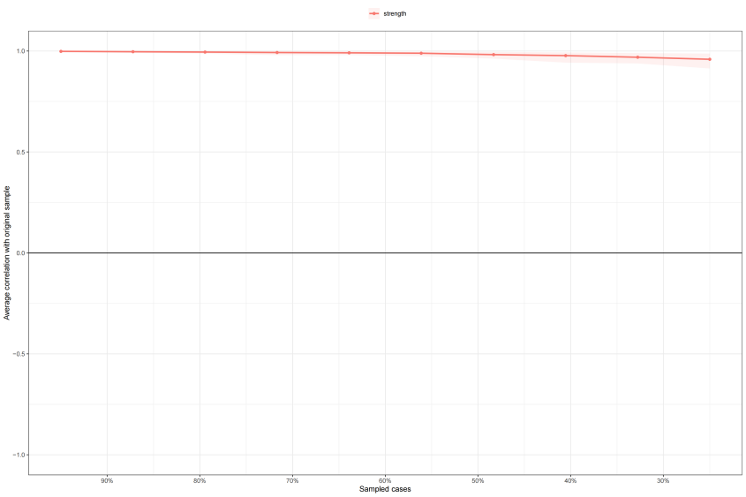
Figure S1 (A) Bootstrapped CIs of estimated edge-weights for the network. (B) Bootstrapped the Expected Influence centrality stability for the network
NOTE. .ADHD, attention-deficit/hyperactivity disorder; ADHD-IA, ADHD inattention; ADHD-HI, ADHD hyperactivity, ADHD-IM, ADHD impulsivity; ODD, oppositional defiant disorder; ODD_AIM, ODD angry and irritable mood, ODD_ADB, ODD argumentative and defiant behaviour, ODD_VIN, ODD vindictive, ATs, autistic traits, ATs_WD, ATs withdrawn/depressed, ATs_S, ATs social problems, ATs_TP, ATs thought problems, SP, sensory processing, SP_VB, SP vestibular-balance, SP_HS, SP hyper-sensory, SP_P, SP proprioception.

Table S3 Strength and direction probability of edges depicted in the DAG.
from | to | strength | direction
ADHD_HY | ADHD_IA | 1.00 | 0.92
ADHD_IM | ADHD_IA | 1.00 | 0.94
ADHD_IM | ADHD_HY | 1.00 | 0.59
ADHD_IM | ODD_ADB | 0.91 | 0.56
ADHD_IM | ATs_WD | 1.00 | 0.85
ODD_AIM | ODD_ADB | 1.00 | 0.60
ODD_AIM | ODD_VIN | 1.00 | 0.79
ODD_AIM | ATs_S | 0.98 | 0.56
ODD_AIM | SP_HS | 1.00 | 0.60
ODD_ADB | ODD_VIN | 1.00 | 0.76
ATs_WD | ADHD_IA | 0.87 | 0.78
ATs_S | ADHD_IM | 1.00 | 0.56
ATs_S | ATs_WD | 1.00 | 0.78
ATs_S | ATs_TP | 1.00 | 0.72
ATs_S | SP_VB | 1.00 | 0.61
ATs_TP | ATs_WD | 1.00 | 0.75
SP_VB | ADHD_HY | 1.00 | 0.59
SP_VB | ADHD_IM | 0.95 | 0.55
SP_VB | ATs_TP | 0.89 | 0.55
SP_HS | ATs_WD | 1.00 | 0.74
SP_HS | ATs_TP | 1.00 | 0.64
SP_P | ADHD_IA | 1.00 | 0.95
SP_P | ATs_WD | 1.00 | 0.76
SP_P | ATs_S | 1.00 | 0.57
SP_P | SP_VB | 1.00 | 0.69
SP_P | SP_HS | 1.00 | 0.62
NOTE. .ADHD, attention-deficit/hyperactivity disorder; ADHD-IA, ADHD inattention; ADHD-HI, ADHD hyperactivity, ADHD-IM, ADHD impulsivity; ODD, oppositional defiant disorder; ODD_AIM, ODD angry and irritable mood, ODD_ADB, ODD argumentative and defiant behaviour, ODD_VIN, ODD vindictive, ATs, autistic traits, ATs_WD, ATs withdrawn/depressed, ATs_S, ATs social problems, ATs_TP, ATs thought problems, SP, sensory processing, SP_VB, SP vestibular-balance, SP_HS, SP hyper-sensory, SP_P, SP proprioception.

