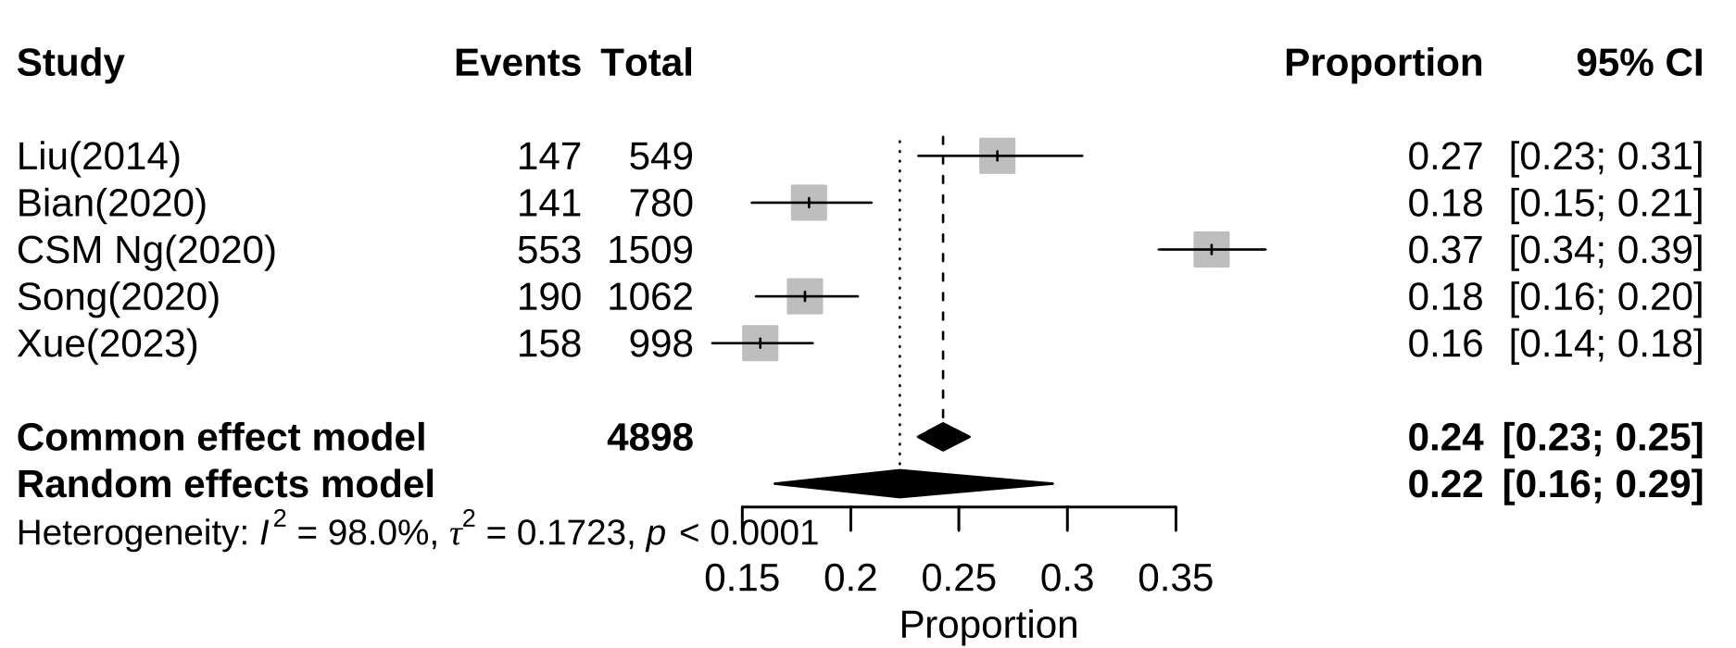
Additional file 1: Subgroup analysis of prevalence of alexithymia among Chinese adolescents by Eastern China

