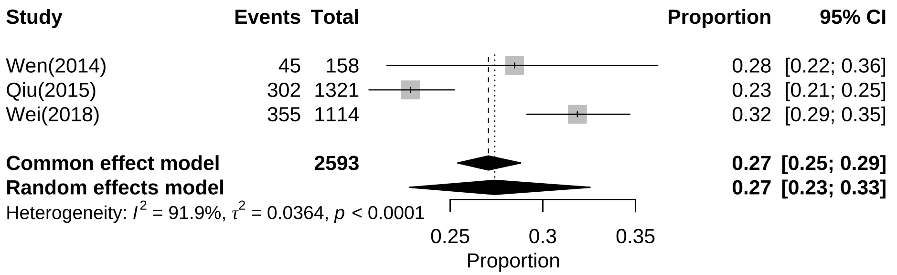
Additional file 2: Subgroup analysis of prevalence of alexithymia among Chinese adolescents by Central China

