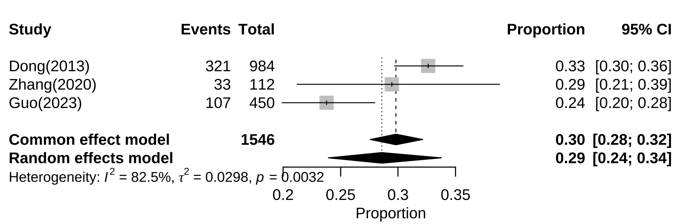
Additional file 3: Subgroup analysis of prevalence of alexithymia among Chinese adolescents by Western China

