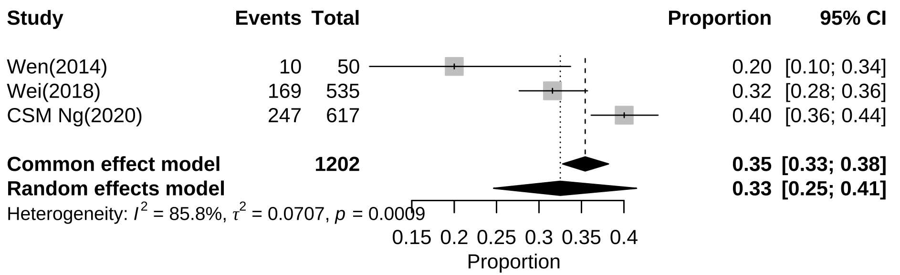
Additional file 4: Subgroup analysis of prevalence of alexithymia among Chinese male adolescents

