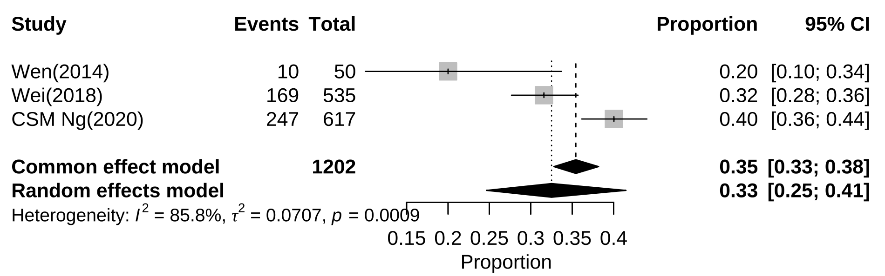
Additional file 5: Subgroup analysis of prevalence of alexithymia among Chinese female adolescents

