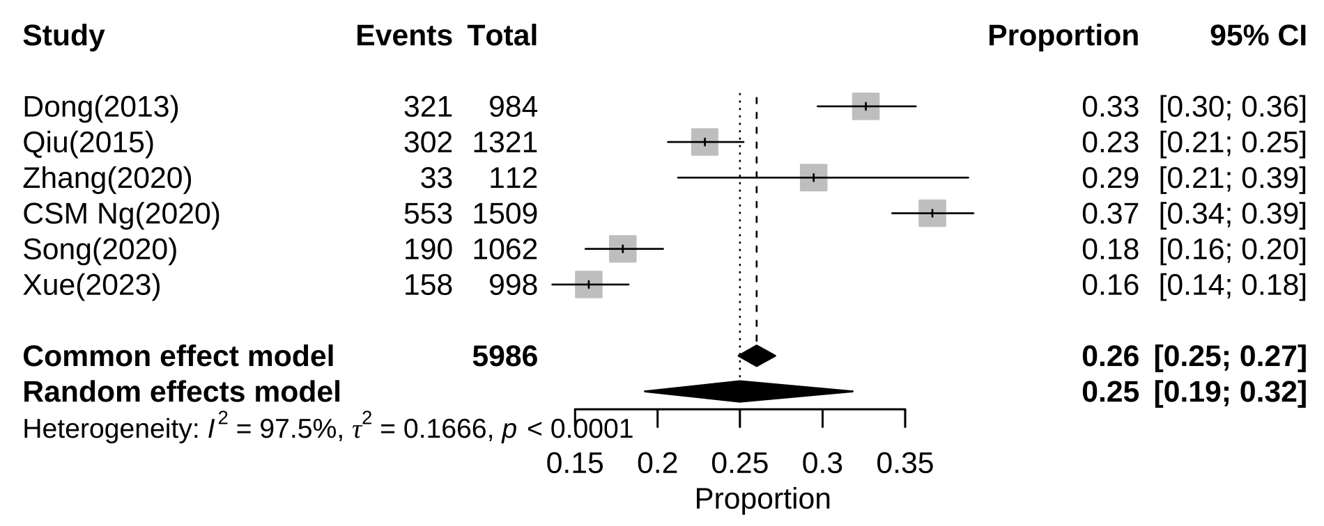
Additional file 6: Subgroup analysis of prevalence of alexithymia among Chinese adolescents by general high school students

