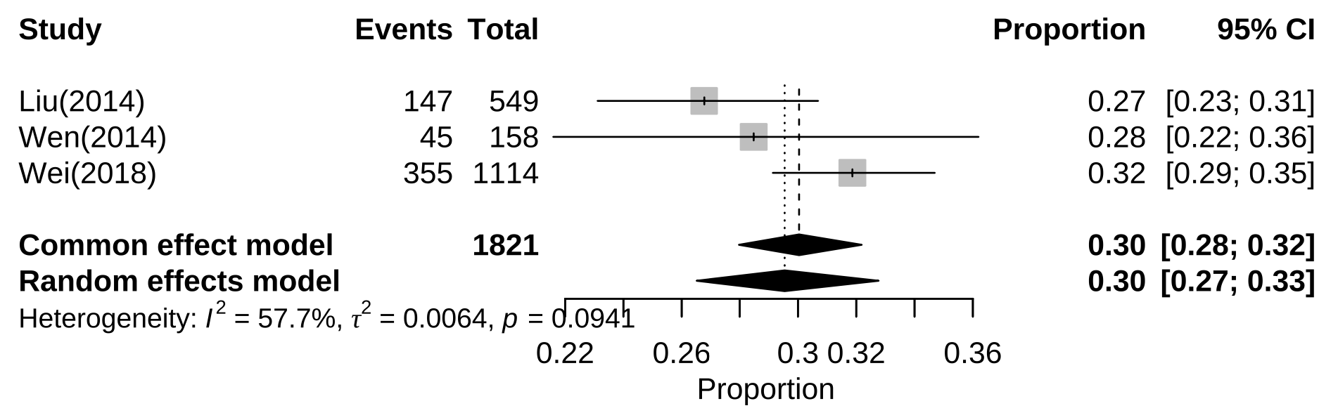
Additional file 7: Subgroup analysis of prevalence of alexithymia among Chinese adolescents by secondary vocational students

