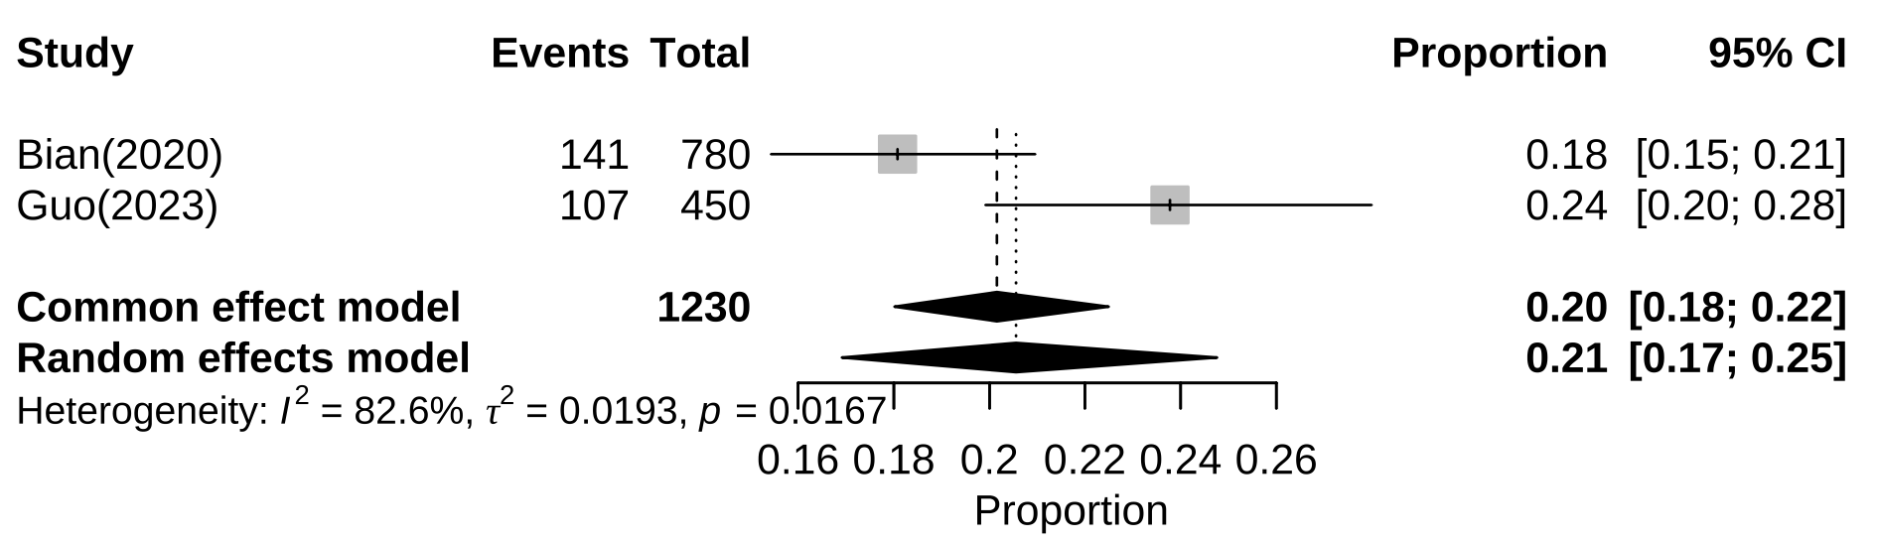
Additional file 8: Subgroup analysis of prevalence of alexithymia among Chinese adolescents by higher vocational students

