Supplemental Online Content
eFigure. Flow chart of study population inclusion.
eTable 1. The frequency (%) of acute phase symptoms of COVID-19 in the sample.
eTable 2. Model fit indices.

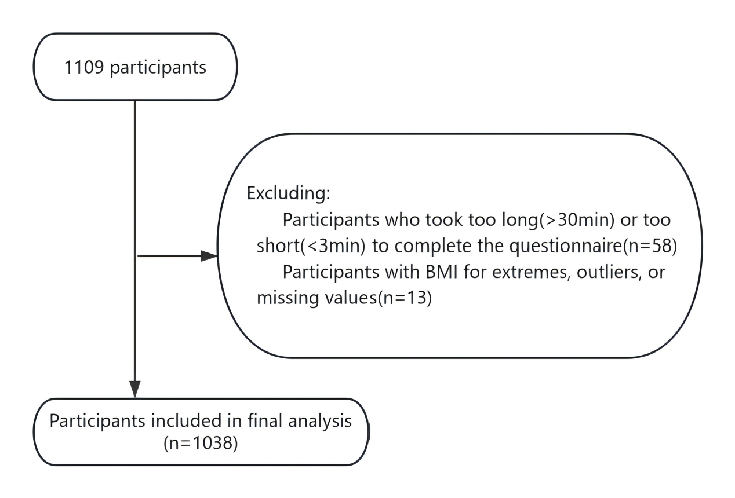
eFigure 1. Flow chart of study population inclusion.

eTable 1. The frequency (%) of acute phase symptoms of COVID-19 in the sample.
 | Frequency (%)
Acute symptoms | 1 day | 3 day | 7 day | 30 day
Fever | 89.4 | 43.9 | 11.7 | 4.3
Sore throat | 75.9 | 58.1 | 31.2 | 11.6
Hoarseness | 36.6 | 34.3 | 19.9 | 7.9
sneezing | 44.5 | 37.4 | 22.0 | 6.8
cough | 32.1 | 34.8 | 30.2 | 19.3
expectoration | 26.8 | 28.9 | 19.8 | 10.0
fatigue | 57.8 | 47.0 | 36.7 | 26.3
Muscle soreness | 62.3 | 40.9 | 22.5 | 9.5
Loss of smell and taste | 21.8 | 21.6 | 14.7 | 8.1
diarrhea | 3.6 | 3.3 | 1.3 | 0.7
Vomit | 4.6 | 3.2 | 1.1 | 0.5
Conjunctivitis | 1.8 | 1.1 | 0.8 | 0.6
Chest tightness | 14.2 | 10.3 | 10.1 | 9.2
Any acute COVID-19 symptoms | 98.4 | 94.7 | 81.5 | 59.1

eTable 2. Model fit indices.
Trajectory classes | Model specification | Fit indices |  | Entropy | Proportion of the sample in each trajectory group (%)
 |  | AIC | BIC |  | Class1 | Class2 | Class3 | Class4 | Class5 | Class6
2 | Quadratic time effect | -8081.20 | -8106.52 | 0.862 | 76.8 | 23.2 | - | - | - | -
 | Cubic time effect | -8031.60 | -8063.25 | 0.867 | 76.7 | 23.3 | - | - | - | -
3 | Quadratic time effect | -7950.71 | -7988.70 | 0.799 | 18.6 | 63.5 | 17.9 | - | - | -
 | Cubic time effect | -7910.86 | -7958.35 | 0.832 | 11.9 | 68.7 | 19.4 | - | - | -
4 | Quadratic time effect | -7831.24 | -7881.90 | 0.726 | 12.1 | 61.4 | 21.0 | 5.5 | - | -
 | Cubic time effect | -7787.67 | -7850.98 | 0.715 | 11.8 | 61.4 | 21.1 | 5.7 | - | -
5 | Quadratic time effect | -7808.16 | -7871.47 | 0.767 | 11.8 | 3.1 | 60.0 | 19.5 | 5.6 | -
 | Cubic time effect | -7775.36 | -7854.50 | 0.688 | 3.4 | 14.6 | 56.9 | 19.7 | 5.4 | -
6 | Quadratic time effect | -7798.38 | -7874.36 | 0.658 | 8.0 | 16.0 | 2.0 | 50.0 | 18.8 | 5.1
 | Cubic time effect | -7763.85 | -7858.82 | 0.667 | 6.1 | 0.1 | 19.7 | 49.4 | 19.2 | 5.5

