Table S1.
Hyperparameter Tuning Ranges
Model | Hyperparameter | Search Range | Notes
k-NN | neighbors | {3, 5, 7, 9, 11, 15, 21}
k-NN | weights | {uniform, distance}
k-NN | metric | {Euclidean, Manhattan}
Random Forest | n_estimators | {500, 800, 1000, 1500}
Random Forest | max_depth | {None, 6, 10, 14}
Random Forest | min_samples_leaf | {1, 2, 4}
Random Forest | max_features | {√p, p/3} | p = number of predictors
SVM (Linear) | C | {0.1, 1, 10, 100}
SVM (RBF) | C | {0.1, 1, 10, 100}
SVM (RBF) | gamma (γ) | {1e−4, 1e−3, 1e−2, 1e−1, 1}
Naïve Bayes (Gaussian) | var_smoothing | {1e−12, 1e−11, 1e−10, 1e−9, 1e−8, 1e−7, 1e−6} | Default 1e−9 if no gain
AdaBoost (tree base) | n_estimators | {50, 100, 200, 400}
AdaBoost (tree base) | learning_rate | {0.01, 0.05, 0.1, 0.2}
AdaBoost (tree base) | base_tree_depth | {1, 2} | stump vs shallow tree
XGBoost | eta (learning_rate) | {0.01, 0.05, 0.1}
XGBoost | max_depth | {3, 4, 6}
XGBoost | min_child_weight | {1, 3, 5}
XGBoost | subsample | {0.6, 0.8, 1.0}
XGBoost | colsample_bytree | {0.6, 0.8, 1.0}
XGBoost | gamma | {0, 1, 5}
XGBoost | lambda (L2) | {1, 5, 10}
Note. All hyperparameters were tuned within the training data using repeated stratified 5-fold cross-validation (10 repetitions). The primary selection metric was mean ROC–AUC across folds; ties were resolved by PR–AUC and then Brier score. Continuous features for SVM/k-NN were standardized within each training fold; tree models used unscaled values. For XGBoost, early stopping was used on validation folds (patience 50 rounds, selection by ROC–AUC). Final models were refit on the full training set with the selected configuration and evaluated once on the held-out test set.

Supplementary Table S2.
Pairwise AUC comparisons (DeLong test) among six classifiers
Model | k-NN | RF | NB | SVM | AdaBoost | XGBoost
k-NN | —
RF | 0.005  (p = .570) | —
NB | 0.003  (p = .895) | 0.008  (p = .593) | —
SVM | 0.023  (p = .396) | 0.028  (p = .282) | 0.020  (p = .350) | —
AdaBoost | 0.050  (p = .062) | 0.055  (p = .032) | 0.047  (p = .045) | 0.027  (p = .373) | —
XGBoost | 0.001  (p = .894) | 0.004  (p = .334) | 0.004  (p = .750) | 0.024  (p = .402) | 0.051  (p = .057) | —
Note. Cells display |ΔAUC| and two-sided DeLong p values for correlated ROC curves on the common test set; only the upper triangle is shown. A Bonferroni-adjusted significance threshold was used for 15 comparisons (αadj = .0033). No pairwise difference reached statistical significance after adjustment.

Table S3.
SHAP-derived breakpoints and operating ranges (RF model)
S3a.
Continuous predictors
Feature | Breakpoint  (z-units) | Mean SHAP  (below) | Mean SHAP  (above) | Mann–Whitney  (p)
Sense of meaning in life | -0.9 | -0.035 | -0.006 | < .001
Psychological suffering | 0.86 | -0.026 | 0.09 | < .001
Psychological resilience | -0.55 | 0.058 | -0.02 | < .001
Problematic mobile phone use | 1.31 | -0.005 | 0.041 | < .001
Learning burnout | 1.29 | -0.002 | 0.016 | < .001
Perceived discrimination at school | -0.05 | -0.008 | 0.003 | < .001
Mother harsh parenting | 2.43 | 0.0 | 0.034 | < .001
Father harsh parenting | 1.67 | 0.003 | 0.031 | < .001
Core self-evaluations | -0.73 | -0.042 | -0.013 | < .001
Psychological burdens | 1.31 | -0.006 | 0.06 | < .001
Being bullied at school | 2.65 | -0.001 | 0.054 | < .001

S3b.
Binary predictors
Feature | Mean SHAP  (category 0) | Mean SHAP  (category 1) | Mann–Whitney U  (p)
Academic performance (0 vs 1) | 0.01 | -0.002 | < .001
Family atmosphere (0 vs 1) | 0.016 | -0.003 | < .001
NSSI (0 vs 1) | -0.012 | 0.037 | < .001

Note. Breakpoints are reported in z-units (standardized on the training data). For continuous predictors, the table lists the breakpoint, median SHAP below vs. above, and the Mann–Whitney U p-value; for binary predictors, median SHAP by category and the Mann–Whitney U p-value are shown. P-values are formatted as p < .001 where appropriate. SHAP attributions are associational and model-specific.

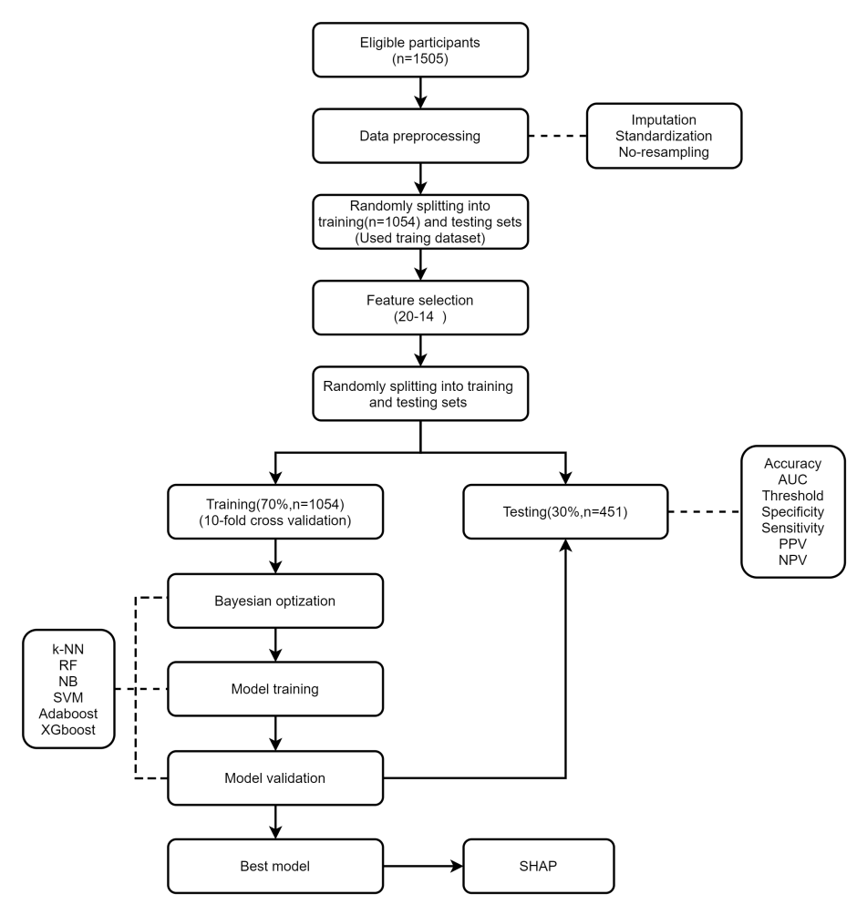
Figure. S1. Flow diagram of building machine learning model. PPV= Positive predictive value, NPV= Negative predictive value, AUC= area under the receiver operating characteristic curve, KNN=K-nearest neighbor, RF =random forest, NB=Naive Bayes classifier, SVM=support vector machine, AdaBoost=adaptive boosting, and XGboost=eXtreme gradient boosting

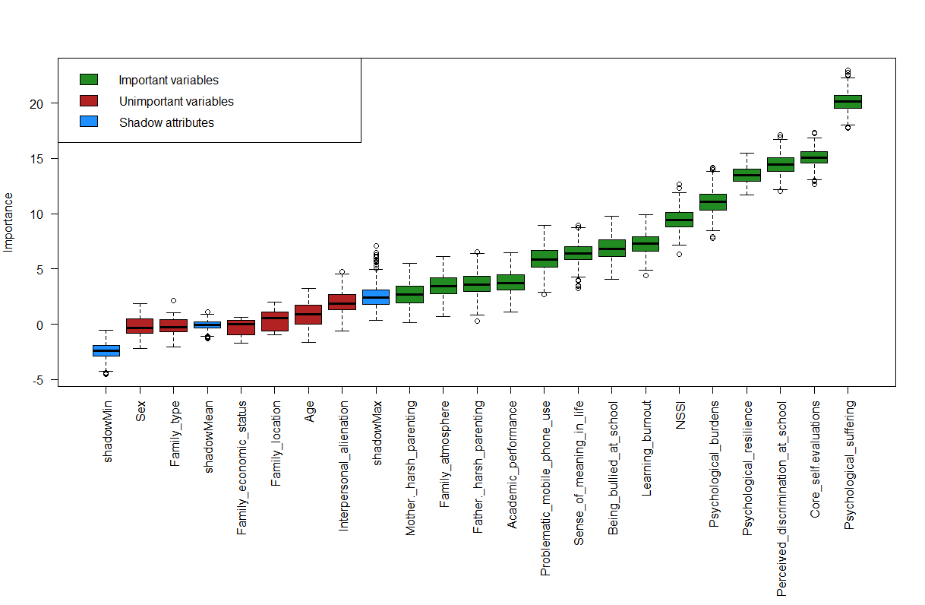
Figure S2. Results of variable selection using the Boruta algorithm. The y-axis represents the mean decrease in accuracy, reflecting the relative importance of each predictor in classifying sleep disturbances. Green boxplots correspond to variables retained as important, while red boxplots represent variables identified as unimportant after comparison with shadow features.

Figure S3. Receiver operating characteristic (ROC) curves of six machine learning models for predicting sleep disturbances. Each curve is accompanied by a shaded band representing the 95% confidence interval. The diagonal dashed line indicates the performance of a random classifier.

