Comorbidity of internet gaming disorder and anxiety in first-year Chinese university students: the mediating role of behavioral inhibition and activation systems
Jie Chen, Zhenzhen Zhang, Siwen Fu, Biyu Wen, Zeming Chen, and Xiaochun Wang *
School of Psychology, Shanghai University of Sport, Shanghai, China
*Corresponding Author: School of Psychology, Shanghai University of Sport, Shanghai, China
E-mail addresses：2411916010@sus.edu.cn (X.C.Wang)

Supplementary Figures and Tables
Supplementary Figures

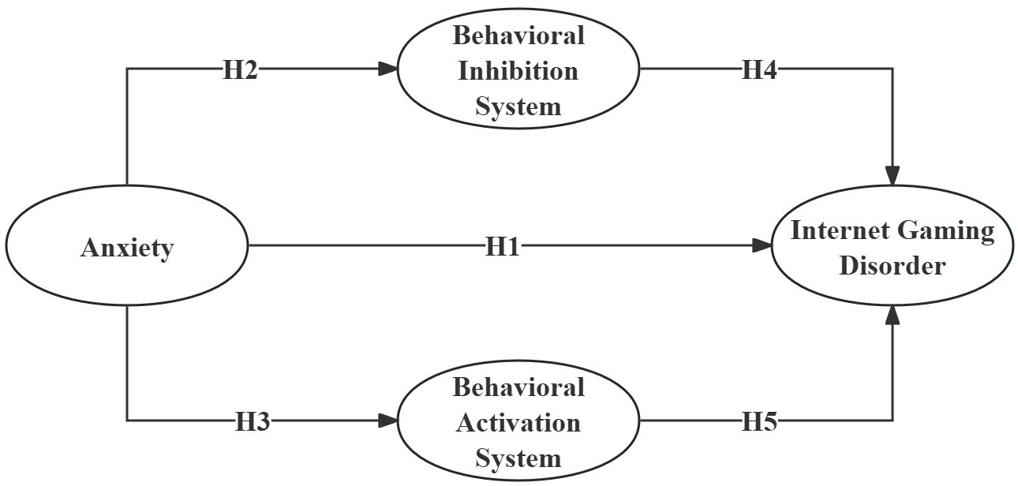
Supplementary Fig 1. Hypothesized Model

Supplementary Fig 2. Accuracy Test for the Edge Weight Estimates

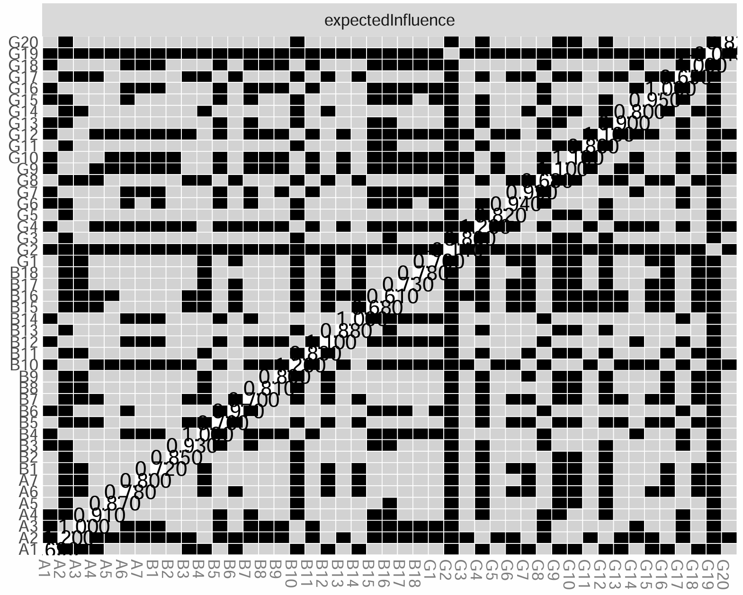
Supplementary Fig 3. Expected Influence Difference Test

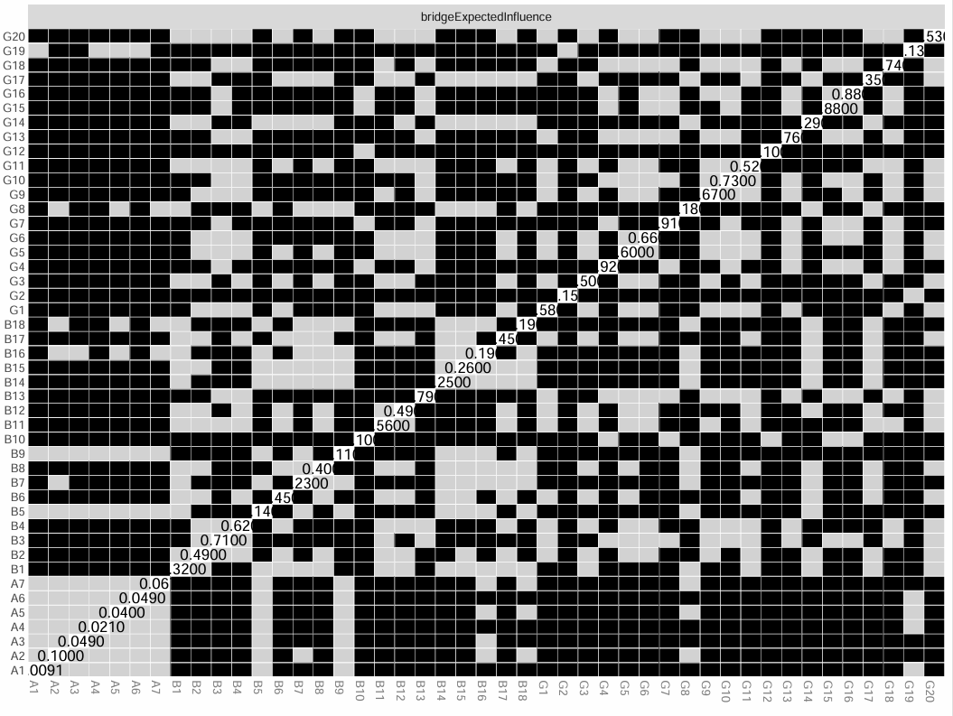
Supplementary Fig 4. Bridge Expected Influence Difference Test

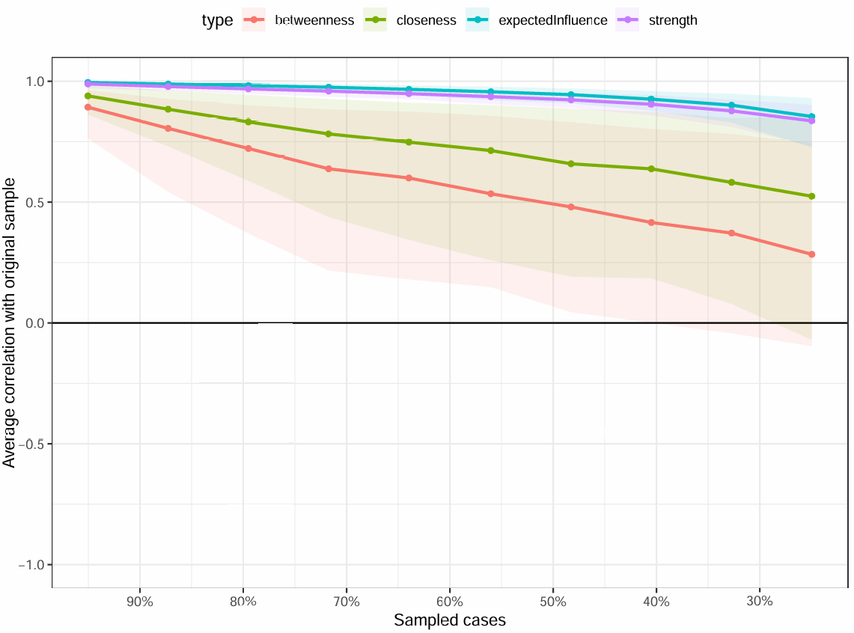
Supplementary Fig 5. Stability Test for Centrality Indices

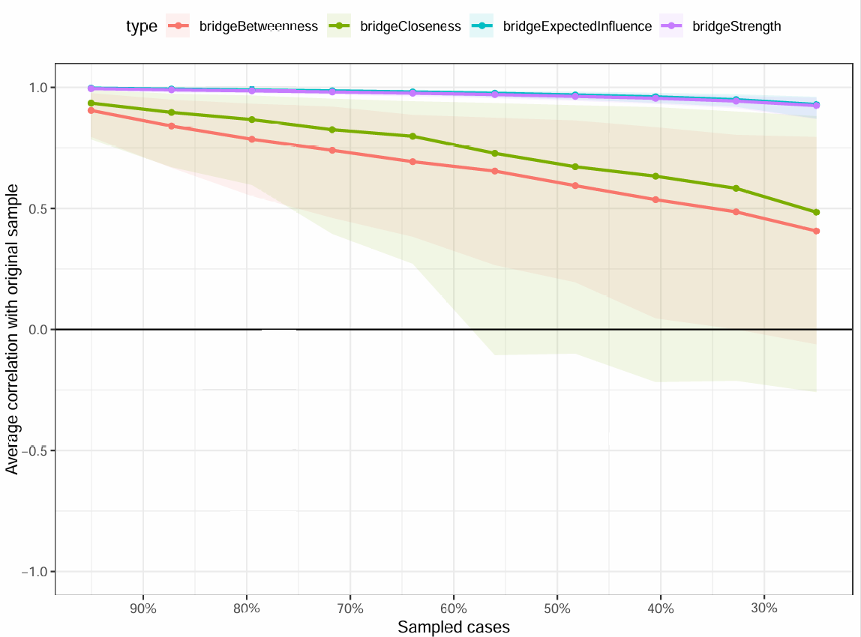
Supplementary Fig 6. Stability Test for Bridge Centrality Indices

Supplementary Tables

Supplementary Table 1. Composition of Latent Factor Scales
Factor | Observed Variables
Internet Gaming Disorder | IGD-1 I often lose sleep because of long gaming sessions
Internet Gaming Disorder | IGD-2R* I never play games in order to feel better
Internet Gaming Disorder | IGD-3 I have significantly increased the amount of time I play games over past year
Internet Gaming Disorder | IGD-4 When I am not gaming, I feel more irritable
Internet Gaming Disorder | IGD-5 I have lost interest in other hobbies because of my gaming
Internet Gaming Disorder | IGD-6 I would like to cut down my gaming time but it’s difficult to do
Internet Gaming Disorder | IGD-7 I usually think about my next gaming session when I am not playing
Internet Gaming Disorder | IGD-8 I play games to help me cope with any bad feelings I might have
Internet Gaming Disorder | IGD-9 I need to spend increasing amounts of time engaged in playing games
Internet Gaming Disorder | IGD-10 I feel sad if I am not able to play games
Internet Gaming Disorder | IGD-11 I have lied to my family members because the amount of gaming I do
Internet Gaming Disorder | IGD-12 I do not think I could stop gaming
Internet Gaming Disorder | IGD-13 I think gaming has become the most time-consuming activity in my life
Internet Gaming Disorder | IGD-14 I play games to forget about whatever’s bothering me
Internet Gaming Disorder | IGD-15 I often think that a whole day is not enough to do everything I need to do in-game
Internet Gaming Disorder | IGD-16 I tend to get anxious if I can’t play games for any reason
Internet Gaming Disorder | IGD-17 I think my gaming has jeopardized the relationship with my partner
Internet Gaming Disorder | IGD-18 I often try to play games less but find I cannot  IGD-19R* I know my main daily activity (i.e., occupation, education, homemaker, etc.) has not been negatively affected by my gaming  IGD-20 I believe my gaming is negatively impacting on important areas of my life
Anxiety | GAD-1 Feeling nervous, anxious, or on edge
Anxiety | GAD-2 Not being able to stop or control worrying
Anxiety | GAD-3 Worrying too much about different things
Anxiety | GAD-4 Trouble relaxing
Anxiety | GAD-5 Being so restless that it is hard to sit still
Anxiety | GAD-6 Becoming easily annoyed or irritable
Anxiety | GAD-7 Feeling afraid as if something awful might happen
Behavioral Inhibition System/ Behavioral Activation System | BIS/BAS-1 I go out of my way to get things I want
Behavioral Inhibition System/ Behavioral Activation System | BIS/BAS-2 When I’m doing well at something, I love to keep at it
Behavioral Inhibition System/ Behavioral Activation System | BIS/BAS-3 I’m always willing to try something new if I think it will be fun
Behavioral Inhibition System/ Behavioral Activation System | BIS/BAS-4 When I get something I want, I feel excited and energized
Behavioral Inhibition System/ Behavioral Activation System | BIS/BAS-5 Criticism or scolding hurts me quite a bit
Behavioral Inhibition System/ Behavioral Activation System | BIS/BAS-6 When I want something, I usually go all-out to get it
Behavioral Inhibition System/ Behavioral Activation System | BIS/BAS-7 I will often do things for no other reason than that they might be fun
Behavioral Inhibition System/ Behavioral Activation System | BIS/BAS-8 If I see a chance to get something I want, I move on it right away
Behavioral Inhibition System/ Behavioral Activation System | BIS/BAS-9 I feel pretty worried or upset when I think or know somebody is angry at me  BIS/BAS-10 When I see an opportunity for something I like, I get excited right away  BIS/BAS-11 I often act on the spur of the moment  BIS/BAS-12 If I think something unpleasant is going to happen, I usually get pretty “worked up”  BIS/BAS-13 When good things happen to me, it affects me strongly  BIS/BAS-14 I feel worried when I think I have done poorly at something  BIS/BAS-15 I crave excitement and new sensations  BIS/BAS-16 When I go after something I use a “no holds barred” approach  BIS/BAS-17 It would excite me to win a contest  BIS/BAS-18 I worry about making mistakes
Note: IGD Dimensions: Salience: 1, 7, 13; Tolerance: 3, 9, 15; Mood modification: 2, 8, 14; Withdrawal: 4, 10, 16; Conflict: 5, 11, 17, 19, 20; Relapse: 6, 12, 18. BIS/BAS Dimensions: BIS: 5, 9, 12, 14, 18; BAS-R: 2, 4, 13, 17; BAS-D: 1, 6, 8, 16; BAS-F: 3, 7, 10, 11, 15. IGD, internet gaming disorder; GAD, generalized anxiety disorder; BIS, behavioral inhibition system; BAS, behavioral activation system. BAS-R, behavioral activation system- reward; BAS-D, behavioral activation system- drive; BAS-F, behavioral activation system- fun seeking. *Reversed items

Supplementary Table 2. HTMT Values of Latent Factors
 | Anxiety | BAS | BIS | IGD
Anxiety
BAS | 0.14
BIS | 0.41 | 0.28
IGD | 0.17 | 0.15 | 0.13
NOTE: IGD, internet gaming disorder; BIS, behavioral inhibition system; BAS, behavioral activation system; HTMT, heterotrait–monotrait ratios

Supplementary Table3. Predictive Relevance (Q²) and Effect Size (f²) for Latent Constructs
Construct | SSO | SSE | Q² (=1-SSE/SSO) | f²
BIS | 3025.00 | 2811.51 | 0.12 | AXT→BIS: 0.15  BIS→IGD: 0.01
BAS | 6050.00 | 6010.40 | 0.01 | AXT→BAS: 0.02  BAS→IGD: 0.02
IGD | 10890.00 | 10654.39 | 0.02 | AXT→IGD: 0.01
Note: IGD, internet game disorder; BIS, behavioral inhibition system; BAS, behavioral activation system; AXT, anxiety; SSO, Sum of Squares Observations; SSE, Sum of Squares Error

Supplementary Table 4. Calibration Parameters for Variables
 | Variable | Fully in (95%) | Crossover point (50%) | Fully out (5%)
Condition | GAD | 13 | 2 | 0
 | BIS | 20 | 15 | 10
 | BAS-R | 16 | 14 | 10
 | BAS-D | 16 | 12 | 9
 | BAS-F | 20 | 15 | 11
Outcome | IGD | 63 | 41 | 24.2
NOTE: IGD, internet gaming disorder; GAD, generalized anxiety disorder; BIS, behavioral inhibition system; BAS, behavioral activation system. BAS-R, behavioral activation system- reward; BAS-D, behavioral activation system- drive; BAS-F, behavioral activation system- fun seeking

