Appendix A. Supplementary tables and figures

Core findings were re-examined using the PHQ-8, including the latent profile analysis, and tests of between-group differences in help-seeking intentions. Table S1, Figure S1, and Figure S2 present the model fit indices for the latent profile analysis, the profile characteristics, and the between-group differences in help-seeking intentions, respectively. Furthermore, statistical agreement tests confirmed a high consistency between the classifications based on the PHQ-8 and the PHQ-9: Adjusted Rand Index (ARI) = 0.985; Chi-square test, χ²(9) = 7158.484, p < 0.001; Cramér’s V = 0.987. These results support the robustness of the main findings.

Table S1 Fit indices for two-to-five-profile models of latent profile analysis (PHQ-8).
LPA Models | AIC | BIC | aBIC | Entropy | LMR(p) | BLRT(p) | Smallest profile(%)
1 | 41683.71 | 41753.34 | 41715.21
2 | 39943.69 | 40053.94 | 39993.58 | 0.915 | < 0.001 | < 0.001 | 0.159
3 | 39187.04 | 39337.91 | 39255.30 | 0.928 | < 0.001 | < 0.001 | 0.050
4 | 38550.84 | 38742.33 | 38637.48 | 0.813 | < 0.001 | < 0.001 | 0.048
5 | 38213.36 | 38345.47 | 38318.38 | 0.830 | 0.001 | < 0.001 | 0.040
Note. Bold entries reflect selected model.

Figure S1. Latent profiles (PHQ-8) of help-seeking characteristics in college students at risk for suicide.
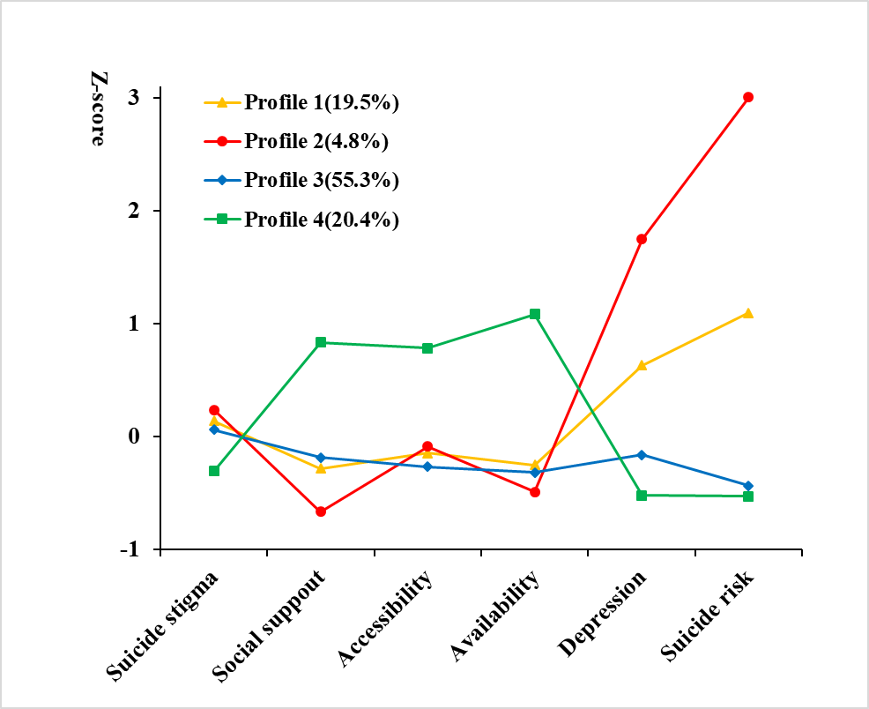
Note. Availability = Availability of mental health services; Accessibility = Accessibility of mental health services.

Figure S2. Differences in help-seeking intentions across profiles derived from PHQ-8.
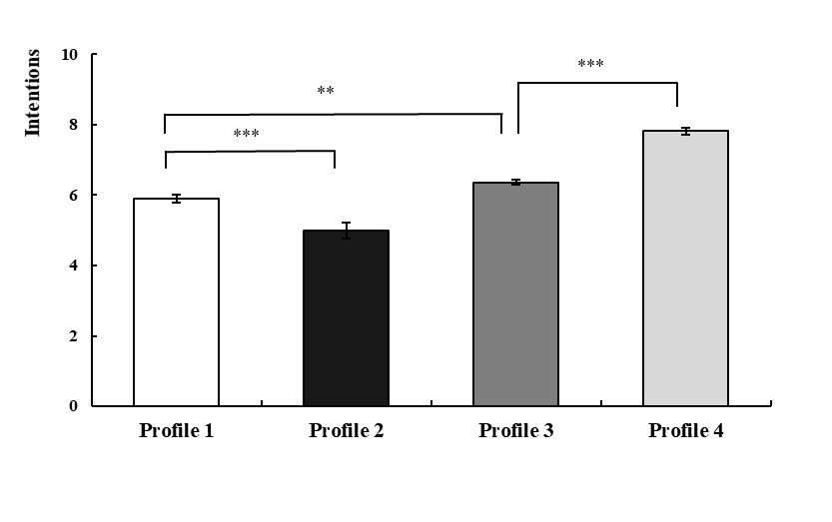
Note. Bars represent estimated marginal means adjusted for covariates (gender, prior mental disorder diagnosis, and previous help-seeking behavior); error bars represent standard errors. An ANCOVA controlling for these covariates revealed a significant main effect of profile group, F(3, 2440) = 79.73, p < 0.001, partial η² = 0.089. Bonferroni-corrected pairwise comparisons indicated that all differences between the four latent profile groups were statistically significant (ps < 0.001), showing the gradient: Resource Advantage Group > Low Risk-Stable Group > Moderate Risk-Resource Limited Group > High-Risk Isolated Group.
***p < 0.001.

