Additional file 2: Figures S1–S5 (.docx)
Title: Supplementary figures
Description: Fig.S1 shows standardized strength, with closeness and betweenness centrality presented for comparison. Closeness and betweenness centrality are based on shortest path length (SPL), where closeness is defined as the inverse of the sum of shortest path lengths between a node and all other nodes, and betweenness quantifies how often a node lies on the shortest paths between pairs of nodes. Fig.S2 presents bootstrapped confidence intervals of edge weights, indicating stable estimates with relatively narrow 95% confidence intervals. Fig.S3 shows the results of case-dropping procedures for closeness (CS-coefficient = 0.439) and betweenness (CS-coefficient = 0.128). Fig.S4-S5 present the results of the sensitivity analyses using a 7:3 train-test split and excluding the SMOTE algorithm, respectively. Both figures include: (A) Comparison of ROC curves; (B) Variable Importance Ranking for the XGBoost; and (C) SHAP beeswarm plot.

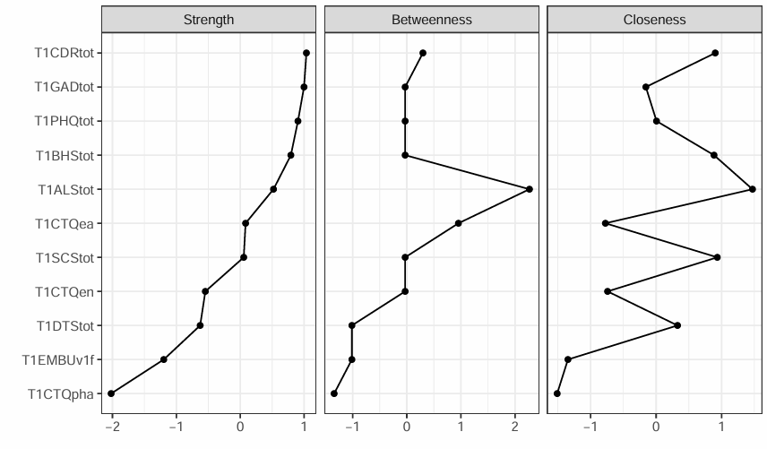
Fig. S1 Standardized Strength, with Closeness and Betweenness shown for comparison. Closeness and betweenness centrality are based on the concept of shortest path length (SPL): specifically, closeness is the inverse of the sum of the shortest path lengths between a node and all other nodes, and betweenness quantifies how often a node lies on the shortest paths between pairs of other nodes.
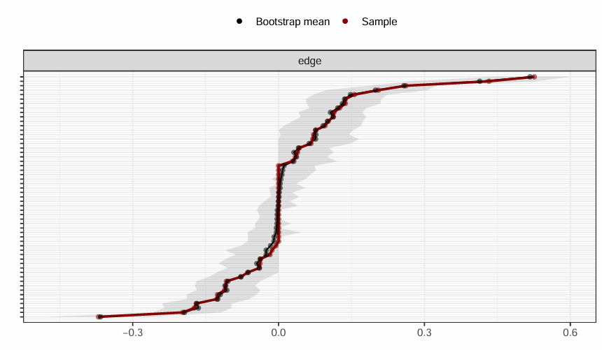
Fig. S2 Bootstrapped confidence intervals of edge weights. The results of the bootstrap for edge weights indicate that most edge weights are stable, with bootstrap means close to the sample estimates and relatively narrow 95% confidence intervals, suggesting that the network structure is robust.

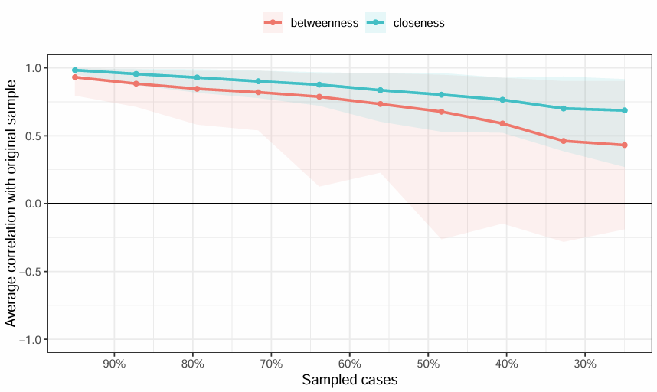
Fig. S3 The case-dropping procedures for closeness (CS-coefficient: 0.439>0.25) and betweenness (CS-coefficient: 0.128 < 0.25).

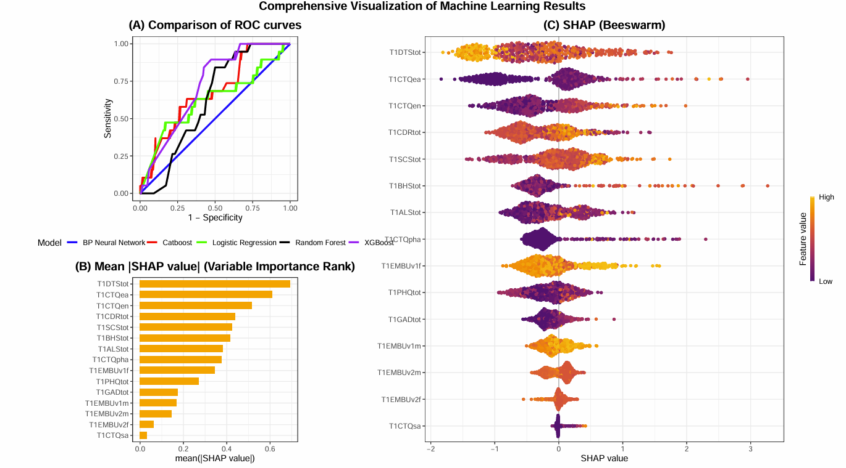
Fig. S4 (A) Receiver Operating Characteristic (ROC) Curves in the testing set for ML Models Predicting suicide risk (based on a 7:3 train-test split). XGBoost (AUC = 0.718), BP Neural Network (AUC = 0.5), Random Forest (AUC = 0.622), Logistic Regression (AUC = 0.625) and CatBoost (AUC=0.677). (B) Variable Importance Ranking for the XGBoost model predicting suicide risk. Features are ranked by their mean |SHAP| values. (C) SHAP beeswarm plot.

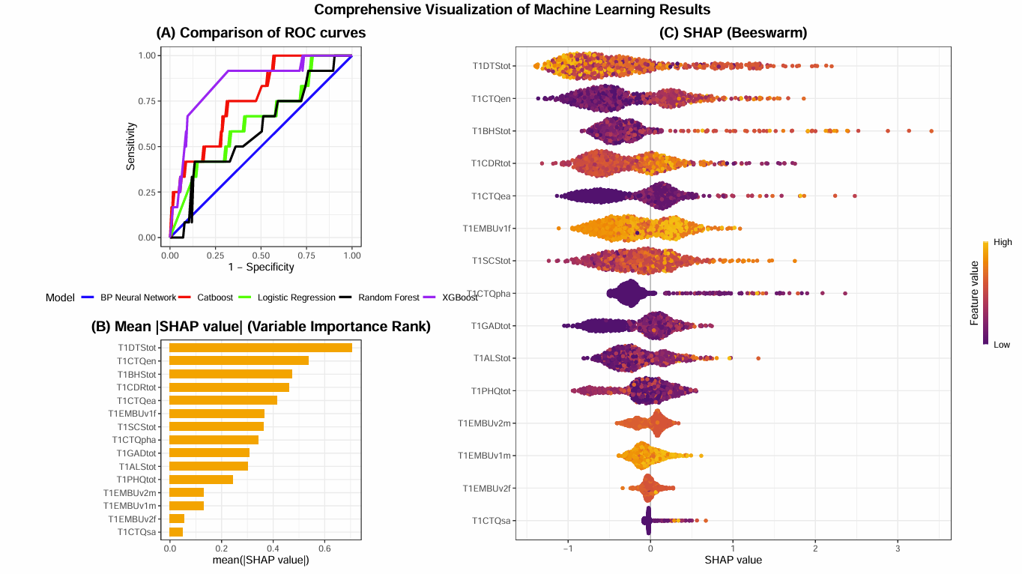
Fig. S5 (A) Receiver Operating Characteristic (ROC) Curves in the testing set for ML Models Predicting suicide risk (without SMOTE algorithm). XGBoost (AUC = 0.851), BP Neural Network (AUC = 0.5), Random Forest (AUC = 0.597), Logistic Regression (AUC = 0.643) and CatBoost (AUC=0.765). (B) Variable Importance Ranking for the XGBoost model predicting suicide risk. Features are ranked by their mean |SHAP| values. (C) SHAP beeswarm plot.

