Supplementary Material
Supplementary Figure 1：Profile plots of CES-D and PDQ-D subscale scores by latent class.
Supplementary Figure 2: The stability of network structure by case dropping bootstrap
Supplementary Figure 3: Bootstrapped confidence intervals of edge weights.
Supplementary Figure 4: Estimation of nodes centrality difference by bootstrapped difference test
Supplementary Table 1: The full weighted adjacency matrix for low comorbid Moderate comorbidity and high comorbid.
Supplementary Table 2. Bridge Expected Influence (BEI) values of depressive and cognitive symptoms across latent profiles
Supplementary Table3：Significant edge differences between the Low and Moderate comorbidity groups (p < 0.05)
Supplementary Table4：Significant edge differences between the Moderate and High comorbidity groups (p < 0.05)

Supplementary Figure S1. Profile plots of CES-D and PDQ-D subscale scores by latent class.

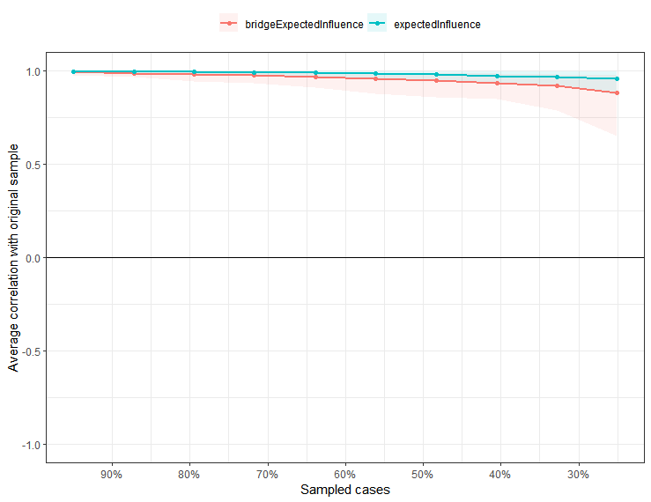
- Low comorbidity group

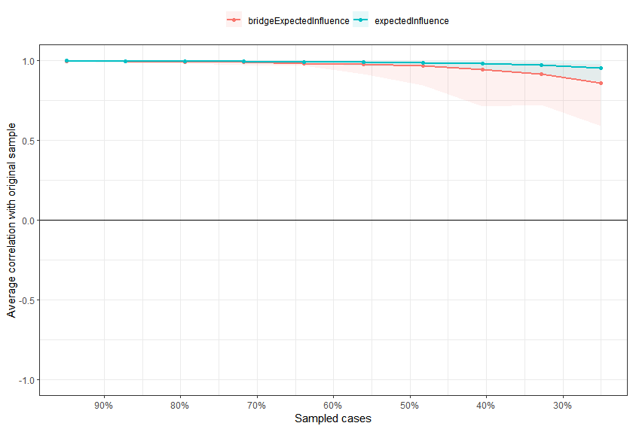

b.Moderate comorbidity group
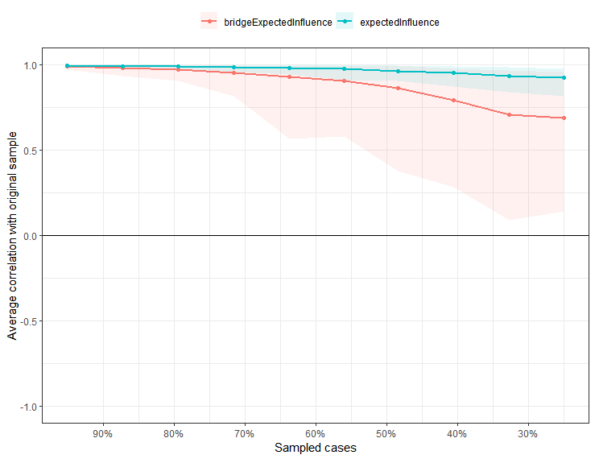
c.High comorbidity group

Supplementary Figure 2: The stability of network structure by case dropping bootstrap. The black dots represent the edge weight values, which are arranged from highest to lowest. The gray region shows the edge weights' 95 percent Confidence Intervals. Wide intervals indicate less stability, whereas tight intervals denote more stability.

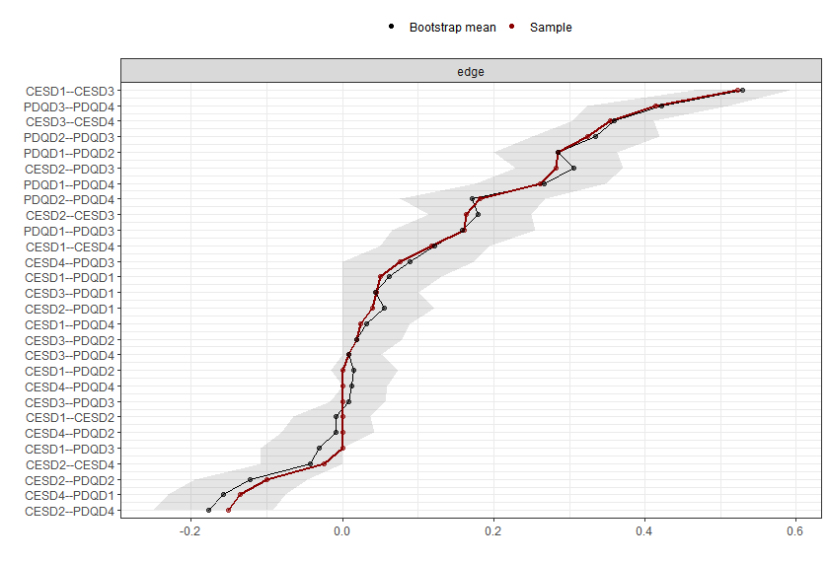
a.Low comorbidity group
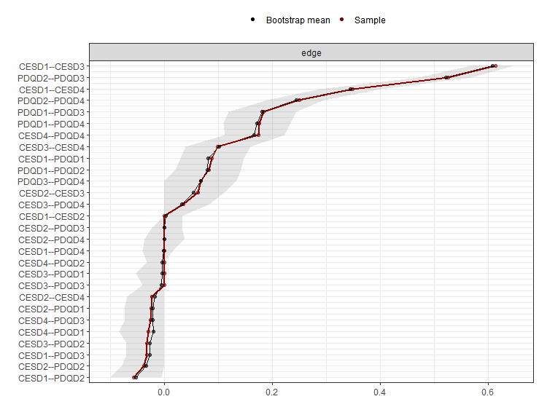
b.Moderate comorbidity group

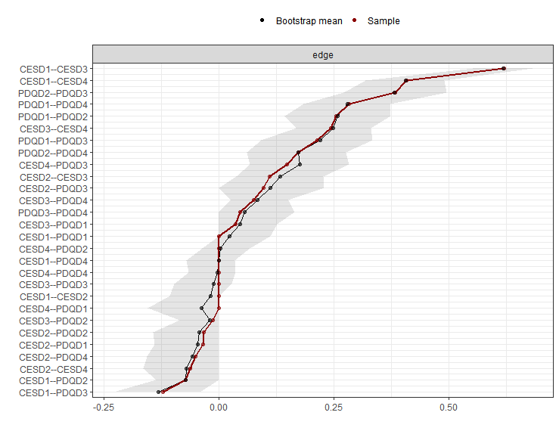
c.High comorbidity group
Supplementary Figure 3: Bootstrapped confidence intervals of edge weights.
The black dots represent the edge weight values, which are arranged from highest to lowest. The gray region shows the edge weights' 95 percent Confidence Intervals. Wide intervals indicate less stability, whereas tight intervals denote more stability.

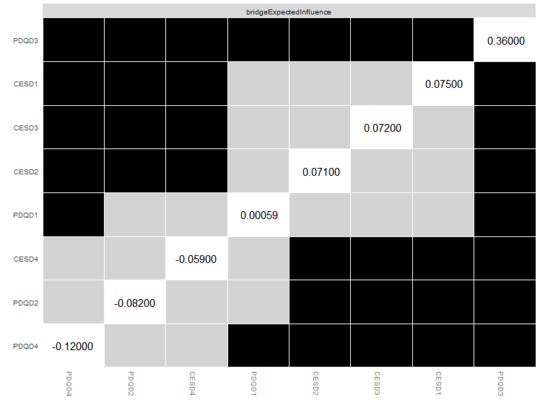
a.Low comorbidity group

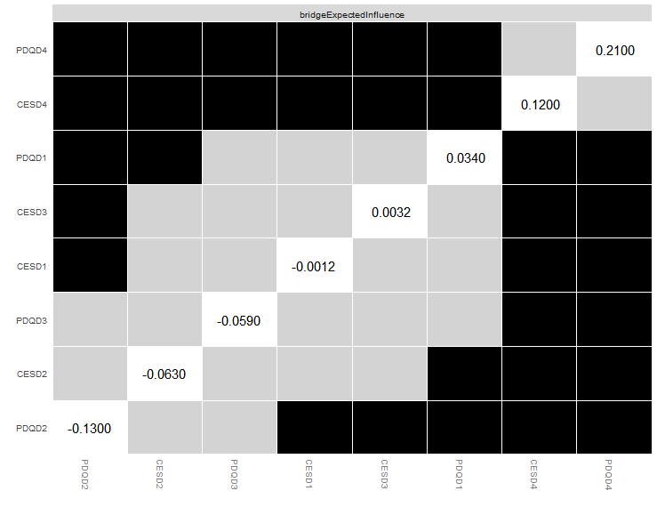
b.Moderate comorbidity group
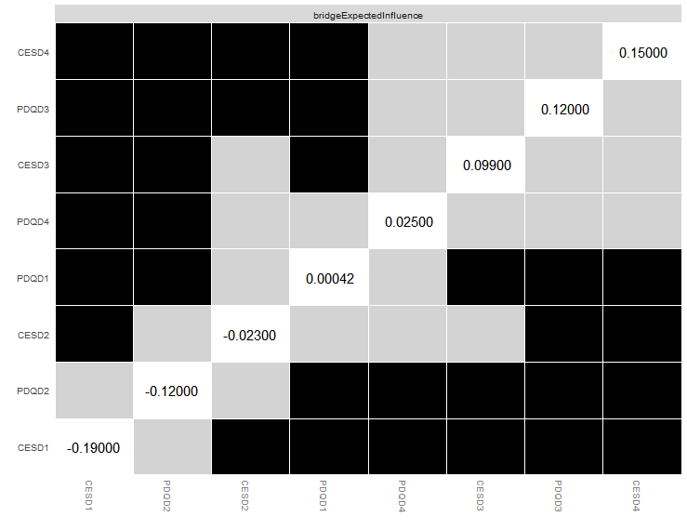
c.High comorbidity group
Supplementary Figure 4: Estimation of nodes centrality difference by bootstrapped difference test.Bootstrapped difference tests between nodes centrality within the network. Gray boxes indicate that are not significantly different from each other. Black boxes represent that are significantly different from each other (α = 0.05).

Supplementary Table 1-1: The full weighted adjacency matrix for the low comorbidity group
 | CESD1 | CESD2 | CESD3 | CESD4 | PDQD1 | PDQD2 | PDQD3 | PDQD4
CESD1 | 0 | 0 | 0.523 | 0.118 | 0.051 | 0 | 0 | 0.024
CESD2 | 0 | 0 | 0.163 | -0.024 | 0.039 | -0.1 | 0.283 | -0.152
CESD3 | 0.523 | 0.163 | 0 | 0.355 | 0.045 | 0.018 | 0 | 0.008
CESD4 | 0.118 | -0.024 | 0.355 | 0 | -0.135 | 0 | 0.076 | 0
PDQD1 | 0.051 | 0.039 | 0.045 | -0.135 | 0 | 0.284 | 0.161 | 0.261
PDQD2 | 0 | -0.1 | 0.018 | 0 | 0.284 | 0 | 0.324 | 0.182
PDQD3 | 0 | 0.283 | 0 | 0.076 | 0.161 | 0.324 | 0 | 0.414
PDQD4 | 0.024 | -0.152 | 0.008 | 0 | 0.261 | 0.182 | 0.414 | 0
Supplementary Table 1-2: The full weighted adjacency matrix for the moderate comorbidity group
 | CESD1 | CESD2 | CESD3 | CESD4 | PDQD1 | PDQD2 | PDQD3 | PDQD4
CESD1 | 0 | 0 | 0.614 | 0.349 | 0.088 | -0.056 | -0.033 | 0
CESD2 | 0 | 0 | 0.062 | -0.023 | -0.024 | -0.038 | 0 | 0
CESD3 | 0.614 | 0.062 | 0 | 0.099 | 0 | -0.032 | 0 | 0.035
CESD4 | 0.349 | -0.023 | 0.099 | 0 | -0.029 | 0 | -0.026 | 0.174
PDQD1 | 0.088 | -0.024 | 0 | -0.029 | 0 | 0.083 | 0.184 | 0.175
PDQD2 | -0.056 | -0.038 | -0.032 | 0 | 0.083 | 0 | 0.526 | 0.25
PDQD3 | -0.033 | 0 | 0 | -0.026 | 0.184 | 0.526 | 0 | 0.068
PDQD4 | 0 | 0 | 0.035 | 0.174 | 0.175 | 0.25 | 0.068 | 0
Supplementary Table 1-3: The full weighted adjacency matrix for the high comorbidity group
 | CESD1 | CESD2 | CESD3 | CESD4 | PDQD1 | PDQD2 | PDQD3 | PDQD4
CESD1 | 0 | 0 | 0.619 | 0.407 | 0 | -0.073 | -0.121 | 0
CESD2 | 0 | 0 | 0.109 | -0.063 | -0.036 | -0.033 | 0.096 | -0.051
CESD3 | 0.619 | 0.109 | 0 | 0.244 | 0.036 | -0.013 | 0 | 0.076
CESD4 | 0.407 | -0.063 | 0.244 | 0 | 0 | 0 | 0.148 | 0
PDQD1 | 0 | -0.036 | 0.036 | 0 | 0 | 0.255 | 0.214 | 0.283
PDQD2 | -0.073 | -0.033 | -0.013 | 0 | 0.255 | 0 | 0.383 | 0.172
PDQD3 | -0.121 | 0.096 | 0 | 0.148 | 0.214 | 0.383 | 0 | 0.046
PDQD4 | 0 | -0.051 | 0.076 | 0 | 0.283 | 0.172 | 0.046 | 0

Supplementary Table2: Bridge Expected Influence (BEI) values of depressive and cognitive symptoms across latent profiles
Symptom | Low comorbidity | Moderate comorbidity | High comorbidity
Depressive mood | 0.0749 | -0.0012 | -0.1948
Positive emotions | 0.079 | -0.0625 | -0.0233
Somatic symptoms | 0.0721 | 0.0032 | 0.0993
Interpersonal relationships | -0.0588 | 0.1188 | 0.1477
Attention/Concentration | 0.0006 | 0.0346 | 0.0004
Retrospective memory | -0.0817 | -0.1266 | -0.1187
Prospective memory | 0.359 | -0.0589 | 0.1221
Inhibitory/Organizational ability | -0.1189 | 0.2094 | 0.0251

Supplementary Table3：Significant edge differences between the Low and Moderate comorbidity groups (p < 0.05)
Edge | Test statistic (E) | p-value
CESD1 – CESD2 | 0.0293 | 0.03596
CESD1 – CESD3 | 0.2409 | 0.00099
CESD2 – CESD3 | 0.1366 | 0.00399
CESD1 – CESD4 | 0.2979 | 0.00099
CESD3 – CESD4 | 0.217 | 0.00199
CESD1 – PDQD1 | 0.09599 | 0.00099
CESD4 – PDQD1 | 0.14518 | 0.00199
CESD1 – PDQD2 | 0.21606 | 0.00099
CESD3 – PDQD2 | 0.08229 | 0.00699
PDQD1 – PDQD2 | 0.12352 | 0.01898
CESD1 – PDQD3 | 0.17871 | 0.00099
CESD2 – PDQD3 | 0.29766 | 0.00099
CESD3 – PDQD3 | 0.10085 | 0.00799
CESD4 – PDQD3 | 0.2355 | 0.00099
PDQD2 – PDQD3 | 0.23534 | 0.00099
CESD2 – PDQD4 | 0.16983 | 0.00099
CESD3 – PDQD4 | 0.11738 | 0.00999
PDQD1 – PDQD4 | 0.15004 | 0.00999
PDQD3 – PDQD4 | 0.27712 | 0.00099
Supplementary Table4：Significant edge differences between the Moderate and High comorbidity groups (p < 0.05)
Edge | Test statistic (E) | p-value
CESD1 – CESD2 | 0.05695 | 0.00899
CESD1 – CESD3 | 0.13056 | 0.00499
CESD2 – CESD3 | 0.14872 | 0.01199
CESD3 – CESD4 | 0.06391 | 0.00199
CESD1 – PDQD1 | 0.10549 | 0.01199
CESD2 – PDQD1 | 0.07795 | 0.01898
PDQD1 – PDQD1 | 0.06939 | 0.01099
CESD2 – PDQD2 | 0.16192 | 0.00099
CESD3 – PDQD2 | 0.08229 | 0.00699
CESD1 – PDQD3 | 0.18084 | 0.00099
CESD2 – PDQD3 | 0.12484 | 0.00099
CESD4 – PDQD3 | 0.33439 | 0.00099
PDQD1 – PDQD3 | 0.35893 | 0.00099
PDQD2 – PDQD3 | 0.36302 | 0.00699
CESD1 – PDQD4 | 0.06257 | 0.02297
CESD2 – PDQD4 | 0.0657 | 0.03896
CESD3 – PDQD4 | 0.11738 | 0.00999
CESD4 – PDQD4 | 0.17666 | 0.00099
PDQD3 – PDQD4 | 0.24551 | 0.00099

