Supplementary Materials
Objective diagnosis and treatment outcome prediction in major depressive disorder based on a machine learning framework with dried-serum NIRS digital biomarkers
Mingxia Liu¹, Yaping Wang¹, Yi He¹, Zuoli Sun^{1,2*}, Jian Yang^{1*}
¹Beijing Key Laboratory of Mental Disorders, National Clinical Research Center for Mental Disorders and National Center for Mental Disorders, Beijing Anding Hospital, Capital Medical University, Beijing, 100088, China
²Laboratory for Clinical Medicine, Capital Medical University, Beijing, 100069, China
*Correspondence:
Zuoli Sun
zuolisun83@163.com
Jian Yang
yangjian@ccmu.edu.cn

1. Supplementary Methodology Information
1.1 Subject recruitment and treatment
The enrolled patients met the following criteria ¹: 1) patients between 18 and 65 years of age; 2) met the DSM-IV criteria for MDD; and 3) HAMD-17 score of ≥ 14. Exclusion criteria were: 1) a lifetime history of bipolar, schizophrenia, schizoaffective, or other Axis I psychiatric disorders; 2) had used antidepressant medication over a period of 7 days or longer 14 days prior to their recruitment; 3) had a history of drug or alcohol abuse; 4) was pregnant or breastfeeding; 5) had a serious suicide risk (score of ≥ 3 on item 3 in HAMD-17); 6) had severe chronic diseases with ongoing treatment; and 7) had significant medical conditions and unstable psychiatric condition.
Inclusion criteria for HC subjects were: 1) no lifetime DSM-IV Axis I psychiatric disorder, 2) no significant medical illness (e.g., chronic inflammatory disorders, diabetes, cardiovascular disease, thyroid disease, or cancer), 3) no significant medical conditions, and 4) not pregnant or breastfeeding. All participants were required to have the ability to communicate and provide written informed consent. The subjects with obesity (body mass index (BMI) >35) or who received any anti-inflammatory medications within 3 days before blood withdrawal were excluded.
Escitalopram (ESC) is among the most frequently prescribed antidepressants in Asian populations, with its efficacy and tolerability well-documented in prior studies ²⁻⁴. In line with clinical practice guidelines, the dosing regimen followed a titration protocol: treatment began with 5 mg/day, and over the course of one week, the dosage was gradually increased to a target range of 10-20 mg/day. Once the optimal dose was achieved based on clinical response and tolerability, it was maintained throughout the remainder of the 12-week treatment period ⁵. No concomitant antidepressant medications were permitted during the study. Depressive symptom severity was assessed using the HAMD-17, administered by trained and experienced independent raters. Evaluations were conducted both at baseline and following the 12-week ESC treatment.
1.2 Model algorithms
1.2.1 Principal Component Analysis (PCA)
PCA is an unsupervised statistical method that reduces data dimensionality by transforming correlated variables into a set of uncorrelated principal components (PCs) ⁶. It was conducted to visualize the variation in sample spectra among groups and to explore the data structure in this study. PCA decomposes the original data matrix X into the product of a score matrix T, a loadings matrix P^{T}, and a residual matrix E, as expressed as X=TP^{T}+E. Each PC is orthogonal to the others and captures a descending order of variance in the dataset, with the first PC accounting for the greatest variance, followed by the second PC, and so on. One of the capabilities of PCA is the visualization of clustering patterns using two- or three-dimensional scatter plots of PC scores, known as score plots. The score plots offer a clear and succinct understanding of the data’s underlying patterns, clusters, and outliers by transforming high-dimensional data onto a lower-dimensional space defined by PCs. This enables straightforward visualization and qualitative validation of clustering ⁷.
1.2.2 Partial least squares discriminant analysis (PLS-DA)
PLS-DA is a supervised classification technique derived from partial least squares regression. It is particularly suitable for high-dimensional and multivariate datasets, as it effectively addresses multicollinearity by transforming a large number of correlated independent variables into a smaller set of uncorrelated latent variables (LVs) ⁸⁻¹⁰. The number of LVs is a critical parameter that directly influences model performance: an insufficient number may lead to underfitting, whereas too many can result in overfitting. PLS-DA has been widely applied across various fields, especially in FTIR and NIRS analyses. In this study, PLS-DA models were constructed using both the full spectral range and the reduced spectral datasets obtained after feature selection.
1.3 Feature selection approaches
Feature selection (also known as variable selection or wavelength selection) is critical for handling high-dimensional and multicollinear spectral data. By reducing dimensionality and eliminating irrelevant or interfering variables, it enhances the predictive performance of calibration models and accelerates computation. Moreover, effective variable selection contributes to improved interpretability and a deeper understanding of the underlying spectral characteristics.
1.3.1 Regression coefficients (RC)
RC, also known as β-coefficients, reflects the quantitative relationship between the predictor variables (e.g., spectral intensities) and the response variable in a calibration model ⁹⁻¹¹. In the context of PLS-DA, RCs indicate the relative contribution of each wavelength to the classification outcome and are widely used as a basis for variable selection. Variables associated with larger absolute RC values are generally considered more influential, whereas those with minimal coefficients are often excluded due to their limited impact on model performance ¹². However, interpretation of RCs should not rely solely on magnitude; it is also essential to consider the corresponding absorbance levels. A large RC associated with a low absorbance region may not substantially influence the prediction, while moderate RCs in high-absorbance regions can be critical. Consequently, RC-based selection should be followed by performance validation to ensure that the retained variables genuinely enhance model predictability.
1.3.2 Variable importance in projection (VIP)
VIP is a widely adopted method for variable selection in PLS-based models, including PLS-DA. VIP scores provide a composite measure of a variable’s contribution to both the response and predictor structures by accounting for the explained variance across all LVs. Variables with higher VIP scores are considered more influential in the model, typically using a threshold of 1.0 as a criterion for selection ¹³. In this study, a bootstrapped VIP approach was employed to enhance selection stability and account for sampling variability. Specifically, 500 bootstrap resamplings were performed, with PLS-DA models fitted at each iteration using an optimal number of LVs. VIP scores were computed for each variable across all resamples, and variables were retained when their mean VIP exceeded 1.0, and the corresponding standard deviation was acceptable. This strategy ensured the robust identification of informative wavelengths while mitigating the risk of overfitting or variability due to random sampling.
1.3.3 Uninformative variable elimination (UVE)
UVE is an effective feature selection technique commonly used in chemometric modeling to eliminate variables that do not provide useful information ¹⁴. UVE works based on introducing noise variables into the dataset and evaluating the stability and relevance of each wavelength variable. Variables with stability values below a predefined threshold are considered uninformative and are subsequently eliminated from the model. This method helps enhance the predictive performance of models by focusing only on variables that contribute meaningfully to the classification or regression task. In this study, UVE was applied based on an analysis of the regression coefficients from PLS-DA, and feature wavelengths were selected according to the classification accuracy during CV, improving model generalization and reducing the risk of overfitting.
1.3.4 Competitive adaptive reweighted sampling-SHapley Additive exPlanations (CARS-SHAP)
CARS algorithm has proven effective for selecting important wavelengths based on PLS regression and Darwin’s Theory of Evolution, particularly the principle of “survival of the fittest” ¹⁵⁻¹⁸. CARS iteratively selects informative variables by combining a Monte Carlo sampling strategy, an exponentially decreasing function (EDF), and adaptive reweighted sampling (ARS). In each iteration, N subsets of variables are generated. First, Monte Carlo sampling is used to construct calibration subsets. Then, variables with relatively small absolute PLS-DA model coefficients are removed using EDF, which operates in two phases: a rapid reduction phase in the early iterations, followed by a more refined selection in later stages. ARS is subsequently applied to further filter variables by emphasizing those contributing more significantly to classification performance. Each subset is evaluated based on the average AUC on test sets from NCV, and the subset yielding the best performance is retained. CARS is particularly effective for high-dimensional, collinear data in classification and regression tasks. In this study, because CARS directly identifies the optimal feature subset without requiring prior ranking based on importance values, the mean SHAP values of the CARS-selected features were calculated and ranked to allow comparison with other feature selection methods. This approach was therefore referred to as CARS-SHAP.
1.3.5 Random Forest (RF)
RF algorithm is a representative ensemble learning method based on decision trees with a bagging framework ¹⁹. The RF model constructs a large number of decision trees, each trained on bootstrapped samples from the original data. The final classification output is determined through majority voting among the individual trees ²⁰. Due to its resistance to overfitting and capability to handle multicollinearity, RF serves as a reliable and interpretable method for spectral feature selection in multivariate classification tasks. In this study, the parameter “n_estimators”, representing the number of trees in the Bagging ensemble, and the maximum depth of each decision tree (max_depth) were tuned using grid search. Feature importance was calculated from the optimized RF model based on the reduction in Gini impurity, and variables were ranked accordingly.
1.3.6 eXtreme Gradient Boosting (XGBoost)
XGBoost is an advanced implementation of gradient boosting decision trees, designed for speed, efficiency, and superior predictive accuracy ²¹. It builds an ensemble of decision trees sequentially, where each subsequent tree is trained to correct the errors made by the previous ones. In this study, the most critical parameters—the maximum tree depth (max_depth), learning rate (eta), and number of boosting rounds (n_estimators)—were adjusted using grid search to prevent overfitting and improve generalizability. XGBoost was employed for feature extraction by calculating the importance of each spectral variable based on the cumulative reduction in Gini impurity across all decision trees. Variables were then ranked in descending order of importance, and those contributing most significantly to impurity reduction were selected as informative features.
1.4 Outlier detection
In multivariate analysis of NIRS, outliers are commonly detected using statistical indices such as leverage, Q residuals, and Hotelling’s T ² ^{8,17}. Leverage quantifies the relative distance of a sample from the model center in the predictor space, with higher values suggesting a stronger influence on the model structure. Q residuals (also known as squared prediction errors) represent the amount of variance in a sample that is not captured by the model, thereby indicating deviations from the modeled data structure in the explanatory variables. Hotelling’s T² measures the multivariate distance of a sample within the model’s latent variable space, providing insight into its extremity in terms of modeled variance. CIs can be established for each index to define thresholds for outlier detection. Since Hotelling’s T² and leverage are inherently correlated, this study focused on the combined use of Q residuals and Hotelling’s T² for identifying potential outliers ⁸.
1.5 Model evaluation
The performance of classification models was quantitatively evaluated using the following metrics: accuracy, sensitivity (recall), specificity, precision, F1 score, Matthews Correlation Coefficient (MCC), Cohen’s Kappa, and AUC derived from the ROC curve. The optimal classification threshold (i.e., value providing the best tradeoff between sensitivity and specificity) was determined by performing a Youden index analysis on the ROC curve generated on the training set or inner loop of NCV. Accuracy is the overall classification accuracy of the model, calculated using equation (1), where true positive (TP) denotes correctly classified positive samples, true negative (TN) denotes correctly classified negative samples, false positive (FP) represents incorrectly classified positive samples, and false negative (FN) represents incorrectly classified negative samples. Sensitivity, also known as recall, represents the probability that the model correctly identifies positive samples when they are actually positive, calculated using equation (2). Specificity represents the probability that a test result is negative when the disease is not present, calculated using equation (3). Precision reflects the proportion of correctly identified positive samples among all samples predicted as positive, calculated using equation (4). The F1 score is the harmonic mean of precision and recall, providing a balanced metric that accounts for both FP and FN, calculated using equation (5). It is especially useful when the class distribution is imbalanced. MCC is a comprehensive metric that takes into account TP, TN, FP, and FN, offering a correlation coefficient between the observed and predicted classifications, calculated using equation (6). Kappa measures the agreement between predicted and true classifications, correcting for the agreement occurring by chance, calculated using equations (7)-(9). A higher Kappa value indicates better classification performance beyond random agreement.

$Accuracy=\frac{TP+TN}{TP+TN+FP+FN}×100\%$ (1)
$Sensitivity/Recall=\frac{TP}{TP+FN}×100\%$ (2)
$Specificity=\frac{TN}{TN+FP}×100\%$ (3)
$Precision=\frac{TP}{TP+FP}×100\%$ (4)
$F1 score=2*\frac{Precision*Recall}{Precision +Recall}×100\%$ (5)
$MCC=\frac{TP*TN-FP*FN}{\sqrt{(TP+FP)(TP+FN)(TN+FP)(TN+FN)}}×100\%$ (6)
$P_{o}=\frac{TP+TN}{N}$ (7)
$P_{e}=\frac{(TP+FN)(TP+FP)+(FP+TN)(FN+TN)}{N^{2}}$ (8)
$Kappa=\frac{P_{o}+P_{e}}{1-P_{e}}$ (9)

2. Supplementary Figures

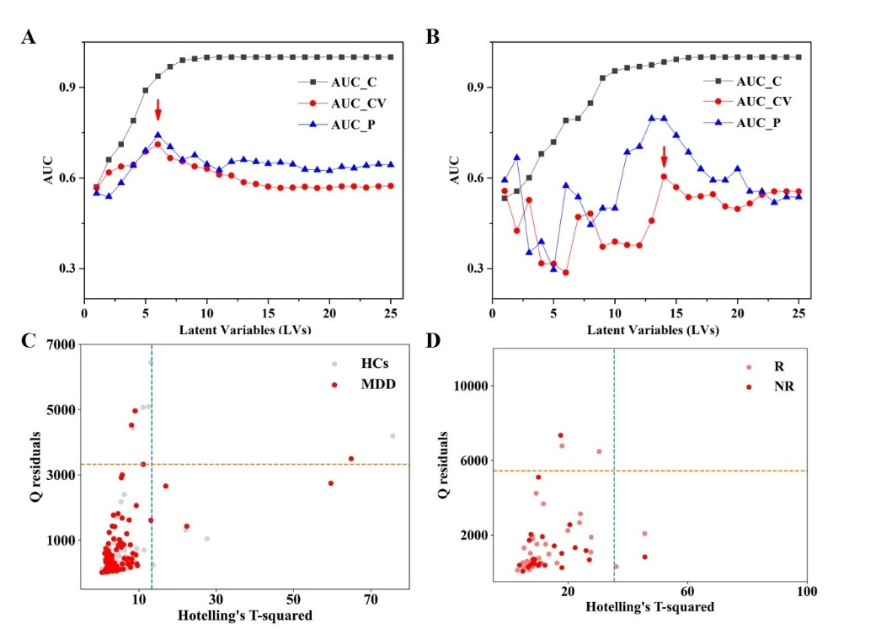
Figure S1. Relationships between evaluation metrics and the number of LVs in PLS-DA for (A) diagnostic and (B) treatment outcome prediction models; Q-residuals and Hotelling’s T² plots for the preliminarily optimized PLS-DA models in (C) diagnosis and (D) treatment outcome prediction (Dashed lines represent the 95% CIs).
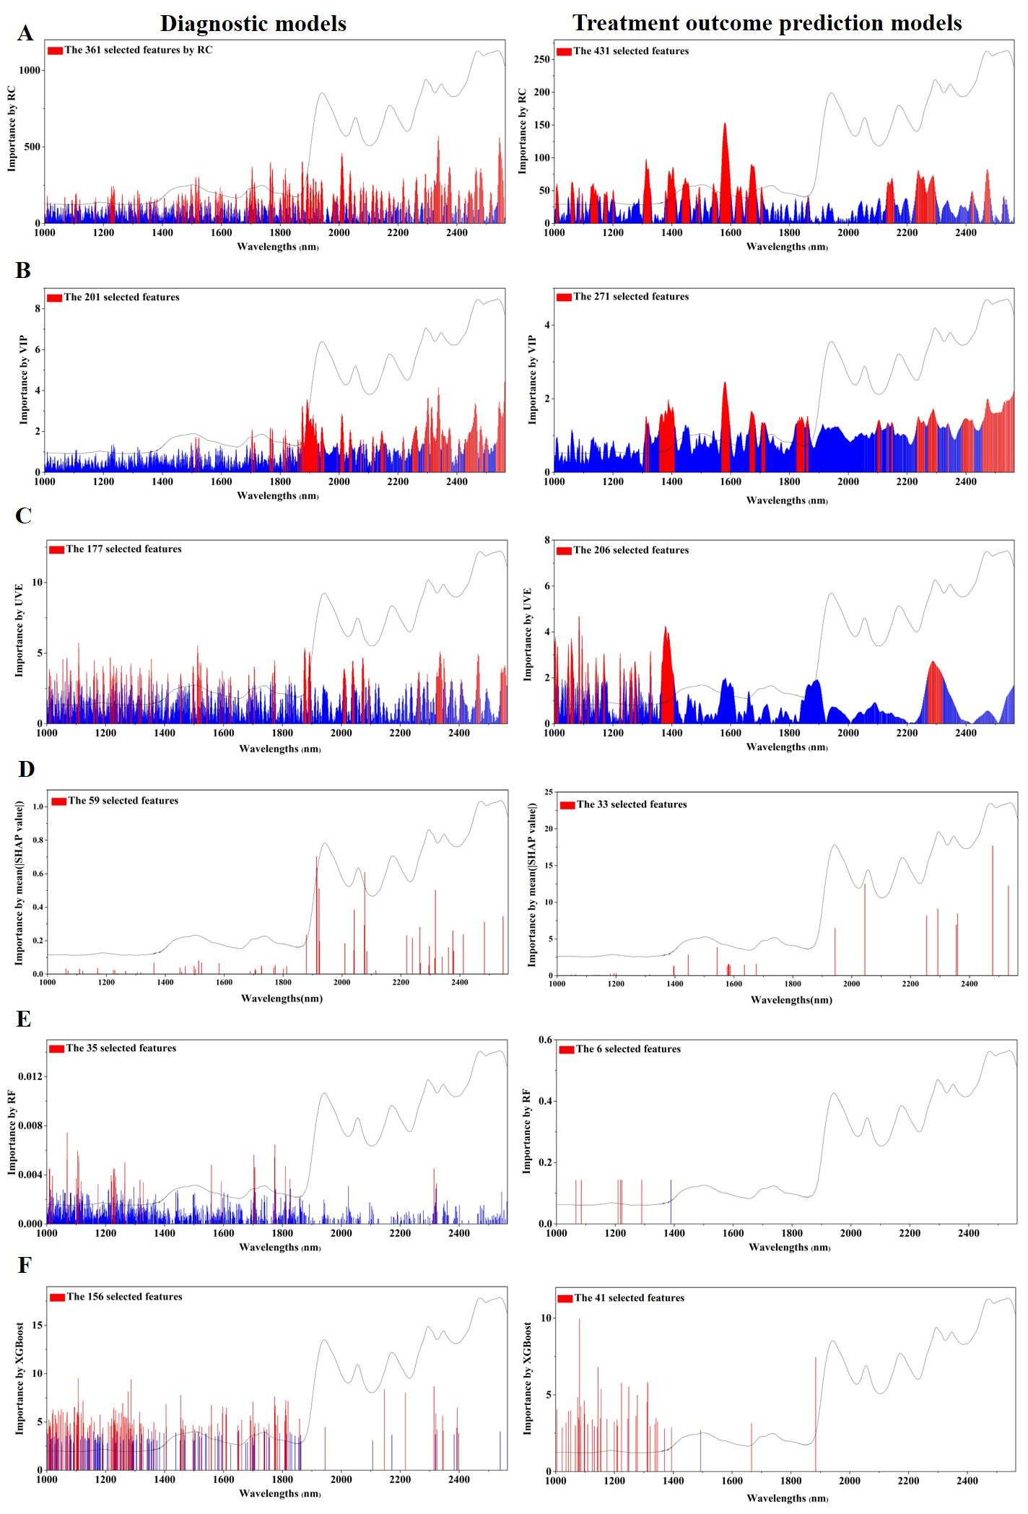
Figure S2. Feature importance and selected wavelength subsets obtained by (A) RC, (B) VIP, (C) UVE, (D) CARS-SHAP, (E) RF, and (F) XGBoost for both diagnostic and treatment outcome prediction models (a representative near-infrared spectrum of dried serum was plotted in each figure as reference).
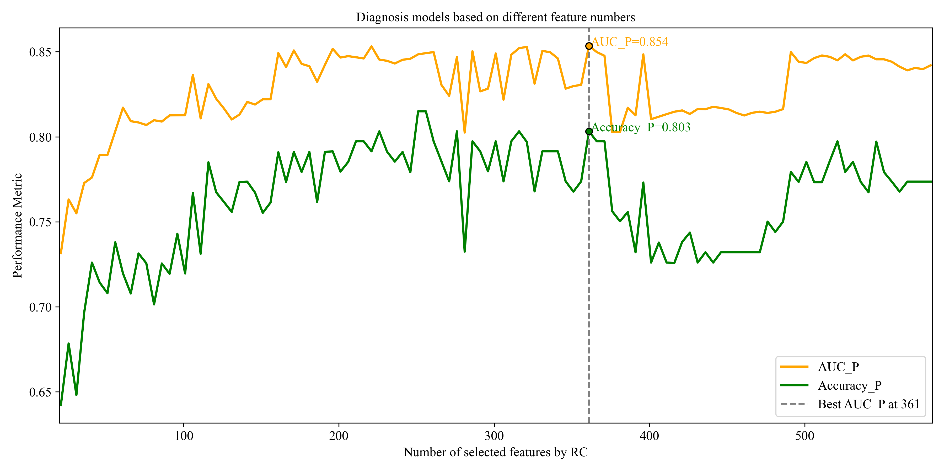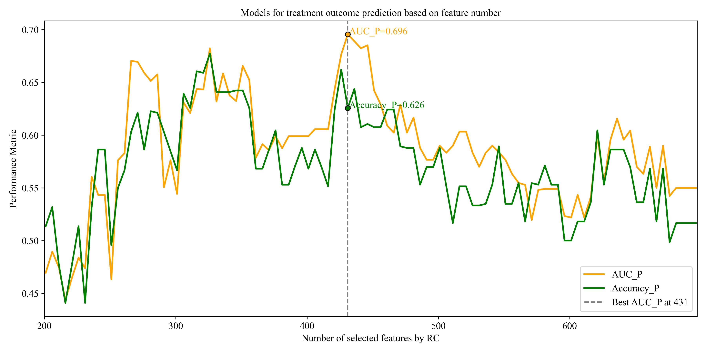
B
A
D
C

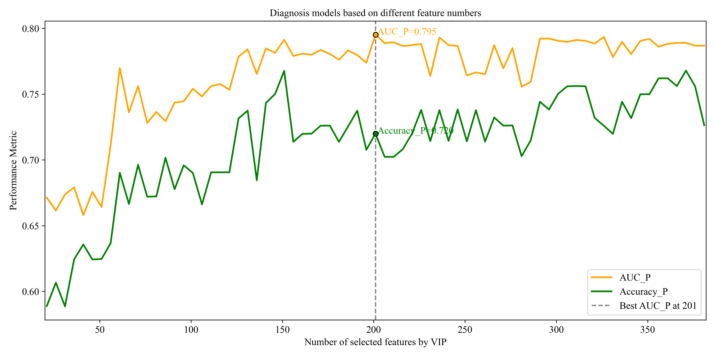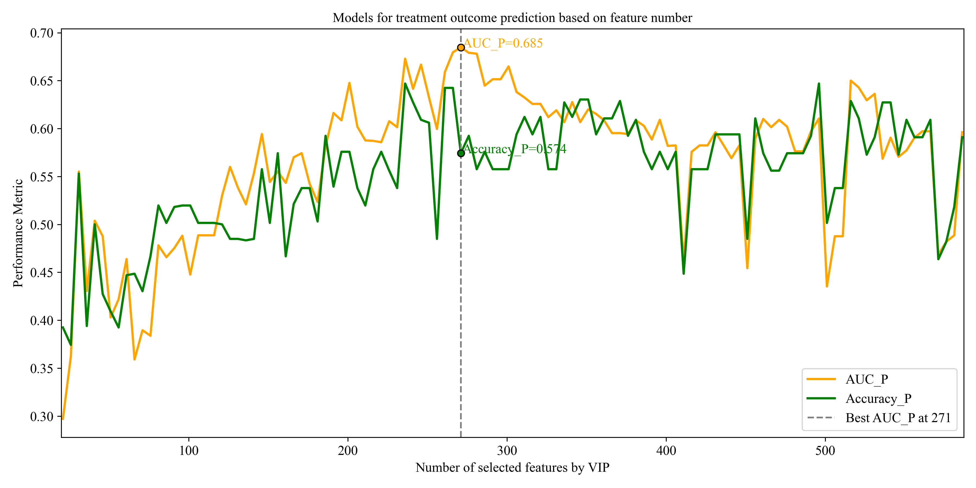
H
G
F
E
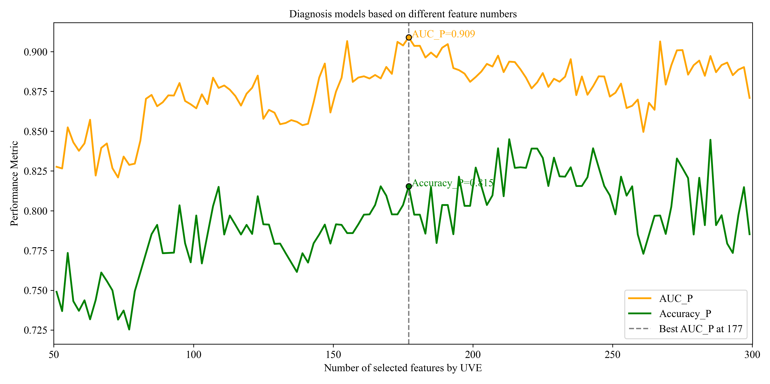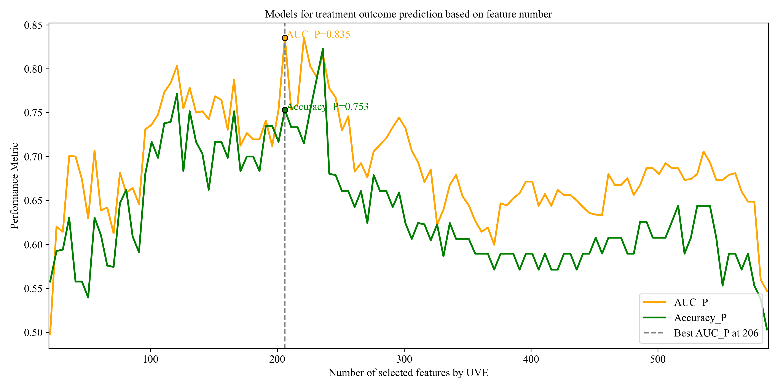
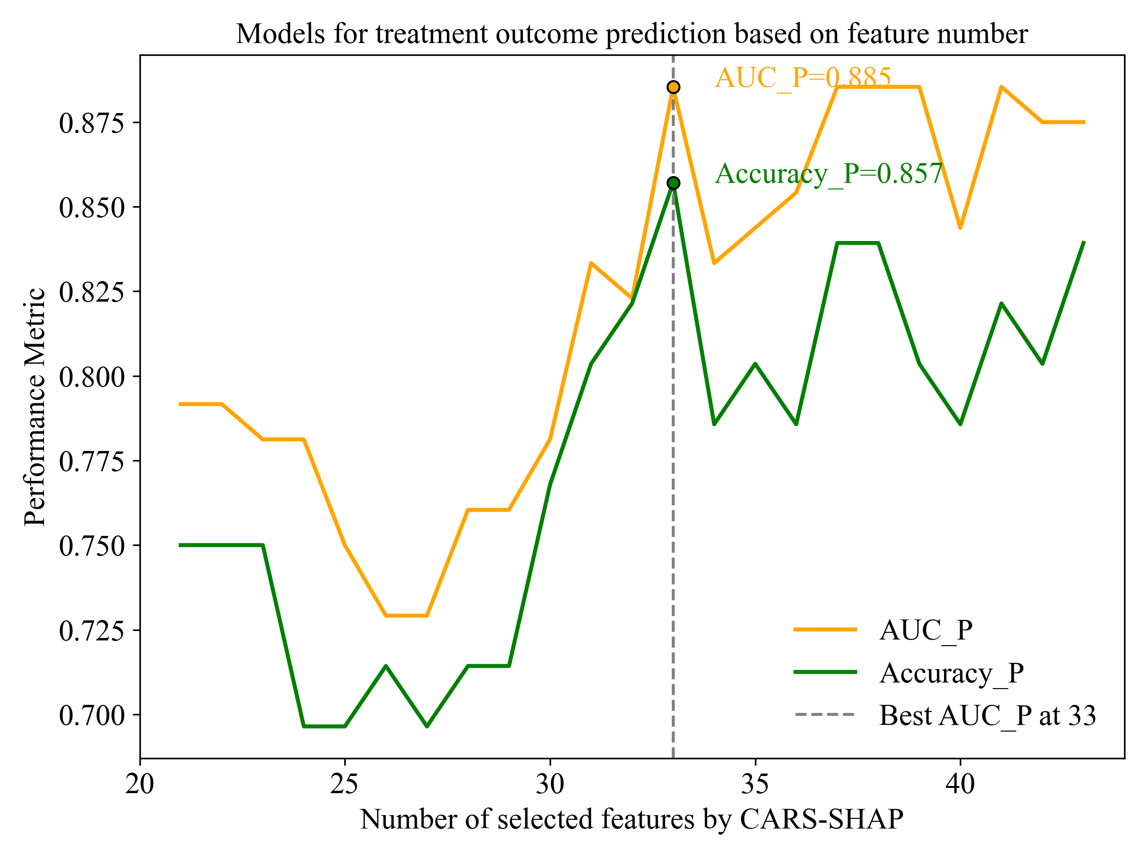
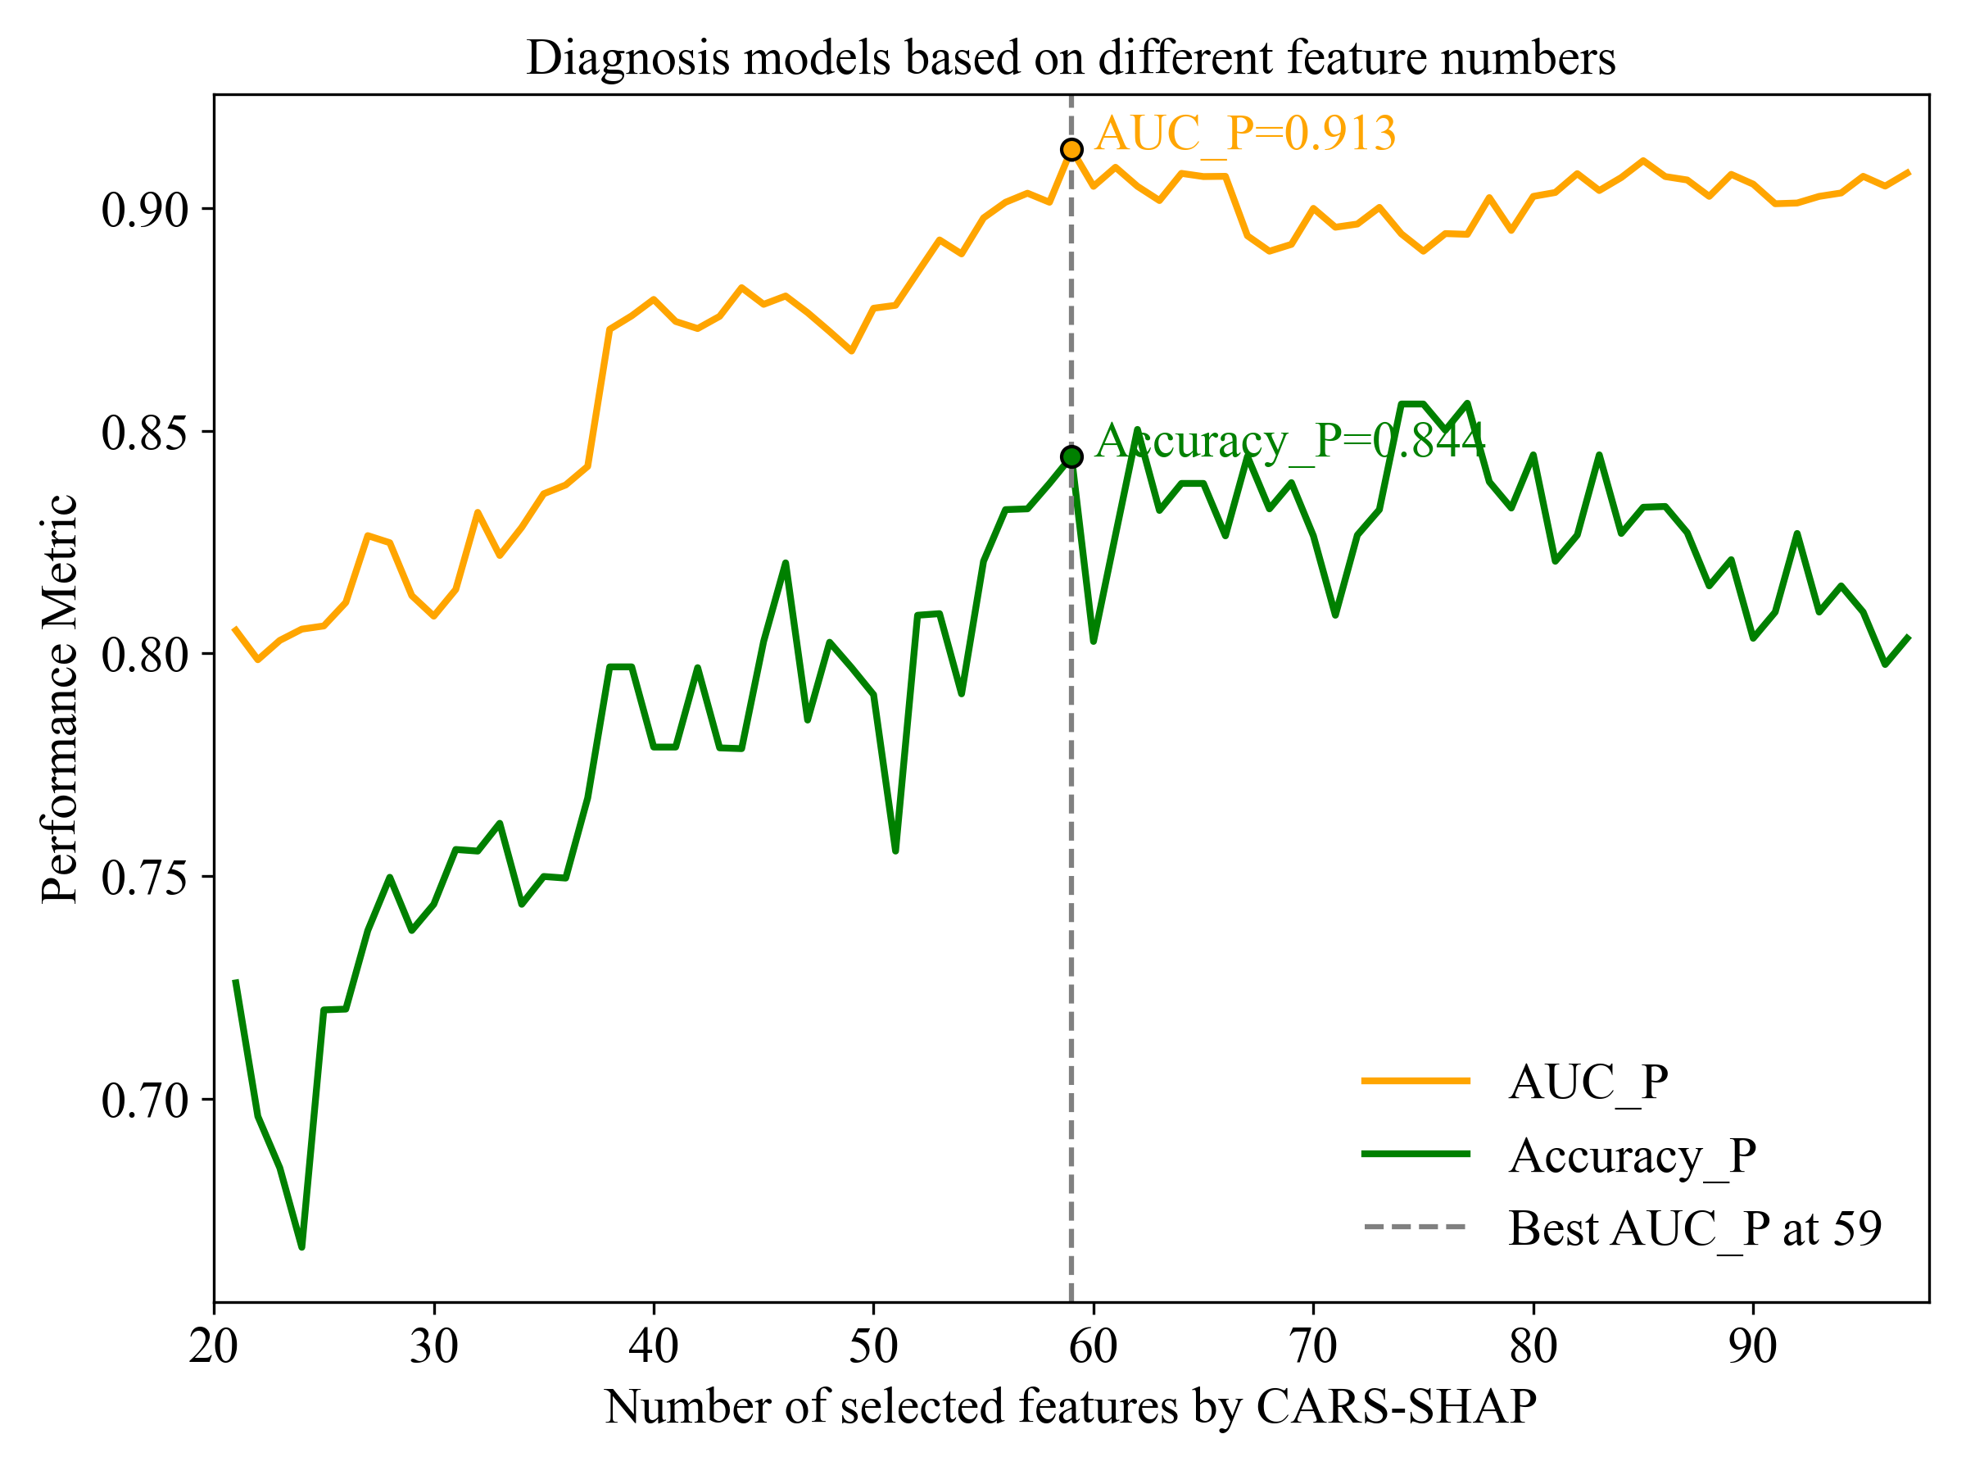
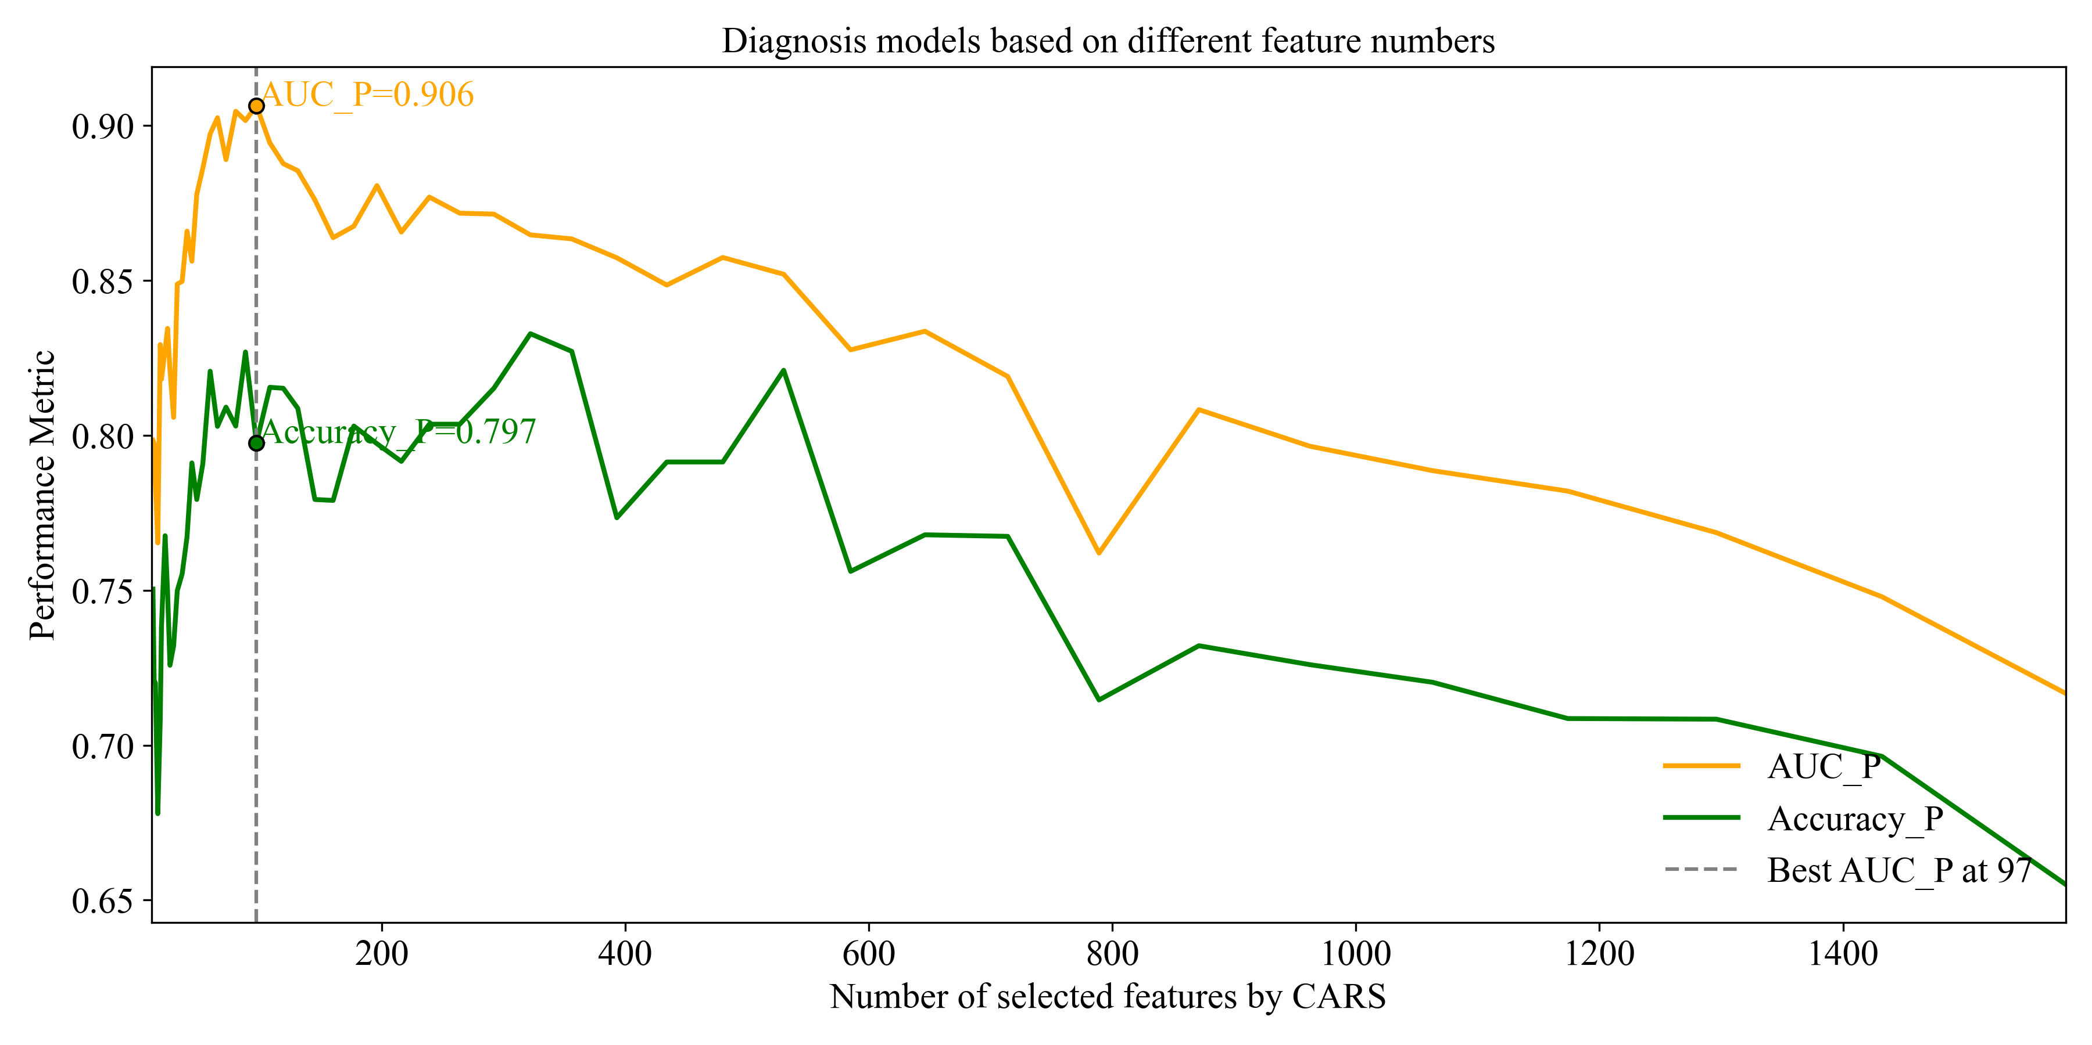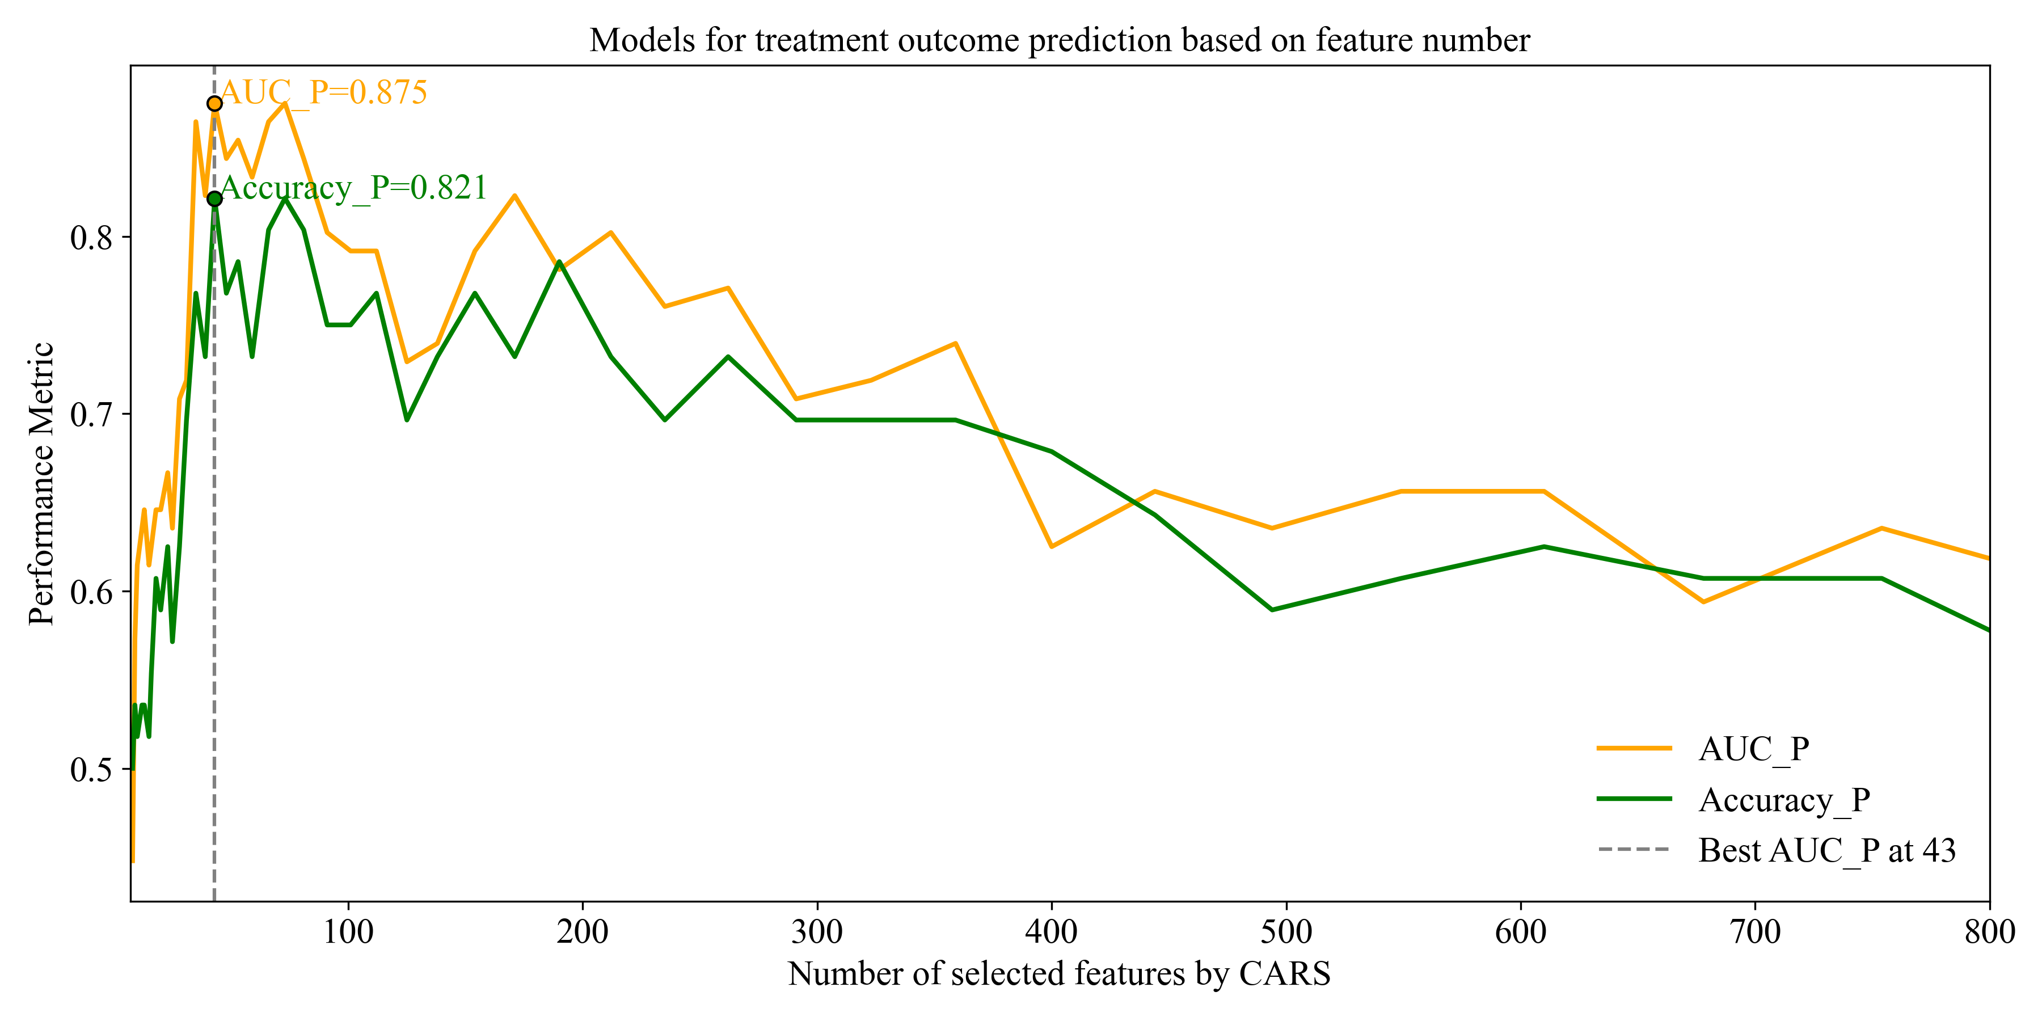
J
I
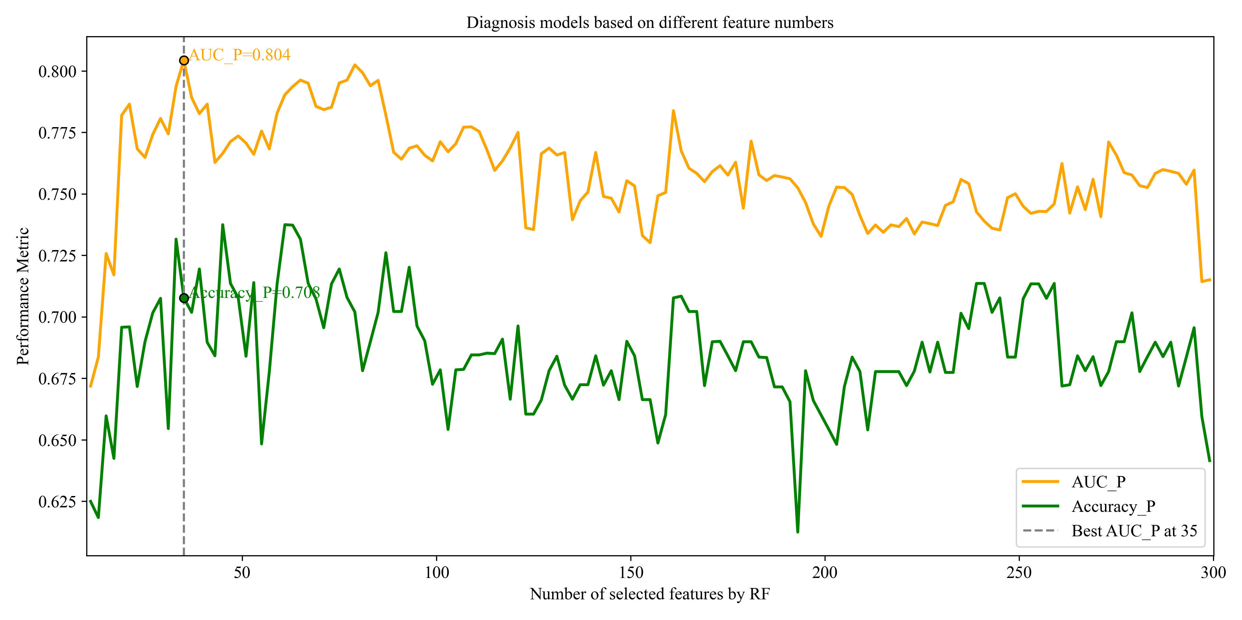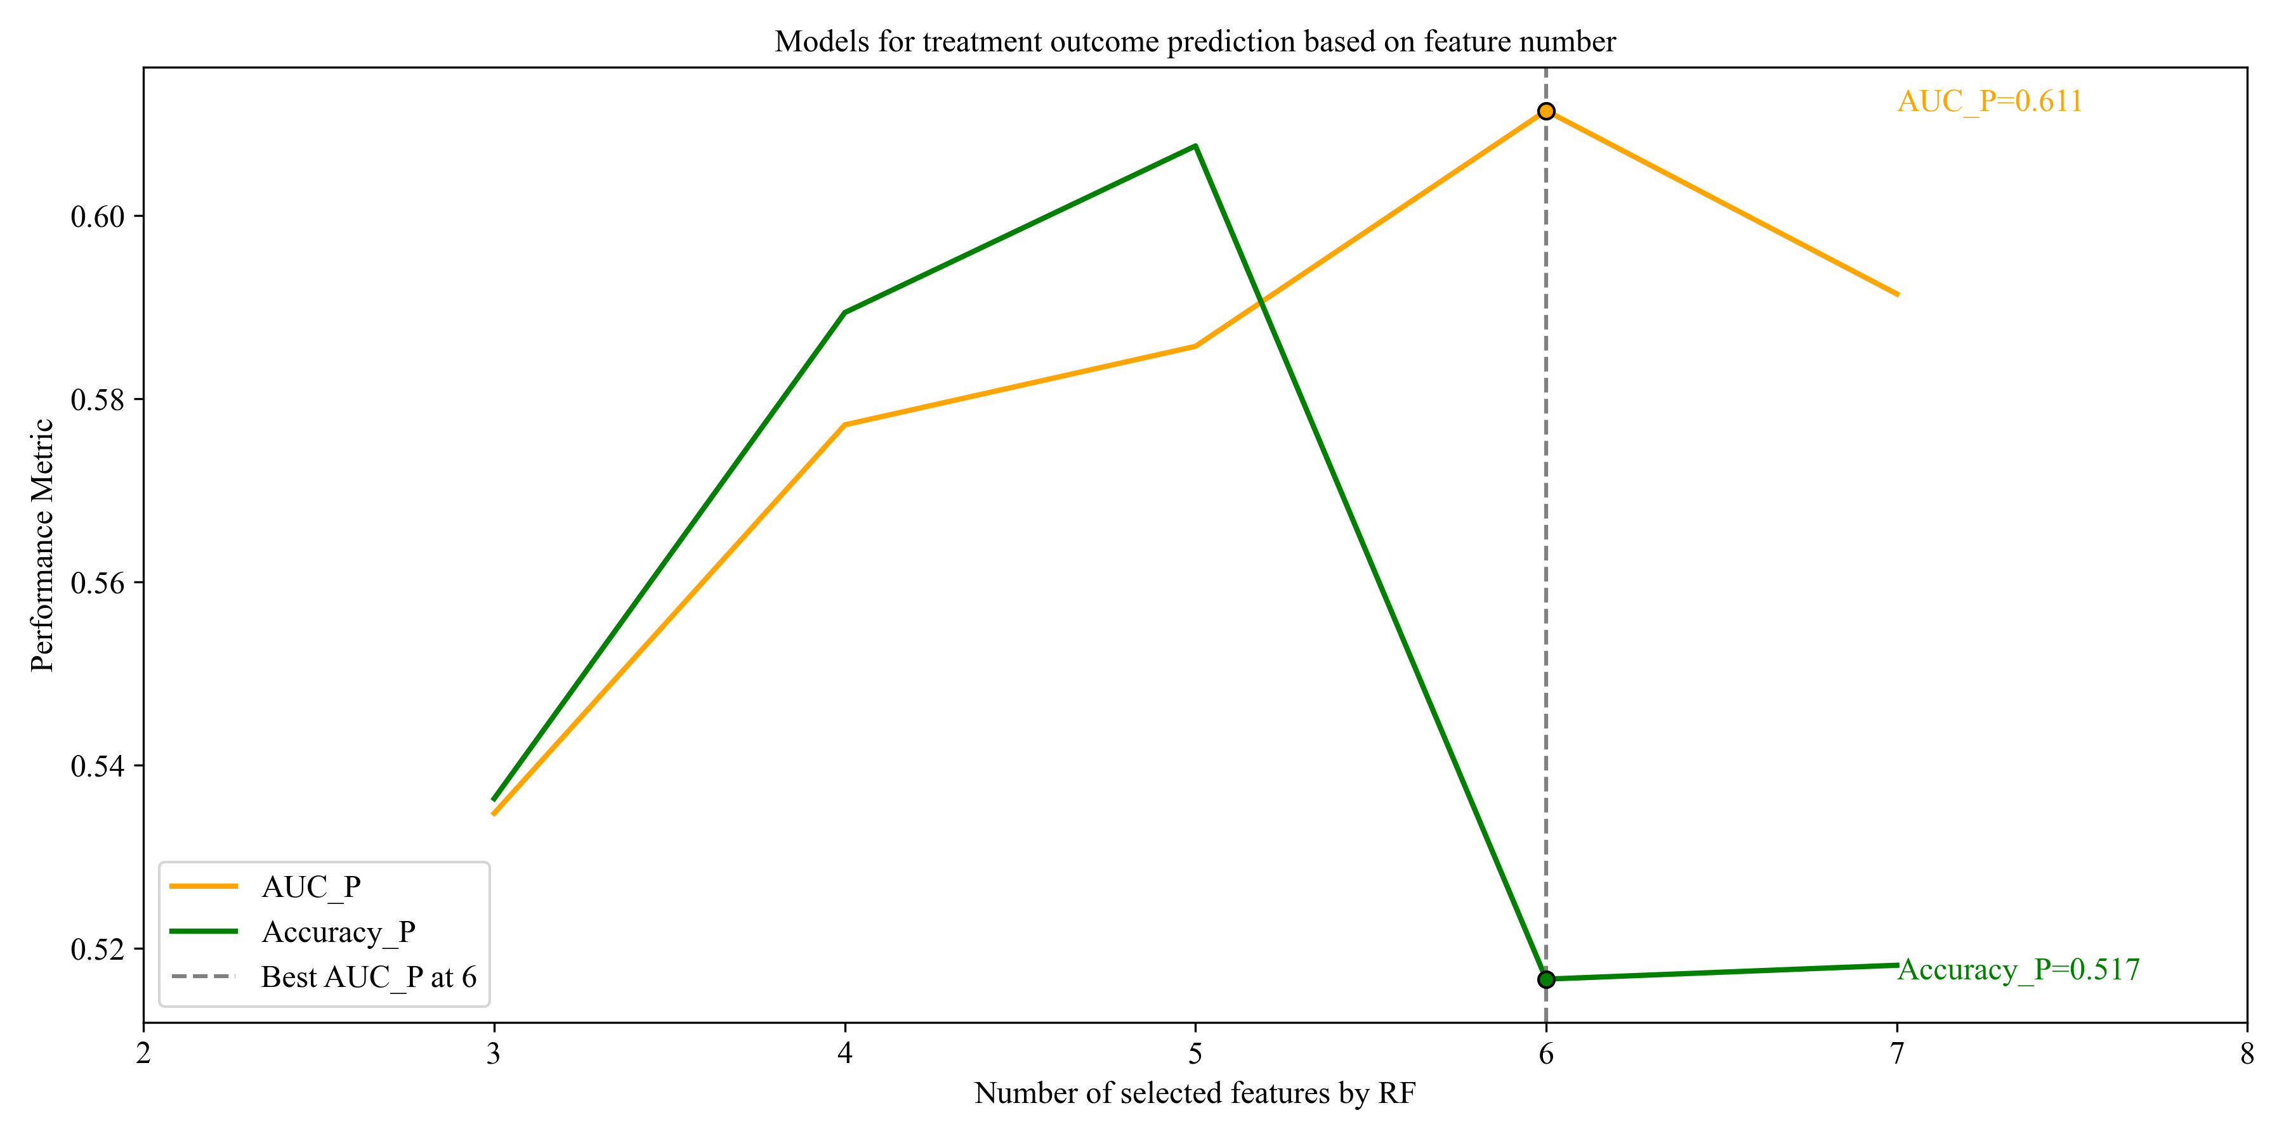
L
K

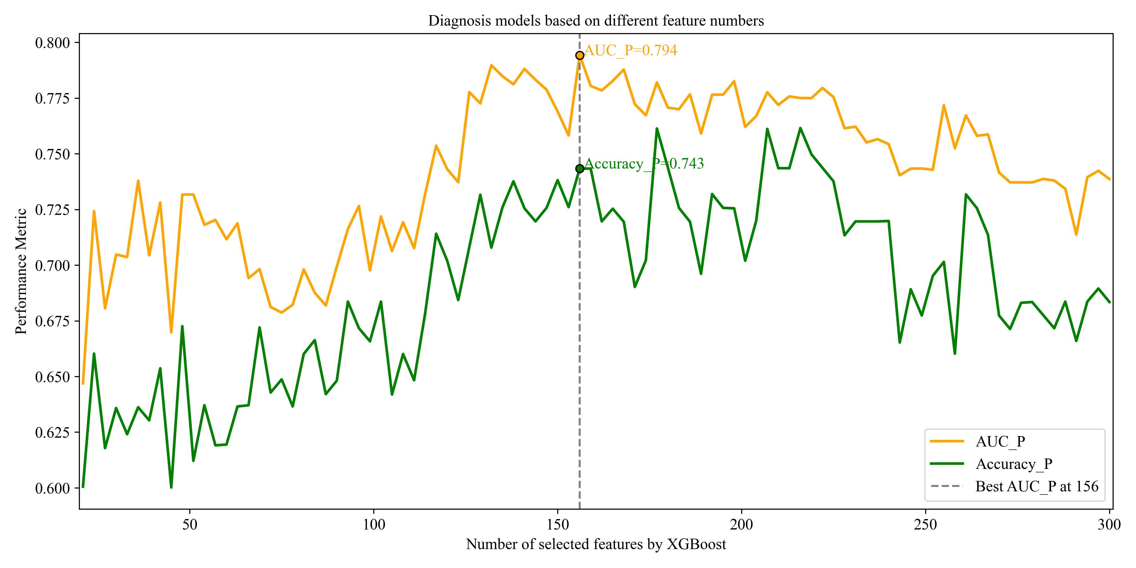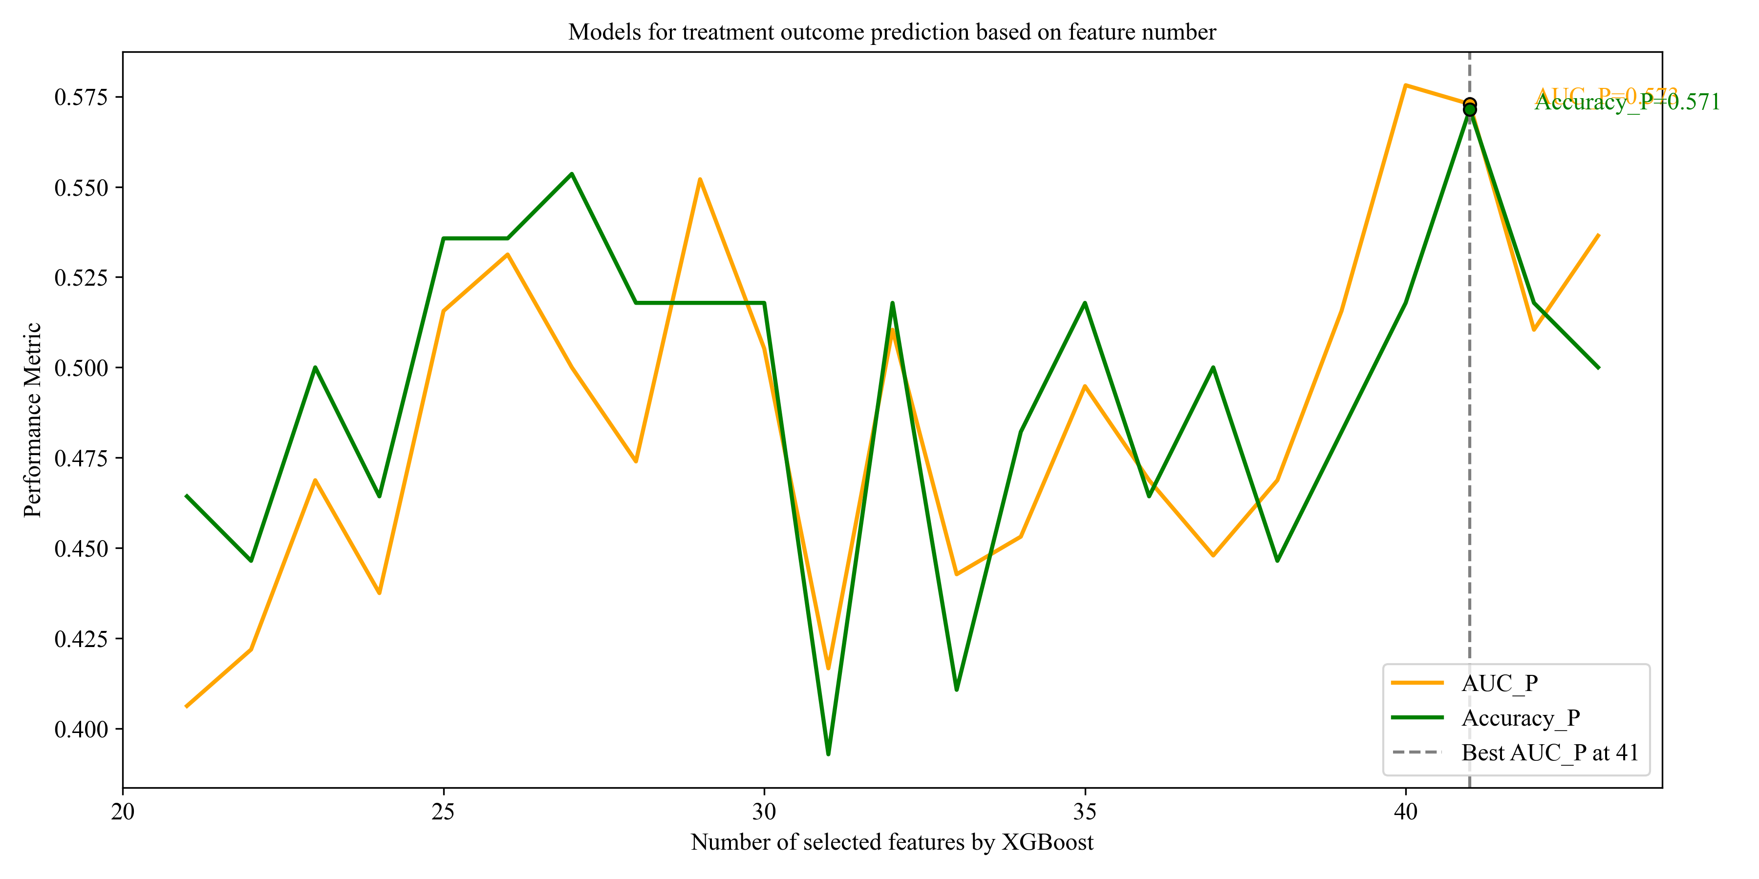
Figure S3. Performance of diagnostic models using different feature numbers by (A) RC, (C) VIP, (E) UVE, (G) CARS-SHAP, (I) RF, and (K) XGBoost; Performance of treatment outcome prediction models using different feature numbers by (B) RC, (D) VIP, (F) UVE, (H) CARS-SHAP, (J) RF, and (L) XGBoost.

B
A
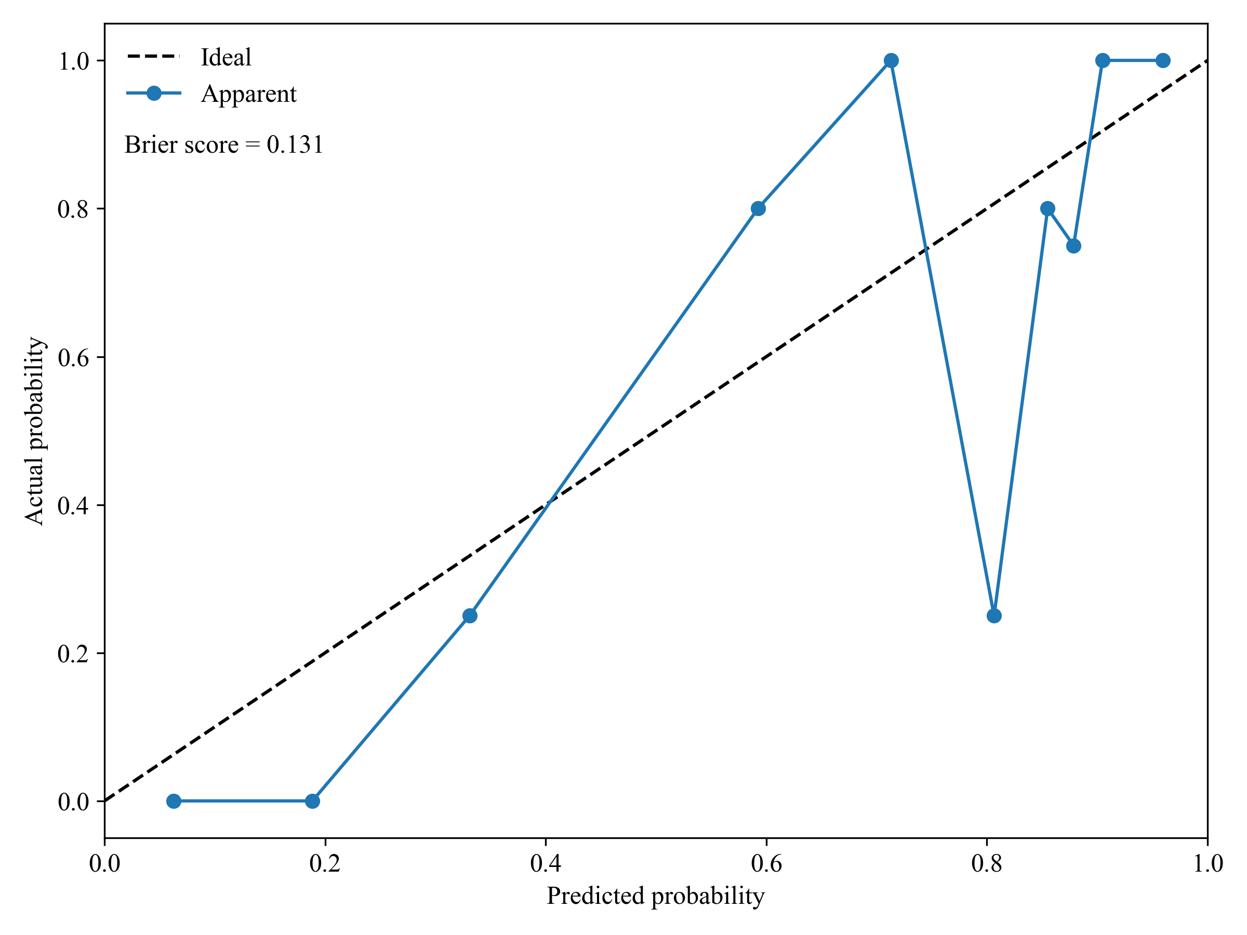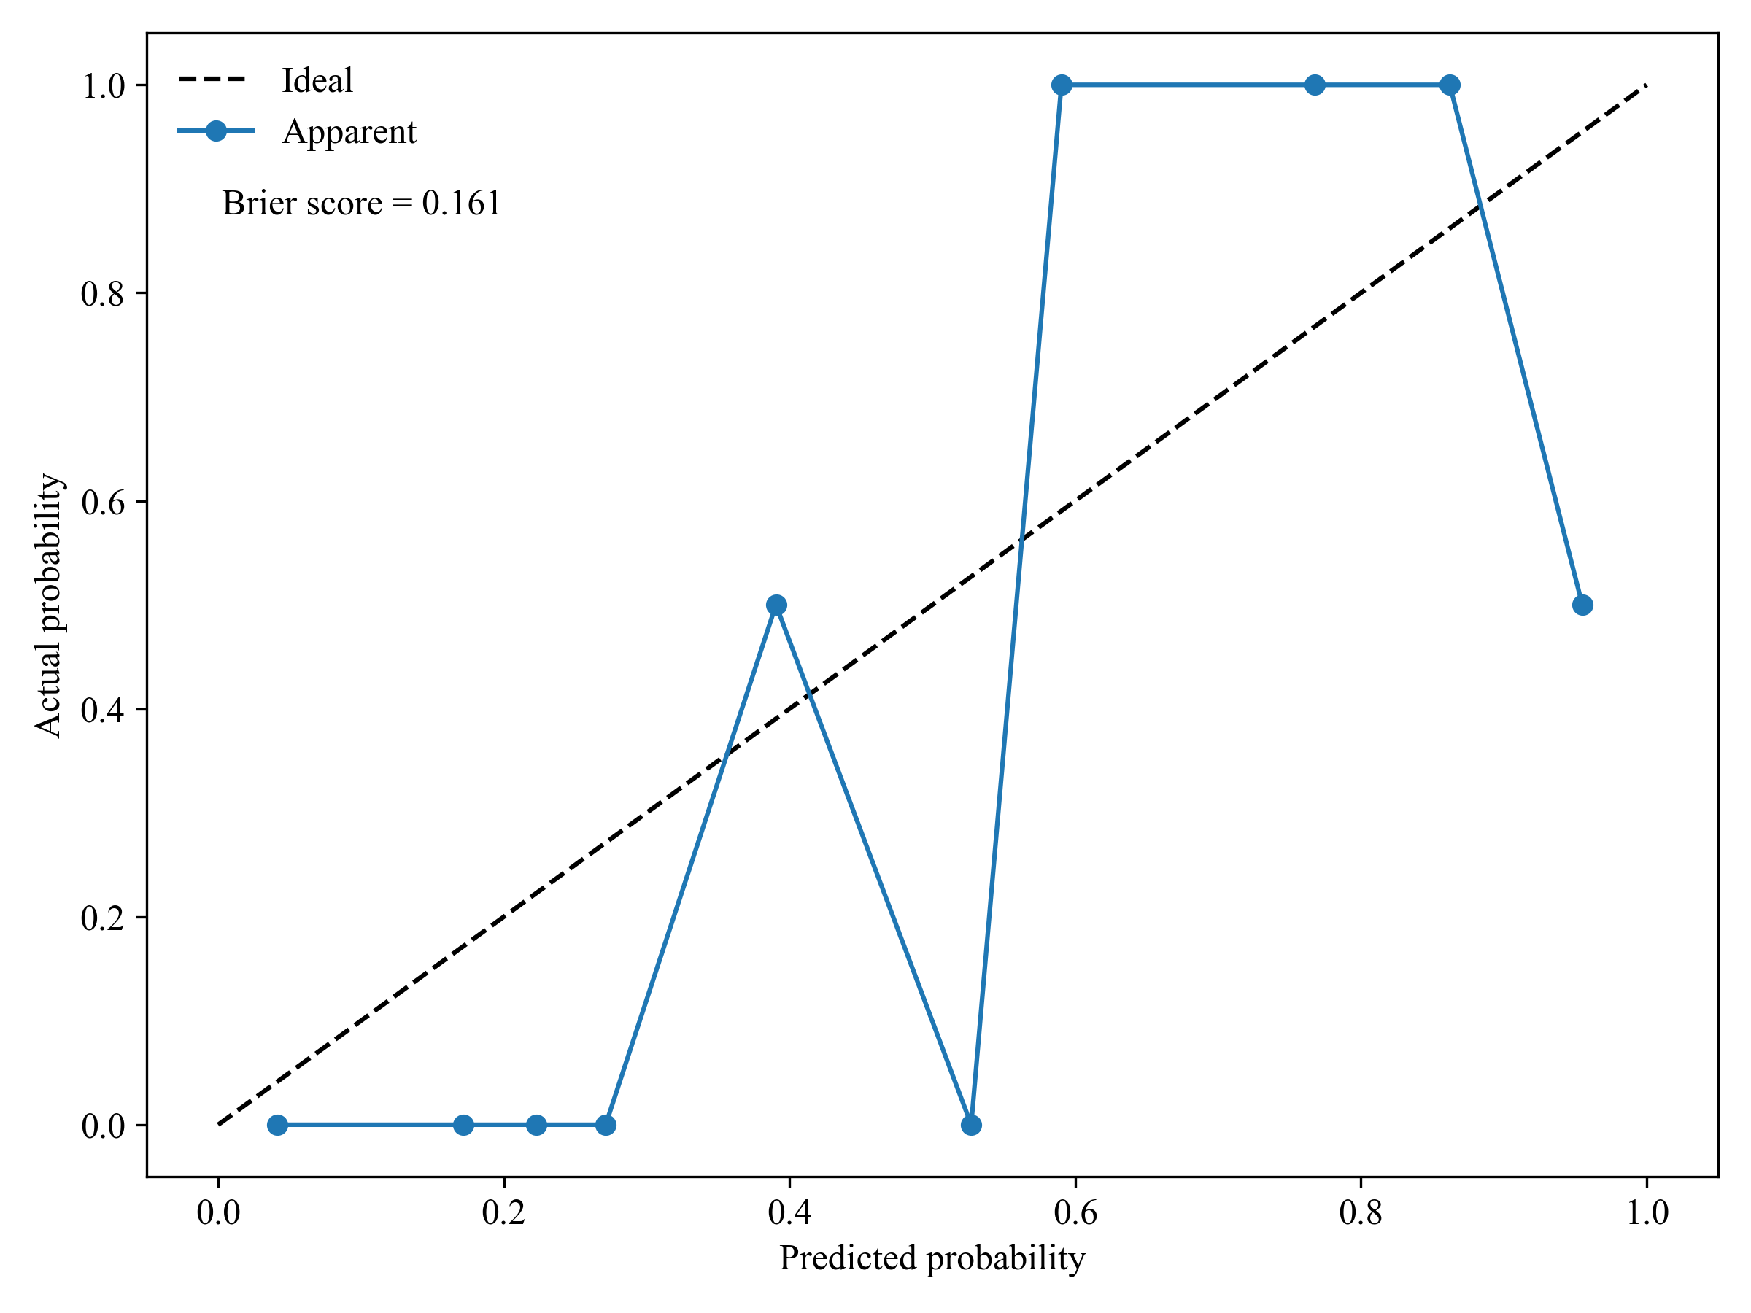
Figure S4. Calibration curves and Brier scores of the final (A) diagnostic and (B) treatment outcome prediction models on the test set.

3. Supplementary Tables

Table S1. Coefficients of variation (CVs, %)ª of baseline-corrected peak intensities at representative wavelengths across technical replicates.
Wavelengths (nm) | Sample 1 | Sample 2 | Sample 3 | Sample 4 | Sample 5
3941.8 | 8.37 | 9.02 | 1.91 | 9.00 | 0.60
4042.1 | 7.45 | 9.05 | 1.74 | 8.50 | 0.03
4261.9 | 5.57 | 9.13 | 0.21 | 8.15 | 1.25
4358.3 | 5.65 | 9.05 | 0.82 | 8.36 | 2.36
4605.2 | 5.26 | 8.23 | 0.73 | 8.25 | 2.78
4863.6 | 5.80 | 7.29 | 2.61 | 8.67 | 4.55
5149 | 9.96 | 5.28 | 10.94 | 12.7 | 9.26
5746.8 | 2.92 | 6.78 | 0.55 | 6.73 | 6.39
6691.8 | 7.21 | 3.53 | 4.82 | 9.60 | 12.67
Mean^{b} | 6.47 | 7.48 | 2.70 | 8.88 | 4.43
ªCVs were calculated from three independent technical replicates for each sample. Representative wavelengths were selected based on major absorption features in the NIR region.
^{b}The “Mean” row represents the average CV across all listed peak positions for each sample.

Table S2. Inter-spectral correlation coefficientsª of technical replicates.
 | Sample 1 | Sample 2 | Sample 3 | Sample 4 | Sample 5
Replicates compared | 3 | 3 | 3 | 3 | 3
Rep1 vs Rep2 | 0.999 | 0.999 | 0.996 | 0.996 | 0.999
Rep2 vs Rep3 | 0.999 | 1.0 | 1.0 | 1.0 | 0.995
Rep1 vs Rep3 | 0.999 | 0.999 | 0.998 | 0.997 | 0.997
Mean^{b} | 0.999 | 0.999 | 0.998 | 0.998 | 0.997
ªInter-spectral correlation coefficients were calculated using Pearson correlation between all pairwise combinations of three independent technical replicate spectra acquired from the same sample.
^{b}The “Mean” row represents the average correlation coefficient across the three replicate pairs for each sample.

Table S3. Detailed parameters of methods and models
Method | Key parametersª
PLS-DA | Implementation: sklearn.cross_decomposition.PLSRegression;  LVs (search range: 1–25): PLS-DA models on full wavelengths: 6 for the diagnostic models and 14 for the treatment outcome prediction models, Final PLS-DA models: Table S4 and S5;  scale= False;  Optimal threshold determined on the training set using Youden index and applied to the test set
RC | Absolute regression coefficients calculated using PLS-DA models on full wavelengths
VIP | Calculated using PLS-DA models on full wavelengths
UVE | Implementation: pynir.FeatureSelection.MCUVE;  Calculated using PLS-DA models on full wavelengths
CARS | Regression model in CARS: PLSRegression(LVs search range: 1–25);  Selection criterion: AUC; Monte Carlo sampling runs: 50;  Sampling ratio:0.8; Minimum retained variables: 5;  Variable reduction: Exponential decay function (EDF);  Variable sampling: Adaptive reweighted sampling (ARS)
RF | Diagnostic model: n_estimators=177, max_depth=11, random_state=100;  Treatment outcome prediction model: n_estimators=90, max_depth=7, random_state=100
XGBoost | Diagnostic model: n_estimators=344, learning_rate=0.017, max_depth=7, random_state=100;  Treatment outcome prediction model: n_estimators=363, learning_rate=0.267, max_depth=10, random_state=100
SHAP Interpretation | Explainer type: LinearExplainer;  Background dataset: training set
ªAll hyperparameters not explicitly specified were left at their default values in scikit-learn (version 1.5.1)

Table S4. Comprehensive performance metrics (mean ± 95% CI) of diagnostic models based on different wavelength selection strategies, estimated via nested cross-validation (NCV) and 1000× bootstrap resampling.
Method | Mean LVs | Mean cut-offª | Metric | Mean | 95% CI lower | 95% CI upper
None | 5.6 | 0.555 | AUC | 0.710 | 0.627 | 0.790
None | 5.6 | 0.555 | Accuracy | 0.685 | 0.613 | 0.750
None | 5.6 | 0.555 | Sensitivity | 0.769 | 0.684 | 0.849
None | 5.6 | 0.555 | Specificity | 0.561 | 0.441 | 0.681
None | 5.6 | 0.555 | Precision | 0.720 | 0.639 | 0.804
None | 5.6 | 0.555 | F1 | 0.743 | 0.677 | 0.804
None | 5.6 | 0.555 | MCC | 0.337 | 0.182 | 0.482
None | 5.6 | 0.555 | Kappa | 0.334 | 0.182 | 0.475
RC | 6.2 | 0.546 | AUC | 0.856 | 0.794 | 0.910
RC | 6.2 | 0.546 | Accuracy | 0.810 | 0.750 | 0.869
RC | 6.2 | 0.546 | Sensitivity | 0.810 | 0.728 | 0.881
RC | 6.2 | 0.546 | Specificity | 0.809 | 0.712 | 0.900
RC | 6.2 | 0.546 | Precision | 0.862 | 0.793 | 0.926
RC | 6.2 | 0.546 | F1 | 0.835 | 0.775 | 0.888
RC | 6.2 | 0.546 | MCC | 0.612 | 0.484 | 0.734
RC | 6.2 | 0.546 | Kappa | 0.609 | 0.482 | 0.732
VIP | 6 | 0.558 | AUC | 0.782 | 0.707 | 0.854
VIP | 6 | 0.558 | Accuracy | 0.738 | 0.667 | 0.804
VIP | 6 | 0.558 | Sensitivity | 0.769 | 0.680 | 0.849
VIP | 6 | 0.558 | Specificity | 0.694 | 0.588 | 0.809
VIP | 6 | 0.558 | Precision | 0.786 | 0.704 | 0.867
VIP | 6 | 0.558 | F1 | 0.777 | 0.706 | 0.836
VIP | 6 | 0.558 | MCC | 0.460 | 0.316 | 0.597
VIP | 6 | 0.558 | Kappa | 0.458 | 0.316 | 0.596
UVE | 11.2 | 0.511 | AUC | 0.902 | 0.856 | 0.944
UVE | 11.2 | 0.511 | Accuracy | 0.816 | 0.756 | 0.869
UVE | 11.2 | 0.511 | Sensitivity | 0.860 | 0.794 | 0.918
UVE | 11.2 | 0.511 | Specificity | 0.752 | 0.647 | 0.857
UVE | 11.2 | 0.511 | Precision | 0.836 | 0.767 | 0.908
UVE | 11.2 | 0.511 | F1 | 0.847 | 0.792 | 0.895
UVE | 11.2 | 0.511 | MCC | 0.616 | 0.495 | 0.733
UVE | 11.2 | 0.511 | Kappa | 0.614 | 0.493 | 0.733
CARS-SHAP | 8.6 | 0.524 | AUC | 0.908 | 0.858 | 0.948
CARS-SHAP | 8.6 | 0.524 | Accuracy | 0.852 | 0.792 | 0.899
CARS-SHAP | 8.6 | 0.524 | Sensitivity | 0.869 | 0.800 | 0.934
CARS-SHAP | 8.6 | 0.524 | Specificity | 0.827 | 0.732 | 0.914
CARS-SHAP | 8.6 | 0.524 | Precision | 0.880 | 0.813 | 0.942
CARS-SHAP | 8.6 | 0.524 | F1 | 0.874 | 0.819 | 0.920
CARS-SHAP | 8.6 | 0.524 | MCC | 0.694 | 0.574 | 0.799
CARS-SHAP | 8.6 | 0.524 | Kappa | 0.692 | 0.574 | 0.796
RF | 3.6 | 0.607 | AUC | 0.798 | 0.731 | 0.861
RF | 3.6 | 0.607 | Accuracy | 0.708 | 0.637 | 0.780
RF | 3.6 | 0.607 | Sensitivity | 0.660 | 0.567 | 0.758
RF | 3.6 | 0.607 | Specificity | 0.779 | 0.672 | 0.869
RF | 3.6 | 0.607 | Precision | 0.815 | 0.723 | 0.896
RF | 3.6 | 0.607 | F1 | 0.728 | 0.655 | 0.802
RF | 3.6 | 0.607 | MCC | 0.432 | 0.293 | 0.563
RF | 3.6 | 0.607 | Kappa | 0.419 | 0.284 | 0.556
XGBoost | 5.2 | 0.478 | AUC | 0.794 | 0.720 | 0.860
XGBoost | 5.2 | 0.478 | Accuracy | 0.744 | 0.673 | 0.810
XGBoost | 5.2 | 0.478 | Sensitivity | 0.799 | 0.720 | 0.880
XGBoost | 5.2 | 0.478 | Specificity | 0.664 | 0.556 | 0.772
XGBoost | 5.2 | 0.478 | Precision | 0.778 | 0.703 | 0.852
XGBoost | 5.2 | 0.478 | F1 | 0.787 | 0.722 | 0.842
XGBoost | 5.2 | 0.478 | MCC | 0.467 | 0.330 | 0.593
XGBoost | 5.2 | 0.478 | Kappa | 0.465 | 0.329 | 0.592
ª The optimal classification cut-off was determined by performing a Youden index analysis on the ROC generated on inner loop of NCV.

Table S5. Comprehensive performance metrics (mean ± 95% CI) of models for treatment outcome prediction based on different wavelength selection strategies, estimated via nested cross-validation (NCV) and 1000× bootstrap resampling.
Method | Mean LVs | Mean cut-offª | Metric | Mean | 95%CIlower | 95%CIupper
None | 16.2 | 0.316 | AUC | 0.553 | 0.424 | 0.686
None | 16.2 | 0.316 | Accuracy | 0.563 | 0.451 | 0.662
None | 16.2 | 0.316 | Sensitivity | 0.634 | 0.462 | 0.800
None | 16.2 | 0.316 | Specificity | 0.511 | 0.368 | 0.667
None | 16.2 | 0.316 | Precision | 0.487 | 0.325 | 0.641
None | 16.2 | 0.316 | F1 | 0.547 | 0.392 | 0.676
None | 16.2 | 0.316 | MCC | 0.144 | -0.073 | 0.354
None | 16.2 | 0.316 | Kappa | 0.138 | -0.072 | 0.339
RC | 10.8 | 0.492 | AUC | 0.718 | 0.577 | 0.847
RC | 10.8 | 0.492 | Accuracy | 0.625 | 0.500 | 0.750
RC | 10.8 | 0.492 | Sensitivity | 0.539 | 0.333 | 0.741
RC | 10.8 | 0.492 | Specificity | 0.690 | 0.529 | 0.844
RC | 10.8 | 0.492 | Precision | 0.565 | 0.364 | 0.762
RC | 10.8 | 0.492 | F1 | 0.546 | 0.364 | 0.717
RC | 10.8 | 0.492 | MCC | 0.230 | -0.016 | 0.492
RC | 10.8 | 0.492 | Kappa | 0.227 | -0.016 | 0.489
VIP | 12.8 | 0.510 | AUC | 0.669 | 0.521 | 0.814
VIP | 12.8 | 0.510 | Accuracy | 0.643 | 0.518 | 0.768
VIP | 12.8 | 0.510 | Sensitivity | 0.661 | 0.458 | 0.850
VIP | 12.8 | 0.510 | Specificity | 0.629 | 0.455 | 0.788
VIP | 12.8 | 0.510 | Precision | 0.572 | 0.375 | 0.759
VIP | 12.8 | 0.510 | F1 | 0.609 | 0.444 | 0.764
VIP | 12.8 | 0.510 | MCC | 0.288 | 0.013 | 0.545
VIP | 12.8 | 0.510 | Kappa | 0.282 | 0.013 | 0.536
UVE | 17.6 | 0.674 | AUC | 0.848 | 0.735 | 0.945
UVE | 17.6 | 0.674 | Accuracy | 0.750 | 0.625 | 0.857
UVE | 17.6 | 0.674 | Sensitivity | 0.538 | 0.333 | 0.741
UVE | 17.6 | 0.674 | Specificity | 0.909 | 0.794 | 1.000
UVE | 17.6 | 0.674 | Precision | 0.816 | 0.600 | 1.000
UVE | 17.6 | 0.674 | F1 | 0.643 | 0.444 | 0.807
UVE | 17.6 | 0.674 | MCC | 0.490 | 0.247 | 0.712
UVE | 17.6 | 0.674 | Kappa | 0.463 | 0.224 | 0.696
CRAS-SHAP | 12 | 0.551 | AUC | 0.896 | 0.805 | 0.967
CRAS-SHAP | 12 | 0.551 | Accuracy | 0.839 | 0.750 | 0.929
CRAS-SHAP | 12 | 0.551 | Sensitivity | 0.832 | 0.667 | 0.962
CRAS-SHAP | 12 | 0.551 | Specificity | 0.843 | 0.710 | 0.968
CRAS-SHAP | 12 | 0.551 | Precision | 0.800 | 0.632 | 0.955
CRAS-SHAP | 12 | 0.551 | F1 | 0.813 | 0.682 | 0.923
CRAS-SHAP | 12 | 0.551 | MCC | 0.673 | 0.467 | 0.859
CRAS-SHAP | 12 | 0.551 | Kappa | 0.668 | 0.464 | 0.857
RF | 2 | 0.426 | AUC | 0.584 | 0.415 | 0.746
RF | 2 | 0.426 | Accuracy | 0.571 | 0.446 | 0.714
RF | 2 | 0.426 | Sensitivity | 0.705 | 0.520 | 0.889
RF | 2 | 0.426 | Specificity | 0.470 | 0.300 | 0.636
RF | 2 | 0.426 | Precision | 0.499 | 0.333 | 0.667
RF | 2 | 0.426 | F1 | 0.580 | 0.415 | 0.725
RF | 2 | 0.426 | MCC | 0.178 | -0.062 | 0.444
RF | 2 | 0.426 | Kappa | 0.165 | -0.059 | 0.431
XGBoost | 7 | 0.438 | AUC | 0.548 | 0.399 | 0.694
XGBoost | 7 | 0.438 | Accuracy | 0.481 | 0.357 | 0.607
XGBoost | 7 | 0.438 | Sensitivity | 0.537 | 0.333 | 0.739
XGBoost | 7 | 0.438 | Specificity | 0.438 | 0.265 | 0.630
XGBoost | 7 | 0.438 | Precision | 0.419 | 0.250 | 0.588
XGBoost | 7 | 0.438 | F1 | 0.466 | 0.292 | 0.616
XGBoost | 7 | 0.438 | MCC | -0.025 | -0.279 | 0.217
XGBoost | 7 | 0.438 | Kappa | -0.023 | -0.260 | 0.214
ª The optimal classification cut-off was determined by performing a Youden index analysis on the ROC generated on inner loop of NCV.

Table S6. Assignment of the top 28 wavelengths for the diagnostic model and the top 17 wavelengths for the treatment outcome prediction model (in the order of SHAP values)
Diagnostic model |  |  |  | Treatment outcome prediction model
Wavelengths (nm) | Assignments | Most relevant components | Region | Wavelengths  (nm) | Assignments | Most relevant components | Region
1922 | C=O and C=ONH from amides | Proteins | Ⅴ | 2359.2 | C-H from polysaccharides/C-H aryl | Carbohydrates/proteins | Ⅵ
2077.5 | N-H bonds | Proteins | Ⅴ | 1583.8 | O-H from alcohols as R-C-O-H | Carbohydrates | Ⅲ
2075.8 | N-H bonds | Proteins | Ⅴ | 2478.7 | C-H from aliphatic hydrocarbons/C-N-C from proteins | Lipids/proteins | Ⅵ
2483.5 | C-H from aromatic hydrocarbons | Proteins | Ⅵ | 2532 | C-N-C from amide/C-H aryl | Proteins | Ⅵ
2219.8 | C=O/C-N/N-H from polyamide | Proteins | Ⅴ | 2044.7 | N-H bonds | Proteins | Ⅴ
1913.5 | P-OH/O-H from phosphate | Phospholipids/ nucleic acids | Ⅴ | 2292.4 | C-H from polysaccharides/C-H aryl | Carbohydrates/proteins | Ⅴ
2041.5 | N-H bonds | Proteins | Ⅴ | 1587.7 | O-H from alcohols | Carbohydrates | Ⅲ
2317 | C-H from lipids | Lipids | Ⅵ | 2254.6 | O-H bonds | Carbohydrates | Ⅴ
2546.9 | C-H aryl | Proteins | Ⅵ | 1581.9 | O-H from alcohols as R-C-O-H | Carbohydrates | Ⅲ
1914.9 | P-OH/O-H from phosphate | Phospholipids/nucleic acids | Ⅴ | 1577.1 | N-H from amide/protein | Proteins | Ⅲ
1923.4 | C=O and C=ONH from amides | Proteins | Ⅴ | 1943.6 | O-H from alcohols | Carbohydrates | Ⅴ
2314.9 | C-H from lipids | Lipids | Ⅵ | 1543.3 | N-H from polyamide | Proteins | Ⅲ
2411.8 | C-H aryl | Proteins | Ⅵ | 2354.9 | C-H from polysaccharides/C-H aryl | Carbohydrates/proteins | Ⅵ
2239 | O-H/C-O combination | Carbohydrates | Ⅴ | 1396.9 | C-H from aliphatic hydrocarbon, combination | Lipids | Ⅱ
2039.9 | N-H bonds | Proteins | Ⅴ | 1445.2 | C-H from aliphatic hydrocarbons, combination | Lipids | Ⅲ
2264.4 | O-H/C-O combination | Carbohydrates | Ⅴ | 1635.8 | C-H from aliphatic hydrocarbons | Lipids | Ⅳ
2361.3 | C-H from polysaccharides | Carbohydrates | Ⅵ | 1192.6 | C-H methyl from aliphatic hydrocarbons | Lipids | Ⅰ
2294.5 | C-H aryl | Proteins | Ⅴ
1878.8 | O-H from alcohols | Carbohydrates | Ⅴ
2296.5 | C-H aryl | Proteins | Ⅴ
2376.5 | C-H from aliphatic hydrocarbons | Lipids | Ⅵ
2340 | C-H from polysaccharides | Carbohydrates | Ⅵ
2009.9 | N-H bonds | Proteins | Ⅴ
2378.7 | C-H from aliphatic hydrocarbons | Lipids | Ⅵ
1773.4 | C-H from aromatic hydrocarbons | Proteins | Ⅳ
2114.8 | C=O-O from polysaccharides | Carbohydrates | Ⅴ
1768.6 | C-H from aliphatic hydrocarbons | Lipids | Ⅳ
2084.2 | N-H/C-N bonds | Proteins | Ⅴ

References
1. Yang J, Zhou J, Zhou J, Wang H, Sun Z, Zhu X, et al. Serum amyloid P component level is associated with clinical response to escitalopram treatment in patients with major depressive disorder. J Psychiatr Res 2022; 146: 172-8.
2. Tripathi A, Avasthi A, Desousa A, Bhagabati D, Shah N, Kallivayalil RA, et al. Prescription pattern of antidepressants in five tertiary care psychiatric centres of India. Indian J Med Res 2016; 143(4): 507-13.
3. Chon MW, Lee J, Chung S, Kim Y, Kim HW. Prescription Pattern of Antidepressants for Children and Adolescents in Korea Based on Nationwide Data. J Korean Med Sci 2017; 32(10): 1694-701.
4. Cipriani AF, Toshi A; Salanti, Georgia; Chaimani, Anna; Atkinson, Lauren Z; Ogawa, Yusuke; Leucht, Stefan; Ruhe, Henricus G; Turner, Erick H; Higgins, Julian P T; Egger, Matthias; Takeshima, Nozomi; Hayasaka, Yu; Imai, Hissei; Shinohara, Kiyomi; Tajika, Aran; Ioannidis, John P A; Geddes, John R. Comparative efficacy and acceptability of 21 antidepressant drugs for the acute treatment of adults with major depressive disorder: a systematic review and network meta-analysis. Lancet 2018; 16(4): 420-9.
5. Kennedy SH, Lam RW, McIntyre RS, Tourjman SV, Bhat V, Blier P, et al. Canadian Network for Mood and Anxiety Treatments (CANMAT) 2016 Clinical Guidelines for the Management of Adults with Major Depressive Disorder: Section 3. Pharmacological Treatments. Can J Psychiatry 2016; 61(9): 540-60.
6. Lapcharoensuk R, Fhaykamta C, Anurak W, Chadwut W, Sitorus A. Nondestructive Detection of Pesticide Residue (Chlorpyrifos) on Bok Choi (Brassica rapa subsp. Chinensis) Using a Portable NIR Spectrometer Coupled with a Machine Learning Approach. Foods 2023; 12(5): 955.
7. Crase S, Hall B, Thennadil S. Cluster analysis for IR and NIR spectroscopy: Current practices to future perspectives. Comput, Mater & Continua 2021; 69(2): 1945-65.
8. Ballabio D, Consonni V. Classification tools in chemistry. Part 1: linear models. PLS-DA. Anal Methods 2013; 5(16): 3790-8.
9. Mehmood T, Sæbø S, Liland KH. Comparison of variable selection methods in partial least squares regression. J Chemom 2020; 34(6): e3226.
10. Yun Y-H, Li H-D, Deng B-C, Cao D-S. An overview of variable selection methods in multivariate analysis of near-infrared spectra. TrAC-Trend Anal Chem 2019; 113: 102-15.
11. Mehmood T, Liland KH, Snipen L, Sæbø S. A review of variable selection methods in Partial Least Squares Regression. Chemom Intell Lab Syst 2012; 118: 62-9.
12. ElMasry G, Sun D-W, Allen P. Chemical-free assessment and mapping of major constituents in beef using hyperspectral imaging. J Food Eng 2013; 117(2): 235-46.
13. Chong I-G, Jun C-H. Performance of some variable selection methods when multicollinearity is present. Chemom Intell Lab Syst 2005; 78(1): 103-12.
14. Centner V, Massart D-L, de Noord OE, de Jong S, Vandeginste BM, Sterna C. Elimination of uninformative variables for multivariate calibration. Anal Chem 1996; 68(21): 3851-8.
15. Kamruzzaman M, Kalita D, Ahmed MT, ElMasry G, Makino Y. Effect of variable selection algorithms on model performance for predicting moisture content in biological materials using spectral data. Anal Chim Acta 2022; 1202: 339390.
16. Li Y, Yang X. Quantitative analysis of near infrared spectroscopic data based on dual-band transformation and competitive adaptive reweighted sampling. Spectrochim Acta Part A 2023; 285: 121924.
17. Zheng R, Jia Y, Ullagaddi C, Allen C, Rausch K, Singh V, et al. Optimizing feature selection with gradient boosting machines in PLS regression for predicting moisture and protein in multi-country corn kernels via NIR spectroscopy. Food Chem 2024; 456: 140062.
18. Li H, Liang Y, Xu Q, Cao D. Key wavelengths screening using competitive adaptive reweighted sampling method for multivariate calibration. Anal Chim Acta 2009; 648(1): 77-84.
19. Breiman L. Random Forests. Mach Learn 2001; 45(1): 5-32.
20. Si Y, Brumercik F, Yang C, Glowacz A, Ma Z, Siarry P, et al. Prediction and evaluation of energy and exergy efficiencies of a nanofluid-based photovoltaic-thermal system with a needle finned serpentine channel using random forest machine learning approach. Eng Anal Bound Elem 2023; 151: 328-43.
21. Ogunleye A, Wang Q-G. XGBoost model for chronic kidney disease diagnosis. IEEE/ACM transactions on computational biology and bioinformatics 2019; 17(6): 2131-40.

