Supplementary material

Supplementary Figure 1: Study design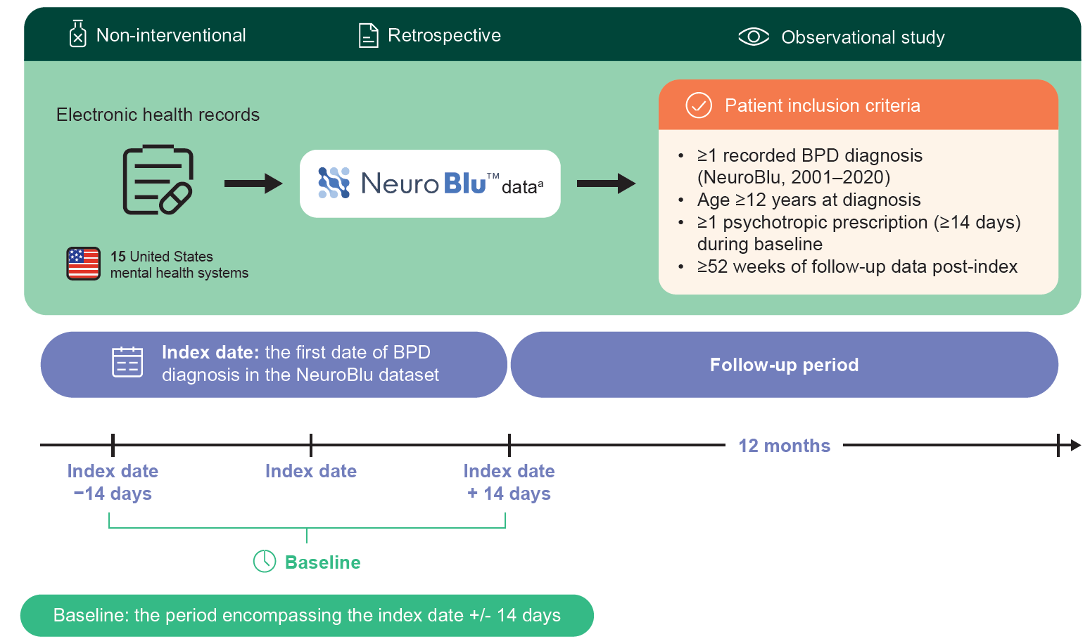
ªA longitudinal behavioural health real-world database comprising both structured and unstructured patient-level clinical data.

Supplementary Figure 2: Patient flow chart
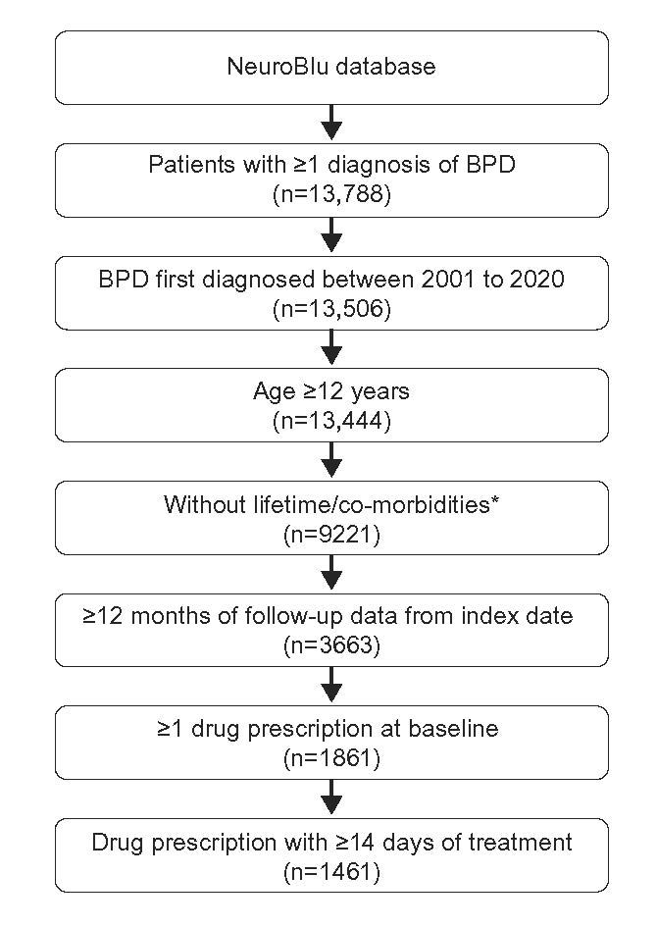
*Current diagnosis of paranoid, schizoid, schizotypal and antisocial personality disorders. Lifetime
diagnosis of schizophrenia, schizoaffective disorder, schizophreniform disorder, bipolar I
disorder, or delusional disorder.
BPD, borderline personality disorder.

Supplementary Table 1: MSE labels and categories associated with BPD symptoms
MSE category | MSE factors | Sample text snippets
BPD symptom category: Impulsivity
Impulse control | Limited/some issues | “limited, but likely improved”
Impulse control | Poor/serious issues | “poor impulse control during depressed mood”, “history of poor impulse control”
BPD symptom category: Emotional dysregulation
Affect | Aggressive | “irrate, hostile, demanding, threatening suicidal ideation / homicidal ideation”, “easily angered and enraged”
Affect | Irritable/angry | “angry at first, more euthymic as session progressed”, “argumentative/testy”, “at times irritable”
Affect | Labile | “fluctuates from smiling to tearful periods per subject”, “initially calm and cooperative, as discussion of symptoms progressed became increasingly agitated”
Affect | Intense | “intense stare at times”, “glares at times”, “demanding”
Mood | Irritable, angry | “annoyed”, “constricted”, ”hostile”, ”resentful”
Mood | Labile | “labile”, “up and down”
BPD symptom category: Suicidal intent / ideation
Mood | Suicidal | “I want to kill myself”
Suicidality | Suicidal ideation | “chronic suicidal thoughts without intent”, “threats of suicide”, “verbally contracts for safety”
Suicidality | Suicidal with intent | “suicidal ideation with plan & intent”
Suicidality | Suicidal with plan | “suicide ideation with plan but no current intent”
Suicidality | History of ideation | “history of recent suicidal statements”, “denied current suicidal ideation, has recent history at intake”
Suicidality | Suicidal ideation with means | “with means”
BPD symptom category: Suicidal attempt / self-injury
Suicidality | Suicide attempt | “recent suicide attempt”, “current suicide attempt”
Suicidality | History of attempt | “history of suicidal overdose last attempt 2011”, “history of multiple suicide attempts”
Suicidality | Self-injurious | “self-mutilation”
Suicidality | History of self-injury | “history of self-injurious behaviors”

Supplementary Table 2: Pharmacological treatment class groupings of prescribed medications
Category | Medication compound
Antidepressants | Amitriptyline, amoxapine, bupropion, butriptyline, citalopram, clomipramine, desipramine, desvenlafaxine, dothiepin, doxepin, duloxetine, escitalopram, esketamine, fluoxetine, fluvoxamine, imipramine, isocarboxazid, ketamine, levomilnacipran, maprotiline, melitracen, mianserin, milnacipran, mirtazapine, nefazodone, nortriptyline, paroxetine, phenelzine, protriptyline, reboxetine, sertraline, tranylcypromine, trazodone, trimipramine, tryptophan, venlafaxine, vilazodone, vortioxetine
Antipsychotics | 1st Generation: chlorpromazine, droperidol, fluphenazine, haloperidol, loxapine, mesoridazine, molindone, perphenazine, pimozide, prochlorperazine, thioridazine, thiothixene, trifluoperazine  2nd Generation: aripiprazole, aripiprazole lauroxil, asenapine, brexpiprazole, cariprazine, clozapine, Iloperidone, lumateperone, lurasidone, olanzapine, paliperidone, quetiapine, risperidone, ziprasidone
Analgesics | Acetaminophen, almotriptan, antipyrine, aspirin, butorphanol, diflunisal, dihydrocodeine, dihydroergotamine, eletriptan, ergotamine, fentanyl, frovatriptan, hydromorphone, levorphanol, meperidine, methoxyflurane, morphine, naratriptan, oxycodone, oxymorphone, pentazocine, propoxyphene, rizatriptan, salsalate, salicylamide, sumatriptan, tapentadol, tramadol, zolmitriptan
Mood stabilisers | Carbamazepine, lamotrigine, gabapentin, topiramate, valproate
Lithium | Lithium, lithium carbonate, lithium citrate
Anticonvulsants | Acetazolamide, brivaracetam, cannabidiol, clobazam, clonazepam, diazepam, divalproex sodium, eslicarbazepine, ethosuximide, felbamate, fosphenytoin, lacosamide, levetiracetam, magnesium sulfate, methsuximide, oxcarbazepine, perampanel, phenobarbital, phenytoin, pregabalin, primidone, rufinamide, stiripentol, tiagabine, vigabatrin, zonisamide
Anxiolytics | Alprazolam, bromazepam, buspirone, chlordiazepoxide, clorazepate, halazepam, hydroxyzine, kava, lorazepam, meprobamate, oxazepam, prazepam, propranolol, diphenhydramine
Hypnotics and sedatives | Amobarbital, butabarbital, chlormethiazole, dexmedetomidine, dichloralphenazone, estazolam, eszopiclone, ethchlorvynol, flurazepam, hexobarbital, melatonin, methyprylon, midazolam, nitrazepam, quazepam, ramelteon, scopolamine, suvorexant, tasimelteon, temazepam, triazolam, valerian root extract, zaleplon, zolpidem, zopiclone
Stimulants | Amphetamine, armodafinil, atomoxetine, dexmethylphenidate, dextroamphetamine, lisdexamfetamine, methamphetamine, methylphenidate, modafinil, pemoline
Substance-abuse drugs | Acamprosate, buprenorphine, disulfiram, methadone, nalmefene, naloxone, naltrexone, nicotine, varenicline

Supplementary Table 3: Five most common treatment journeys in the 12-month pre- and post- baseline periods
Medication class at baseline | Medication class at 1st switchª | Proportion of patients, n (%)
12-month period before diagnosis (n=1132)
Antidepressants | Antidepressants | 167 (14.8)
Anxiolytics + antidepressants | Anxiolytics + antidepressants | 36 (3.2)
Antidepressants + anticonvulsants | Antidepressants + anticonvulsants | 32 (2.8)
SGA + antidepressants | SGA + antidepressants | 31 (2.7)
Antidepressants + mood stabiliser | Antidepressants + mood stabiliser | 28 (2.5)
12-month period after diagnosis (n=1461)
Antidepressants | Antidepressants | 128 (8.8)
SGA + antidepressants | SGA + antidepressants | 44 (3.0)
Anxiolytics + antidepressants | Anxiolytics + antidepressants | 42 (2.9)
Antidepressants + mood stabiliser | Antidepressants + mood stabiliser | 29 (2.0)
Antidepressants + anticonvulsants | Antidepressants + anticonvulsants | 27 (1.8)
ªIn cases where patients did not switch, they continued both with the medication class initially prescribed, and the individual medications prescribed within those classes.
SGA, second generation antipsychotic.

Supplementary Table 4: Most common medication class journeys for patients with BPD in the 12-month period before diagnosis
Medication class at diagnosis | Medication class at 1st switchª | Proportion of patients, n (%)
Antidepressants (n=861)
Fluoxetine | Fluoxetine | 72 (8.4)
Sertraline | Sertraline | 59 (6.9)
Citalopram | Citalopram | 56 (6.5)
Escitalopram | Escitalopram | 52 (6.0)
Venlafaxine | Venlafaxine | 51 (5.9)
Second-generation antipsychotics (n=405)
Quetiapine | Quetiapine | 105 (25.9)
Aripiprazole | Aripiprazole | 90 (22.2)
Quetiapine | Discontinued | 34 (8.4)
Aripiprazole | Discontinued | 29 (7.2)
Risperidone | Risperidone | 24 (5.9)
Mood stabilisers (n=307)
Lamotrigine | Lamotrigine | 94 (30.6)
Gabapentin | Gabapentin | 60 (19.5)
Valproate | Valproate | 33 (10.7)
Topiramate | Topiramate | 20 (6.5)
Gabapentin | Discontinued | 19 (6.2)
ªIn cases where patients did not switch, they continued both with the medication class initially prescribed, and the individual medications prescribed within those classes.
BPD, borderline personality disorder.

Supplementary Table 5: Most common medication combinations at baseline stratified by age group
Age Group
 | 12-17 (n=87) |  | 18-25 (n=301) |  | 26-35 (n=415) |  | 36-45 (n=315) |  | 46-55 (n=247) |  | 56-65 (n=82) |  | >65 (n=14)
Number of patients with more than 1 medication prescribed, n (%)
 | 60 (69.0%) |  | 230 (76.4%) |  | 347 (83.6%) |  | 266 (84.4%) |  | 225 (91.1%) |  | 74 (90.2%) |  | 12 (85.7%)
Number of patients with top 5 most common first-line first recorded medication combinations, n (%)
aripiprazole, fluoxetine | 5 (5.7%) | clonazepam, sertraline | 10 (3.3%) | clonazepam, quetiapine | 22 (5.3%) | clonazepam, quetiapine | 18 (5.7%) | clonazepam, quetiapine | 22 (8.9%) | clonazepam, fluoxetine | 6 (7.3%) | aspirin, sertraline | 3 (21.4%)
escitalopram, trazodone | 4 (4.6%) | aripiprazole, trazodone | 10 (3.3%) | clonazepam, trazodone | 19 (4.6%) | clonazepam, lamotrigine | 14 (4.4%) | clonazepam, sertraline | 17 (6.9%) | fluoxetine, trazodone | 6 (7.3%) | clonazepam, gabapentin | 3 (21.4%)
fluoxetine, lamotrigine | 4 (4.6%) | clonazepam, lamotrigine | 9 (3.0%) | citalopram, clonazepam | 17 (4.1%) | aripiprazole, trazodone | 14 (4.4%) | clonazepam, trazodone | 15 (6.1%) | alprazolam, lamotrigine | 5 (6.1%) | bupropion, trazodone | 2 (14.3%)
aripiprazole, citalopram | 4 (4.6%) | gabapentin, quetiapine | 9 (3.0%) | clonazepam, sertraline | 15 (3.6%) | quetiapine, zolpidem | 14 (4.4%) | clonazepam, zolpidem | 15 (6.1%) | aripiprazole, trazodone | 5 (6.1%) | clonazepam, venlafaxine | 2 (14.3%)
aripiprazole, lamotrigine | 3 (3.4%) | fluoxetine, trazodone | 9 (3.0%) | aripiprazole, clonazepam | 15 (3.6%) | citalopram, clonazepam | 12 (3.8%) | clonazepam, gabapentin | 12 (4.9%) | lamotrigine, quetiapine | 5 (6.1%) | clonazepam, zolpidem | 2 (14.3%)
Note: A patient may be present in more than 1 combination category. Results are presented as N and % of total number of patients in each age group with ≥12 months of treatment data.

Supplementary Table 6: Polypharmacy rates at baseline for patients with BPD and comorbid psychiatric disorders
 | Comorbid psychiatric disorders with BPD
 | MDD | PTSD | SUD | Other bipolar disorder | Other mood disorder | Anxiety disorder | Eating disorder | OCD | ADHD
Number of patients, n | 849 | 486 | 458 | 468 | 328 | 517 | 103 | 68 | 132
Number of patients with ˃1 medication prescribed, n (%) | 705 (83.0) | 416 (85.6) | 389 (84.9) | 399 (85.3) | 257 (78.4) | 432 (83.6) | 81 (78.6) | 62 (91.2) | 114 (86.4)
ADHD, attention deficit hyperactivity disorder; BPD, borderline personality disorder; MDD, major depressive disorder; OCD, obsessive compulsive disorder; PTSD, post-traumatic stress disorder; SUD, substance use disorder.

