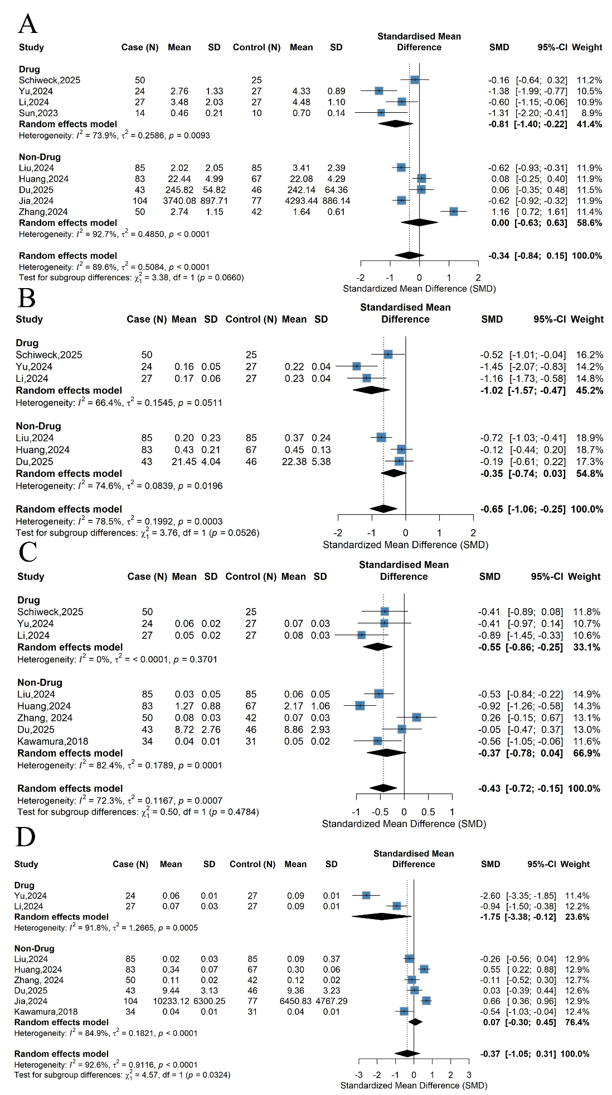
Figure S1. Subgroup analysis by medication status. (A) Acetate ; (B) Propionate; (C) Butyrate; (D) Caproate.
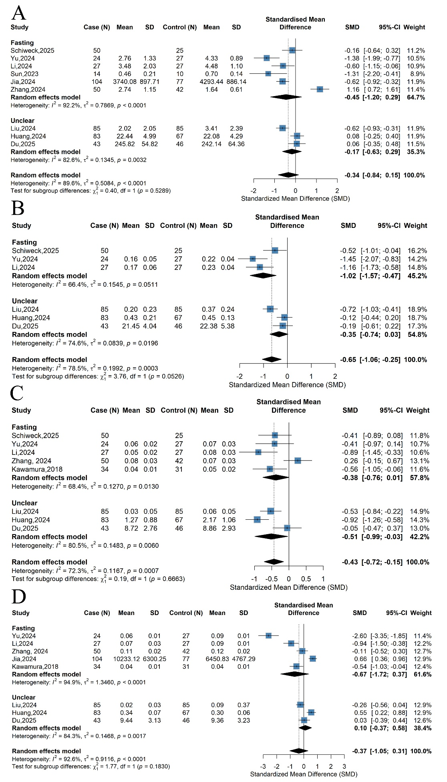
Figure S2. Subgroup analysis by fasting status. (A) Acetate ; (B) Propionate; (C) Butyrate; (D) Caproate.

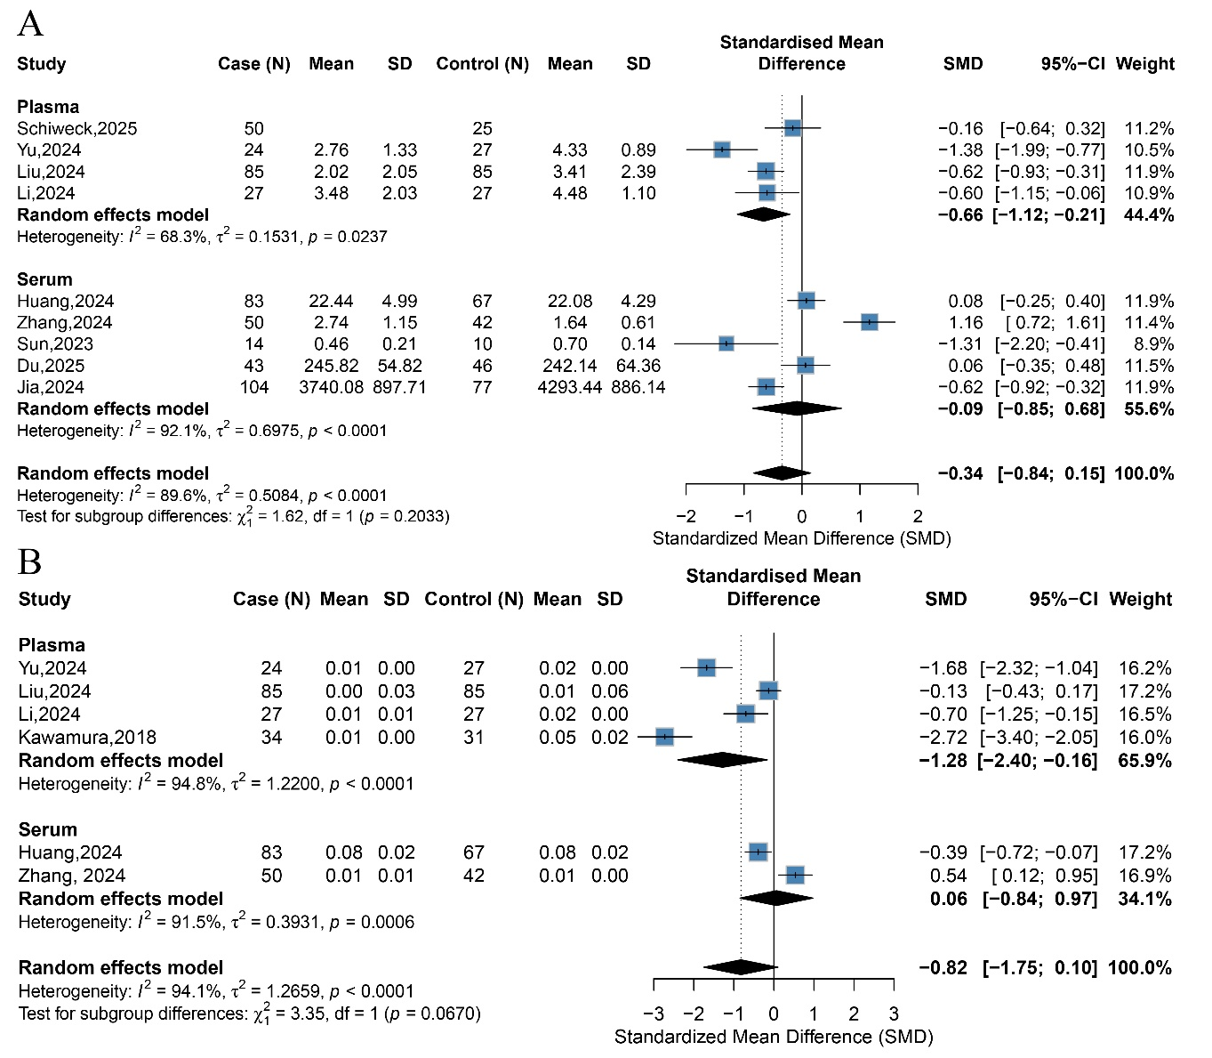
Figure S3. Meta-analysis results of case-control studies before removing outliers. (A) Acetate; (B) Valerate

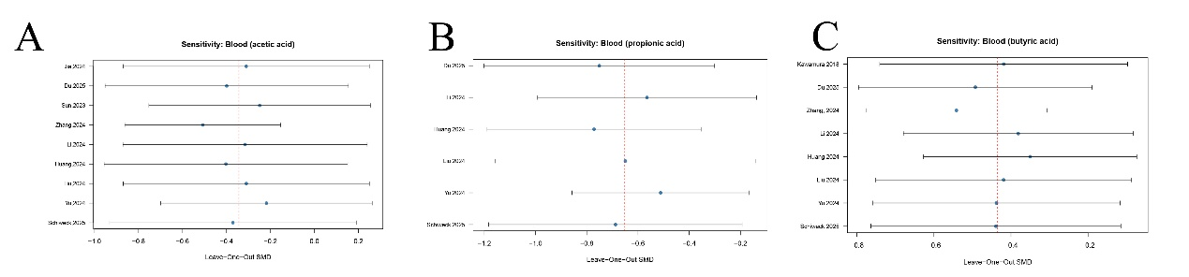
Figure S4. Leave-one-out sensitivity analysis for case-control studies. (A) Acetate; (B) Propionate; (C) Butyrate.

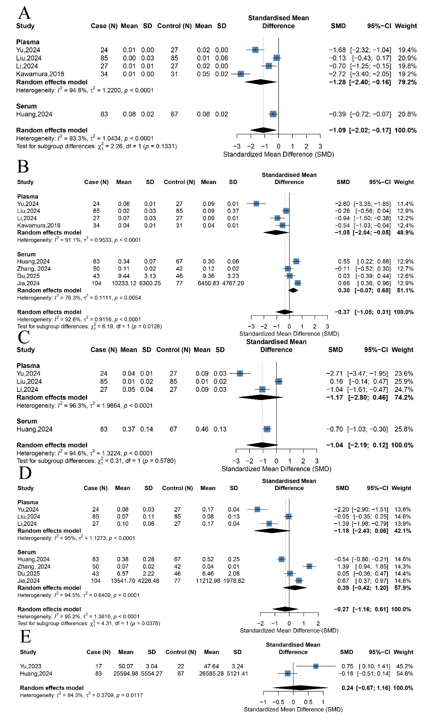
Figure S5. Meta-analysis results of non-major SCFAs in the blood group of case-control studies. (A) Valerate (after sensitivity analysis); (B) Caproate; (C) Isobutyrate; (D) Isovalerate;(E) Total SCFAs

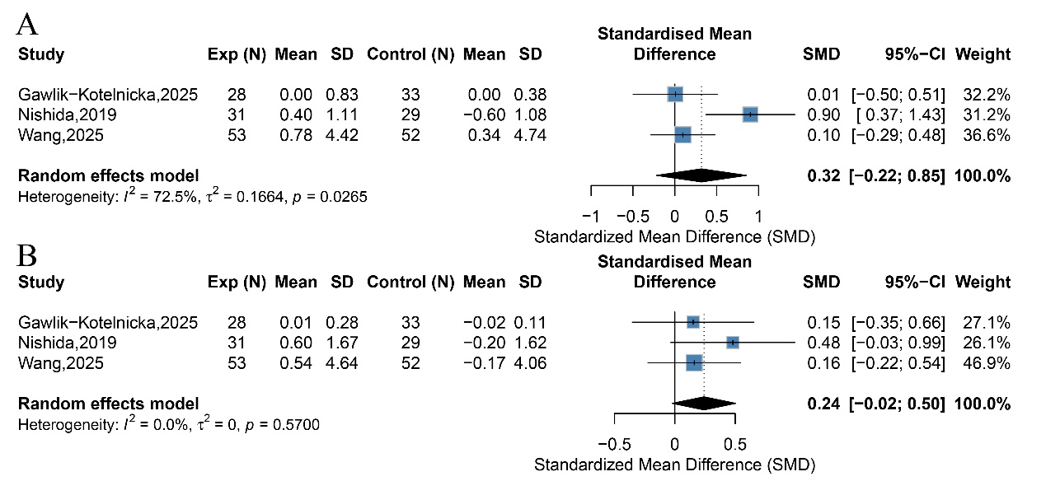
Figure S6. Meta-analysis results of non-major SCFAs in randomized controlled trials. (A) Valerate; (B) Isovalerate

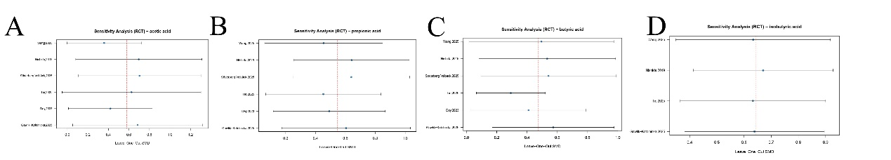
Figure S7. Contour-enhanced sensitivity analysis of major SCFAs in randomized controlled trials. (A) Acetate; (B) Propionate; (C) Butyrate; (D) Isobutyrate

