Supplementary materials of Anodal tDCS Over Right DLPFC Does Not Improve Visuospatial Working Memory in Schizophrenia: A Single-Session, Sham-Controlled Study

Participant Flow
A total of 36 potential candidates were screened for eligibility between May 1, 2019, and August 30, 2021. Among them, 8 individuals were excluded: 2 did not meet the predefined inclusion criteria, and 6 declined to participate. Consequently, 28 participants were enrolled and randomized into two treatment sequences: Sequence AB (n=14) and Sequence BA (n=14).
No participants discontinued the intervention during Period 1 or the washout period. After completing both treatment phases, one participant was excluded from the final analysis due to incomplete data. Therefore, the final analysis included a total of 27 participants (n=13 in Sequence AB; n=14 in Sequence BA).

Participants
Adults aged 20–55 years with a stable, chronic course of SCZ were recruited from the outpatient and day-care services. Diagnoses were independently verified by two psychiatrists using structured DSM-5 interviews and the Mini International Neuropsychiatric Interview (Pinninti et al., 2003). Exclusion criteria comprised claustrophobia, substance use within the previous six months, electroconvulsive therapy during the same period, history of coma secondary to brain injury, and Magnetic Resonance Imaging (MRI)-incompatible metal implants. Twenty-eight participants with normal or corrected vision completed the study. The protocol was approved by the Joint Institutional Review Board of Taipei Medical University (N201701040), and all participants provided written informed consent. Trial registration: ClinicalTrials.gov (NCT03872310).
A total of 28 clinically stable patients with SCZ were enrolled; one female was excluded for failure to comprehend cognitive instructions, leaving n=27 for final analysis (14 males, 13 females). All participants were maintained on a stable antipsychotic regimen (mean CPZ equivalent: 566.90 ± 273.32 mg/day).

Randomization, Blinding, and Recruitment Procedures
The randomization sequence was generated by an independent biostatistician with no participant contact, utilizing a computer-generated random number table to ensure concealment. Participants were randomly assigned to one of two treatment sequences (AB or BA) in a 1:1 ratio using permuted blocks (block size of 4) to maintain balanced assignment throughout the recruitment period. This study employed a double-blind, randomized, sham-controlled design. Randomization into two treatment sequences was performed by a research assistant using a computer-generated random number table. While the investigating physician was aware of the group assignment (e.g., Group A or B), both the investigators and participants were blinded to the identity of the active or sham stimulation. The blinding codes were maintained by the research assistant and were only revealed to the investigators after the completion of all experimental sessions and data collection. Following the electrical stimulation protocol, each participant underwent a one-week follow-up period to systematically monitor for potential adverse events and ensure safety.

Baseline clinical evaluation
Before initiation of tDCS and WM tasks, participants underwent baseline clinical assessments. Symptom severity was evaluated using the Positive and Negative Syndrome Scale (PANSS; Wu et al., 2015), and depressive symptoms were measured with the Beck Depression Inventory-II (BDI; ML, 2002). Cognitive performance was assessed with the Montreal Cognitive Assessment (MoCA) and the Wechsler Adult Intelligence Scale—Fourth Edition (WAIS-IV), which provided indices of full-scale IQ and WM (Tsai et al., 2012; Wechsler, 2008). All instruments, including PANSS, BDI, WAIS-IV, and MoCA, have demonstrated robust reliability, validity, and sensitivity in clinical populations. Antipsychotic exposure was standardized by calculating daily chlorpromazine (CPZ) equivalents for each participant (Woods, 2003).

Image acquisition of structural and functional MRI:
For all participants, resting-state fMRI and high-resolution T1 structural MRI scans of the brain were performed at Taipei Medical University-Shuang Ho Hospital by using a 3.0-T MRI scanner (Discovery MR750, GE Inc., USA). Resting-state fMRI images were acquired using a gradient echo planar imaging sequence with the following parameters: flip angle = 90°, repetition time = 2000 ms, echo time = 30 ms, field of view = 230 mm2, acquisition matrix = 64 × 64, and slice thickness = 4.0 mm with 40 slices per image volume. During scanning, participants were instructed to keep their eyes open and focus on a fixed cross in front of them. High-resolution T1 structural MRI images were acquired using the following parameters: repetition time = 8.2 ms, echo time = 3.2 ms, flip angle = 12°, acquisition matrix = 256 x 256, and slice thickness = 1 mm.

Image analysis of structural MRI:
For analysis of voxel-based morphometry (VBM), T1 images were processed through the Computational Anatomy Toolbox (CAT12, v12.9; http://www.neuro.uni-jena.de/cat/) pipeline (Gaser et al. 2024) and Statistical Parametric Mapping (SPM12; http://www.fil.ion.ucl.ac.uk/spm/) software within the MATLAB environment (version R2023a; MathWorks, Natick, MA). Images underwent tissue segmentation. Regions of interest (ROIs) are right superior frontal gyrus (Rt SFG) and right middle frontal gyrus (Rt MFG) defined by Automated Anatomical Labeling atlas 3 (AAL3) inside CAT12 representing right DLPFC. Total intracranial volume (TIV) and mean value of gray matter volume (GMV) inside ROIs were estimated. The normalized volume was computed as: Normalized volume (%) = (GMV / TIV) × 100.

Image analysis of fMRI: Preprocessing and functional connectivity (FC):
Preprocessing of resting-state fMRI images was conducted using the Data Processing Assistant for Resting-State fMRI (DPARSF; Yan & Zang, 2010), v5.2, http://rfmri.org/DPARSF, which is based on SPM12 and the toolbox for Data Processing & Analysis of Brain Imaging (DPABI; Yan et al., 2016) , v6.0, http://rfmri.org/DPABI.
All scans were subjected to slice timing correction, head movement correction, and normalization to the Montreal Neurological Institute (MNI) template. Spatial smoothing was applied with a 6-mm full-width half-maximum Gaussian kernel. To eliminate spurious or nonspecific sources of variance, variables including head movements based on rigid body translation and rotation, the mean signal within the lateral ventricles, and the deep white matter were regressed out during preprocessing. Low-frequency time series were extracted using a band-pass filter (0.01 to 0.1Hz). Rt SFG and Rt MFG defined by AAL3 from Cat12 were used as regions of interest (ROIs). The time courses of each ROI were then extracted. The Pearson correlation coefficient of the average time courses for the pair of ROIs was calculated, and Fisher’s z transformation was applied to convert it to a normal distribution. The z scores were used to represent the FC of the right DLPFC.

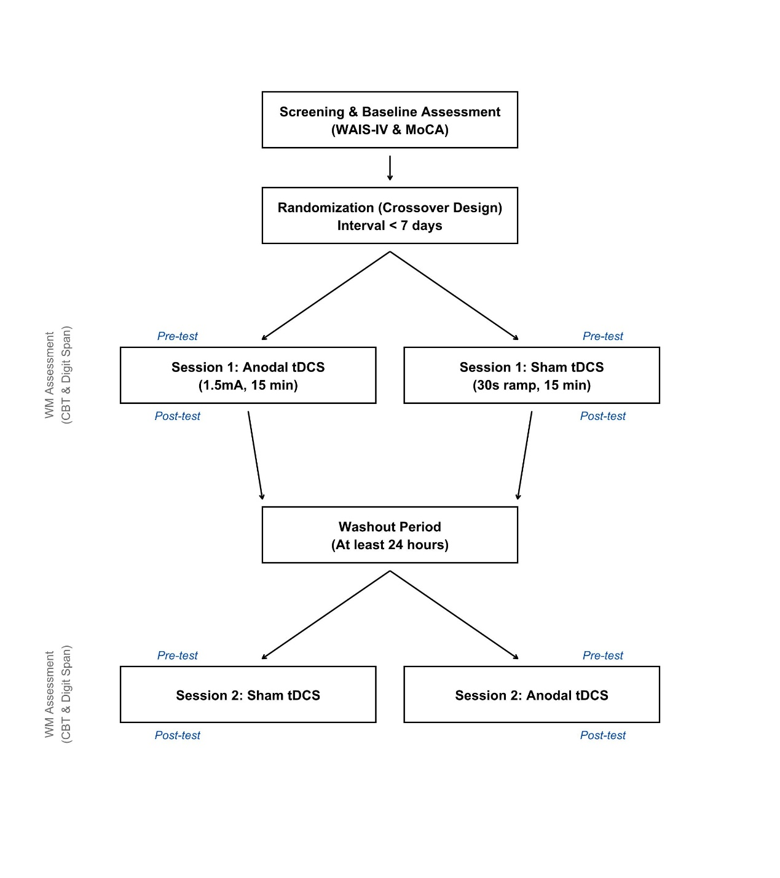
Figure S1: Study flowchart and experimental timeline.

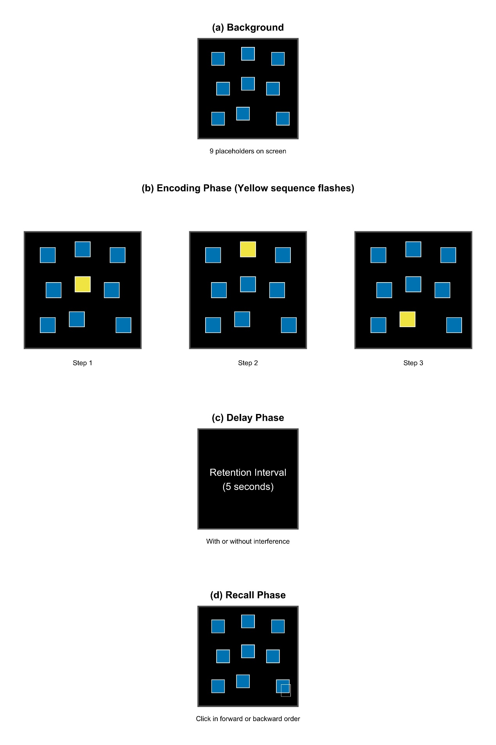
Figure S2: Schematic of the computerized Corsi Block-Tapping (CBT) task. (a) Background with nine placeholders; (b) Encoding phase with yellow target sequence; (c) 5-second delay phase; (d) Recall phase where participants click the squares in forward or backward order.

References
ML, L. (2002). Reliability and validity of the Chinese version of the Beck Depression Inventory-II. Taiwanese. J. Psychiatry, 16, 301-310.
Pinninti, N. R., Madison, H., Musser, E., & Rissmiller, D. (2003). MINI International Neuropsychiatric Schedule: clinical utility and patient acceptance. Eur Psychiatry, 18(7), 361-364. https://doi.org/10.1016/j.eurpsy.2003.03.004
Tsai, C. F., Lee, W. J., Wang, S. J., Shia, B. C., Nasreddine, Z., & Fuh, J. L. (2012). Psychometrics of the Montreal Cognitive Assessment (MoCA) and its subscales: validation of the Taiwanese version of the MoCA and an item response theory analysis. Int Psychogeriatr, 24(4), 651-658. https://doi.org/10.1017/S1041610211002298
Wechsler, D. (2008). Wechsler adult intelligence scale (WAIS-IV). Pearson, The Psychological Corporation.
Woods, S. W. (2003). Chlorpromazine equivalent doses for the newer atypical antipsychotics. Journal of Clinical Psychiatry, 64(6), 663-667. https://doi.org/10.4088/jcp.v64n0607
Wu, B. J., Lan, T. H., Hu, T. M., Lee, S. M., & Liou, J. Y. (2015). Validation of a five-factor model of a Chinese Mandarin version of the Positive and Negative Syndrome Scale (CMV-PANSS) in a sample of 813 schizophrenia patients. Schizophr Res, 169(1-3), 489-490. https://doi.org/10.1016/j.schres.2015.09.011
Yan, C.-G., Wang, X.-D., Zuo, X.-N., & Zang, Y.-F. (2016). DPABI: data processing & analysis for (resting-state) brain imaging. Neuroinformatics, 14(3), 339-351. https://doi.org/10.1007/s12021-016-9299-4
Yan, C., & Zang, Y. (2010). DPARSF: a MATLAB toolbox for" pipeline" data analysis of resting-state fMRI. Frontiers in systems neuroscience, 4, 1377.

