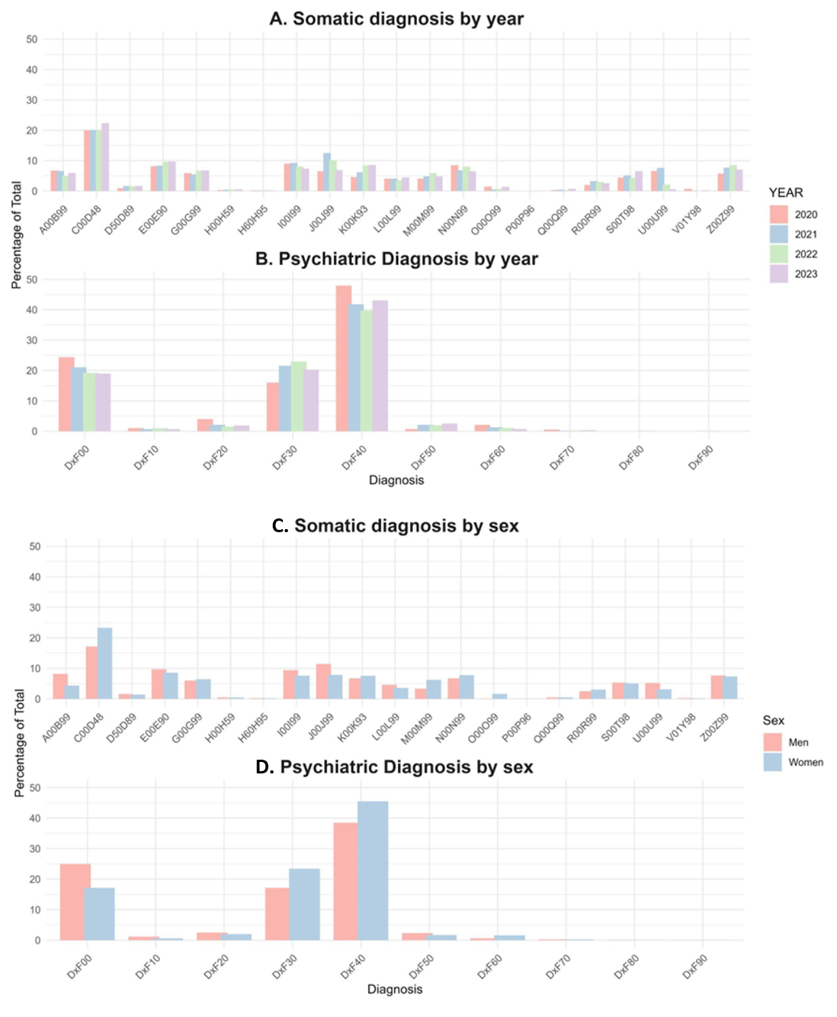
Supplement material 4. Percentage of somatic and psychiatric diagnoses: (A) and (B) and by year: (C) and (D) by sex.

