Table S1 Edge weights of the network structure
from | to | weight | pvalue
GAD2 | GAD3 | 0.455700542 | 0.000
PHQ8 | GAD5 | 0.29164552 | 0.000
PHQ6 | PHQ9 | 0.279063216 | 0.000
GAD1 | GAD2 | 0.254566913 | 0.000
PHQ2 | GAD4 | 0.22731096 | 0.001
GAD5 | GAD7 | 0.215622623 | 0.001
GAD3 | GAD4 | 0.213323185 | 0.003
PHQ2 | GAD1 | 0.208755416 | 0.000
PHQ2 | PHQ4 | 0.206832621 | 0.001
PHQ3 | PHQ5 | 0.194780201 | 0.000
GAD4 | GAD5 | 0.189763913 | 0.001
PHQ3 | PHQ7 | 0.188178363 | 0.001
PHQ6 | PHQ7 | 0.181337239 | 0.007
PHQ7 | GAD5 | 0.180008251 | 0.005
PHQ9 | GAD6 | 0.158748301 | 0.017
GAD1 | GAD6 | 0.145317368 | 0.007
PHQ1 | PHQ4 | 0.139854268 | 0.060
NSSI | GAD6 | 0.139004339 | 0.047
GAD2 | GAD7 | 0.134017304 | 0.028
PHQ4 | PHQ5 | 0.128650649 | 0.027
PHQ6 | GAD7 | 0.12455693 | 0.100
GAD3 | GAD6 | 0.123383227 | 0.075
GAD1 | GAD4 | 0.122305235 | 0.087
NSSI | PHQ9 | 0.121862745 | 0.027
PHQ1 | PHQ8 | 0.118728764 | 0.123
PHQ1 | GAD6 | 0.108588764 | 0.058
PHQ5 | PHQ8 | 0.105823036 | 0.067
GAD5 | GAD6 | 0.104604553 | 0.100
PHQ8 | GAD6 | 0.099636887 | 0.099
PHQ1 | PHQ7 | 0.095256135 | 0.237
NSSI | PHQ5 | 0.08916958 | 0.079
PHQ4 | PHQ6 | 0.088856069 | 0.332
PHQ3 | PHQ9 | 0.086144954 | 0.195
PHQ9 | GAD2 | 0.083240959 | 0.040
PHQ1 | PHQ2 | 0.080978439 | 0.088
PHQ9 | GAD7 | 0.079873271 | 0.066
PHQ4 | PHQ7 | 0.079292896 | 0.060
PHQ4 | PHQ9 | 0.078470042 | 0.189
PHQ2 | PHQ5 | 0.077008669 | 0.090
PHQ5 | GAD2 | 0.07448974 | 0.093
GAD1 | GAD5 | 0.074475663 | 0.111
PHQ3 | GAD1 | 0.070110539 | 0.017
Table S1 Continued
PHQ2 | GAD3 | 0.067917464 | 0.149
PHQ8 | GAD3 | 0.067568809 | 0.040
PHQ1 | PHQ9 | 0.066070146 | 0.227
GAD6 | GAD7 | 0.062075386 | 0.404
PHQ1 | PHQ3 | 0.058670535 | 0.265
PHQ6 | GAD2 | 0.057940471 | 0.152
NSSI | PHQ6 | 0.057475544 | 0.265
PHQ4 | GAD4 | 0.05658078 | 0.414
PHQ5 | PHQ9 | 0.053992346 | 0.730
GAD3 | GAD5 | 0.048564624 | 0.940
GAD2 | GAD4 | 0.045447028 | 0.763
NSSI | GAD5 | 0.044629696 | 0.261
GAD3 | GAD7 | 0.044313351 | 0.973
PHQ7 | GAD3 | 0.04352039 | 0.008
PHQ7 | GAD7 | 0.042514137 | 0.162
NSSI | PHQ8 | 0.040347476 | 0.828
GAD4 | GAD7 | 0.039099242 | 0.609
PHQ3 | PHQ6 | 0.038711417 | 0.307
PHQ2 | PHQ6 | 0.037168997 | 0.189
PHQ6 | GAD4 | 0.03522118 | 0.688
PHQ8 | GAD7 | 0.035050679 | 0.423
PHQ4 | GAD2 | 0.03393894 | 0.357
PHQ4 | GAD6 | 0.032338271 | 0.223
PHQ3 | PHQ8 | 0.030095156 | 0.231
PHQ4 | GAD3 | 0.028028418 | 0.913
GAD2 | GAD6 | 0.027940564 | 0.571
PHQ4 | GAD1 | 0.024241584 | 0.886
PHQ3 | PHQ4 | 0.023920726 | 0.466
PHQ7 | GAD1 | 0.023813444 | 0.166
PHQ9 | GAD4 | 0.018257541 | 0.292
PHQ1 | PHQ6 | 0.01777172 | 0.640
PHQ5 | PHQ6 | 0.01723887 | 0.771
NSSI | GAD7 | 0.017121086 | 0.883
PHQ6 | GAD3 | 0.014859769 | 0.871
PHQ1 | GAD4 | 0.012530509 | 0.797
NSSI | GAD1 | 0.009699633 | 0.403
PHQ1 | GAD3 | 0.008418877 | 0.404
PHQ5 | GAD7 | 0.008331351 | 0.539
PHQ8 | GAD4 | 0.00711398 | 0.875
PHQ5 | GAD3 | 0.002400915 | 0.890
PHQ5 | GAD6 | 0.001760066 | 0.865
PHQ8 | PHQ9 | 0.001703583 | 0.142
PHQ3 | GAD3 | -0.042002419 | 0.045
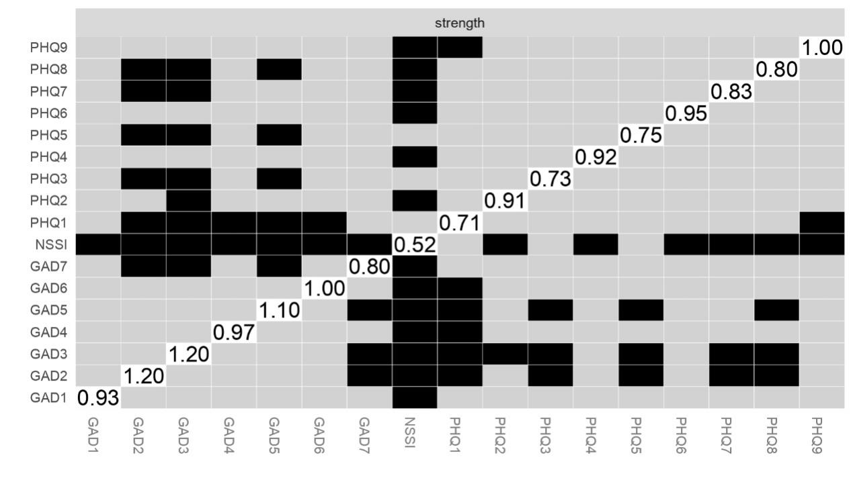Figure S1 Test for the difference in nodes strength 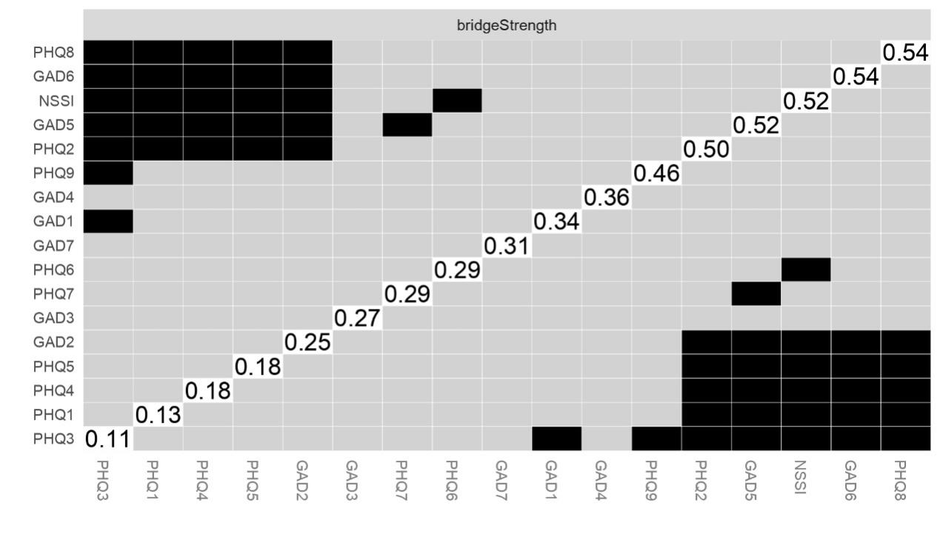 Figure S2 Test for the difference in nodes bridgestrength
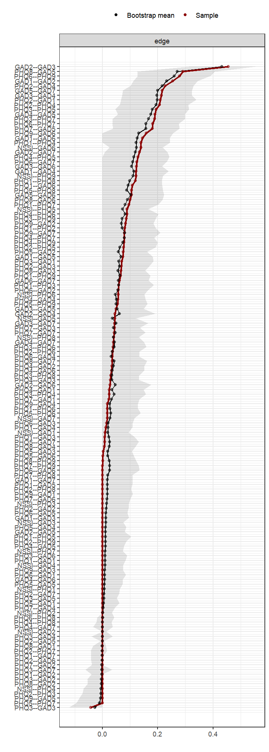
Figure S3. The accuracy of the network.

