Supplementary Materials
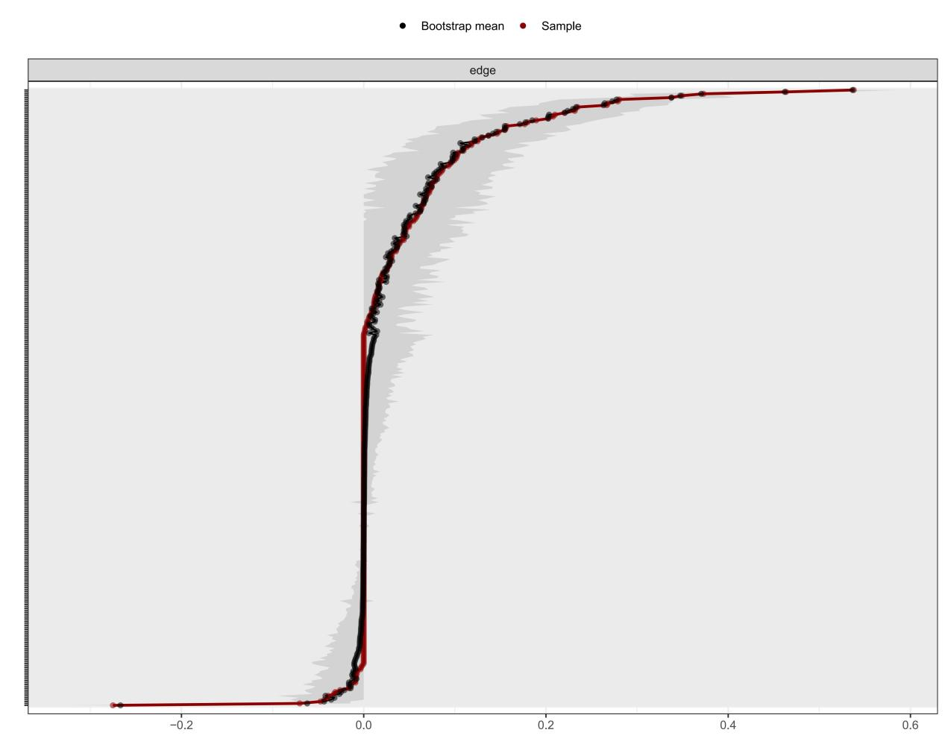
Figure S1. Bootstrapped 95% confidence intervals for edge weights. The red line indicates the sample edge weight values, the black line represents bootstrap means, and the gray area shows the bootstrapped 95% confidence intervals. Narrower confidence intervals indicate more accurate edge weight estimation. Edge weights are ordered by sample values.

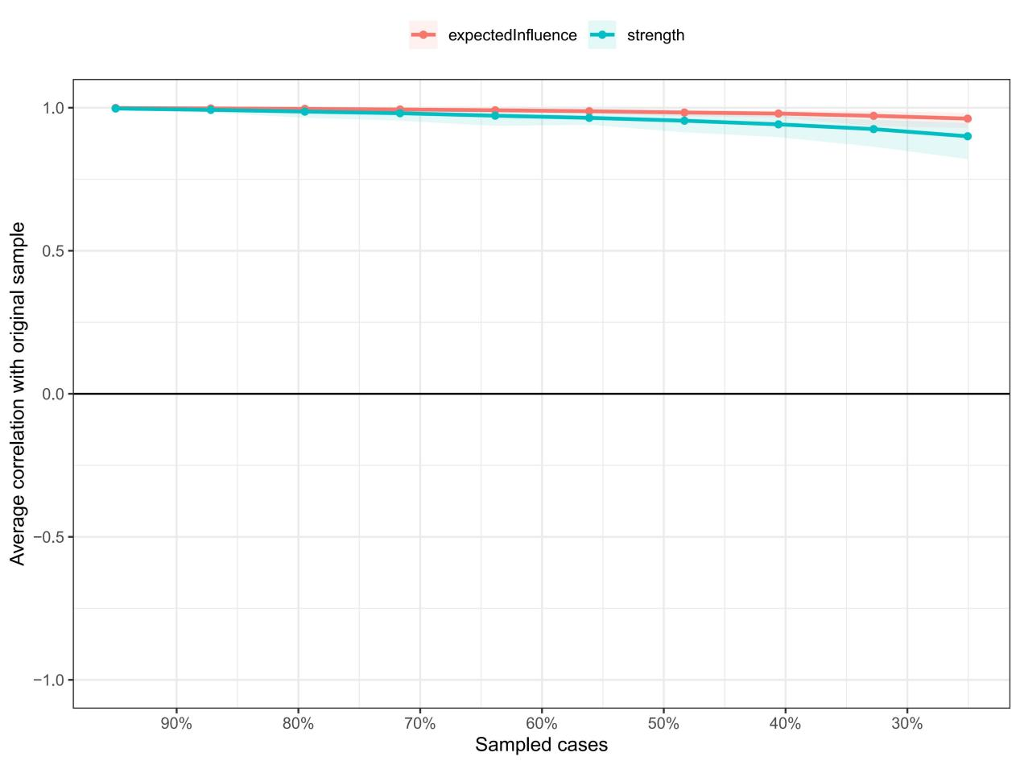
Figure S2. Stability of centrality indices using case-dropping bootstrap. The x-axis represents the percentage of cases retained from the original sample. The y-axis represents the average correlation between centrality indices from the original network and centrality indices from re-estimated networks after excluding increasing percentages of cases. Lines indicate average correlations; shaded areas indicate 95% confidence intervals based on 1,000 bootstrap samples.

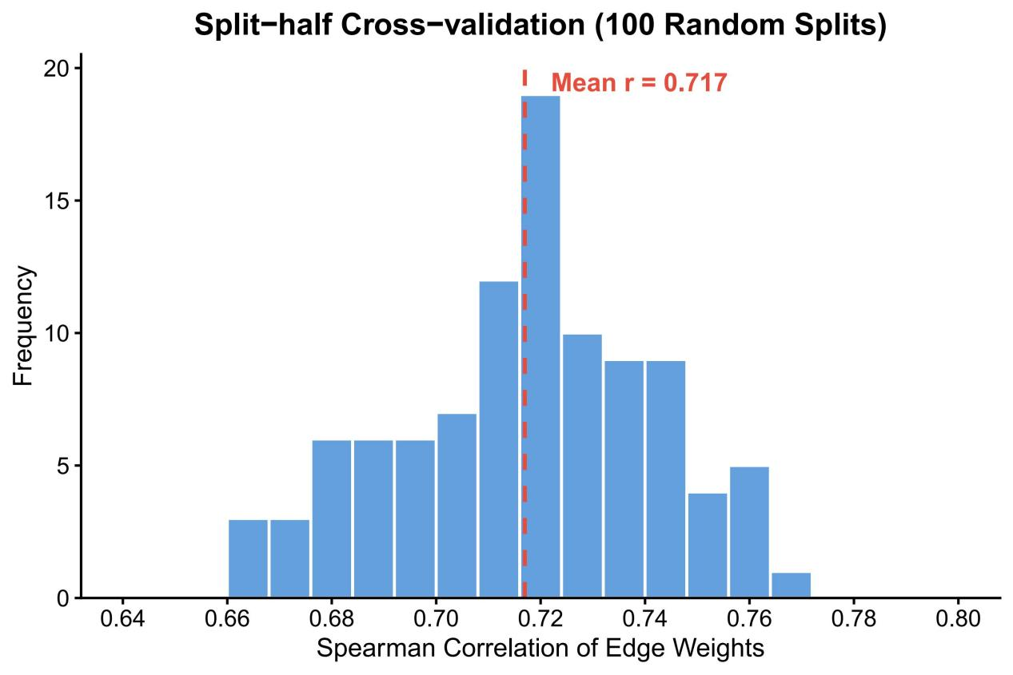
Figure S3. Distribution of Spearman correlation coefficients between edge weight matrices from 100 random split-half cross-validation iterations. The red dashed line indicates the mean correlation (r = 0.717).

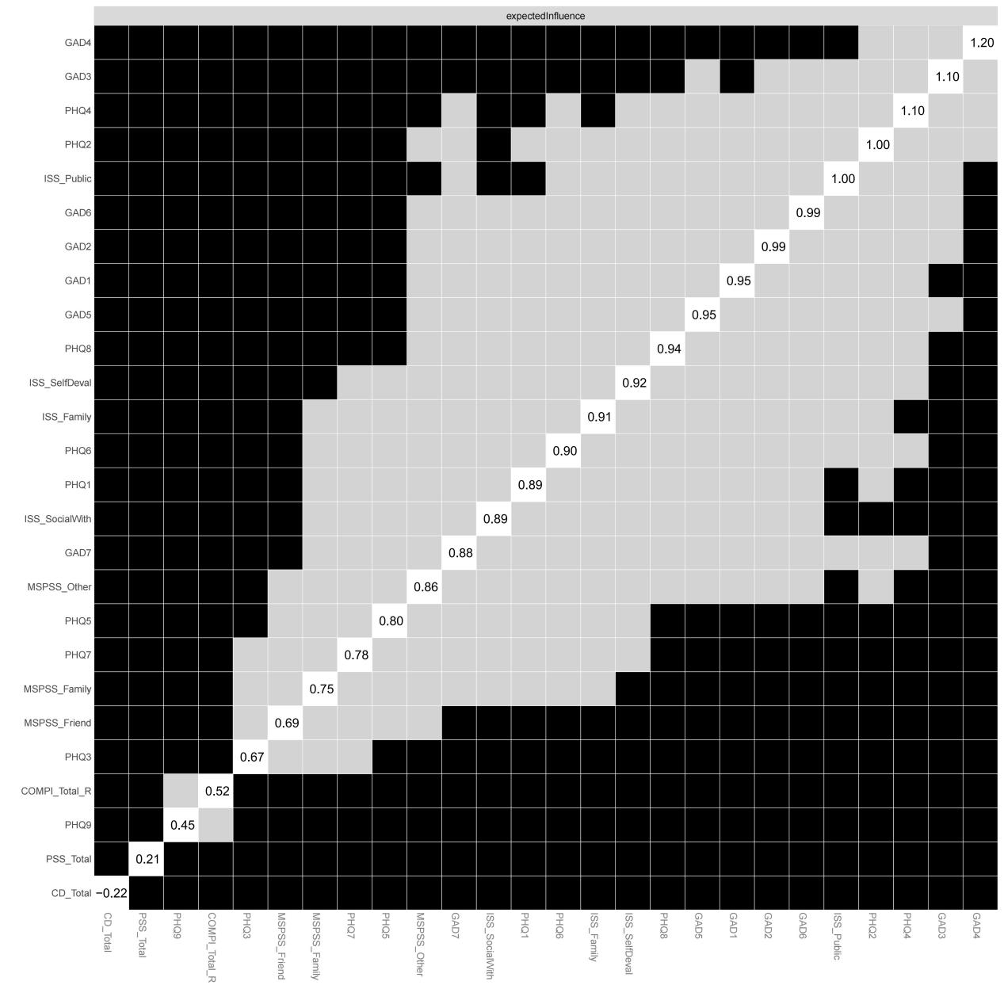
Figure S4. Bootstrapped difference test for expected influence. Black cells indicate pairs of nodes whose expected influence values differ significantly (95% bootstrapped confidence interval does not include zero). Values on the right represent the sample expected influence for each node.

Table S1. Cross-Community Edges Between Symptom and Psychosocial Factor Communities
Symptom Node | Psychosocial Node | Edge Weight
GAD2 (Uncontrollable worry) | ISS-SW (Social withdrawal) | 0.063
GAD7 (Feeling afraid) | PSS (Perceived stress) | 0.059
PHQ1 (Anhedonia) | COMPI (Fertility-specific stress) | 0.058
PHQ6 (Guilt/worthlessness) | ISS-SD (Self-devaluation) | 0.056
PHQ4 (Fatigue) | PSS (Perceived stress) | 0.050
GAD4 (Difficulty relaxing) | PSS (Perceived stress) | 0.039
PHQ2 (Depressed mood) | SUP-Fr (Friend support) | −0.039
PHQ9 (Suicidal ideation) | ISS-SW (Social withdrawal) | −0.039
GAD1 (Nervousness) | PSS (Perceived stress) | 0.036
PHQ2 (Depressed mood) | PSS (Perceived stress) | 0.031
Only the 10 strongest cross-community edges are shown. A total of 40 cross-community edges were identified, representing 26.5% of all edges in the network. The symptom community includes depression (PHQ-9) and anxiety (GAD-7) symptoms; the psychosocial factors community includes perceived stress, fertility-specific stress, infertility stigma dimensions, social support dimensions, and resilience.
Table S2. Strongest Edge Weights in the Network
Rank | Node 1 | Node 2 | Edge Weight
Strongest Positive Edges (Top 15)
1 | ISS-Pu (Public stigma) | ISS-Fa (Family stigma) | 0.538
2 | SUP-Fa (Family support) | SUP-Ot (Significant other support) | 0.464
3 | SUP-Fr (Friend support) | SUP-Ot (Significant other support) | 0.373
4 | ISS-SD (Self-devaluation) | ISS-SW (Social withdrawal) | 0.349
5 | SUP-Fa (Family support) | SUP-Fr (Friend support) | 0.338
6 | ISS-SW (Social withdrawal) | ISS-Pu (Public stigma) | 0.280
7 | PHQ1 (Anhedonia) | PHQ2 (Depressed mood) | 0.279
8 | GAD2 (Uncontrollable worry) | GAD3 (Excessive worry) | 0.268
9 | PHQ3 (Sleep disturbance) | PHQ4 (Fatigue) | 0.267
10 | GAD4 (Difficulty relaxing) | GAD6 (Irritability) | 0.235
11 | PHQ7 (Concentration difficulty) | PHQ8 (Psychomotor changes) | 0.232
12 | GAD5 (Restlessness) | GAD7 (Feeling afraid) | 0.232
13 | ISS-SD (Self-devaluation) | ISS-Pu (Public stigma) | 0.220
14 | PHQ8 (Psychomotor changes) | PHQ9 (Suicidal ideation) | 0.210
15 | GAD4 (Difficulty relaxing) | GAD5 (Restlessness) | 0.208
Strongest Negative Edges (Top 10)
1 | PSS (Perceived stress) | CD (Resilience) | −0.275
2 | ISS-SD (Self-devaluation) | CD (Resilience) | −0.070
3 | ISS-Fa (Family stigma) | SUP-Fa (Family support) | −0.047
4 | COMPI (Fertility-specific stress) | SUP-Fa (Family support) | −0.043
5 | PHQ2 (Depressed mood) | SUP-Fr (Friend support) | −0.039
6 | PHQ9 (Suicidal ideation) | ISS-SW (Social withdrawal) | −0.039
7 | ISS-Pu (Public stigma) | SUP-Fr (Friend support) | −0.033
8 | PSS (Perceived stress) | SUP-Ot (Significant other support) | −0.031
9 | PHQ9 (Suicidal ideation) | SUP-Fa (Family support) | −0.026
10 | PHQ6 (Guilt/worthlessness) | CD (Resilience) | −0.016
Edge weights represent regularized partial correlations estimated using the graphical LASSO with EBIC model selection (tuning parameter γ = 0.25). Positive edges indicate that higher levels of one node are associated with higher levels of the connected node after controlling for all other nodes; negative edges indicate inverse associations.

Table S3. Centrality Indices and Predictability for All Network Nodes (N = 1,062)
Node | Full Name | Strength | Expected Influence | Bridge Expected Influence | Predictability (R²)
Depression (PHQ-9)
PHQ1 | Anhedonia | −0.171 | 0.116 | 0.058 | 0.468
PHQ2 | Depressed mood | 1.347 | 0.768 | −0.006 | 0.555
PHQ3 | Sleep disturbance | −1.558 | −0.145 | 0.000 | 0.389
PHQ4 | Fatigue | 1.008 | 0.826 | 0.041 | 0.544
PHQ5 | Appetite changes | −0.774 | 0.165 | 0.000 | 0.438
PHQ6 | Guilt/worthlessness | 0.069 | 0.416 | 0.086 | 0.495
PHQ7 | Concentration difficulty | −0.844 | 0.119 | 0.014 | 0.418
PHQ8 | Psychomotor changes | 0.086 | 0.417 | 0.010 | 0.495
PHQ9 | Suicidal ideation | −2.069 | −0.778 | −0.0049 | 0.292
Anxiety (GAD-7)
GAD1 | Nervousness | 0.187 | 0.471 | 0.082 | 0.578
GAD2 | Uncontrollable worry | 0.413 | 0.592 | 0.074 | 0.630
GAD3 | Excessive worry | 1.127 | 0.974 | 0.042 | 0.639
GAD4 | Difficulty relaxing | 1.539 | 1.195 | 0.039 | 0.662
GAD5 | Restlessness | 0.151 | 0.452 | 0.007 | 0.564
GAD6 | Irritability | 0.637 | 0.642 | 0.046 | 0.581
GAD7 | Feeling afraid | −0.176 | 0.356 | 0.070 | 0.507
Psychosocial Factors
PSS | Perceived stress | −0.592 | −2.016 | 0.297 | 0.345
COMPI | Fertility-specific stress | −1.735 | −3.095 | 0.143 | 0.340
ISS-SD | Self-devaluation | 0.879 | −0.075 | 0.073 | 0.717
ISS-SW | Social withdrawal | 0.394 | 0.029 | 0.104 | 0.676
ISS-Pu | Public stigma | 1.106 | 0.694 | 0.010 | 0.793
ISS-Fa | Family stigma | 0.535 | −0.111 | 0.009 | 0.760
SUP-Fa | Family support | 0.394 | 0.255 | −0.023 | 0.764
SUP-Fr | Friend support | −0.314 | −0.097 | −0.048 | 0.674
SUP-Ot | Significant other support | 0.278 | 0.356 | −0.001 | 0.767
CD | Resilience | −1.917 | −2.286 | −0.050 | 0.264
Values are standardized z-scores except for predictability (R²). The symptom community includes PHQ-9 and GAD-7 items (nodes 1–16); the psychosocial factors community includes PSS, COMPI, ISS subscales, MSPSS subscales, and CD-RISC-10 (nodes 17–26). PHQ, Patient Health Questionnaire; GAD, Generalized Anxiety Disorder scale; PSS, Perceived Stress Scale; COMPI, Copenhagen Multi-centre Psychosocial Infertility scale; ISS, Infertility Stigma Scale (SD, Self-devaluation; SW, Social withdrawal; Pu, Public stigma; Fa, Family stigma); SUP, Social support (Fa, Family; Fr, Friend; Ot, Significant other); CD, Connor-Davidson Resilience Scale.

