Table S1 search strategy
((((((Autism Spectrum Disorder[MeSH Terms]) OR (Autism Spectrum Disorder[Title/Abstract])) OR (Autistic Spectrum Disorder[Title/Abstract])) OR (Autistic Spectrum Disorders[Title/Abstract])) OR (Disorder, Autistic Spectrum[Title/Abstract])) OR (Autism Spectrum Disorders[Title/Abstract])) AND (((((((((((((((((((((((((((((((Dietary Supplements[MeSH Terms]) OR (Dietary Supplements[Title/Abstract])) OR (Dietary Supplement[Title/Abstract])) OR (Supplements, Dietary[Title/Abstract])) OR (Dietary Supplementations[Title/Abstract])) OR (Supplementations, Dietary[Title/Abstract])) OR (Food Supplementations[Title/Abstract])) OR (Food Supplements[Title/Abstract])) OR (Food Supplement[Title/Abstract])) OR (Supplement, Food[Title/Abstract])) OR (Supplements, Food[Title/Abstract])) OR (Nutraceuticals[Title/Abstract])) OR (Nutraceutical[Title/Abstract])) OR (Nutriceuticals[Title/Abstract])) OR (Nutriceutical[Title/Abstract])) OR (Neutraceuticals[Title/Abstract])) OR (Neutraceutical[Title/Abstract])) OR (Herbal Supplements[Title/Abstract])) OR (Herbal Supplement[Title/Abstract])) OR (Supplement, Herbal[Title/Abstract])) OR (Supplements, Herbal[Title/Abstract])) OR (Vitamins[Title/Abstract])) OR (Fish oil[Title/Abstract])) OR (Omega-3[Title/Abstract])) OR (Selenium[Title/Abstract])) OR (Zinc[Title/Abstract])) OR (Green tea[Title/Abstract])) OR (Curcumin[Title/Abstract])) OR (Ginseng root[Title/Abstract])) OR (Probiotics[Title/Abstract])) OR (Supplementation[Title/Abstract]))

Table S2 Results of consistency modeling
Outcomes | Consistency test | Inconsistency test | I²(%)
Social | 49.76 | 49.69 | 12
Irritability | 22.61 | 22.62 | 13
Hyperactivity | 30.21 | 30.20 | 1

Table S3 League table of social scores
MD 95%（Crl）
Carnosine
1.27 (-0.75, 3.29) | Omega3
0.97 (-2.66, 4.62) | -0.3 (-3.8, 3.2) | Prebiotic
-0.47 (-2.21, 1.28) | -1.74 (-3.15, -0.34)* | -1.44 (-4.8, 1.91) | Probiotic |  | -2.34(-4.63, -0.06)
-1.02 (-2.63, 0.59) | -2.29 (-3.52, -1.07) * | -1.99 (-5.27, 1.28) | -0.55 (-1.24, 0.14) | UT | -2.89(-5.08, -0.72)
1.88 (-0.82, 4.58) | 0.61 (-1.9, 3.11) | 0.9 (-3.03, 4.83) | 2.34 (0.06, 4.63) * | 2.89 (0.72, 5.08) * | VD

Table S4 League table of irritability scores
MD 95%（Crl）
Carnosine
3.81 (-1.07, 8.66) | Omega3
4.08 (-1.65, 9.8) | 0.27 (-4.95, 5.48) | Probiotic
-0.3 (-4.16, 3.55) | -4.1 (-7.09, -1.13)* | -4.37 (-8.66, -0.11) * | UT
2.96 (-1.89, 7.81) | -0.84 (-3.68, 2.01) | -1.12 (-6.31, 4.08) | 3.26 (0.31, 6.2) | VD
1.91 (-3.34, 7.16) | -1.89 (-5.16, 1.37) | -2.16 (-7.77, 3.41) | 2.21 (-1.37, 5.78) | -1.05 (-4.35, 2.24) | VD_Omega3

Table S5 League table of hyperactivity scores.
MD 95%（Crl）
Carnosine
0.67 (-1.14, 2.45) | Omega3
0.05 (-1.51, 1.6) | -0.61 (-1.96, 0.74) | Probiotic
-0.3 (-1.68, 1.07) | -0.97 (-2.11, 0.19) | -0.35 (-1.07, 0.36) | UT
0.44 (-1.29, 2.18) | -0.22 (-1.24, 0.8) | 0.39 (-0.88, 1.66) | 0.75 (-0.31, 1.8) | VD
0.46 (-1.61, 2.53) | -0.2 (-1.63, 1.22) | 0.41 (-1.3, 2.11) | 0.76 (-0.79, 2.31) | 0.02 (-1.39, 1.41) | VD_Omega3

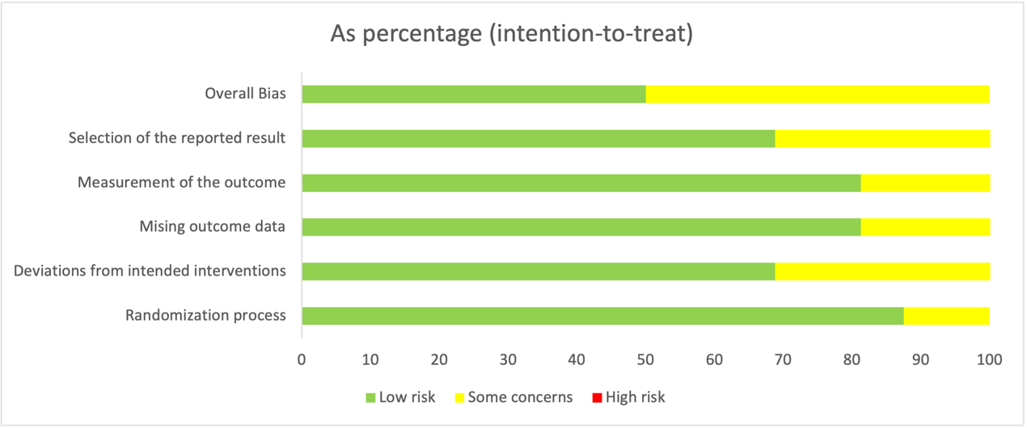
Figure S1 risk bias of summary

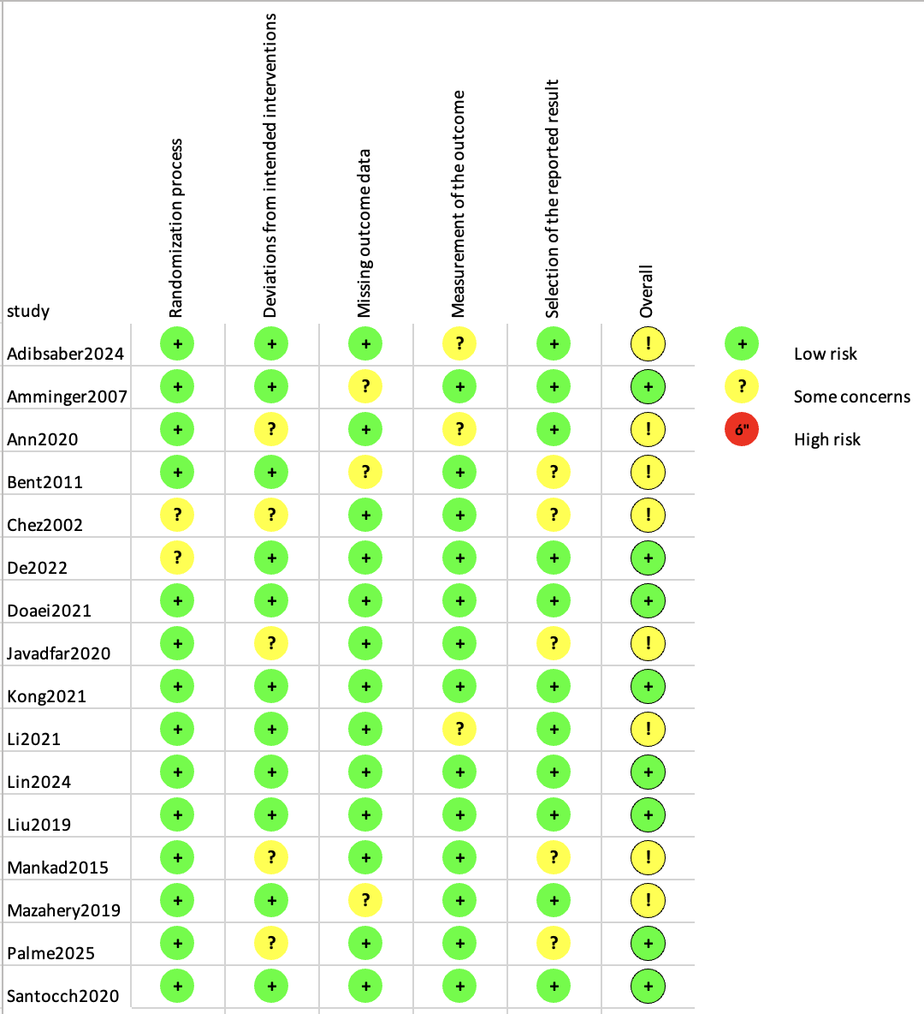
Figure S2 risk bias of graph

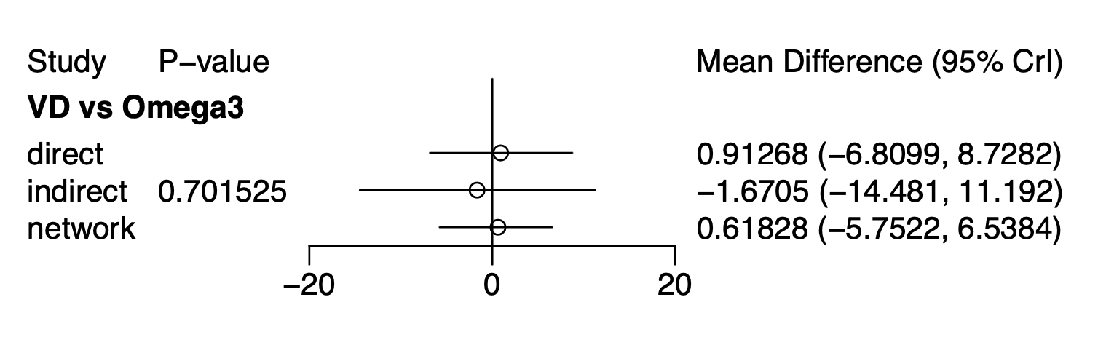Figure S3 Local inconsistency test of irritability scores

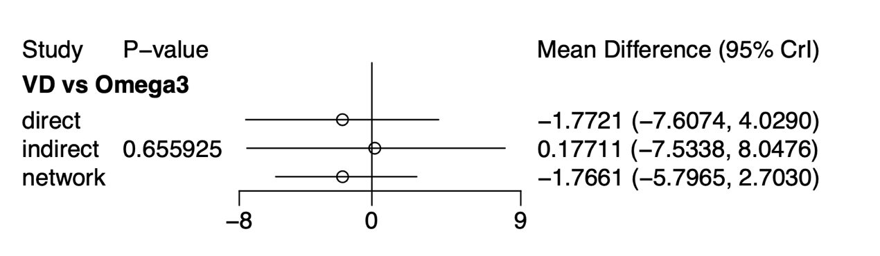Figure S4 Local inconsistency test of hyperactivity scores

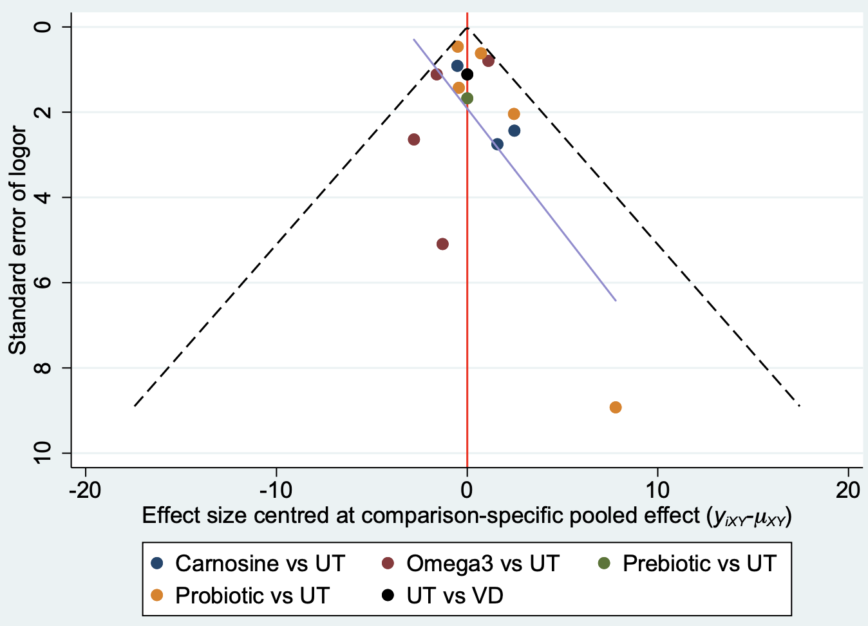
Figure S5 Funnel plot of social scores

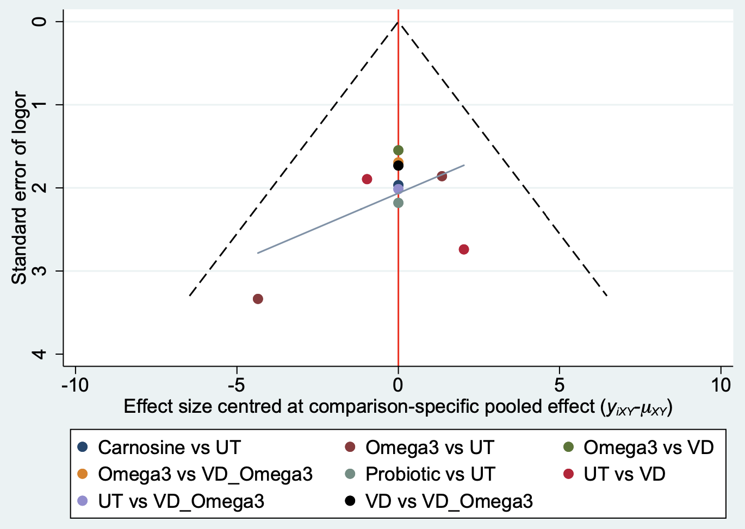
Figure S6 Funnel plot of irritability scores

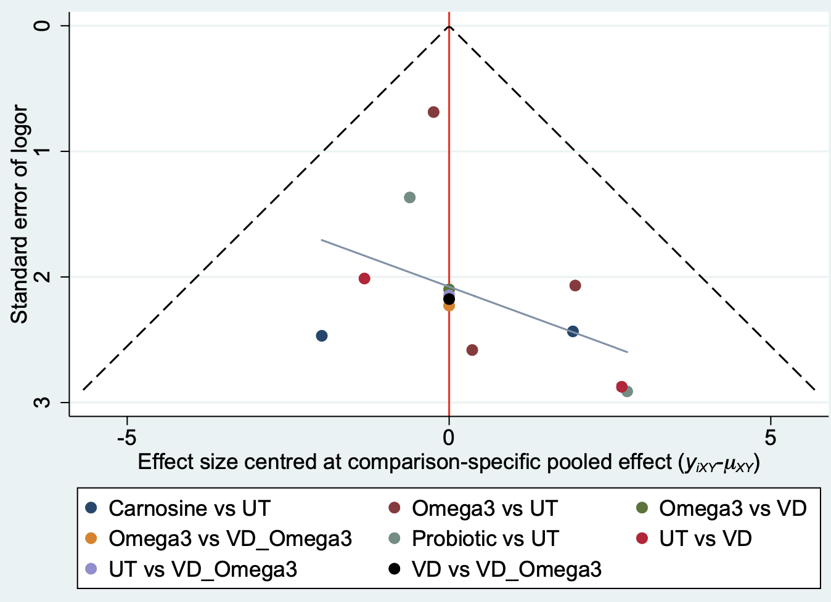
Figure S7 Funnel plot of hyperactivity scores

