Supplemental Table [S1]: Summary of Feature Extraction and Hyperparameter Optimization Space.
Component | Description | Specific Parameters/Settings Used
Feature Extraction | Atlas: | Brainnetome Atlas (246 ROIs)
 | Local Activity Metrics: | ALFF, fALFF, ReHo, DC
 | Functional Connectivity: | 30 Seed Regions; Whole-brain connectivity profiles (Pearson correlation to 246 ROIs)
 | Total Features: | 8,634 features per participant
 | Feature Selection: | SelectKBest (k dynamically set: 10-50 based on sample size)
Hyperparameter Tuning | Optimization Method: | Bayesian Optimization (50 iterations)
 | SVM (RBF Kernel): | C: 1.0, class_weight: balanced
 | Random Forest: | n_estimators: 200, max_depth: 10, min_samples_split: 5, class_weight: balanced_subsample
 | XGBoost: | n_estimators: 200, max_depth: 5, learning_rate: 0.1, scale_pos_weight: adjusted for class imbalance
 | Logistic Regression: | C: 0.5, solver: 'liblinear', class_weight: balanced, penalty: L2
 | Gradient Boosting: | n_estimators: 200, max_depth: 5, learning_rate: 0.1
Validation Framework | Strategy: | Nested Cross-Validation (5-fold outer, 5-fold inner)
 | Preprocessing: | RobustScaler (fitted only on inner training folds to prevent leakage)
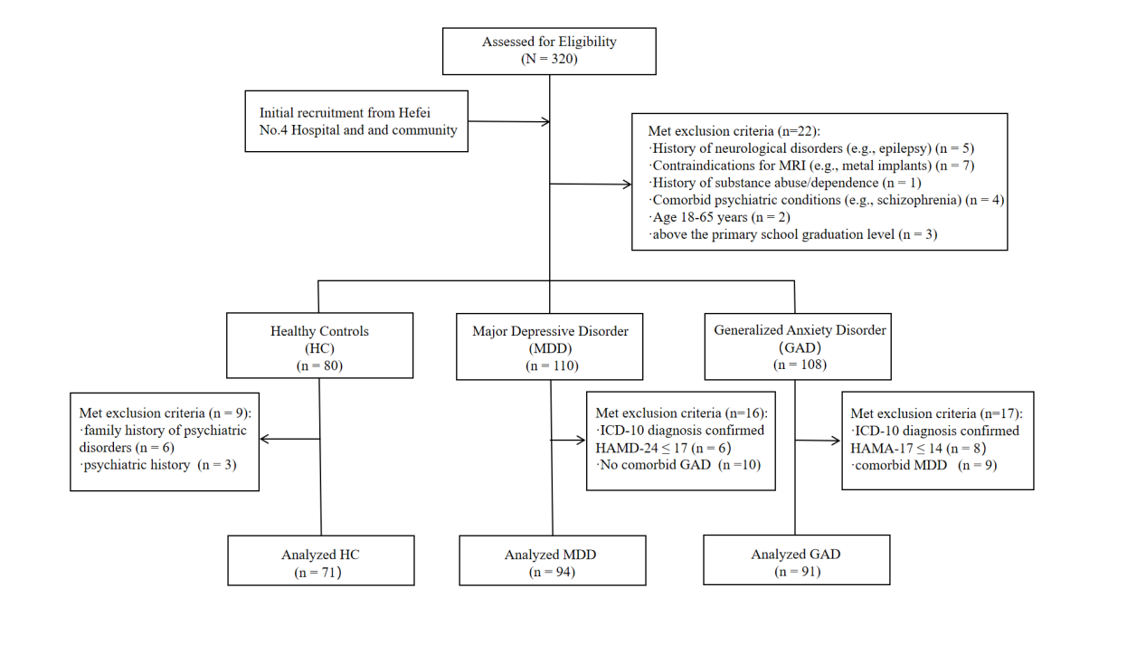
Supplementary Figure 1. CONSORT flow diagram of participant selection. The chart details the recruitment, screening, exclusion, and final allocation of participants into the Healthy Control (HC), Major Depressive Disorder (MDD), and Generalized Anxiety Disorder (GAD) groups.
Supplementary Note. Cleaned analysis code for the machine-learning pipeline, including the demographic baseline comparison, explicit positive-class specification, AUC directionality check, nested cross-validation, Bayesian optimization, covariate residualization, permutation importance, and SHAP-based interpretation, is available at https://github.com/xiaobi891292/neuro-ml-imaging. Participant-level clinical and neuroimaging data are not publicly shared due to ethical and privacy restrictions.

