Supplementary Information for Gray Matter Volume Alterations in Early-Adulthood Major Depressive Disorder Patients With Non-Suicidal Self-Injury and Suicide Attempts

Contents:
Supplementary Figure 1. Correlation Analysis Between Gray Matter Volume in Differential Brain Regions and Clinical Scale Scores
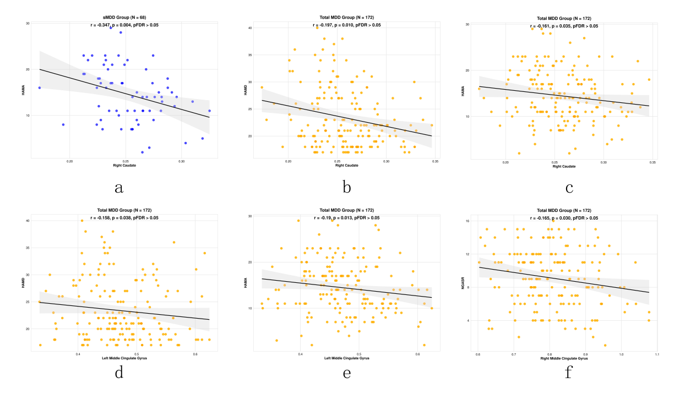
Supplementary Figure 1. Scatter plots illustrate the correlations between gray matter volume (GMV) of selected brain regions and clinical scale scores. (a) Correlation between right caudate GMV and HAMA scores in the pure major depressive disorder group (sMDD, n = 68). (b–c) Correlations between right caudate GMV and HAMD (b) and HAMA (c) scores in all participants (n = 172). (d–e) Correlations between left middle cingulate gyrus GMV and HAMD (d) and HAMA (e) scores in all participants (n = 172). (f) Correlation between right middle cingulate gyrus GMV and NGASR scores in all participants (n = 172). Solid lines represent linear regression fits, and shaded areas indicate 95% confidence intervals. Correlation coefficients (r) and uncorrected p values are shown in each panel. None of the correlations survived false discovery rate (FDR) correction (pFDR > 0.05).

Supplementary Table 1. Gray Matter Valume Differences In Brain Regions Across The Four Groups
Brain Region（AAL） | Peak MNI Coordinates（x，y，z） | Cluster Size | Peak F/t Value
Brain Regions with Group Differences
Right Superior Frontal Gyrus/Rectus Gyrus | 11 33 -24 | 2163 | 16.603
Right Caudate | 14 -2 20 | 5122 | 11.765
Left Superior Frontal Gyrus/Right Superior Frontal Gyrus | 2 63 27 | 3898 | 11.199
Right Superior Temporal Gyrus/Middle Temporal Gyrus | 63 -14 12 | 3836 | 13.438
Left Caudate | -6 15 5 | 2661 | 11.485
Left Middle Cingulate Gyrus/Right Middle Cingulate Gyrus | -2 -44 50 | 1148 | 9.977
MDD/SA VS MDD/NSSI
Right Rectus gyrus | 5 39 -24 | 2132 | -6.943
Right Caudate | 12 -3 21 | 5120 | -5.507
Right Middle Temporal Gyrus | 66 -30 -2 | 2460 | -5.757
Left Middle Cingulate Gyrus | -2 45 50 | 3679 | -5.493
Left Caudate | -14 8 0 | 2661 | -5.492
Right Superior Temporal Gyrus | 63 -14 12 | 1227 | -3.921
Right Middle Cingulate Gyrus | 5 -33 38 | 1146 | -5.649
MDD/SA VS sMDD
Right Superior Frontal Gyrus | 17 35 -23 | 535 | -4.823
MDD/SA VS HCs
Right Superior Temporal Gyrus/Right Amygdate | 21 0 -18 | 384 | -4.217
Right Middle Temporal Gyrus | 54 -11 -17 | 213 | -4.317
Right Caudate | 14 15 21 | 150 | -3.831
Supplementary Table 1. Brain regions are defined according to the Automated Anatomical Labeling (AAL) atlas. Peak MNI coordinates (x, y, z) indicate the location of the maximum statistical difference within each cluster, and cluster size (K) refers to the number of contiguous voxels. Peak F values are reported for the overall group comparison, whereas peak t values are reported for pairwise comparisons.
Statistical significance was set at a voxel-level threshold of p < 0.001, with cluster-level Gaussian random field (GRF) correction at p < 0.05.
Abbreviations: AAL, Automated Anatomical Labeling; MNI, Montreal Neurological Institute; MDD/SA, major depressive disorder with suicide attempt; MDD/NSSI, major depressive disorder with non-suicidal self-injury; sMDD, major depressive disorder without self-harm behaviors; HCs, healthy controls.

Supplementary Table 2. General linear model of regional gray matter volume associated with MDD, SA, and NSSI
Brain Region | Predictor | B | 95%CI | P | η²p
Right Rectus Gyrus | MDD | 0.001 | -0.019, 0.022 | 0.900 | 0.000
 | SA | -0.013 | -0.040, 0.013 | 0.312 | 0.004
 | NSSI | 0.049 | 0.026, 0.071 | < 0.001* | 0.076
Right Caudate | MDD | -0.004 | -0.015, 0.006 | 0.420 | 0.003
 | SA | -0.002 | -0.016, 0.012 | 0.770 | 0.000
 | NSSI | 0.025 | 0.013, 0.036 | < 0.001* | 0.072
Right Middle Temporal Gyrus | MDD | -0.020 | -0.042, 0.002 | 0.069 | 0.014
 | SA | 0.004 | -0.023, 0.031 | 0.790 | 0.000
 | NSSI | 0.051 | 0.028, 0.074 | < 0.001* | 0.078
Left Middle Cingulate Gyrus | MDD | 0.000 | -0.020, 0.019 | 0.977 | 0.000
 | SA | 0.007 | -0.017, 0.032 | 0.558 | 0.001
 | NSSI | 0.044 | 0.023, 0.064 | < 0.001* | 0.072
Left Caudate | MDD | 0.006 | -0.007, 0.018 | 0.374 | 0.003
 | SA | -0.004 | -0.020, 0.012 | 0.627 | 0.001
 | NSSI | 0.024 | 0.010, 0.037 | < 0.001* | 0.049
Right Superior Temporal Gyrus | MDD | -0.020 | -0.039, 0.000 | 0.049* | 0.017
 | SA | 0.005 | -0.019, 0.030 | 0.674 | 0.001
 | NSSI | 0.053 | 0.033, 0.074 | < 0.001* | 0.101
Right Middle Cingulate Gyrus | MDD | -0.002 | -0.034, 0.030 | 0.898 | 0.000
 | SA | -0.018 | -0.058, 0.022 | 0.372 | 0.003
 | NSSI | 0.054 | 0.021, 0.088 | 0.002* | 0.042
Supplementary Table 2. A general linear model (GLM) was performed to examine the independent associations of MDD, SA, and NSSI with regional gray matter volume. All clinical variables were entered simultaneously into the same model. Healthy controls (HCs) served as the reference category. The model included age, sex, years of education, and TIV as covariates. Each predictor was coded as a binary variable (0 = absence, 1 = presence). B represents the regression coefficient reflecting the difference in gray matter volume relative to the HC group. 95% CI indicates the 95% confidence interval. η²p denotes partial eta-squared as a measure of effect size. *p < 0.05.
Abbreviations: MDD, major depressive disorder; NSSI, non-suicidal self-injury; sMDD, major depressive disorder without self-harm behaviors; HCs, healthy controls.

Supplementary Table 3. Sensitivity analysis excluding participants with a lifetime history of suicide attempts
Brain Region | Original P | Excluding 9 NSSI patients with lifetime SA history | Direction consistency
Right Rectus Gyrus | 0.001 | 0.001 | Yes
Right Caudate | 0.001 | 0.001 | Yes
Right Middle Temporal Gyrus | 0.004 | 0.016 | Yes
Left Middle Cingulate Gyrus | 0.020 | 0.142 | No
Left Caudate | 0.005 | 0.005 | Yes
Right Superior Temporal Gyrus | 0.001 | 0.007 | Yes
Right Middle Cingulate Gyrus | 0.003 | 0.014 | Yes
Supplementary Table 3. To assess the robustness of the main findings, we performed a sensitivity analysis excluding nine participants with a lifetime history of suicide attempts. The same general linear model (GLM) was applied as in the primary analysis, including age, sex, and total intracranial volume as covariates. Direction consistency indicates whether the direction of GMV differences remained consistent with the primary analysis.

Supplementary Table 4. Sensitivity analysis with alternative covariate specification
Brain Region | Original P | P value (alternative covariate model) | Direction consistency
Right Rectus Gyrus | 0.001 | 0.001 | Yes
Right Caudate | 0.001 | 0.033 | Yes
Right Middle Temporal Gyrus | 0.003 | 0.021 | Yes
Left Middle Cingulate Gyrus | 0.012 | 0.125 | No
Left Caudate | 0.006 | 0.034 | Yes
Right Superior Temporal Gyrus | 0.001 | 0.002 | Yes
Right Middle Cingulate Gyrus | 0.002 | 0.010 | Yes
Supplementary Table 4. P values represent Bonferroni-adjusted pairwise comparisons between the MDD/NSSI and MDD/SA groups. Sensitivity analyses replaced years of education with illness duration and additionally adjusted for HAMD-17 scores and medication load index. Direction consistency indicates whether the direction of GMV differences remained consistent with the primary analysis.

