Supplementary Information
Predicting Olanzapine Induced BMI increase using Machine Learning on population-based Electronic Health Records

Authors: Foteini D. Aktypi¹, Michael E. Benros^{2,3}, Simon Rasmussen¹
Affiliations:
- Novo Nordisk Foundation Center for Basic Metabolic Research, University of Copenhagen, Copenhagen, Denmark.
- Copenhagen Research Center for Biological and Precision Psychiatry, Mental Health Centre Copenhagen, Copenhagen University Hospital, Hellerup, Denmark.
- Department of Clinical Medicine, Faculty of Health and Medical Sciences, University of Copenhagen, Copenhagen, Denmark.

Keywords: olanzapine, antipsychotics, BMI, weight gain, predictive modeling, electronic health records, machine learning

Correspondence: Simon Rasmussen (srasmuss@sund.ku.dk) and Michael Eriksen Benros (michael.eriksen.benros@regionh.dk)

Supplementary Tables

Supplementary Table 1. Comparison of BMI and BMI variance between individuals treated and not treated with olanzapine. Summary statistics for individuals without recorded olanzapine treatment and individuals with BMI measurements during olanzapine treatment. BMI is reported in kg/m², and BMI variance represents within-individual variability across available BMI measurements. Variables are summarized using mean with standard deviation (SD), median with interquartile range (IQR) and missing values. Group differences were assessed using the Mann–Whitney U test. Effect size is reported as (r), with values interpreted as small effects.
Supplementary Table 1. Comparison of BMI and BMI variance between olanzapine-treated and non-treated individuals.
Variable | Without olanzapine (n=166,186) | On olanzapine (n=11,984) | p-value | Effect size (r)
BMI (kg/m²)
Mean (SD) | 26.21 (6.08) | 26.86 (6.22) | <0.001 | 0.07 (small)
Median [IQR] | 25.16 [21.97, 29.34] | 25.88 [22.52, 30.15]
Missing n (%) | 0.000% | 0.000%
BMI variance (kg/m²)²
Mean (SD) | 3.62 (8.22) | 4.57 (10.57) | <0.001 | 0.08 (small)
Median [IQR] | 1.22 [0.32, 3.69] | 1.53 [0.45, 4.45]
Missing n (%) | 31.80% | 52.60%

Supplementary Table 2. Performance metrics of all machine-learning models. Models tested include Logistic Regression, Random Forest, Gradient Boosting, and XGBoost across the three prediction cohorts. Reported metrics include AUROC (area under the ROC curve), PR AUC (Precision Recall), F1 Score (positive class), F1 Score (weighted), Accuracy, Sensitivity (true positive rate), Specificity (true negative rate), PPV (positive predictive value), NPV (negative predictive value), and MCC (Matthews correlation coefficient) and the 95% CI across the 5 runs for each model.

A. Model performance in the treatment-initiation cohort (prediction cohort 1) using all features in the 2016-2024 data to predict BMI increase >5%
Model | AUROC | PR AUC | F1 (positive) | F1 (weighted) | Accuracy | Sensitivity | Specificity |  | PPV |  | NPV |  | MCC
GradientBoosting | 0.717 (0.688–0.74) | 0.487 (0.457–0.511) | 0.536 (0.507–0.564) | 0.665 (0.596–0.707) | 0.65 (0.578–0.695) | 0.724 (0.619–0.846) | 0.622 (0.497–0.724) |  | 0.431 (0.377–0.466) |  | 0.857 (0.831–0.898) |  | 0.315 (0.254–0.359)
LogisticRegression | 0.703 (0.681–0.726) | 0.467 (0.438–0.5) | 0.527 (0.492–0.571) | 0.642 (0.628–0.657) | 0.624 (0.608–0.639) | 0.756 (0.676–0.885) | 0.573 (0.531–0.62) |  | 0.405 (0.385–0.422) |  | 0.862 (0.824–0.924) |  | 0.296 (0.234–0.379)
RandomForest | 0.713 (0.692–0.738) | 0.475 (0.45–0.506) | 0.516 (0.498–0.549) | 0.646 (0.533–0.709) | 0.632 (0.526–0.696) | 0.7 (0.634–0.85) | 0.606 (0.401–0.71) |  | 0.415 (0.356–0.468) |  | 0.843 (0.823–0.877) |  | 0.281 (0.239–0.342)
XGBoost | ***0.722 (0.708–0.742) | 0.492 (0.451–0.542) | 0.531 (0.513–0.541) | 0.668 (0.65–0.688) | 0.65 (0.631–0.672) | 0.712 (0.678–0.774) | 0.626 (0.577–0.67) |  | 0.425 (0.406–0.443) |  | 0.85 (0.837–0.869) |  | 0.304 (0.272–0.321)
B. Model performance in the treatment-initiation cohort (prediction cohort 1) using all features in the held-out 2025 data to predict BMI increase >5%
Model | AUROC | PR AUC | F1 (positive) | F1 (weighted) | Accuracy | Sensitivity | Specificity |  | PPV |  | NPV |  | MCC
XGBoost | 0.789 (0.775-0.808) | 0.623 (0.615-0.631) | 0.585 (0.559-0.638) | 0.714 (0.694-0.763) | 0.699 (0.677-0.751) | 0.766 (0.717-0.826) | 0.674 (0.623-0.736) |  | 0.474 (0.448-0.533) |  | 0.883 (0.867-0.906) |  | 0.396 (0.354-0.481)
C. Model performance in the treatment-initiation cohort (prediction cohort 1) using the minimal feature set in the 2016–2024 data to predict BMI increase >5%
Model | AUROC | PR AUC | F1 (positive) | F1 (weighted) | Accuracy | Sensitivity | Specificity |  | PPV |  | NPV |  | MCC
XGBoost | 0.699 (0.676–0.734) | 0.468 (0.434–0.515) | 0.499 (0.466–0.52) | 0.617 (0.577–0.66) | 0.6 (0.563–0.645) | 0.721 (0.562–0.843) | 0.553 (0.455–0.678) |  | 0.386 (0.37–0.405) |  | 0.842 (0.8–0.883) |  | 0.25 (0.216–0.281)
D. Model performance in the treatment-initiation cohort (prediction cohort 1) using the minimal feature set in the held-out 2025 data to predict BMI increase >5%
Model | AUROC | PR AUC | F1 (positive) | F1 (weighted) | Accuracy | Sensitivity | Specificity |  | PPV |  | NPV |  | MCC
XGBoost | 0.773 (0.762-0.784) | 0.592 (0.561-0.621) | 0.57 (0.55-0.594) | 0.685 (0.64-0.732) | 0.669 (0.624-0.721) | 0.794 (0.666-0.886) | 0.622 (0.527-0.742) |  | 0.449 (0.414-0.496) |  | 0.893 (0.854-0.93) |  | 0.377 (0.34-0.419)
E. Model performance in the treatment-initiation cohort (prediction cohort 1) using all features in the 2016-2024 data to predict BMI increase > 2 BMI units
Model | AUROC | PR AUC | F1 (positive) | F1 (weighted) | Accuracy | Sensitivity | Specificity |  | PPV |  | NPV |  | MCC
GradientBoosting | 0.7 (0.661–0.728) | 0.328 (0.275–0.399) | 0.371 (0.34–0.401) | 0.673 (0.646–0.693) | 0.623 (0.593–0.646) | 0.697 (0.618–0.767) | 0.609 (0.562–0.629) |  | 0.253 (0.234–0.275) |  | 0.914 (0.894–0.928) |  | 0.226 (0.173–0.273)
LogisticRegression | 0.675 (0.641–0.701) | 0.279 (0.265–0.285) | 0.351 (0.318–0.38) | 0.7 (0.625–0.735) | 0.658 (0.568–0.703) | 0.574 (0.513–0.638) | 0.674 (0.557–0.738) |  | 0.255 (0.213–0.276) |  | 0.893 (0.883–0.904) |  | 0.191 (0.136–0.235)
RandomForest | 0.7 (0.641–0.733) | 0.327 (0.236–0.397) | 0.373 (0.341–0.387) | 0.661 (0.583–0.721) | 0.611 (0.526–0.682) | 0.718 (0.626–0.767) | 0.591 (0.48–0.692) |  | 0.254 (0.22–0.28) |  | 0.917 (0.907–0.925) |  | 0.23 (0.182–0.252)
XGBoost | ***0.707 (0.663–0.741) | 0.346 (0.288–0.431) | 0.375 (0.347–0.396) | 0.711 (0.673–0.754) | 0.67 (0.623–0.726) | 0.615 (0.544–0.667) | 0.681 (0.616–0.761) |  | 0.272 (0.241–0.302) |  | 0.903 (0.896–0.914) |  | 0.228 (0.185–0.259)
F. Model performance in the treatment-initiation cohort (prediction cohort 1) using all features in the 2016-2024 data to predict exact BMI change (regression outcome)
Model | MAE | RMSE | R² | Explained variance | Median AE
DecisionTree | 1.422 (1.229–1.619) | 1.867 (1.585–2.242) | -0.093 (-0.955–0.251) | 0.001 (-0.596–0.256) | 1.038 (0.697–1.399)
GradientBoosting | 1.207 (1.096–1.317) | 1.667 (1.49–1.96) | ***0.163 (-0.115–0.356) | 0.238 (-0.077–0.368) | 0.907 (0.791–1.206)
LinearRegression | 1.863 (1.483–2.066) | 2.256 (1.805–2.435) | -0.539 (-1.131–-0.005) | -0.397 (-0.652–0.009) | 1.547 (1.132–1.855)
RandomForest | 1.278 (1.17–1.336) | 1.712 (1.52–1.917) | 0.125 (-0.104–0.27) | 0.202 (-0.011–0.293) | 0.975 (0.864–1.143)
XGBoost | 1.282 (1.055–1.5) | 1.701 (1.468–1.962) | 0.13 (-0.12–0.346) | 0.201 (-0.09–0.347) | 0.989 (0.682–1.354)
G. Model performance in the on-treatment BMI follow-up cohort (prediction cohort 2) using all features in the 2016–2024 data to predict BMI increase >5%
Model | AUROC | PR AUC | F1 (positive) | F1 (weighted) | Accuracy | Sensitivity | Specificity |  | PPV |  | NPV |  | MCC
GradientBoosting | 0.708 (0.7–0.719) | 0.405 (0.397–0.421) | 0.471 (0.462–0.479) | 0.649 (0.631–0.675) | 0.62 (0.601–0.649) | 0.722 (0.683–0.746) | 0.589 (0.56–0.639) |  | 0.349 (0.337–0.366) |  | 0.875 (0.868–0.88) |  | 0.264 (0.248–0.278)
LogisticRegression | 0.676 (0.665–0.695) | 0.372 (0.362–0.387) | 0.441 (0.431–0.447) | 0.63 (0.602–0.648) | 0.6 (0.571–0.62) | 0.676 (0.627–0.737) | 0.577 (0.52–0.613) |  | 0.328 (0.319–0.336) |  | 0.855 (0.843–0.867) |  | 0.215 (0.201–0.222)
RandomForest | 0.702 (0.688–0.716) | 0.397 (0.381–0.419) | 0.462 (0.456–0.468) | 0.623 (0.589–0.665) | 0.593 (0.559–0.638) | 0.749 (0.662–0.813) | 0.546 (0.488–0.631) |  | 0.336 (0.321–0.354) |  | 0.878 (0.86–0.896) |  | 0.251 (0.239–0.263)
XGBoost | ***0.711 (0.703–0.719) | 0.413 (0.404–0.424) | 0.474 (0.469–0.481) | 0.652 (0.625–0.672) | 0.623 (0.595–0.646) | 0.727 (0.682–0.766) | 0.591 (0.543–0.635) |  | 0.352 (0.338–0.363) |  | 0.877 (0.867–0.884) |  | 0.271 (0.262–0.282)
H. Model performance in the on-treatment BMI follow-up cohort (prediction cohort 2) using all features in the held-out 2025 data to predict BMI increase >5%
Model | AUROC | PR AUC | F1 (positive) | F1 (weighted) | Accuracy | Sensitivity | Specificity |  | PPV |  | NPV |  | MCC
XGBoost | 0.612 (0.603-0.62) | 0.227 (0.218-0.237) | 0.272 (0.248-0.294) | 0.735 (0.724-0.751) | 0.726 (0.711-0.747) | 0.298 (0.275-0.325) | 0.814 (0.791-0.838) |  | 0.25 (0.225-0.281) |  | 0.849 (0.843-0.854) |  | 0.105 (0.074-0.14)
I. Model performance in the on-treatment BMI follow-up cohort (prediction cohort 2) using a minimal feature set in the 2016-2024 data to predict BMI increase >5%
Model | AUROC | PR AUC | F1 (positive) | F1 (weighted) | Accuracy | Sensitivity | Specificity |  | PPV |  | NPV |  | MCC
XGBoost | 0.691 (0.684–0.703) | 0.393 (0.379–0.413) | 0.45 (0.44–0.46) | 0.621 (0.587–0.646) | 0.591 (0.558–0.617) | 0.716 (0.645–0.803) | 0.553 (0.484–0.608) |  | 0.328 (0.322–0.335) |  | 0.866 (0.849–0.89) |  | 0.229 (0.216–0.247)
J. Model performance in the on-treatment BMI follow-up cohort (prediction cohort 2) using a minimal feature set in the held-out 2025 data to predict BMI increase >5%
Model | AUROC | PR AUC | F1 (positive) | F1 (weighted) | Accuracy | Sensitivity | Specificity |  | PPV |  | NPV |  | MCC
XGBoost | 0.584 (0.578-0.591) | 0.203 (0.197-0.206) | 0.198 (0.162-0.223) | 0.725 (0.706-0.736) | 0.725 (0.692-0.741) | 0.2 (0.149-0.236) | 0.833 (0.786-0.857) |  | 0.199 (0.175-0.219) |  | 0.834 (0.829-0.838) |  | 0.033 (0.004-0.055)
K. Model performance in the on-treatment fixed-window follow-up cohort (prediction cohort 3) using all features in the 2016–2024 data to predict BMI increase >5%
Model | AUROC | PR AUC | F1 (positive) | F1 (weighted) | Accuracy | Sensitivity | Specificity |  | PPV |  | NPV |  | MCC
GradientBoosting | 0.633 (0.588–0.685) | 0.309 (0.263–0.352) | 0.367 (0.325–0.404) | 0.573 (0.539–0.612) | 0.53 (0.495–0.568) | 0.699 (0.585–0.851) | 0.488 (0.416–0.544) |  | 0.25 (0.225–0.265) |  | 0.872 (0.834–0.922) |  | 0.151 (0.075–0.227)
LogisticRegression | 0.639 (0.621–0.657) | 0.31 (0.287–0.333) | 0.358 (0.338–0.373) | 0.615 (0.552–0.675) | 0.575 (0.509–0.645) | 0.607 (0.462–0.743) | 0.567 (0.452–0.69) |  | 0.256 (0.247–0.267) |  | 0.857 (0.84–0.879) |  | 0.14 (0.126–0.159)
RandomForest | 0.64 (0.615–0.68) | 0.291 (0.264–0.329) | 0.365 (0.35–0.39) | 0.559 (0.416–0.652) | 0.524 (0.403–0.615) | 0.702 (0.529–0.912) | 0.48 (0.28–0.636) |  | 0.25 (0.235–0.263) |  | 0.878 (0.847–0.932) |  | 0.152 (0.126–0.192)
XGBoost | ***0.642 (0.623–0.67) | 0.303 (0.282–0.332) | 0.37 (0.357–0.389) | 0.589 (0.536–0.642) | 0.546 (0.494–0.602) | 0.679 (0.597–0.774) | 0.514 (0.428–0.603) |  | 0.255 (0.244–0.269) |  | 0.869 (0.856–0.893) |  | 0.155 (0.13–0.19)
L. Model performance in the on-treatment fixed-window follow-up cohort (prediction cohort 3) using all features in the held-out 2025 data to predict BMI increase >5%
Model | AUROC | PR AUC | F1 (positive) | F1 (weighted) | Accuracy | Sensitivity | Specificity |  | PPV |  | NPV |  | MCC
XGBoost | 0.578 (0.54-0.606) | 0.288 (0.227-0.317) | 0.332 (0.299-0.37) | 0.509 (0.462-0.56) | 0.466 (0.423-0.51) | 0.693 (0.543-0.846) | 0.412 (0.343-0.502) |  | 0.219 (0.206-0.236) |  | 0.853 (0.821-0.905) |  | 0.087 (0.034-0.165)
M. Model performance in the on-treatment fixed-window follow-up cohort (prediction cohort 3) using a minimal feature set in the 2016–2024 data to predict BMI increase >5%
Model | AUROC | PR AUC | F1 (positive) | F1 (weighted) | Accuracy | Sensitivity | Specificity |  | PPV |  | NPV |  | MCC
XGBoost | 0.627 (0.59–0.662) | 0.29 (0.273–0.31) | 0.368 (0.346–0.391) | 0.596 (0.517–0.635) | 0.554 (0.479–0.593) | 0.664 (0.556–0.803) | 0.528 (0.402–0.6) |  | 0.256 (0.241–0.272) |  | 0.868 (0.846–0.894) |  | 0.154 (0.112–0.191)
N. Model performance in the on-treatment fixed-window follow-up cohort (prediction cohort 3) using a minimal set of features in the held-out 2025 data to predict BMI increase >5%
Model | AUROC | PR AUC | F1 (positive) | F1 (weighted) | Accuracy | Sensitivity | Specificity |  | PPV |  | NPV |  | MCC
XGBoost | 0.523 (0.51-0.546) | 0.26 (0.245-0.274) | 0.289 (0.259-0.324) | 0.499 (0.39-0.548) | 0.452 (0.356-0.495) | 0.579 (0.468-0.675) | 0.422 (0.286-0.495) |  | 0.194 (0.175-0.213) |  | 0.805 (0.765-0.838) |  | -0.0 (-0.069-0.063)
O. Model performance in the on-treatment BMI to next follow-up cohort (prediction cohort 2) after removing the follow-up timing feature and predict BMI increase >5%
Model | AUROC | PR AUC | F1 (positive) | F1 (weighted) | Accuracy | Sensitivity | Specificity |  | PPV |  | NPV |  | MCC
XGBoost | 0.637 (0.618–0.646) | 0.331 (0.316–0.341) | 0.415 (0.403–0.425) | 0.52 (0.474–0.549) | 0.493 (0.453–0.518) | 0.771 (0.736–0.811) | 0.409 (0.349–0.451) |  | 0.285 (0.271–0.29) |  | 0.854 (0.845–0.87) |  | 0.158 (0.128–0.178)
Supplementary Table 3. SHAP-derived feature importance for the XGBoost models across the three prediction cohorts. The table shows the top 15 predictors for each prediction cohort, ranked by the mean absolute SHAP value calculated across five model runs using the 2016–2024 test sets. Mean ∣SHAP∣ represents the average contribution of each feature to the model predictions, regardless of direction, with higher values indicating greater influence on predicted risk of >5% BMI increase. SD ∣SHAP∣ represents the variability in feature importance across the five model runs. SHAP values should be interpreted as model-based predictive associations, not as causal effects.
Supplementary Table 3. SHAP-derived feature importance for each of the three prediction cohorts.
A. Prediction Cohort 1. Summary of the top 15 features contributing to the XGBoost predictions in the 2016–2024 test data across runs
Feature | Mean |SHAP| | STD |SHAP|
Baseline BMI (kg/m²) | 0.066202865 | 0.05279645
Age (years) | 0.055798074 | 0.040068196
Number of Previous Anxiolytic Treatments | 0.026007109 | 0.014152915
Historical BMI Variance ((kg/m²)²) | 0.024876148 | 0.0190075
Proportion of Abnormal Lab Tests | 0.018560986 | 0.012963442
Historical BMI Trend per Year | 0.017406983 | 0.015152569
Active Cancer Diagnosis | 0.017128111 | 0.012758628
Sodium | 0.016390638 | 0.01657575
Number of Unique Previous Medications | 0.013971098 | 0.010622775
Olanzapine Dosage (mg) | 0.013790975 | 0.014123707
Total Previous Hospitalization Duration (days) | 0.008341361 | 0.007766445
Number of Previous BMI Assessments | 0.00743123 | 0.006916023
ATC_A12A (Calcium) | 0.006857902 | 0.011867164
Total Cholesterol | 0.006139124 | 0.006960431
ATC_B05X (Electrolyte supplements) | 0.00598016 | 0.011116025
B. Prediction Cohort 1. Summary of the top 15 features contributing to the XGBoost predictions in the 2025 test data across runs
Feature | Mean |SHAP| | STD |SHAP|
Baseline BMI (kg/m²) | 0.061726571 | 0.057662941
Age (years) | 0.054689139 | 0.040854665
Number of Previous Anxiolytic Treatments | 0.027608594 | 0.012570293
Historical BMI Variance ((kg/m²)²) | 0.025234685 | 0.020778795
Proportion of Abnormal Lab Tests | 0.018768649 | 0.011978445
Active Cancer Diagnosis | 0.018586673 | 0.010716314
Sodium | 0.018526481 | 0.016921277
Historical BMI Trend per Year | 0.014785725 | 0.013773124
Number of Unique Previous Medications | 0.013551719 | 0.009929963
Olanzapine Dosage (mg) | 0.012711508 | 0.012332472
Total Previous Hospitalization Duration (days) | 0.010322585 | 0.009297881
Number of Previous BMI Assessments | 0.00921907 | 0.007113315
Total Cholesterol | 0.007664411 | 0.006956796
ATC_G03A (Hormonal Contraceptives) | 0.007117759 | 0.009810803
Estimated Average Glucose | 0.006455745 | 0.007340359
C. Prediction Cohort 2. Summary of the top 15 features contributing to the XGBoost predictions in the 2016–2024 test data across runs
Feature | Mean |SHAP| | STD |SHAP|
Days to Next BMI Assessment | 0.126214013 | 0.074309919
Baseline BMI (kg/m²) | 0.057447696 | 0.04109463
Age (years) | 0.042263366 | 0.021512992
Days Since Olanzapine Start | 0.027968315 | 0.011603808
Olanzapine Dosage (mg) | 0.019488877 | 0.009293879
Historical BMI Trend per Year | 0.017295796 | 0.019873108
Historical BMI Variance ((kg/m²)²) | 0.011061131 | 0.008810939
ATC_A10B (Blood glucose lowering drugs) | 0.011002315 | 0.008763416
Number of Previously Unique Diagnoses | 0.008603226 | 0.010361383
Number of Previous Anxiolytic Treatments | 0.008250301 | 0.004041662
Estimated Average Glucose | 0.00800042 | 0.012875754
Albumin | 0.007745056 | 0.0057657
Number of Previous BMI Assessments | 0.007114864 | 0.008322789
Number of Active Diagnoses | 0.006641145 | 0.005688531
Currently Hospitalized | 0.005226547 | 0.007639979
D. Prediction Cohort 2. Summary of the top 15 features contributing to the XGBoost predictions in the 2025 test data across runs
Feature | Mean |SHAP| | STD |SHAP|
Days to Next BMI Assessment | 0.09335963 | 0.063406991
Baseline BMI (kg/m²) | 0.049060159 | 0.038369374
Olanzapine Dosage (mg) | 0.027268714 | 0.011376878
Age (years) | 0.027255444 | 0.015678235
Historical BMI Trend per Year | 0.018735215 | 0.013018778
Historical BMI Variance ((kg/m²)²) | 0.017746917 | 0.012267833
Number of Previous BMI Assessments | 0.014246189 | 0.007992674
ATC_A10B (Antidiabetic Agents) | 0.008523254 | 0.008012813
Number of Previous Anxiolytic Treatments | 0.008480195 | 0.004988329
Albumin | 0.006525696 | 0.004964475
Number of Previous Antipsychotic Treatments | 0.006268718 | 0.006451429
ATC_L03A (Immunostimulants) | 0.006126469 | 0.006959714
Days Since Olanzapine Start | 0.005768014 | 0.007688926
Number of Active Diagnoses | 0.00499325 | 0.004954604
ATC_L01B (Antimetabolite analogues) | 0.00496075 | 0.00713386
E. Prediction Cohort 3. Summary of the top 15 features contributing to the XGBoost predictions in the 2016–2024 test data across runs
Feature | Mean |SHAP| | STD |SHAP|
Baseline BMI (kg/m²) | 0.057819977 | 0.044169412
Age (years) | 0.040137791 | 0.030868302
Days Since Olanzapine Start | 0.031157658 | 0.02001086
Olanzapine Dosage (mg) | 0.017805654 | 0.011798877
Albumin | 0.013348718 | 0.011577288
Historical BMI Variance ((kg/m²)²) | 0.012720039 | 0.013836286
Number of Active Diagnoses | 0.010633567 | 0.009745994
Number of Previous BMI Assessments | 0.01025437 | 0.012687658
Total Previous Hospitalization Duration (days) | 0.009008693 | 0.006812897
ATC_A04A (Antiemetics and Antinauseants) | 0.00825176 | 0.004752699
Alkaline Phosphatase (ALP) | 0.008099402 | 0.01120067
Number of Previous Anxiolytic Treatments | 0.007601729 | 0.005168029
Proportion of Abnormal Lab Tests | 0.007158719 | 0.007474896
Currently Hospitalized | 0.006508202 | 0.01031511
ATC_A10B (Blood glucose lowering drugs) | 0.006120699 | 0.00828097
F. Prediction Cohort 3. Summary of the top 15 features contributing to the XGBoost predictions in the 2025 test data across runs
Feature | Mean |SHAP| | STD |SHAP|
Baseline BMI (kg/m²) | 0.047240182 | 0.041541344
Age (years) | 0.042857847 | 0.029667389
Olanzapine Dosage (mg) | 0.022586434 | 0.014539567
Number of Previous BMI Assessments | 0.018638583 | 0.014232351
Historical BMI Variance ((kg/m²)²) | 0.016182403 | 0.015295274
Albumin | 0.014237722 | 0.01134299
Active Cancer Diagnosis | 0.009188706 | 0.006344317
Number of Active Diagnoses | 0.009151283 | 0.008477397
Alkaline Phosphatase (ALP) | 0.007923906 | 0.012000392
Total Previous Hospitalization Duration (days) | 0.007904376 | 0.006056416
Proportion of Abnormal Lab Tests | 0.007687794 | 0.007576789
Days Since Olanzapine Start | 0.007669629 | 0.007376706
Number of Previous Anxiolytic Treatments | 0.007351335 | 0.006219654
ATC_L01B (Antimetabolite analogues) | 0.007232431 | 0.013907725
ATC_A04A (Antiemetics and Antinauseants) | 0.007092444 | 0.004055161

Supplementary Table 4. Table of engineered features. Summary of the set of engineered features used for modeling and analysis, organized into categories: BMI History, Medication Exposure, Diagnosis History, Healthcare utilization, Smoking, Temporal Dynamics and Laboratory values. Each feature/feautre set is listed alongside a brief description of how it is defined or derived from the raw data. By capturing multiple dimensions—body weight historical trends, medication use, clinical background, and temporal information—we can capture a comprehensive view of each patient’s longitudinal health profile. Such multidimensional data can enhance predictive modeling and help identify patterns associated with treatment responses or disease progression.
Supplementary Table 4. Table of engineered features with descriptions.
Category | Feature | Description
Demographics | Age (years) | Age of the individual at the baseline BMI index date
BMI History | Baseline BMI (kg/m²) | BMI value at the baseline/index BMI assessment.
BMI History | Historical BMI Variance (kg/m²)² | Variability in previous BMI measurements.
BMI History | Number of Previous BMI Assessments | Number of BMI measurements recorded before the index assessment.
BMI History | Historical BMI Trend per Year | Estimated longitudinal BMI slope based on previous BMI measurements.
BMI History | BMI increase >5% | Binary prediction outcome indicating whether BMI increased by more than 5% at the next BMI assessment.
Medication Exposure | Number of Unique Previous Medications | Number of distinct medications prescribed before the index date.
Medication Exposure | Number of Previous Olanzapine Treatments | Number of previous olanzapine treatment episodes or prescriptions before the index date.
Medication Exposure | Number of Previous Antipsychotic Treatments | Number of previous antipsychotic treatment episodes before the index date.
Medication Exposure | Number of Previous Antidepressant Treatments | Number of previous antidepressant treatment episodes before the index date.
Medication Exposure | Number of Previous Anxiolytic Treatments | Number of previous anxiolytic treatment episodes before the index date.
Medication Exposure | ATC code indicators (all 'ATC_' features) | Set of binary indicators encoding whether the individual had exposure to specific medication classes, grouped by ATC code.
Diagnosis / Comorbidity | Number of Active Diagnoses | Number of diagnosis codes active at the index date.
Diagnosis / Comorbidity | Number of Previously Unique Diagnoses | Number of unique diagnosis codes recorded before the index date.
Diagnosis / Comorbidity | Active Schizophrenia Diagnosis | Binary indicator for active schizophrenia diagnosis at the index date.
Diagnosis / Comorbidity | Active Bipolar Disorder Diagnosis | Binary indicator for active bipolar disorder diagnosis at the index date.
Diagnosis / Comorbidity | Active Cancer Diagnosis | Binary indicator for active cancer diagnosis at the index date.
Diagnosis / Comorbidity | SKS code indicators (all 'SKS_' features) | Set of binary indicators encoding whether the individual had specific diagnosis categories recorded in their clinical history, grouped by SKS code.
Healthcare utilization | Currently Hospitalized | Binary indicator for whether the patient was hospitalized at the index date.
Healthcare utilization | Number of Previous Hospitalizations | Number of hospital admissions before the index date.
Healthcare utilization | Total Previous Hospitalization Duration (days) | Total number of hospital days before the index date.
Healthcare utilization | Number of Previous Emergency Visits | Number of emergency visits before the index date.
Lifestyle | Smoking Status indicators | Set of binary indicators for smoking status categories: frequently, never, passive, previously, and rarely.
Temporal dynamics | Days Since Olanzapine Start | Number of days between olanzapine treatment start and the index BMI assessment.
Temporal dynamics | Days to Next BMI Assessment (used only in prediction cohort 2) | Number of days between the index BMI assessment and the next BMI assessment.
Laboratory values | Proportion of Abnormal Lab Tests | Number of abnormal lab values compared to the values tested.

Supplementary Table 5. Descriptive statistics table of all features used in prediction cohort 1 (SupplementaryTables.xlsx). Summary statistics of the 457 model features used in the treatment-initiation prediction cohort. In this cohort, baseline BMI was defined as the most recent BMI measurement recorded up to 90 days before olanzapine initiation, and follow-up BMI was defined as the first BMI measurement recorded 30–180 days after olanzapine initiation. The table includes feature missingness, binary feature prevalence, and mean, median (Q₂₅, Q₇₅) summary statistics for continuous variables.

Supplementary Table 6. Descriptive statistics table of all features used in prediction cohort 2 (SupplementaryTables.xlsx). Summary statistics for all 459 feature variables across individuals included in prediction cohort 2, where baseline BMI was defined as the first BMI measurement during olanzapine treatment and follow-up BMI was defined as the next available BMI measurement. The table includes feature missingness, binary feature prevalence, and mean, median (Q₂₅, Q₇₅) summary statistics for continuous variables.

Supplementary Table 7. Descriptive statistics table of all features used in prediction cohort 3 (SupplementaryTables.xlsx). Summary statistics for all 458 feature variables across individuals included in prediction cohort 3, where baseline BMI was defined as the first BMI measurement during olanzapine treatment and follow-up BMI was within a fixed window of 30-180 days later. The table includes feature missingness, binary feature prevalence, and mean, median (Q₂₅, Q₇₅) summary statistics for continuous variables.

Supplementary Figures

Supplementary Figure 1. Density plots of treatment start date and age for individuals treated with olanzapine to compare those included with those excluded from the study. (A) Olanzapine start date by age in included vs excluded females. (B) Olanzapine start date by age in included vs excluded males. Included individuals were younger than excluded individuals at first recorded olanzapine treatment, and more often had their first recorded olanzapine treatment between 2017-2019, whereas excluded individuals were much older and more concentrated towards the end of the study period. This pattern may reflect limited follow-up time for individuals treated near the end of the study period, preventing them from meeting the BMI follow-up inclusion criteria. Additionally, some individuals with early olanzapine records may already have been psychiatric patients before the EHR system was introduced in 2016, meaning that the first recorded olanzapine date may not always represent true treatment initiation.

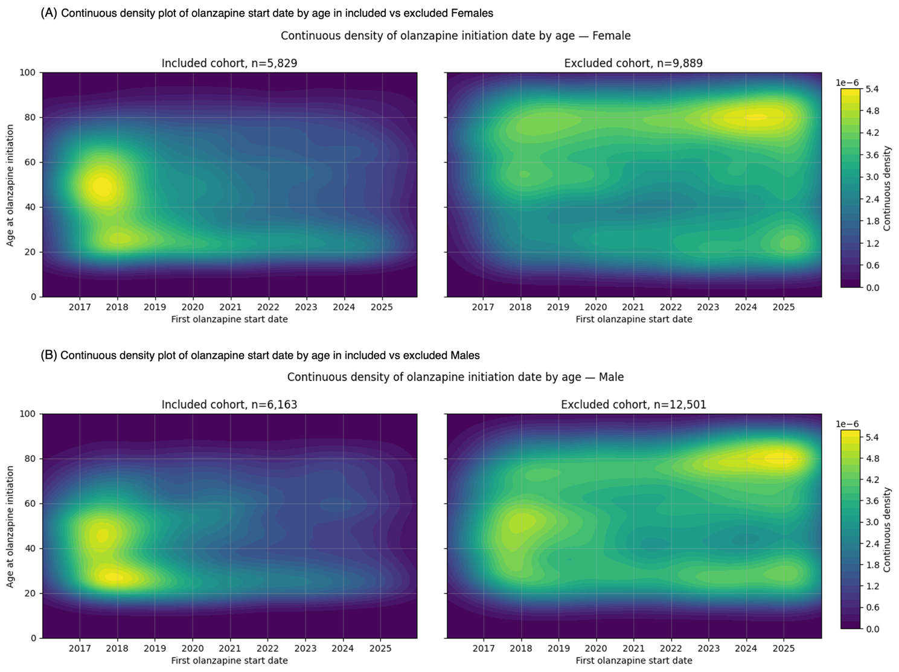

Supplementary Figure 2. Characteristics of olanzapine-treated individuals included and excluded from the prediction cohorts, stratified by sex. (A) Source of olanzapine treatment records among included and excluded individuals. Treatment source record was categorized as prescription, medication administration, or both. Excluded individuals had proportionally more olanzapine records from hospital administration, suggesting that a larger fraction of excluded patients received olanzapine in an inpatient or acute-care context. (B) Disease and medication burden in included and excluded individuals. Disease burden was summarized as the number of unique previous diagnosis codes, and medication burden as the number of unique previous ATC medication codes. Excluded individuals generally had higher disease and medication burden than included individuals, consistent with older age. (C) BMI distributions before and after olanzapine treatment among included and excluded individuals. BMI values were broadly comparable between groups, but included individuals showed slightly higher BMI distributions, suggesting possible differences in BMI monitoring or metabolic risk documentation.

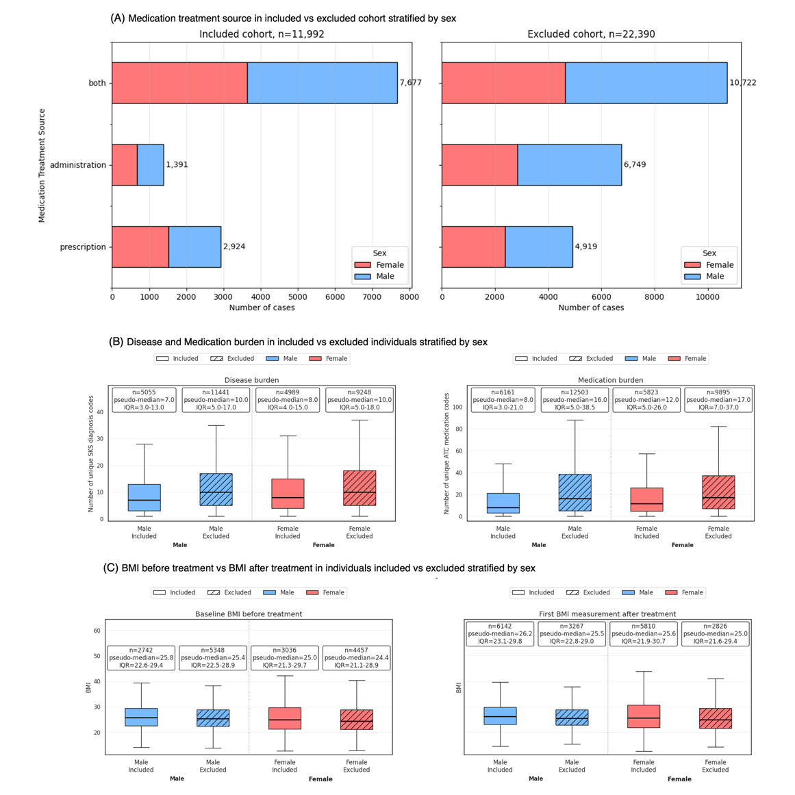

Supplementary Figure 3. Correlation heatmap of the outcome variable with historical summary features and laboratory variables. The heatmap shows pairwise Spearman correlation coefficients. Red indicates positive correlations and blue indicates negative correlations. The analysis was performed as a descriptive assessment of relationships within the EHR-derived feature set before model training. Overall, the binary outcome of >5% BMI increase showed only weak pairwise correlations with individual predictors, indicating that no single variable strongly explained the outcome on its own. Higher risk of BMI increase tended to be associated with lower baseline BMI and younger age, while positive associations were observed for features reflecting clinical complexity and prior patient history, including olanzapine dosage, previous anxiolytic treatment, hospitalization burden, and historical BMI variability. These findings supported the inclusion of engineered longitudinal and healthcare-use features in the predictive models. The heatmap also showed clinically plausible relationships among the predictors themselves. Measures of disease burden and treatment complexity, such as previous hospitalizations, hospitalization duration, medication burden, diagnosis burden, and previous psychotropic treatments, were positively correlated with one another. Olanzapine dosage was associated with markers of more intensive treatment exposure, including longer hospitalization-related history and greater prior medication burden. Laboratory variables also formed expected correlation patterns, including clustering among hematological markers, lipid-related markers, glycaemic markers, and inflammatory or liver-related tests. In addition, kidney-function markers showed the expected inverse relationship between creatinine and estimated glomerular filtration rate. Taken together, these patterns suggest that the EHR-derived feature set captured coherent biological and clinical structure relevant for downstream modeling.

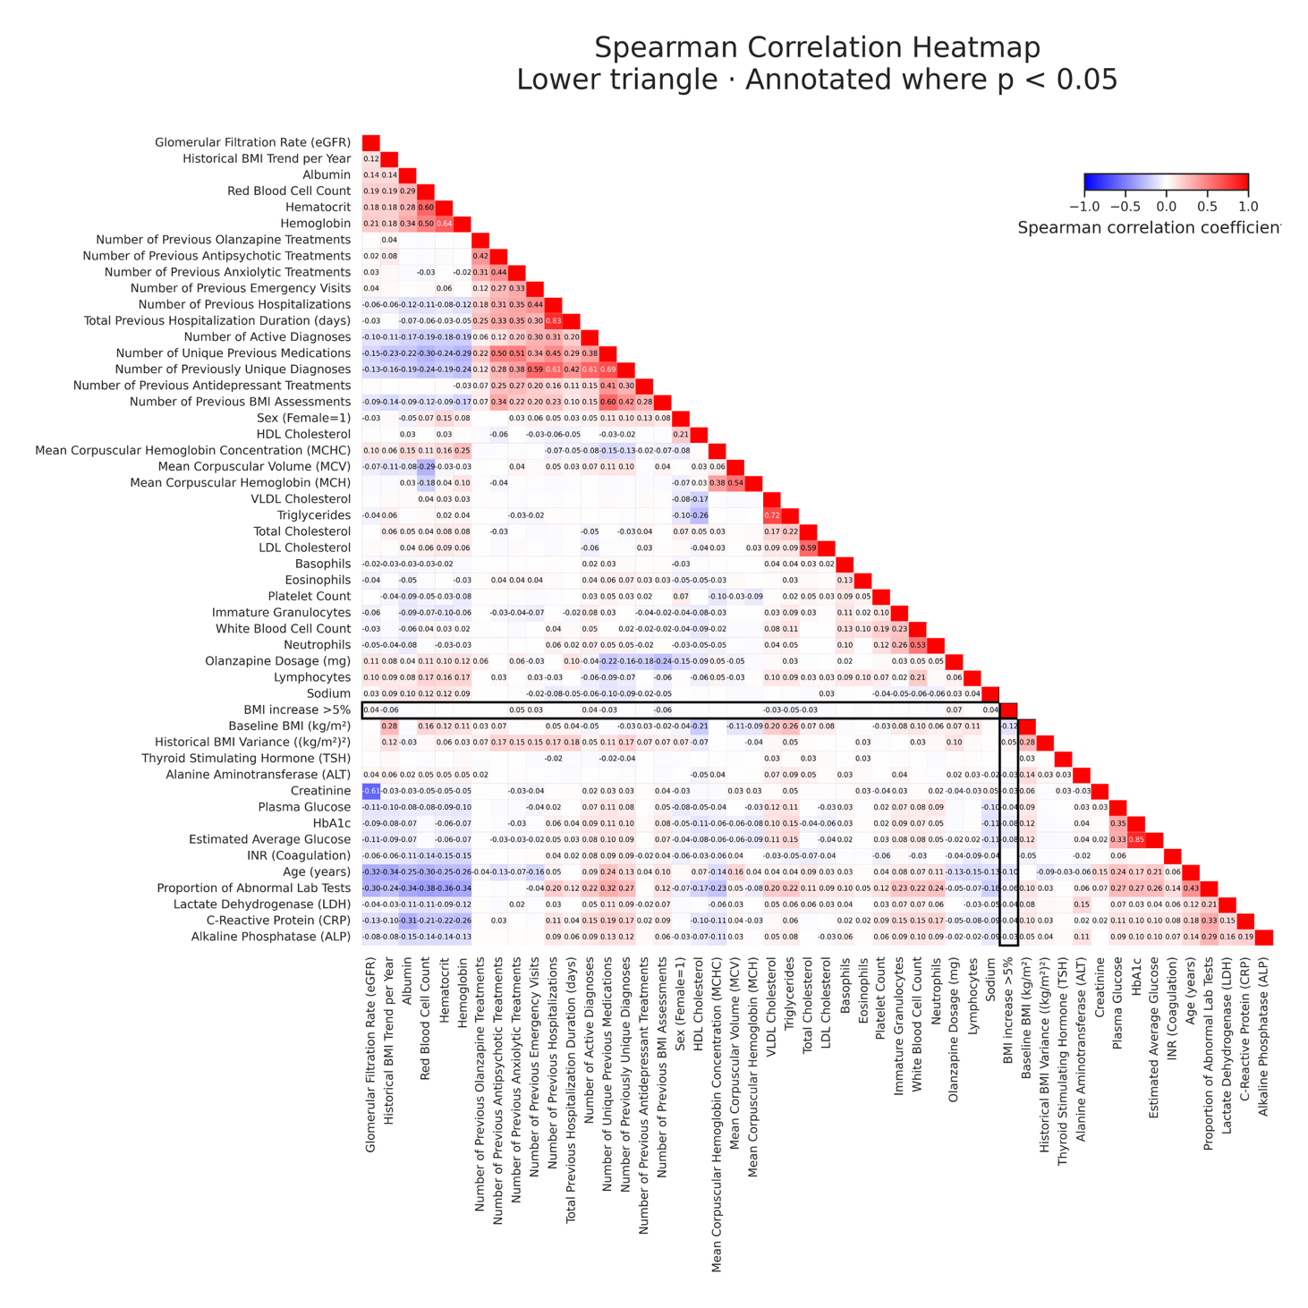

Supplementary Figure 4. SHAP analysis for the held-out 2025 test set across the three prediction cohorts. SHAP density plots show the contribution of the top-ranked features from the corresponding 2016–2024 XGBoost models when evaluated on the held-out 2025 data. Panels show (A) prediction cohort 1, (B) prediction cohort 2, and (C) prediction cohort 3. Each point represents an individual prediction, with red indicating higher feature values and blue indicating lower feature values. Positive SHAP values indicate features contributing toward higher predicted risk of >5% BMI increase, while negative values indicate features contributing toward lower predicted risk. These plots were used to assess whether feature effects in the temporal test set were broadly consistent with the 2016–2024 analyses.

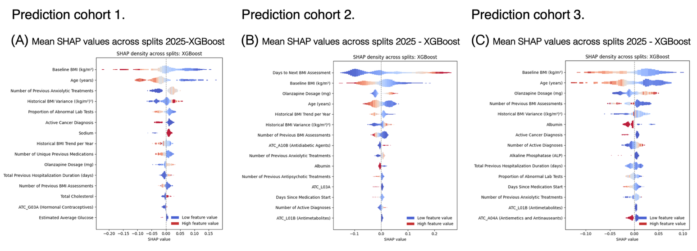

Supplementary Methods

Source tables and initial preprocessing
The EHR source tables used in this study included patient demographics including sex and birth date, health assessments including height, weight and BMI and smoking status, medication records, diagnosis records, laboratory results, hospital admissions and emergency encounters. Tables were first cleaned to ensure consistent variable types. Numeric fields were converted to numeric values, timestamps were converted to datetime format, categorical fields were standardized, and binary fields were converted to Boolean or integer encodings. Placeholder strings representing missing values were replaced with a uniform missing-value marker, and duplicate records were removed.
All records were restricted to the study period from 2016 to 2025. To reduce memory use and ensure relevance to the study population, preprocessing was performed on individuals with at least one olanzapine medication record.

BMI preprocessing and longitudinal BMI features
BMI was calculated using recorded weight and each individual’s median adult height. BMI records were retained only for individuals aged ≥18 years at the time of measurement. Height values were restricted to 100–220 cm, and records without valid recalculated BMI were removed. Extreme recalculated BMI values outside the 0.1st and 99.9th percentiles were excluded. BMI records were sorted by individual and timestamp, duplicate records were removed, and multiple records at the same timestamp were collapsed to one observation.
Longitudinal BMI features were calculated using only BMI measurements available up to each timestamp. These included the number of previous BMI assessments, historical BMI variance, historical BMI slope per year. Future BMI values were used only to define the outcome and were not included as predictors.

Medication preprocessing and olanzapine exposure
Olanzapine exposure was defined using ATC code N05AH03. Medication records were cleaned by removing duplicate entries, standardizing timestamps, and excluding invalid intervals. For olanzapine, records with implausible dosage values outside the expected range of 2.5–40 mg were excluded. Medication frequency descriptions were standardized, and corrected daily dosage estimates were calculated where possible.
Medication periods/intervals were created from prescription and administration timestamps. If a discontinued date was missing, administration timestamps were used when available. Otherwise, medication intervals were treated as ongoing until the end of the study period. Medication intervals with end dates earlier than start dates were corrected by setting the start and end time to the same timestamp. Intervals for the same individual and medication were merged when they were separated by less than 48 hours. From these intervals, we derived features including prior medication counts, olanzapine dosage, previous olanzapine exposure, previous antipsychotic, antidepressant and anxiolytic treatments and the number of unique previous medications.

Diagnosis preprocessing
Diagnosis records were cleaned and standardized using SKS diagnosis codes. When valid SKS codes were missing, diagnosis descriptions were cleaned and matched to valid codes using pattern matching and fuzzy matching against official code descriptions. Records without a valid code after this process were excluded. Diagnosis codes were truncated to a four-character format to reduce sparsity and grouped according to the SKS hierarchy. For each individual, diagnosis intervals were sorted and overlapping intervals within 48 hours were merged. Diagnosis-derived features included active diagnoses at the baseline timestamp, counts of previous unique diagnoses, selected diagnosis group indicators, and diagnosis burden measures.

Laboratory test preprocessing
Laboratory test records were restricted to relevant individuals and processed before being merged to BMI or medication baseline timestamps. Laboratory abnormality flags were encoded as ordinal values, where low=1, normal=2, and high=3 values were represented as separate ordered categories. Laboratory results were processed so that each laboratory test code became a separate feature. For each individual, the latest available laboratory result before the baseline timestamp was used, and previous laboratory measurements were forward-filled within individual histories. Additional laboratory history features included the proportion of abnormal laboratory tests. Laboratory features with more than 50% missingness were removed before modeling.

Hospital admissions, healthcare contacts, and clinical assessments
Hospital admission records were merged to the baseline timestamp using historical information only. Features included the number of previous hospitalizations, total previous hospitalization duration, and whether the individual was hospitalized at the baseline timestamp. Additionally, emergency visit healthcare contact features were summarized in the variable number of previous emergency visits.
The code for the study presented in this paper is openly accessible and can be found in on the GitHub repository at https://github.com/fotiniak/bmipred. The code was tailored specifically to the data structure available for our system, and it might therefore not be easily generalizable to other data sources.

