Comparative effectiveness and dose–response relationships of exercise for depressive symptoms in children and adolescents: a Bayesian network meta-analysis

Supplementary Material
No. | Supplemental material | Page
1 | Search Strategy | 1
2 | Reasons for Excluding Studies | 2-4
3 | Characteristics of Included Studies | 5-7
4 | Risk of Bias Assessment | 8-9
5 | Model selection and heterogeneity assessment | 9-15
6 | Key Assumptions of Network Meta-Analysis | 16
7 | Effect size analysis and SUCRA ranking | 16-17
8 | Subgroup analysis | 17-29
9 | Publication bias and sensitivity analysis | 30-32
10 | Key Assumptions of Dose-Response Network Meta-Analysis | 32-35
11 | Model Selection for Dose-Response Analysis | 35-37
12 | Dose-Response Relationship | 37-38
13 | GRADE Evidence Quality | 39-41

1. Search Strategy
Supplementary Table 1. Search Strategy
Pubmed | (Exercise*[Title/Abstract]  OR "physical activity*"[Title/Abstract]  OR sport*[Title/Abstract]  OR aerobic*[Title/Abstract]  OR "resistance training"[Title/Abstract]  OR "strength training"[Title/Abstract]  OR "high intensity interval training"[Title/Abstract]  OR HIIT[Title/Abstract]  OR yoga[Title/Abstract]  OR pilates[Title/Abstract]  OR "tai chi"[Title/Abstract]  OR qigong[Title/Abstract])  AND  (Depress*[Title/Abstract]  OR depressive[Title/Abstract]  OR "mood disorder*"[Title/Abstract])  AND  (child*[Title/Abstract]  OR adolescen*[Title/Abstract]  OR youth*[Title/Abstract])  AND  (randomized[Title/Abstract]  OR randomly[Title/Abstract]  OR trial[Title]  OR RCT[Title/Abstract])
Cochrane | #1 (Exercise*  OR (physical NEXT activity*)  OR sport*  OR aerobic*  OR (resistance NEXT training)  OR (strength NEXT training)  OR (high NEXT intensity NEXT interval NEXT training)  OR HIIT  OR yoga  OR pilates  OR (tai NEXT chi)  OR qigong  ):ti,ab,kw  #2 (Depress*  OR depressive  OR (mood NEXT disorder*)  ):ti,ab,kw  #3 (child* OR adolescen* OR youth*):ti,ab,kw  #4 (random* OR (controlled NEXT trial) OR RCT):ti,ab,kw  #5 #1 AND #2 AND #3 AND #4
2. Reasons for Excluding Studies
Supplementary Table 2. Reasons for Excluding Studies
Study | Reasons for Exclusion
Ahmed et al. (2023) [1] | No relevant data
Bao and Jin (2015) [2] | Irrelevant outcomes
Blumenthal et al. (2007)[ 3] | Not the relevant population
Brown et al. (1992) [4] | Not relevant intervention
Bunketorp et al. (2015) [5] | No relevant data
Chau et al. (2022) [6] | Not the relevant population
Eather et al. (2016) [7] | Irrelevant outcomes
Fishbein et al. (2016) [8] | No relevant data
Frank et al. (2017) [9] | Irrelevant outcomes
Haden et al. (2014) [10] | Irrelevant outcomes
Halliwell et al. (2018) [11] | Irrelevant outcomes
Hong et al. (2020) [12] | Not the relevant control
Imboden et al. (2020) [13] | Not population
Lau et al. (2004) [14] | No relevant data
Migueles et al. (2023) [15] | No relevant data
Mirzaei (2023) [16] | Not the relevant population
Mota-Pereira et al. (2011) [17] | Not the relevant population
Nabkasorn et al. (2006) [18] | Not the relevant population
Philippot et al. (2022) [19] | Not the relevant population
Romero-Pérez et al. (2020) [20] | Not the RCT
Roth and Holmes (1987) [21] | Not the relevant population
Schuch et al. (2015) [22] | Not the relevant population
Shachar et al. (2016) [23] | Irrelevant outcomes
Vancini et al. (2017) [24] | Not population
Veale et al. (1992) [25] | Not the relevant population
Wei et al. (2025) [26] | No relevant data
- Ahmed KR, Horwood S, Kolbe-Alexander T, Khan A. Effects of a school-based physical activity intervention on adolescents’ mental health: a cluster randomized controlled trial. Journal of Physical Activity and Health. 2023;20(12):1102-1108. doi:10.1123/jpah.2023-0062.
- Bao X, Jin K. The beneficial effect of Tai Chi on self-concept in adolescents. International Journal of Psychology. 2015;50(2):101-105. doi:10.1002/ijop.12066.
- Blumenthal JA, Babyak MA, Doraiswamy PM, Watkins L, Hoffman BM, Barbour KA, et al. Exercise and pharmacotherapy in the treatment of major depressive disorder. Psychosomatic Medicine. 2007;69(7):587-596. doi:10.1097/PSY.0B013E318148C19A.
- Brown SW, Welsh MC, Labbé EE, Vitulli WF, Kulkarni P. Aerobic exercise in the psychological treatment of adolescents. Perceptual and Motor Skills. 1992;74(2):555-560. doi:10.2466/pms.1992.74.2.555.
- Bunketorp Käll L, Malmgren H, Olsson E, Lindén T, Nilsson M. Effects of a curricular physical activity intervention on children's school performance, wellness, and brain development. Journal of School Health. 2015. doi:10.1111/josh.12303.
- Chau RMW, Tsui AYY, Wong EYW, Cheung EYY, Chan DYC, Lau PMY, et al. Effectiveness of a structured physical rehabilitation program on the physical fitness, mental health and pain for Chinese patients with major depressive disorders in Hong Kong: a randomized controlled trial with 9-month follow-up outcomes. Disability and Rehabilitation. 2022;44(8):1294-1304. doi:10.1080/09638288.2020.1800833.
- Eather N, Morgan PJ, Lubans DR. Effects of exercise on mental health outcomes in adolescents: Findings from the CrossFit™ teens randomized controlled trial. Psychology of Sport and Exercise. 2016;26:14-23. doi:10.1016/j.psychsport.2016.05.008.
- Fishbein D, Miller S, Herman-Stahl M, Williams J, Lavery B, Markovitz L, et al. Behavioral and psychophysiological effects of a yoga intervention on high-risk adolescents: a randomized control trial. Journal of Child and Family Studies. 2016. doi:10.1007/s10826-015-0231-6.
- Frank JL, Kohler K, Peal A, Bose B. Effectiveness of a school-based yoga program on adolescent mental health and school performance: findings from a randomized controlled trial. Mindfulness. 2017;8(3):544-553. doi:10.1007/s12671-016-0628-3.
- Haden SC, Daly L, Hagins M. A randomised controlled trial comparing the impact of yoga and physical education on the emotional and behavioural functioning of middle school children. Focus on Alternative and Complementary Therapies. 2014;19(3):148-155. doi:10.1111/fct.12130.
- Halliwell E, Jarman H, Tylka TL, Slater A. Evaluating the impact of a brief yoga intervention on preadolescents’ body image and mood. Body Image. 2018;27:196-201. doi:10.1016/j.bodyim.2018.10.003.
- Hong JS, Kim SM, Kang KD, Han DH, Kim JS, Hwang H, et al. Effect of physical exercise intervention on mood and frontal alpha asymmetry in internet gaming disorder. Mental Health and Physical Activity. 2020;18:100318. doi:10.3390/nu12010194.
- Imboden C, Gerber M, Beck J, Holsboer-Trachsler E, Pühse U, Hatzinger M. Aerobic exercise or stretching as add-on to inpatient treatment of depression: similar antidepressant effects on depressive symptoms and larger effects on working memory for aerobic exercise alone. Journal of Affective Disorders. 2020;276:866-876. doi:10.1016/j.jad.2020.07.052.
- Lau PW, Yu CW, Lee AM, Sung RY. The physiological and psychological effects of resistance training on Chinese obese adolescents. Journal of Exercise Science & Fitness. 2004.
- Migueles JH, Cadenas-Sanchez C, Lubans DR, Henriksson P, Torres-Lopez LV, Rodriguez-Ayllon M, et al. Effects of an exercise program on cardiometabolic and mental health in children with overweight or obesity: a secondary analysis of a randomized clinical trial. JAMA Network Open. 2023. doi:10.1001/jamanetworkopen.2023.24839.
- Mirzaei M. Comparison of the effects of emotional intelligence training and yoga exercises on the social anxiety of women with depression. Novelty in Clinical Medicine. 2023. doi:10.22034/ncm.2023.394935.1082.
- Mota-Pereira J, Silverio J, Carvalho S, Ribeiro JC, Fonte D, Ramos J. Moderate exercise improves depression parameters in treatment-resistant patients with major depressive disorder. Journal of Psychiatric Research. 2011;45(8):1005-1011. doi:10.1016/j.jpsychires.2011.02.005.
- Nabkasorn C, Miyai N, Sootmongkol A, Junprasert S, Yamamoto H, Arita M, et al. Effects of physical exercise on depression, neuroendocrine stress hormones and physiological fitness in adolescent females with depressive symptoms. European Journal of Public Health. 2006;16(2):179-184. doi:10.1093/eurpub/cki159.
- Philippot A, Dubois V, Lambrechts K, Grogna D, Robert A, Jonckheer U, et al. Impact of physical exercise on depression and anxiety in adolescent inpatients: a randomized controlled trial. Journal of Affective Disorders. 2022;301:145-153. doi:10.1016/j.jad.2022.01.011.
- Romero-Pérez EM, González-Bernal JJ, Soto-Cámara R, González-Santos J, Tánori-Tapia JM, Rodríguez-Fernández P, et al. Influence of a physical exercise program in the anxiety and depression in children with obesity. International Journal of Environmental Research and Public Health. 2020;17(13):4655. doi:10.3390/ijerph17134655.
- Roth DL, Holmes DS. Influence of aerobic exercise training and relaxation training on physical and psychologic health following stressful life events. Psychosomatic Medicine. 1987;49(4):355-365.
- Schuch FB, Vasconcelos-Moreno MP, Borowsky C, Zimmermann AB, Rocha NS, Fleck MP. Exercise and severe major depression: effect on symptom severity and quality of life at discharge in an inpatient cohort. Journal of Psychiatric Research. 2015;61:25-32. doi:10.1016/j.jpsychires.2014.11.005.
- Shachar K, Ronen-Rosenbaum T, Rosenbaum M, Orkibi H, Hamama L. Reducing child aggression through sports intervention: the role of self-control skills and emotions. Children and Youth Services Review. 2016;71:241-249. doi:10.1016/j.childyouth.2016.11.012.
- Vancini RL, Rayes ABR, de Lira CAB, Sarro KJ, Andrade MS. Pilates and aerobic training improve levels of depression, anxiety and quality of life in overweight and obese individuals. Arquivos de Neuro-Psiquiatria. 2017;75(12):850-857. doi:10.1590/0004-282X20170149.
- Veale D, Le Fevre K, Pantelis C, de Souza V, Mann A, Sargeant A. Aerobic exercise in the adjunctive treatment of depression: a randomized controlled trial. Journal of the Royal Society of Medicine. 1992;85(9):541-544. doi:10.1177/014107689208500910.
- Wei X, Li H, Jia Y, Qu D, Chen S, Huang L, et al. Efficacy of a combined aerobic exercise and mindfulness intervention on depressive symptoms: a pilot randomized controlled trial. Research on Social Work Practice. 2025. doi:10.1177/10497315251316844.
- Zhang J, Qin S, Zhou Y, Meng L, Su H, Zhao S. A randomized controlled trial of mindfulness-based Tai Chi Chuan for subthreshold depression adolescents. Neuropsychiatric Disease and Treatment. 2018:2313-2321. doi:10.2147/NDT.S173255.

3. Characteristics of Included Studies
Supplementary Table 3. Characteristics of Included Studies
Author | Country | Participants  (EG/CG) | Female Proportion | Age (Mean/ Range) | Duration  (Weeks) | Frequency | Time  /Session | Interventions | Exact Dose | Dose | Residual Dose | Outcomes Measured
Annesi et al. (2005) | USA | 50/42 | 50% | 10.7 | 12 | 3 | 45 | RT | 405 | 300 | 105 | P-MSSF
Ardic et al. (2017) | USA | 33/33 | 51% | 12.83 | 12 | 1 | 10-15 | MBE | 37.5 | 300 | 262.5 | BDI
Bonhauser et al. (2005) | USA | 90/93 | 52% | 15.53 | 10 | 3 | 90 | AE+RT | 1309.5 | 1200 | 109.5 | HADS
Butzer et al. (2016) | Czech Republic | 114/94 | 63% | 12.64 | 24 | 2 | 45 | MBE | 270 | 300 | 30 | BRUMS
 |  |  |  |  |  |  |  | AE | 1116 | 1200 | 84 | BRUMS
Carter et al. (2011) | UK | 44/43 | 78% | 15.4 | 6 | 2 | 45 | AE+RT | 517.5 | 600 | 82.5 | CDI-2
Chen et al. (2022) | China | 29/32 | 57% | 15-18 | 6 | 1-2 | 120 | MBE | 540 | 600 | 60 | BDI-II-C
Crews et al. (2004) | USA | 34/32 | 50% | 9-10 | 6 | 3 | 20 | AE | 372 | 300 | 72 | BDI
Daley et al. (2014) | UK | 27/26 | NA | 13.1 | 8 | 3 | 30 | IT | 486 | 600 | 114 | CDI-2
Gaurav et al. (2013) | India | 30/30 | 0% | 16-17 | 6 | 5 | 120 | MBE | 1500 | 1500 | 0 | BADSS
Goldfield et al. (2015) | Canada | 75/78/75/76 | 70% | 14-18 | 4 | 4 | 20-45 | AE | 1098 | 1200 | 102 | BRUMS
 |  |  |  |  |  |  |  | RT | 738 | 600 | 138 | BRUMS
 |  |  |  |  |  |  |  | AE+RT | 909 | 900 | 9 | BRUMS
Gu et al. (2024) | China | 57/27 | 100% | 16.77 | 8 | 3 | 40 | AE | 792 | 900 | 108 | CES-D
Hilyer et al. (1982) | USA | 23/20 | 0% | 17 | 20 | 3 | 90 | RT | 810 | 900 | 90 | BDI
Hughes et al. (2013) | USA | 12/12 | 58% | 17 | 12 | 3 | 40 | AE+RT | 558 | 600 | 42 | CDRS-R
 |  |  |  |  |  |  |  | AE | 276 | 300 | 24 | CDRS-R
Jeong et al. (2005) | Korea | 20/20 | 100% | 16 | 12 | 3 | 45 | MBE | 648 | 600 | 48 | SCL-90-R
Koniak-Griffin (1994) | USA | 35/23 | 100% | 16.66 | 60 | 2 | 55 | AE | 528 | 600 | 72 | CES-D
Lee et al. (2009) | Korea | 21/27 | 100% | 13.3 | 8 | 2 | 40 | MBE | 320 | 300 | 20 | SCL-90-R
Lima et al. (2021) | Brazil | 218/308 | 56% | 14-16 | 24 | 4 | 50 | AE | 900 | 900 | 0 | CES-D
Lin et al. (2020) | China | 20/18 | 59% | 12-14 | 12 | 4 | 30 | AE | 840 | 900 | 60 | PHQ-9
MacMahon et al. (1988) | USA | 32/37 | 0% | 16.3 | 12 | 4 | 30 | AE | 792 | 900 | 108 | BDI
Melnyk et al. (2009) | USA | 12/7 | 73% | 15.42 | 9 | 2 | 15-20 | AE | 615 | 600 | 15 | BYI-II
Melnyk et al. (2013) | USA | 286/341 | 53% | 14.75 | 12 | 1 | 15-20 | AE | 90 | 300 | 210 | BYI-II
Mohammadi et al. (2011) | Islamic | 20/20 | NA | 15-18 | 8 | 3 | 75 | AE | 1822 | 1800 | 22 | BDI
Noggle et al. (2012) | USA | 36/15 | 54% | 17.2 | 10 | 2 | 30-40 | MBE | 200 | 300 | 100 | POMS-SF
 |  |  |  |  |  |  |  | AE | 244 | 300 | 56 | POMS-SF
Norris (1992) | UK | 29/16 | 47% | 16.8 | 10 | 2 | 25-30 | AE | 294 | 300 | 6 | MAACL
Olive et al. (2023) | Australia | 18/17 | 42% | 11.28 | 6 | 1 | 120 | AE | 360 | 300 | 60 | RCADS-S
Petty et al. (2009) | USA | 139/68 | 42% | 9.35 | 14 | 5 | 40 | IT | 1380 | 1500 | 120 | RCDS
 |  |  |  |  |  |  | 20 | AE | 690 | 600 | 90 | RCDS
Philippot et al. (2019) | Belgium | 12/11 | 48% | 10 | 5 | 4 | 50 | AE+RT | 1200 | 1200 | 0 | CDI
 |  |  |  |  |  |  |  | MBE | 500 | 600 | 100 | CDI
Philippot et al. (2022) | Belgium | 20/20 | 63% | 15.35 | 5 | 4 | 60 | AE+RT | 1080 | 1200 | 120 | HADS
Robinson et al. (2010) | USA | 134/127 | 100% | 9.4 | 72 | 5 | 45-60 | MBE | 1230 | 1200 | 30 | CDI-10
Roh et al. (2018) | Korea | 15/15 | 40% | 11.46 | 16 | 1 | 60 | AE+RT | 300 | 300 | 0 | K-POMS-B
Roshan et al. (2011) | Iran | 12/12 | 100% | 16.87 | 6 | 3 | 30-40 | AE | 696 | 600 | 96 | Ham-D
Shao (2021) | China | 32/30 | 52% | 15.83 | 8 | 1 | 120 | MBE | 576 | 600 | 24 | HADS
Silva et al. (2025) | Brazil | 165/141 | 54% | 13.5 | 12 | 2 | 20 | RT | 160 | 300 | 140 | DASS-21
Stella et al. (2005) | Brazil | 10/10 | 100% | 16 | 12 | 3 | 60 | AE | 810 | 900 | 190 | BDI
 |  |  |  |  |  |  |  | IT | 1224 | 1200 | 24 | BDI
Velasquez et al. (2015) | Colombia | 57/57 | NA | 12.5 | 12 | 2 | 120 | MBE | 600 | 600 | 0 | SDQ
Wang et al. (2023) | China | 15/15 | 37% | 12.5 | 12 | 4 | 30 | AE | 840 | 900 | 60 | PHQ-9
Weintraub et al. (2008) | USA | 9/12 | NA | 9.7 | 24 | 3-4 | 75 | AE | 1822 | 1800 | 22 | CDI-10
Williams et al. (2019) | USA | 90/85 | 61% | 9.7 | 32 | 5 | 40 | AE | 1200 | 1200 | 0 | CDI-2
Wunram et al. (2017) | Germany | 17/17 | 28% | 15.9 | 6 | 4 | 30 | RT | 324 | 300 | 24 | DIKJ
 |  |  |  |  |  |  |  | IT | 768 | 900 | 132 | DIKJ
Yu et al. (2020) | China | 99/72 | 21% | 9.8 | 32 | 5 | 60 | AE | 1410 | 1500 | 90 | DSRSC
Zhang et al. (2021) | China | 66/69 | 45% | 14.3 | 12 | 3 | 30 | AE | 720 | 600 | 120 | Ham-D
BADSS: Bhatnagar Anxiety, Depression and Stress Scale; BDI-II-C: Beck Depression Inventory-II in Chinese Version; BDI: Beck Depression Inventory; BRUMS: The 24-item Brunell Mood Scale; BUMS: The Brunel University Mood Scale; BYI-II: The Beck Depression Inventory and The Beck anxiety inventory; CDI-10: the 10-item short form of the Children's Depression Inventory; CDI-2: Children's Depression Inventory-2; CDRS-R: Childhood Depression Rating Scale Revised; CES-D: The Center for Epidemiological Studies Depression Scale; DASS-21: Depression, Anxiety, and Stress Scale - Short Form; DIKJ: Depression Inventory for Children and Adolescents; DSRSC: Depression Self-Rating Scale for Children; HADS: Hospital Anxiety Depression Scale; Ham-D: Hamilton Depression Rating Scale; K-POMS-B: the Korean Version of the Profile of Mood State-Brief; MAACL: Manual for the Multiple Affect Adjective Check List; P-MSSF: Profile of Mood States-Short Form; PHQ-9: Patient Health Questionnaire-9; POMS-SF: The Profile of Mood States-Short; RCADS-S: Revised Children's Anxiety and Depression Scale - Short Form; RCDS: Reynolds Child Depression Scale; SCL-90-R: the Symptom Check List-90-Revision; SDQ: Strengths and Difficulties Questionnaire.
4. Risk of Bias Assessment
Supplementary Table 4. Bias risk of each study
Study | Randomization process | Deviations from intended interventions | Missing outcome data | Measurement of the outcome | Selection of the reported result | Overall Bias
Annesi et al. (2005) | S | L | L | L | L | S
Ardic et al. (2017) | L | L | L | L | L | L
Bonhauser et al. (2005) | H | S | L | L | L | H
Butzer et al. (2016) | S | S | L | S | L | S
Carter et al. (2011) | L | L | L | L | L | L
Chen et al. (2022) | S | S | L | L | L | S
Crews et al. (2004) | S | S | L | L | L | S
Daley et al. (2014) | S | L | L | L | L | S
Gaurav et al. (2013) | L | L | L | L | L | L
Goldfield (2015) | L | S | L | L | L | S
Gu et al. (2024) | L | L | L | L | L | L
Hilyer et al. (1982) | L | L | S | L | L | S
Hughes et al. (2013) | L | L | L | L | L | L
Jeong et al. (2005) | L | L | L | L | L | L
Koniak-Griffin (1994) | H | L | S | L | L | H
Lee et al. (2009) | L | L | L | L | L | L
Lima et al. (2021) | L | L | S | L | L | S
Lin et al. (2020) | L | L | L | L | L | L
MacMahon et al. (2020) | S | S | L | L | L | S
Melnyk et al. (2009) | L | L | S | L | L | S
Melnyk et al. (2013) | L | L | S | L | L | S
Mohammadi et al. (2011) | H | S | L | L | L | H
Noggle et al. (2012) | L | L | S | L | L | S
Norris (1992) | S | L | S | L | L | S
Olive et al. (2023) | L | L | L | L | L | L
Petty et al. (2009) | L | S | L | L | L | S
Philippot et al. (2019) | L | L | L | L | L | L
Philippot et al. (2022) | L | L | L | L | L | L
Robinson et al. (2010) | L | L | S | L | L | S
Roh et al. (2018) | S | L | L | L | L | S
Roshan et al. (2011) | S | S | L | L | L | S
Shao (2021) | S | S | L | L | L | S
Silva et al. (2025) | L | L | S | L | L | S
Stella et al. (2005) | H | S | L | L | L | H
Velasquez et al. (2015) | S | S | L | L | L | S
Wang et al. (2023) | L | L | L | L | L | L
Weintraub et al. (2008) | L | L | L | L | L | L
Williams et al. (2019) | L | L | L | L | L | L
Wunram et al. (2017) | L | S | L | L | L | S
Yu et al. (2020) | S | S | L | L | L | S
Zhang et al. (2021) | L | L | L | L | L | L
- Annesi JJ. Correlations of depression and total mood disturbance with physical activity and self-concept in preadolescents enrolled in an after-school exercise program. Psychological Reports. 2005. doi:10.2466/pr0.96.3c.891-898.
- Ardic A, Erdogan S. The effectiveness of the COPE healthy lifestyles TEEN program: a school-based intervention in middle school adolescents with 12-month follow-up. Journal of Advanced Nursing. 2017. doi:10.1111/jan.13217.
- Bonhauser M, Fernandez G, Püschel K, Yañez F, Montero J, Thompson B, et al. Improving physical fitness and emotional well-being in adolescents of low socioeconomic status in Chile: results of a school-based controlled trial. Health Promotion International. 2005;20(2):113-122. doi:10.1093/heapro/dah603.
- Butzer B, LoRusso A, Shin SH, Khalsa SB. Evaluation of yoga for preventing adolescent substance use risk factors in a middle school setting: a preliminary group-randomized controlled trial. Journal of Youth and Adolescence. 2017. doi:10.1007/s10964-016-0513-3.
- Carter T, Guo B, Turner D, Morres I, Khalil E, Brighton E, et al. Preferred intensity exercise for adolescents receiving treatment for depression: a pragmatic randomised controlled trial. BMC Psychiatry. 2015;15(1):247. doi:10.1186/s12888-015-0638-z.
- Chen M, Yao J. Effect of positive rumination-based sports prescription on the mental health of teenagers. Psychiatria Danubina. 2022;34(1):64-70.
- Crews DJ, Lochbaum MR, Landers DM. Aerobic physical activity effects on psychological well-being in low-income Hispanic children. Perceptual and Motor Skills. 2004. doi:10.2466/pms.98.1.319-324.
- Daley AJ, Copeland RJ, Wright NP, Roalfe A, Wales JK. Exercise therapy as a treatment for psychopathologic conditions in obese and morbidly obese adolescents: a randomized controlled trial. Pediatrics. 2006;118(5):2126-2134. doi:10.1542/peds.2006-1285.
- Gaurav P, Bera TK, Uddhav S. Yoga for controlling examination anxiety, depression and academic stress among students appearing for Indian board examination. International Journal of Recent Scientific Research. 2013;4(8):1216-1219.
- Goldfield GS, Kenny GP, Alberga AS, Prud'homme D, Hadjiyannakis S, Gougeon R, et al. Effects of aerobic training, resistance training, or both on psychological health in adolescents with obesity: the HEARTY randomized controlled trial. Journal of Consulting and Clinical Psychology. 2015. doi:10.1037/ccp0000038.
- Gu Q, Zhao X, Lin L, Teo WP, Liu L, Yuan S. Effects of open-skill and closed-skill exercise on subthreshold depression in female adolescents: a randomized controlled trial. International Journal of Clinical and Health Psychology. 2024;24(4):100512. doi:10.1016/j.ijchp.2024.100512.
- Hilyer JC, Wilson DG, Dillon C, Caro L, Jenkins C, Spencer WA, et al. Physical fitness training and counseling as treatment for youthful offenders. Journal of Counseling Psychology. 1982. doi:10.1037/0022-0167.29.3.292.
- Hughes CW, Barnes S, Barnes C, DeFina LF, Nakonezny P, Emslie GJ. Depressed adolescents treated with exercise (DATE): a pilot randomized controlled trial to test feasibility and establish preliminary effect sizes. Mental Health and Physical Activity. 2013;6(2):119-131. doi:10.1016/j.mhpa.2013.06.006.
- Jeong YJ, Hong SC, Lee MS, Park MC, Kim YK, Suh CM. Dance movement therapy improves emotional responses and modulates neurohormones in adolescents with mild depression. International Journal of Neuroscience. 2005. doi:10.1080/00207450590958574.
- Koniak-Griffin D. Aerobic exercise, psychological well-being, and physical discomforts during adolescent pregnancy. Research in Nursing & Health. 1994. doi:10.1002/nur.4770170404.
- Lee HJ, Chae Y, Park HJ, Hahm DH, An K, Lee H. Turo (qi dance) training attenuates psychological symptoms and sympathetic activation induced by mental stress in healthy women. Evidence-Based Complementary and Alternative Medicine. 2009. doi:10.1093/ecam/nem120.
- Lima RA, de Barros MV, Bezerra J, Dos Santos SJ, Monducci E, Rodriguez-Ayllon M, et al. Universal school-based intervention targeting depressive symptoms in adolescents: a cluster randomized trial. Scandinavian Journal of Medicine & Science in Sports. 2022. doi:10.1111/sms.14115.
- Lin K, Stubbs B, Zou W, Zheng W, Lu W, Gao Y, et al. Aerobic exercise impacts the anterior cingulate cortex in adolescents with subthreshold mood syndromes: a randomized controlled trial study. Translational Psychiatry. 2020;10(1):155. doi:10.1038/s41398-020-0840-8.
- MacMahon JR, Gross RT. Physical and psychological effects of aerobic exercise in delinquent adolescent males. American Journal of Diseases of Children. 1988;142(12):1361-1366.
- Melnyk BM, Jacobson D, Kelly S, O'Haver J, Small L, Mays MZ. Improving the mental health, healthy lifestyle choices, and physical health of Hispanic adolescents: a randomized controlled pilot study. Journal of School Health. 2009. doi:10.1111/j.1746-1561.2009.00451.x.
- Melnyk BM, Jacobson D, Kelly S, Belyea M, Shaibi G, Small L, et al. Promoting healthy lifestyles in high school adolescents: a randomized controlled trial. American Journal of Preventive Medicine. 2013. doi:10.1016/j.amepre.2013.05.013.
- Mohammadi M. A study and comparison of the effect of team sports (soccer and volleyball) and individual sports (table tennis and badminton) on depression among high school students. 2011.
- Noggle JJ, Steiner NJ, Minami T, Khalsa SB. Benefits of yoga for psychosocial well-being in a US high school curriculum: a preliminary randomized controlled trial. Journal of Developmental & Behavioral Pediatrics. 2012. doi:10.1097/DBP.0b013e31824afdc4.
- Norris R, Carroll D, Cochrane R. The effects of physical activity and exercise training on psychological stress and well-being in an adolescent population. Journal of Psychosomatic Research. 1992;36(1):55-65. doi:10.1016/0022-3999(92)90114-H.
- Olive L, Dober M, Mazza C, Turner A, Mohebbi M, Berk M, et al. Surf therapy for improving child and adolescent mental health: a pilot randomised control trial. Psychology of Sport and Exercise. 2023. doi:10.1016/j.psychsport.2022.102349.
- Petty KH, Davis CL, Tkacz J, Young-Hyman D, Waller JL. Exercise effects on depressive symptoms and self-worth in overweight children: a randomized controlled trial. Journal of Pediatric Psychology. 2009. doi:10.1093/jpepsy/jsp007.
- Philippot A, Meerschaut A, Danneaux L, Smal G, Bleyenheuft Y, De Volder AG. Impact of physical exercise on symptoms of depression and anxiety in pre-adolescents: a pilot randomized trial. Frontiers in Psychology. 2019;10:1820. doi:10.3389/fpsyg.2019.01820.
- Philippot A, Dubois V, Lambrechts K, Grogna D, Robert A, Jonckheer U, et al. Impact of physical exercise on depression and anxiety in adolescent inpatients: a randomized controlled trial. Journal of Affective Disorders. 2022;301:145-153. doi:10.1016/j.jad.2022.01.011.
- Robinson TN, Matheson DM, Kraemer HC, Wilson DM, Obarzanek E, Thompson NS, et al. A randomized controlled trial of culturally tailored dance and reducing screen time to prevent weight gain in low-income African American girls: Stanford GEMS. Archives of Pediatrics & Adolescent Medicine. 2010. doi:10.1001/archpediatrics.2010.197.
- Roh HT, Cho SY, So WY. Taekwondo training improves mood and sociability in children from multicultural families in South Korea: a randomized controlled pilot study. International Journal of Environmental Research and Public Health. 2018. doi:10.3390/ijerph15040757.
- Roshan VD, Pourasghar M, Mohammadian Z. The efficacy of intermittent walking in water on the rate of MHPG sulfate and the severity of depression. Iranian Journal of Psychiatry and Behavioral Sciences. 2011;5(2):26.
- Shao S. Intervention effect of dance therapy based on the Satir model on the mental health of adolescents during the COVID-19 epidemic. Psychiatria Danubina. 2021. doi:10.24869/psyd.2021.411.
- da Silva JM, Castilho dos Santos G, de Oliveira Barbosa R, de Souza Silva TM, Correa RC, da Costa BG, et al. Effects of a school-based physical activity intervention on mental health indicators in a sample of Brazilian adolescents: a cluster randomized controlled trial. BMC Public Health. 2025. doi:10.1186/s12889-025-21620-y.
- Stella SG, Vilar AP, Lacroix C, Fisberg M, Santos RF, Mello MA, et al. Effects of type of physical exercise and leisure activities on the depression scores of obese Brazilian adolescent girls. Brazilian Journal of Medical and Biological Research. 2005. doi:10.1590/S0100-879X2005001100017.
- Velásquez AM, López MA, Quiñonez N, Paba DP. Yoga for the prevention of depression, anxiety, and aggression and the promotion of socio-emotional competencies in school-aged children. Educational Research and Evaluation. 2015. doi:10.1080/13803611.2015.1111804.
- Wang R, Cai Y, Lu W, Zhang R, Shao R, Yau SY, et al. Exercise effect on the gut microbiota in young adolescents with subthreshold depression: a randomized psychoeducation-controlled trial. Psychiatry Research. 2023;319:115005. doi:10.1016/j.psychres.2022.115005.
- Weintraub DL, Tirumalai EC, Haydel KF, Fujimoto M, Fulton JE, Robinson TN. Team sports for overweight children: the Stanford sports to prevent obesity randomized trial (SPORT). Archives of Pediatrics & Adolescent Medicine. 2008;162(3):232-237. doi:10.1001/archpediatrics.2007.43.
- Williams CF, Bustamante EE, Waller JL, Davis CL. Exercise effects on quality of life, mood, and self-worth in overweight children: the SMART randomized controlled trial. Translational Behavioral Medicine. 2019. doi:10.1093/tbm/ibz015.
- Wunram HL, Hamacher S, Hellmich M, Volk M, Jänicke F, Reinhard F, et al. Whole body vibration added to treatment as usual is effective in adolescents with depression: a partly randomized, three-armed clinical trial in inpatients. European Child & Adolescent Psychiatry. 2017;27(5):645-662.
- Yu HJ, Li F, Hu YF, Li CF, Yuan S, Song Y, et al. Improving the metabolic and mental health of children with obesity: a school-based nutrition education and physical activity intervention in Wuhan, China. Nutrients. 2020;12(1):194. doi:10.3390/nu12010194.
- Zhang J, Ji W. Exercise intervention improves the quality of life, anxiety, and depression of adolescent depression patients. International Journal of Clinical and Experimental Medicine. 2021;14(2):1292-1300.

5.Model selection and heterogeneity assessment
Supplementary Table 5. Meta-regression of potential effect modifiers
Effect modifiers | Mean | 2.50% | 97.50% | ESS | Rhat | tau
Baseline Depression Level | -0.41 | -2.24 | 1.43 | 711 | 1 | 1.28
Female Ratio | -0.04 | -1.95 | 1.86 | 706 | 1 | 1.35
Age​ | -0.12 | -2.22 | 1.81 | 128 | 1.03 | 1.31
Duration (weeks) | 0.11 | -1.31 | 1.85 | 9 | 1.05 | 1.29
Frequency (a week) | 0.02 | -1.98 | 1.89 | 451 | 1 | 1.28
Time/seeison | 0.00 | -0.31 | 0.31 | 36 | 1.16 | 1.31
Adherence | 0.01 | -1.88 | 1.87 | 1169 | 1 | 1.28

Supplementary Figure 1. Fixed model of residuals
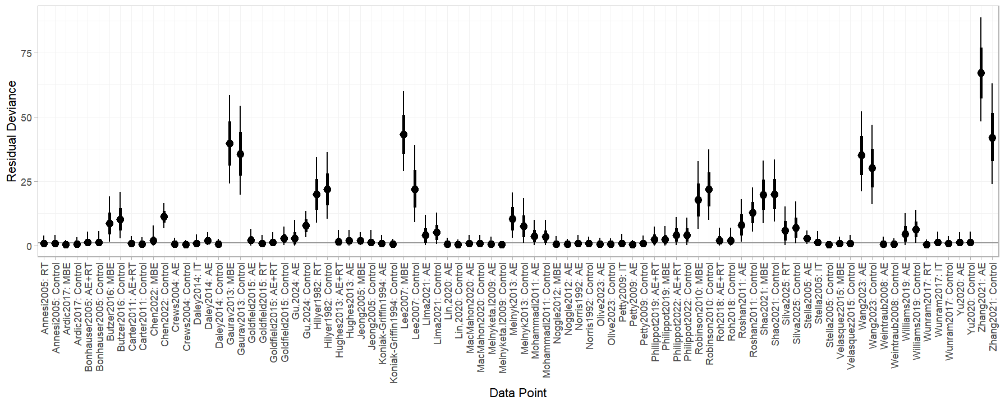

Supplementary Figure 2. Random model of residuals
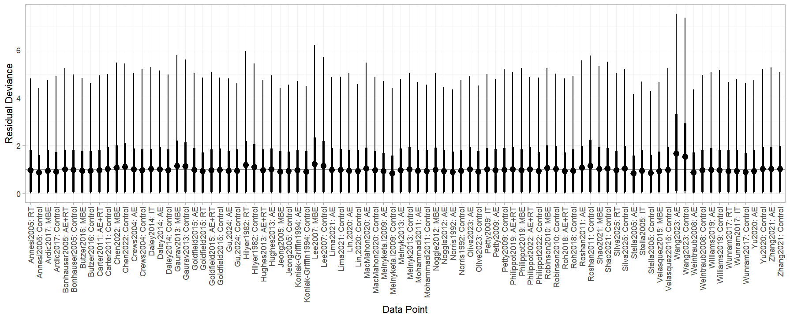

Supplementary Figure 3. Prior and posterior distribution plot of random effects model
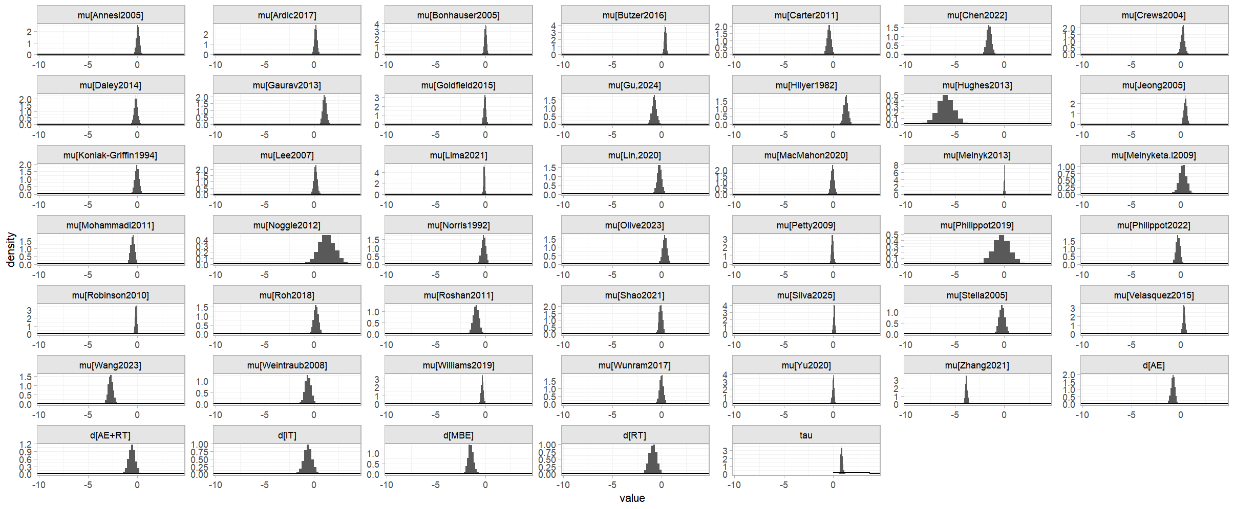
6.Key Assumptions of Network Meta-Analysis
Supplementary Table 6. Baseline comparison table
Interventions | Gender | Age | Duration | Frequency | Time/session | Baseline Depression Level | Adherence
AE | 56% (0%-100%) | 13.8 (9-17) | 15.23 (4-60) | 3.19 (1-5) | 44.76 (15-120) | 37% (14%-79%) | 95% (71%-100%)
RT | 50% (0%-70%) | 14.85 (10-17) | 11 (4-20) | 3.17 (2-4) | 47.08 (20-90) | 31% (19%-52%) | 92% (77%-100%)
AE+RT | 58% (40%-78.17) | 14.39 (11-17) | 8.29 (4-16) | 2.8 (1-4) | 46.0 (35-90) | 36% (22%-52%) | 92% (82%-100%)
MBE | 63% (0%-100%) | 13.22 (9-16) | 14.1 (6-48) | 2.56 (1-5) | 61.81 (15-120) | 32% (10%-52%) | 95% (85%-100%)
IT | 57% (28%-100%) | 13.59 (9-16) | 10 (6-14) | 3.75 (3-5) | 37.5 (30-60) | 33% (18%-52%) | 94% (85%-100%)
Control | 57% (0%-100%) | 13.88 (9-17) | 0 | 0 | 0 | 34% (10%-61%) | 92% (64%-100%)

Supplementary Figure 4. Node splitting method
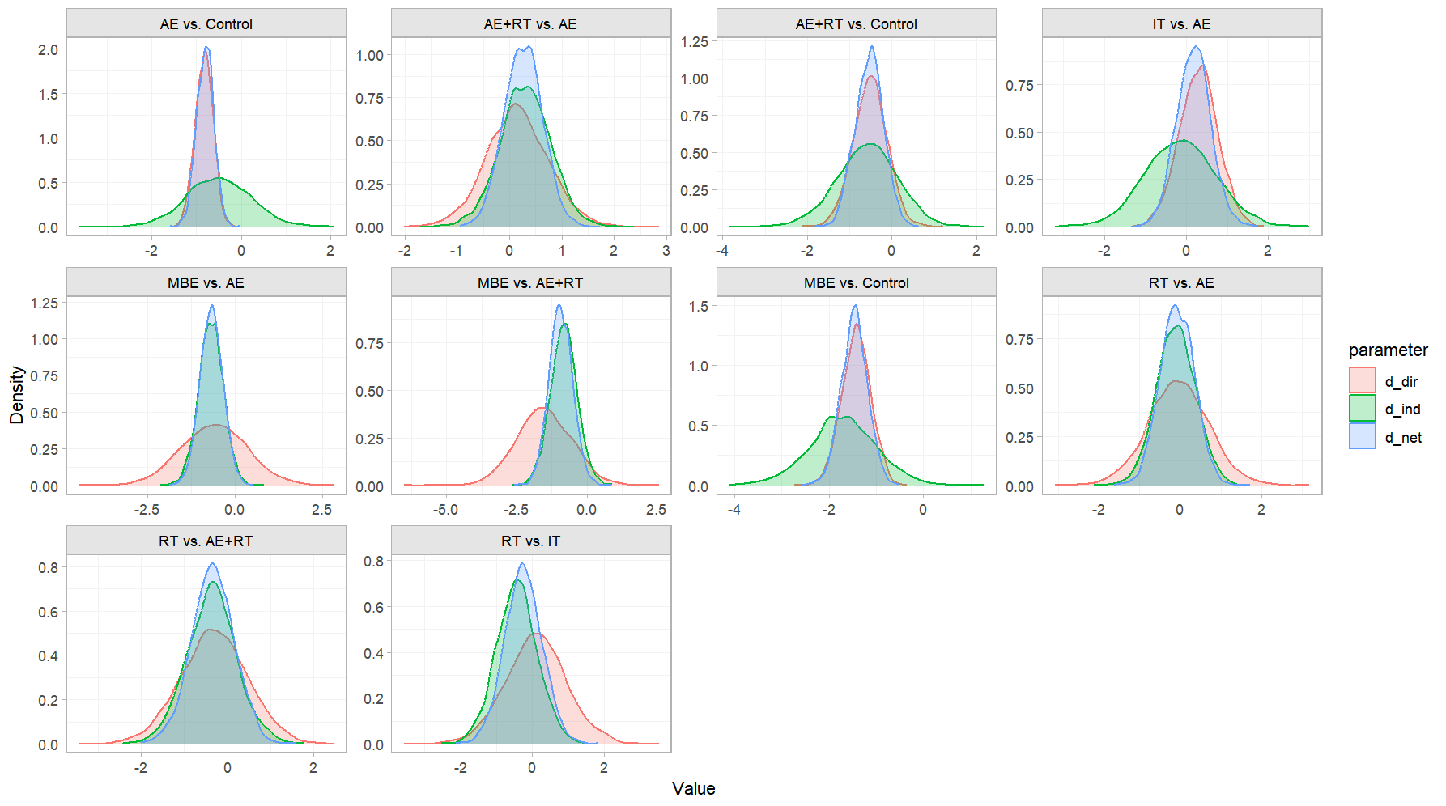
7.Effect size analysis and SUCRA ranking
Supplementary Table 7. R-hat value and effective sample size of Bayesian network meta-analysis
Intervention | Effective sample size (ESS) | R-hat
MBE | 1841 | 1
RT | 2222 | 1
AE | 1571 | 1
IT | 2612 | 1
AE+RT | 1948 | 1

Supplementary Figure 5. Ranking probability plot
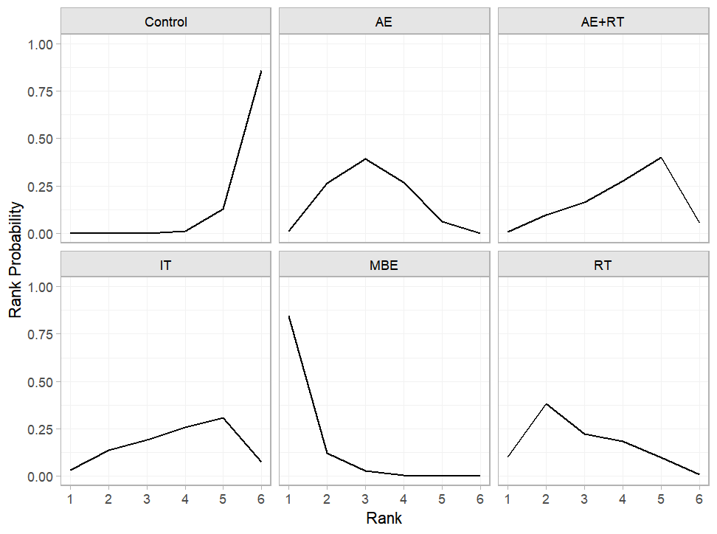

8. Subgroup analysis
Supplementary Table 8. Baseline comparison table for subgroup analysis
Subgroup | Interventions | Gender | Age | Duration | Frequency | Time  /session | Baseline Depression Level | Adherence
Health | AE | 60%  (20%-100%) | 13.53  (9.5-07.2) | 19  (4-60) | 3.23  (1-5) | 42.30  (17.5-75) | 95%  (83%-100%) | 39%  (14%-79%)
Health | MBE | 69%  (47%-100%) | 12.55  (9.4-17.2) | 17  (5-48) | 2.33  (1-5) | 48.75  (12.5-120) | 92%  (83%-100%) | 24%  (10%-49%)
Health | RT | 53%  (0%-70%) | 14.3  (10.7-17) | 12  (4-20) | 3  (2-4) | 48.12  (20-90) | 94%  (77%-100%) | 26%  (19%-36%)
Health | AE+RT | 52%  (40%-70%) | 12.49  (10-16) | 12.33  (4-16) | 2.5  (1-4) | 45  (30-60) | 95%  (86%-100%) | 33%  (22%-52%)
Health | IT | 71%  (42%-100%) | 12.68  (9.35-16) | 13  (12-14) | 4  (3-5) | 45  (30-60) | 97%  (96%-100%) | 29%  (18%-41%)
Subclinical | AE | 47%  (0%-100%) | 13.82  (11.28-19.77) | 9.67  (6-12) | 3  (1-4) | 50  (30-120) | 93%  (71%-100%) | 35%  (19-63%)
Subclinical | MBE | 52.38%  (0%-100%) | 16.25  (16-16.5) | 8  (6-12) | 3.33  (2-5) | 95  (45-120) | 98%  (97%-100%) | 49%  (47%-52%)
Subclinical | AE+RT | 51.52% | 15.53 | 10 | 3 | 90 | 92% | 33%
Subclinical | IT | NA | 13.1 | 8 | 3 | 60 | 96% | 21%
Clinical | AE | 67%  (44%-100%) | 16.05  (14.3-17) | 9.5  (6-12) | 3 | 43.75  (35-75) | 85%  (83%-100%) | 34%  (21%-58%)
Clinical | AE+RT | 66%  (58%-78%) | 15.92  (15.35-17) | 7  (5-12) | 3  (2-4) | 46.67  (35-60) | 82%  (77%-88%) | 48%  (45%-52%)
Clinical | MBE | 51.61% | 15.83 | 8 | 3 | 120 | 83% | 50%
Clinical | RT | 28.10% | 15.9 | 6 | 4 | 30 | 86% | 52%
Clinical | IT | 29.20% | 16.1 | 6 | 4 | 30 | 85% | 52%
Children | AE | 43%  (20%-61%) | 9.88  (9.35-11.28) | 14  (6-32) | 3.83  (1-5) | 57.5  (30-120) | 96%  (89%-100%) | 36%  (14%-79%)
Children | AE+RT | 43%  (40%-47.83%) | 10.73  (10-11.46) | 10.5  (5-16) | 2.5  (1-4) | 55  (50-60) | 92%  (86%-100%) | 37%  (22%-55%)
Children | MBE | 53%  (47%-100%) | 9.7  (9.4-10) | 16.5  (5-48) | 4.5  (4-5) | 50 | 86%  (85%-88%) | 29%  (10%-49%)
Children | RT | 50% | 10.7 | 12 | 3 | 45 | 100% | 24%
Children | IT | 42% | 9.35 | 14 | 5 | 30 | 96% | 41%
Adolescent | AE | 63%  (0%-100%) | 15.64  (12.5-17.2) | 11.55  (4-60) | 2.86  (1-4) | 39.5  (17.5-60) | 94%  (71%-100%) | 37%  (19%-63%)
Adolescent | MBE | 59%  (0%-100%) | 14.6  (12.5-17.2) | 10.88  (6-24) | 2.22  (1-5) | 51.94  (12.5-120) | 96%  (83%-100%) | 32%  (12%-52%)
Adolescent | AE+RT | 64%  (51%-78%) | 15.86  (15.35-17) | 7.4  (4-12) | 3.25  (2-4) | 42.5  (30-90) | 89%  (77%-100%) | 40%  (25%-52%)
Adolescent | RT | 58%  (0%-70%) | 15.6  (13.5-17) | 10.5  (4-20) | 3.25(2-4) | 44.38  (20-90) | 90%  (77%-100%) | 34%  (27%-52%)
Adolescent | IT | 64%  (28%-100%) | 15  (13.1-16) | 8.6  (6-12) | 3.33  (3-4) | 40  (30-60) | 93%  (85%-100%) | 30%  (18%-52%)

Supplementary Table 9. Model selection and consistency test results for subgroup analysis
Subgroup | Model | Deviance information criterion (DIC) | The number of parameters (PD) | Residual bias
Clinical | Fix  consistent | 272.14 | 13 | 259.4
Clinical | Random consistent | 34.2 | 17.1 | 17.1
Clinical | Random inconsistent | 33.6 | 16.8 | 16.8
Subclinical | Fix  consistent | 162.4 | 13.9 | 148.5
Subclinical | Random consistent | 42 | 20.8 | 21.1
Subclinical | Random inconsistent | 41.6 | 20.6 | 21
Health | Fix  consistent | 241 | 27.7 | 213.3
Health | Random consistent | 97.2 | 47.1 | 50.2
Health | Random inconsistent | 98.1 | 47.8 | 50.3
Children | Fix  consistent | 40.2 | 14 | 26.2
Children | Random consistent | 39.6 | 17.9 | 21.7
Children | Random inconsistent | 40.5 | 18.4 | 22
Adolescent | Fix  consistent | 1368.5 | 34.7 | 1333.8
Adolescent | Random consistent | 129.9 | 64.4 | 65.5
Adolescent | Random inconsistent | 129.7 | 64.4 | 65.3

Supplementary Table 10 Node-splitting analysis for subgroup analysis
Subgroup | Comparison | Deviance information criterion (DIC) | The number of parameters (PD) | Residual bias | P-value
Clinical | AE vs. Control | 33.9 | 16.9 | 17 | 0.38
Clinical | AE+RT vs. Control | 34.2 | 17.1 | 17.1 | 0.44
Clinical | AE+RT vs. AE | 33.9 | 16.9 | 17.1 | 0.42
Subclinical | NA | NA | NA | NA | NA
Health | AE vs. Control | 98.8 | 47.9 | 50.8 | 0.86
Health | AE+RT vs. Control | 97.6 | 47.4 | 50.2 | 0.39
Health | MBE vs. Control | 99 | 48.1 | 50.9 | 0.65
Health | AE+RT vs. AE | 98.2 | 47.7 | 50.5 | 0.96
Health | MBE vs. AE | 97.7 | 47.5 | 50.2 | 0.82
Health | RT vs. AE | 97.8 | 47.6 | 50.3 | 0.53
Health | MBE vs. AE+RT | 98.4 | 47.8 | 50.6 | 0.35
Health | RT vs. AE+RT | 97.8 | 47.6 | 50.3 | 0.54
Children | NA | NA | NA | NA | NA
Adolescent | AE vs. Control | 128.7 | 63.8 | 64.9 | 0.51
Adolescent | AE+RT vs. Control | 129.5 | 64.2 | 65.3 | 0.46
Adolescent | MBE vs. Control | 128.4 | 63.7 | 64.7 | 0.95
Adolescent | AE+RT vs. AE | 128.1 | 63.5 | 64.6 | 0.56
Adolescent | IT vs. AE | 129.5 | 64.2 | 65.2 | 0.84
Adolescent | MBE vs. AE | 129.2 | 64.1 | 65.1 | 0.93
Adolescent | RT vs. AE | 129 | 64 | 65 | 0.99
Adolescent | RT vs. AE+RT | 128.9 | 63.9 | 65 | 0.99
Adolescent | RT vs. IT | 128.3 | 63.7 | 64.7 | 0.69

Supplementary Table 11. R-hat value and effective sample size for subgroup analysis
Subgroup | Intervention | Effective sample size | R-hat
Clinical | AE | 3092 | 1
Clinical | MBE | 3519 | 1
Clinical | AE+RT | 2270 | 1
Clinical | IT | 3170 | 1
Clinical | AE | 3716 | 1
Subclinical | MBE | 1565 | 1
Subclinical | AE | 1305 | 1
Subclinical | IT | 2185 | 1
Subclinical | AE+RT | 1980 | 1
Health | MBE | 1357 | 1
Health | RT | 1636 | 1
Health | AE | 936 | 1
Health | AE+RT | 1877 | 1
Health | MBE | 2176 | 1
Children | AE | 2002 | 1
Children | MBE | 1598 | 1
Children | RT | 2602 | 1
Children | IT | 1876 | 1
Children | AE+RT | 2522 | 1
Adolescent | MBE | 1198 | 1
Adolescent | AE | 1127 | 1
Adolescent | RT | 2019 | 1
Adolescent | IT | 1869 | 1
Adolescent | AE+RT | 2282 | 1

Subgroup analysis: Clinical
Supplementary Figure 6. Random model of prior and posterior distribution plot
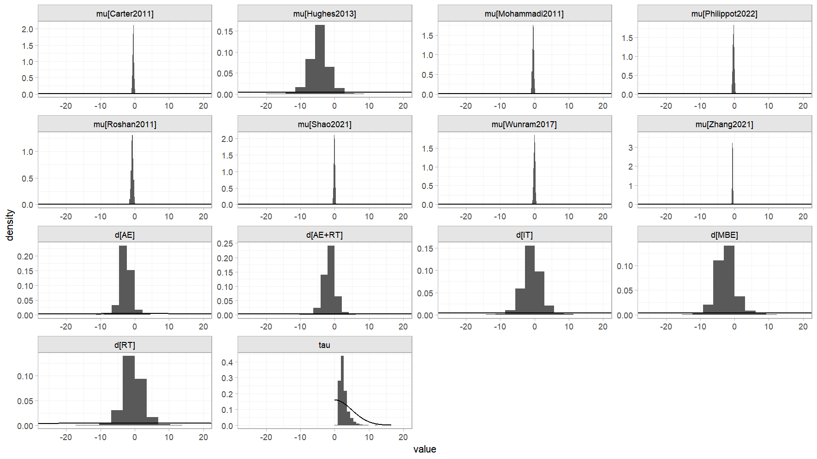

Supplementary Figure 7. Ranking of effectiveness
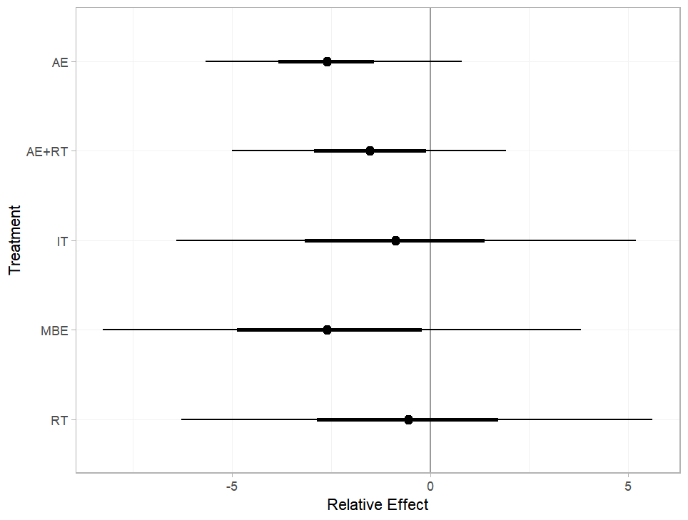
Supplementary Figure 8. SUCRA plot
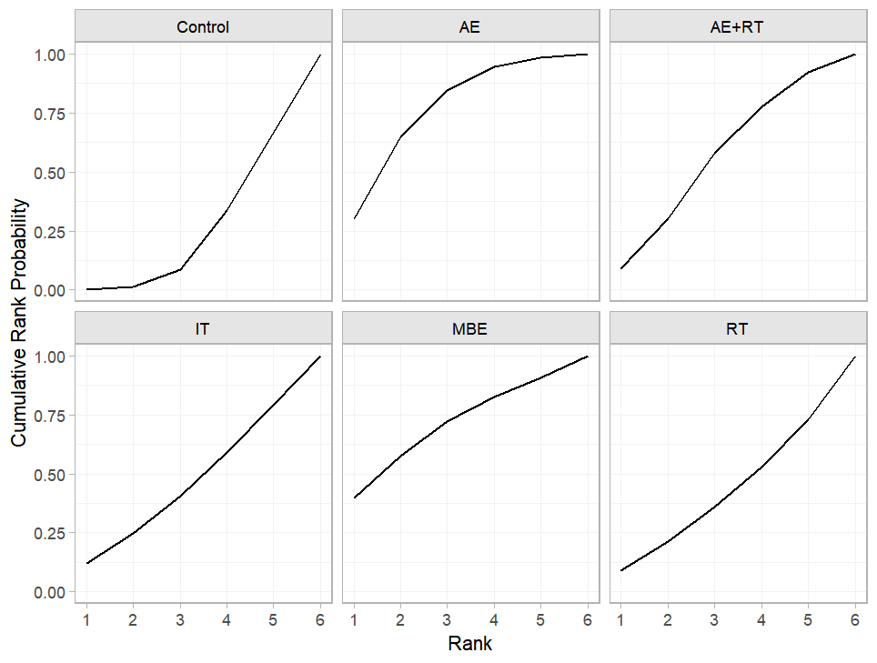
Subgroup analysis: Subclinical
Supplementary Figure 9. Random model of prior and posterior distribution plot
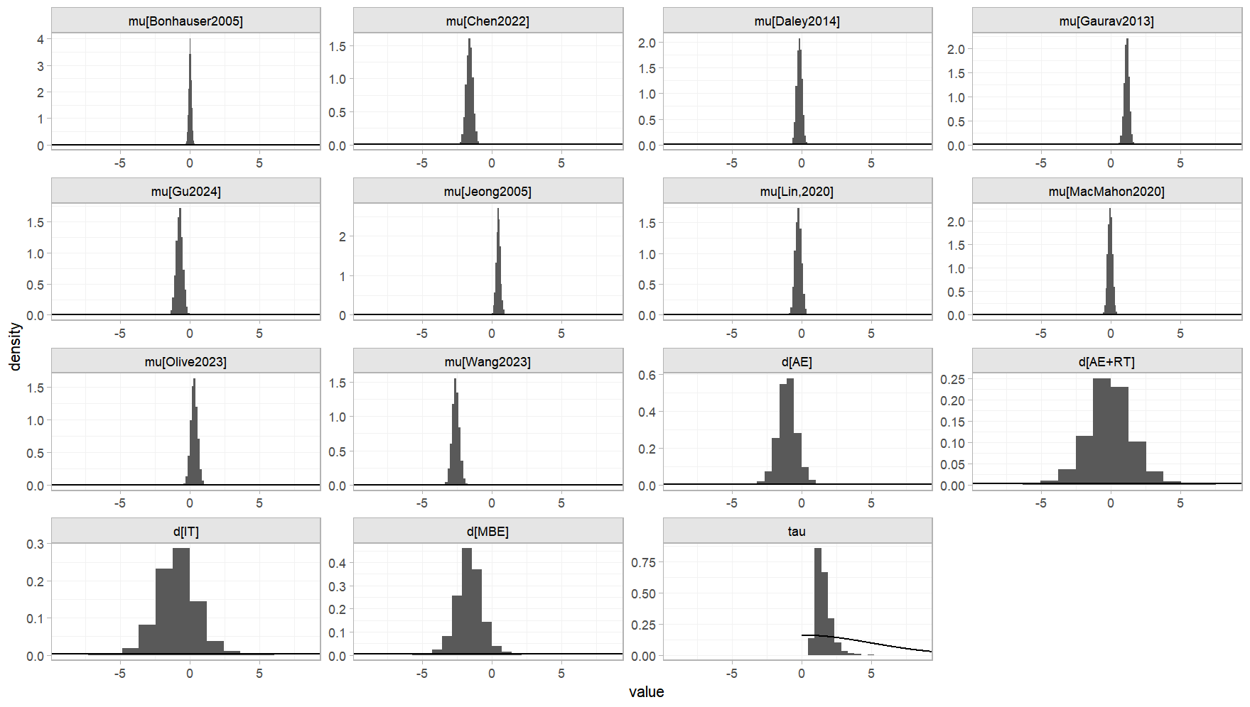

Supplementary Figure 10. Ranking of effectiveness
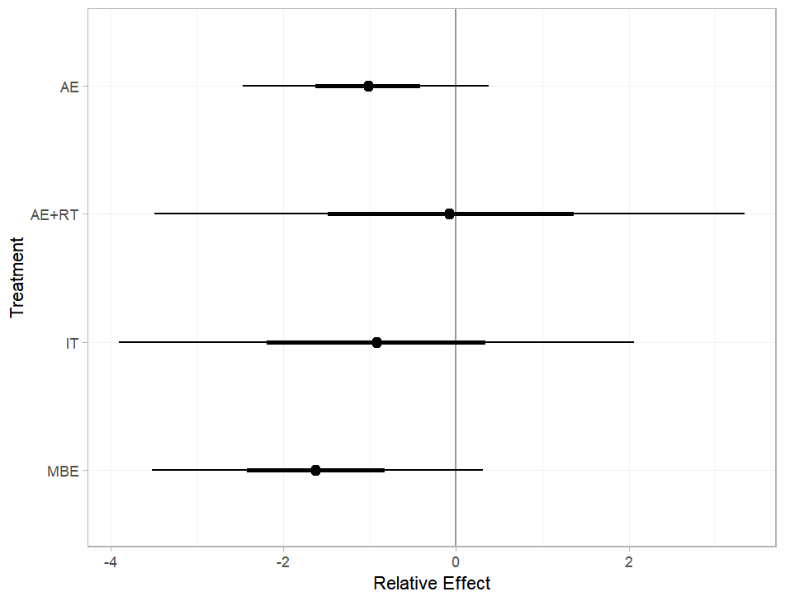

Supplementary Figure 11. SUCRA plot
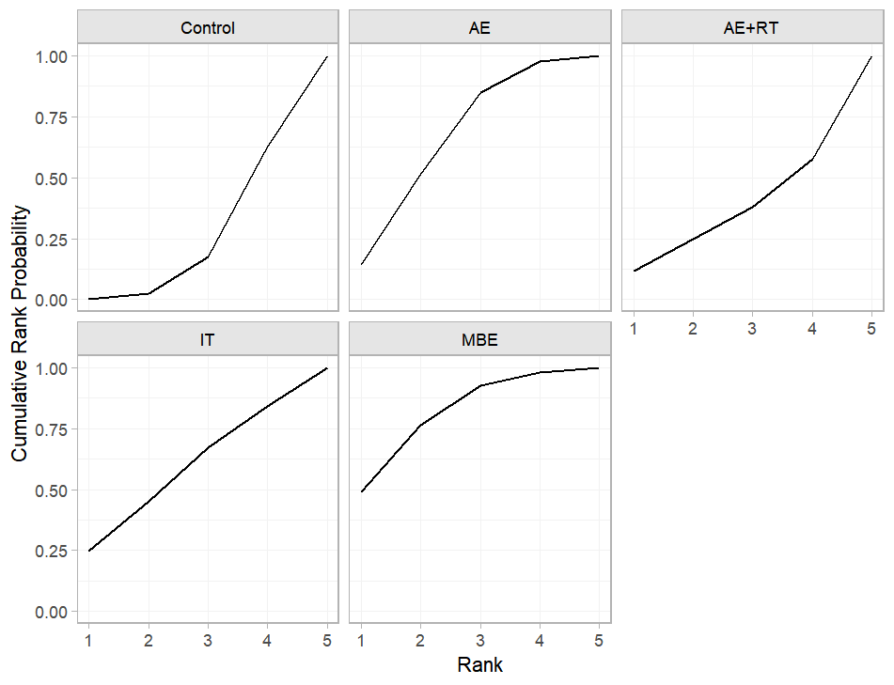

Subgroup analysis: Health
Supplementary Figure 12. Random model of prior and posterior distribution plot
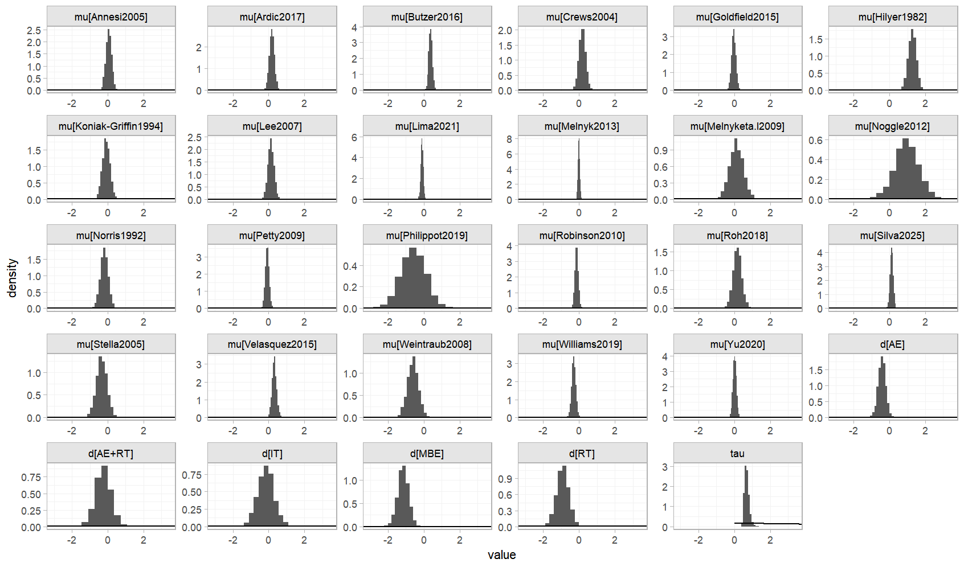
Supplementary Figure 13. Ranking of effectiveness
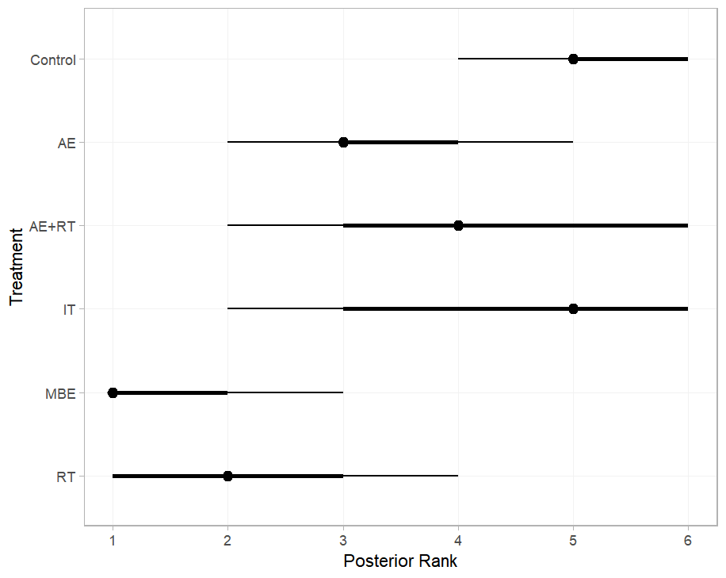
Supplementary Figure 14. SUCRA plot
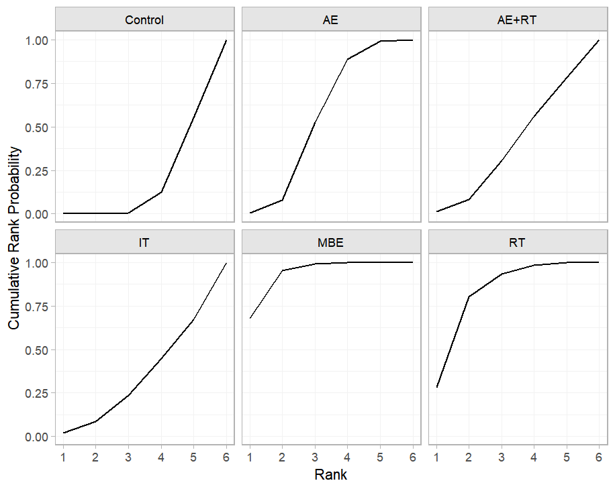
Subgroup analysis: Children
Supplementary Figure 15. Random model of prior and posterior distribution plot
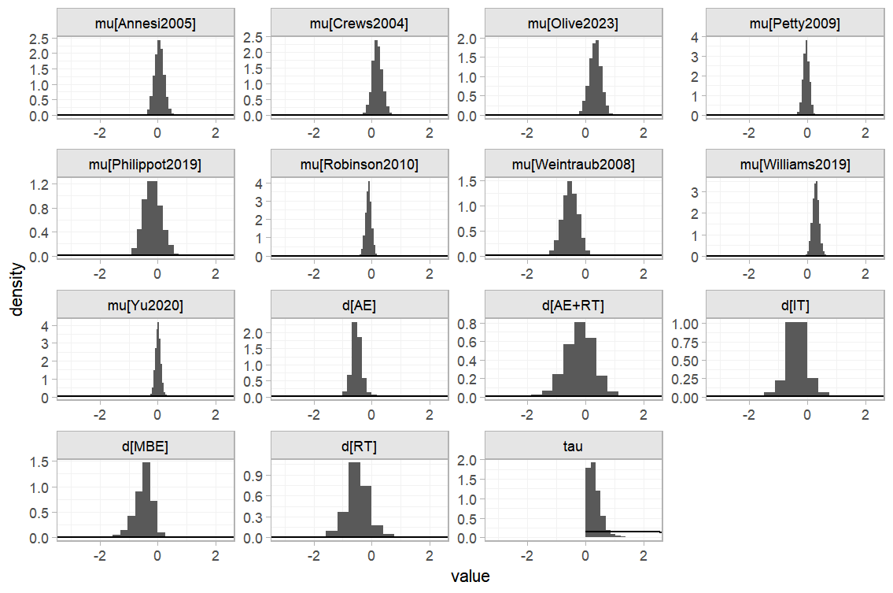
Supplementary Figure 16. Ranking of effectiveness
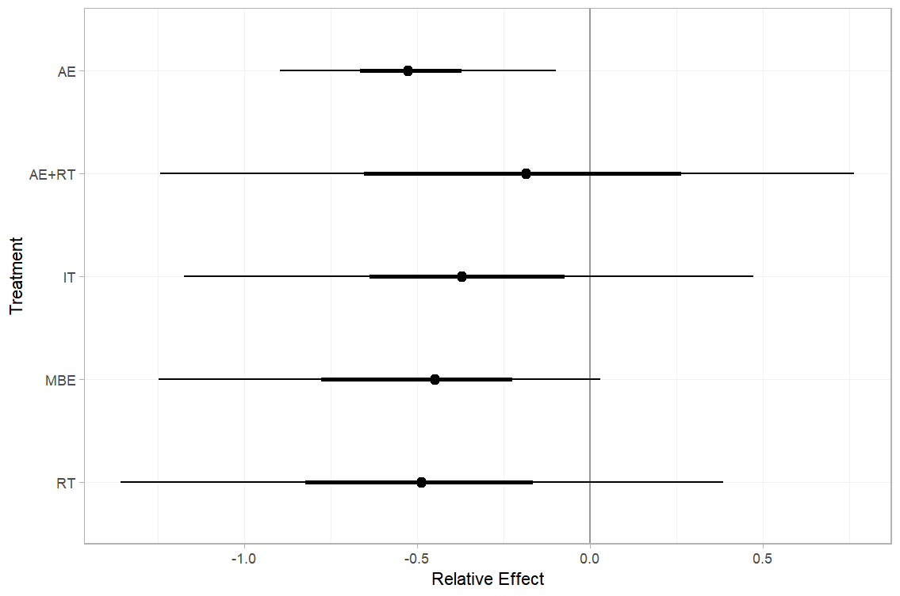

Supplementary Figure 17. SUCRA plot
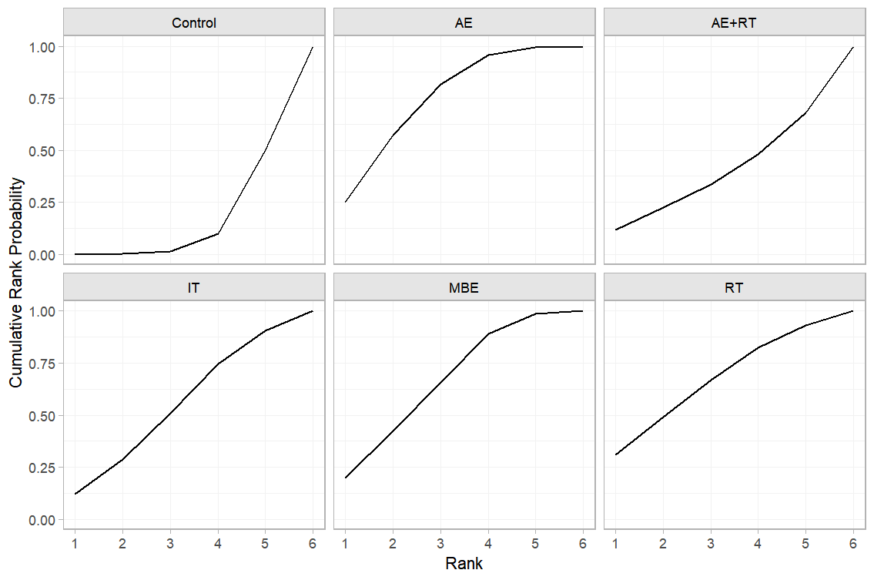

Subgroup analysis: Adolescent
Supplementary Figure 18. Random model of prior and posterior distribution plot
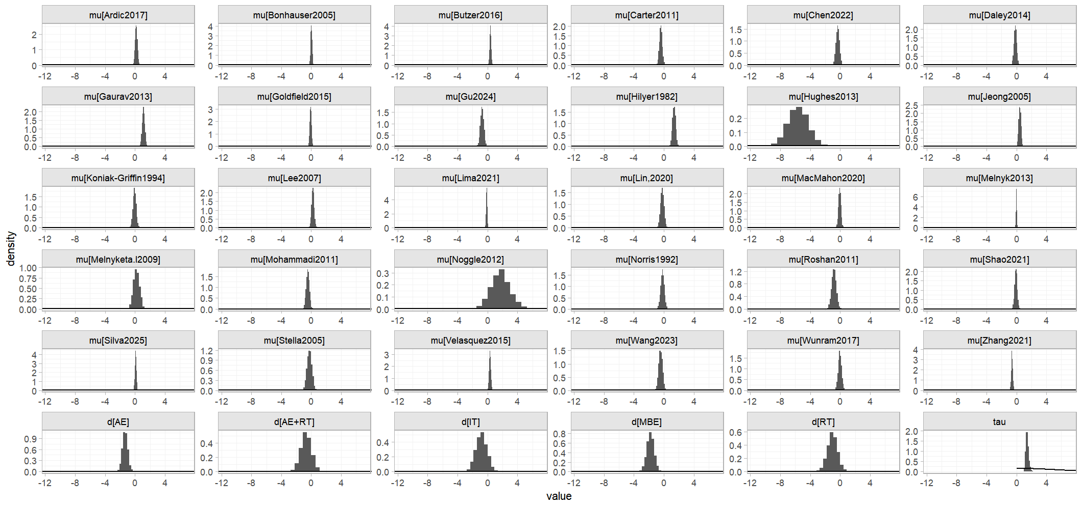
Supplementary Figure 19. Ranking of effectiveness
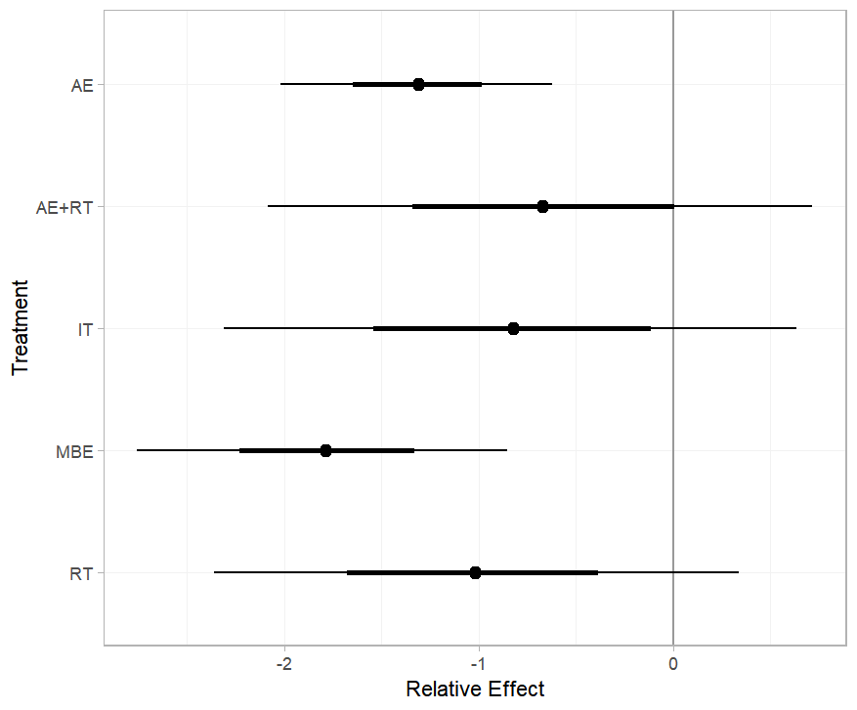
Supplementary Figure 20. SUCRA plot
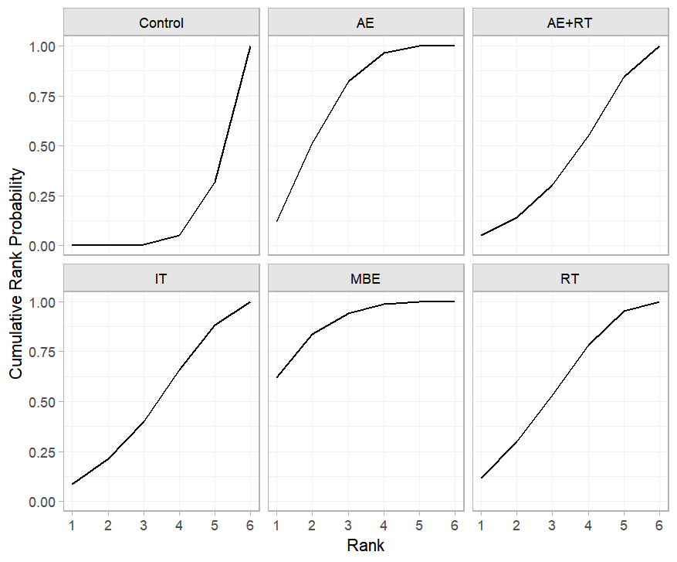
9. Publication bias and sensitivity analysis
Supplementary Figure 21. ‘Comparison-adjusted’ funnel plot
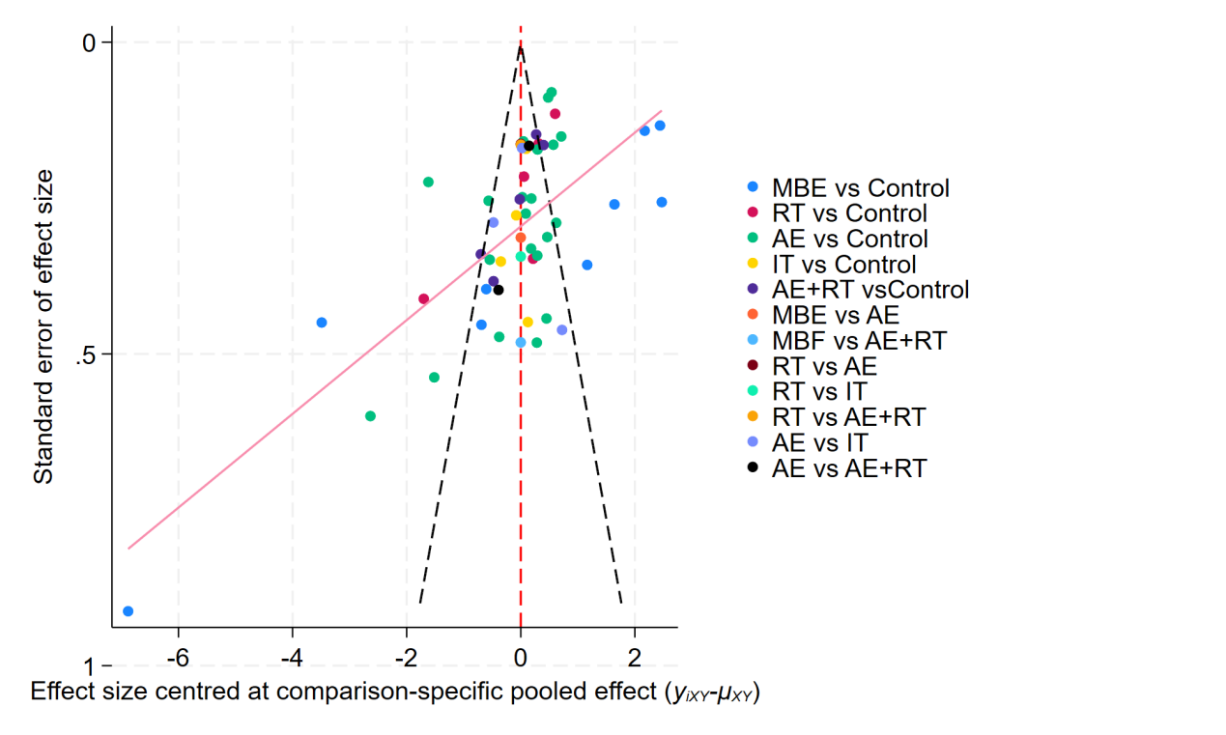

Supplementary Figure 22. Ranking of effectiveness
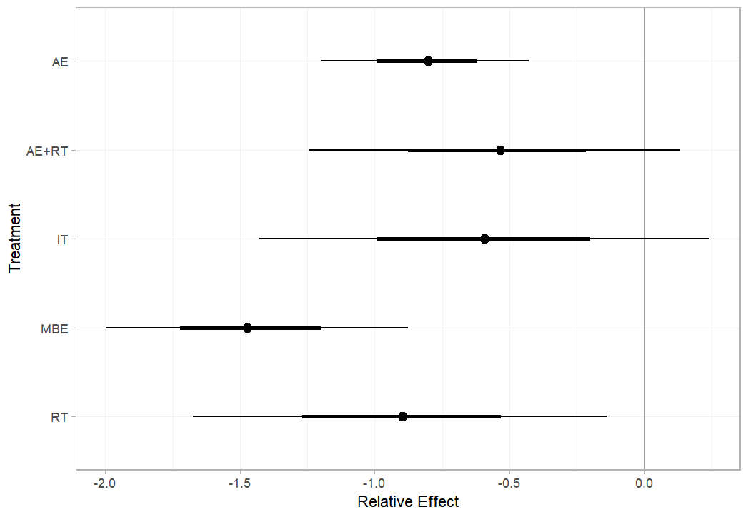
Supplementary Figure 23. Random model of prior and posterior distribution plot
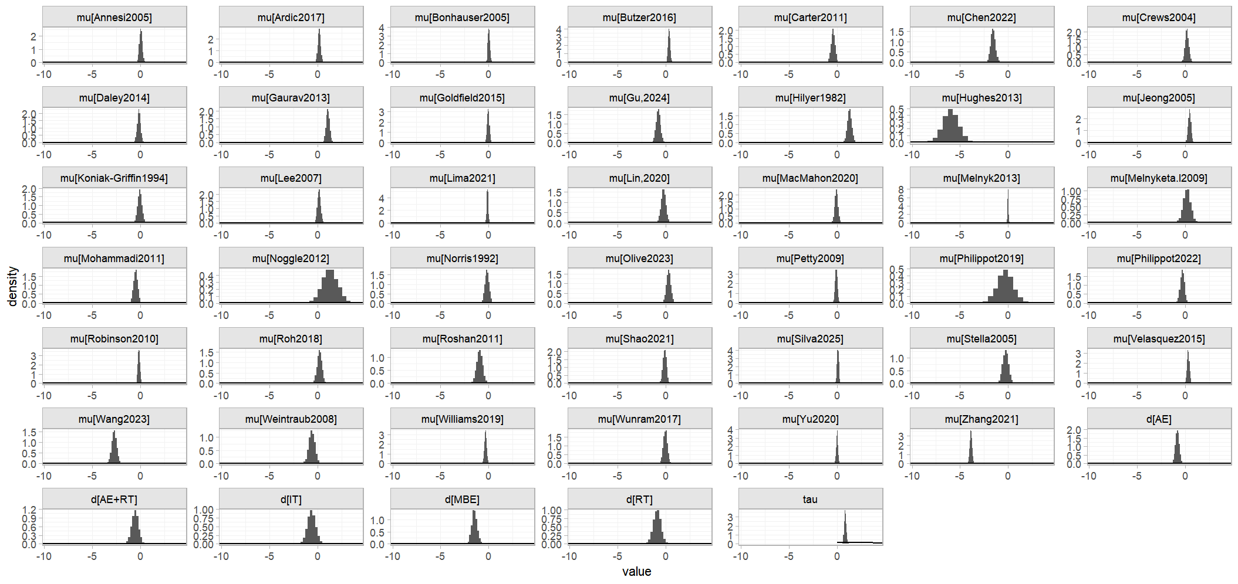

Supplementary Figure 24. SUCRA plot
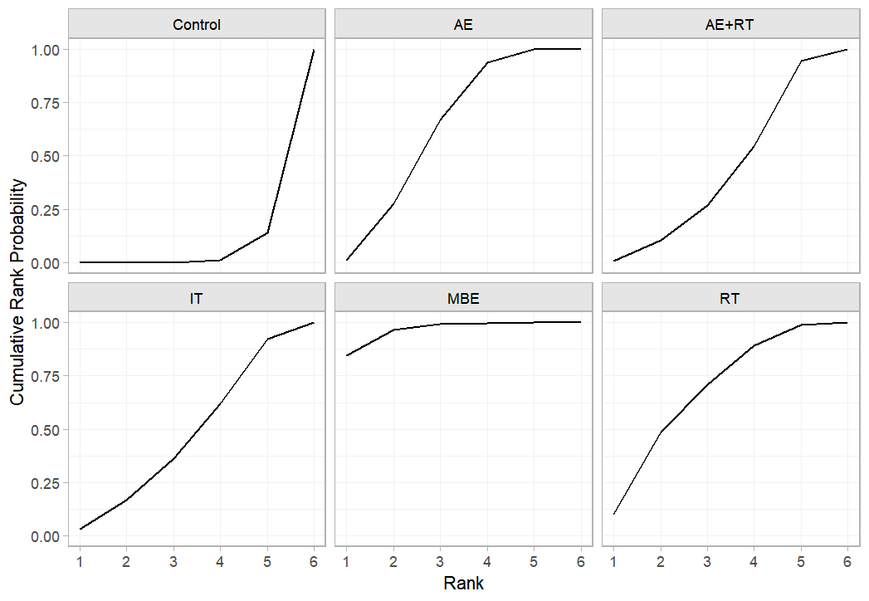
10. Key Assumptions of Dose-Response Network Meta-Analysis
Connectivity
Our study assessed network connectivity at the motor and dose levels and did not find any evidence of network unconnectedness (Figure 25 and Figure 26).
Supplementary Figure 25. Treatment-level network.
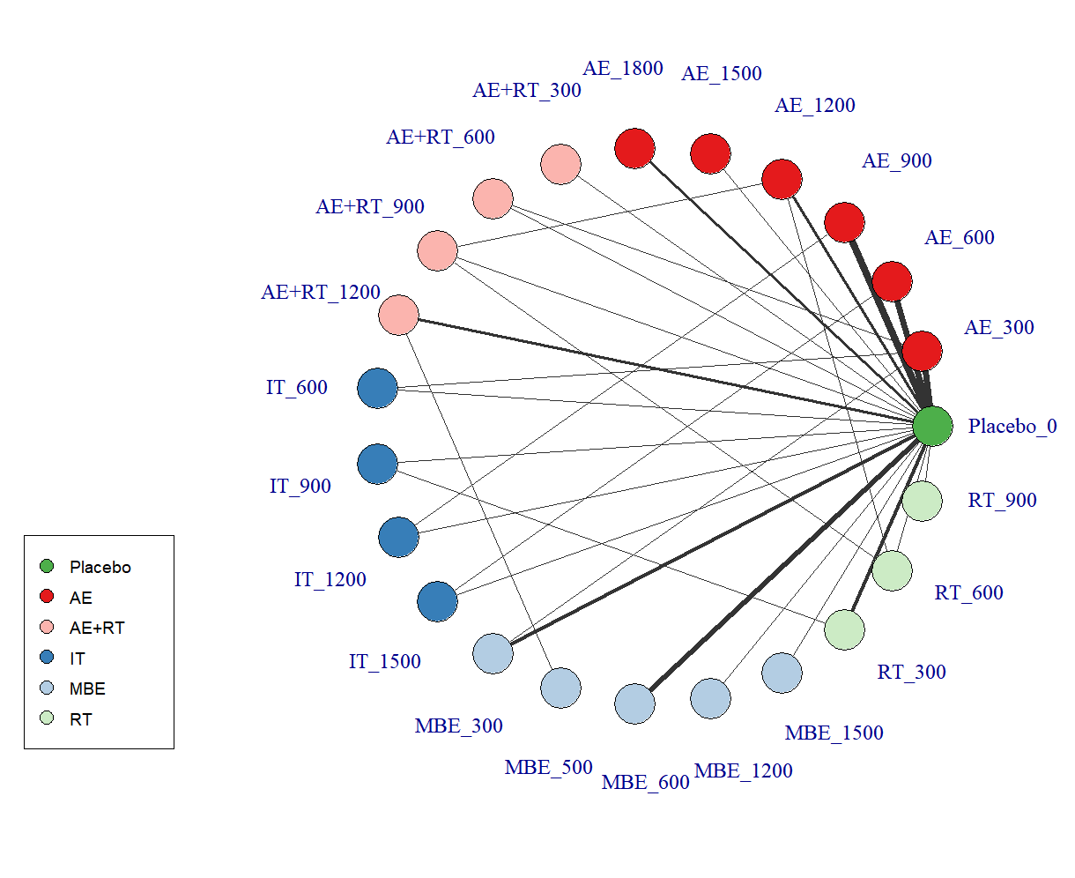
Supplementary Figure 26. Node-level network
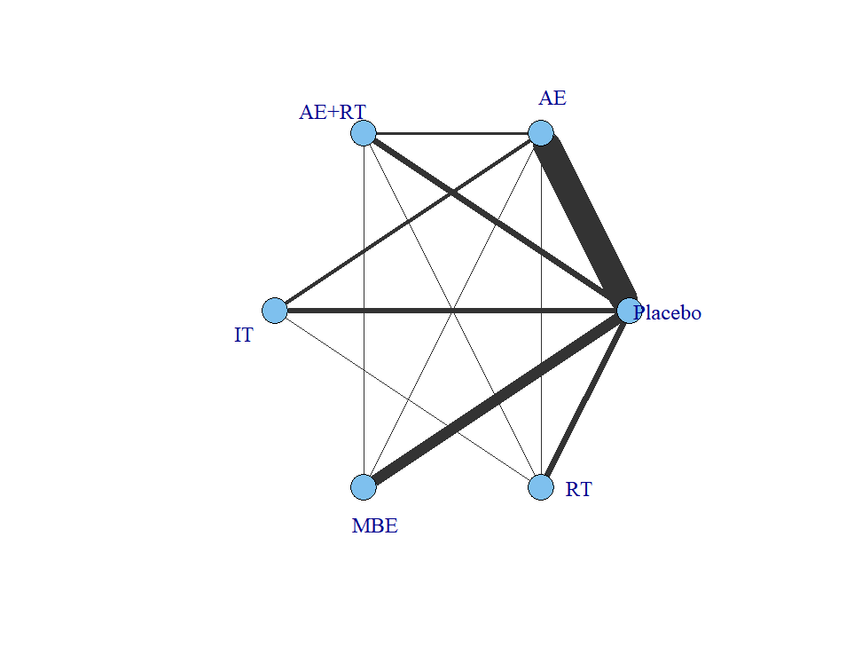
Transitivity
As shown in supplementary table 5 and 9, it shows that these interventions are not significantly intransitivity.

Consistency
Global consistency was assessed by comparing the fit of the consistency model with that of the unrelated mean effects (UME) model, while local consistency was evaluated using a node-splitting approach. The results showed strong agreement across models, with all node-splitting tests yielding p-values greater than 0.05, indicating no evidence of inconsistency within the network (Tables 8 and Figure 27.).

Table 12. Consistent and UME models fit comparison.
Model | Deviance | DIC | pD | SD
Consistent | -61.4 | 23.9 | 85.3 | 1.28
UME | -61.5 | 25.3 | 86.2 | 1.29

Supplementary Figure 27. MBNMA node-splitting method (density plot).
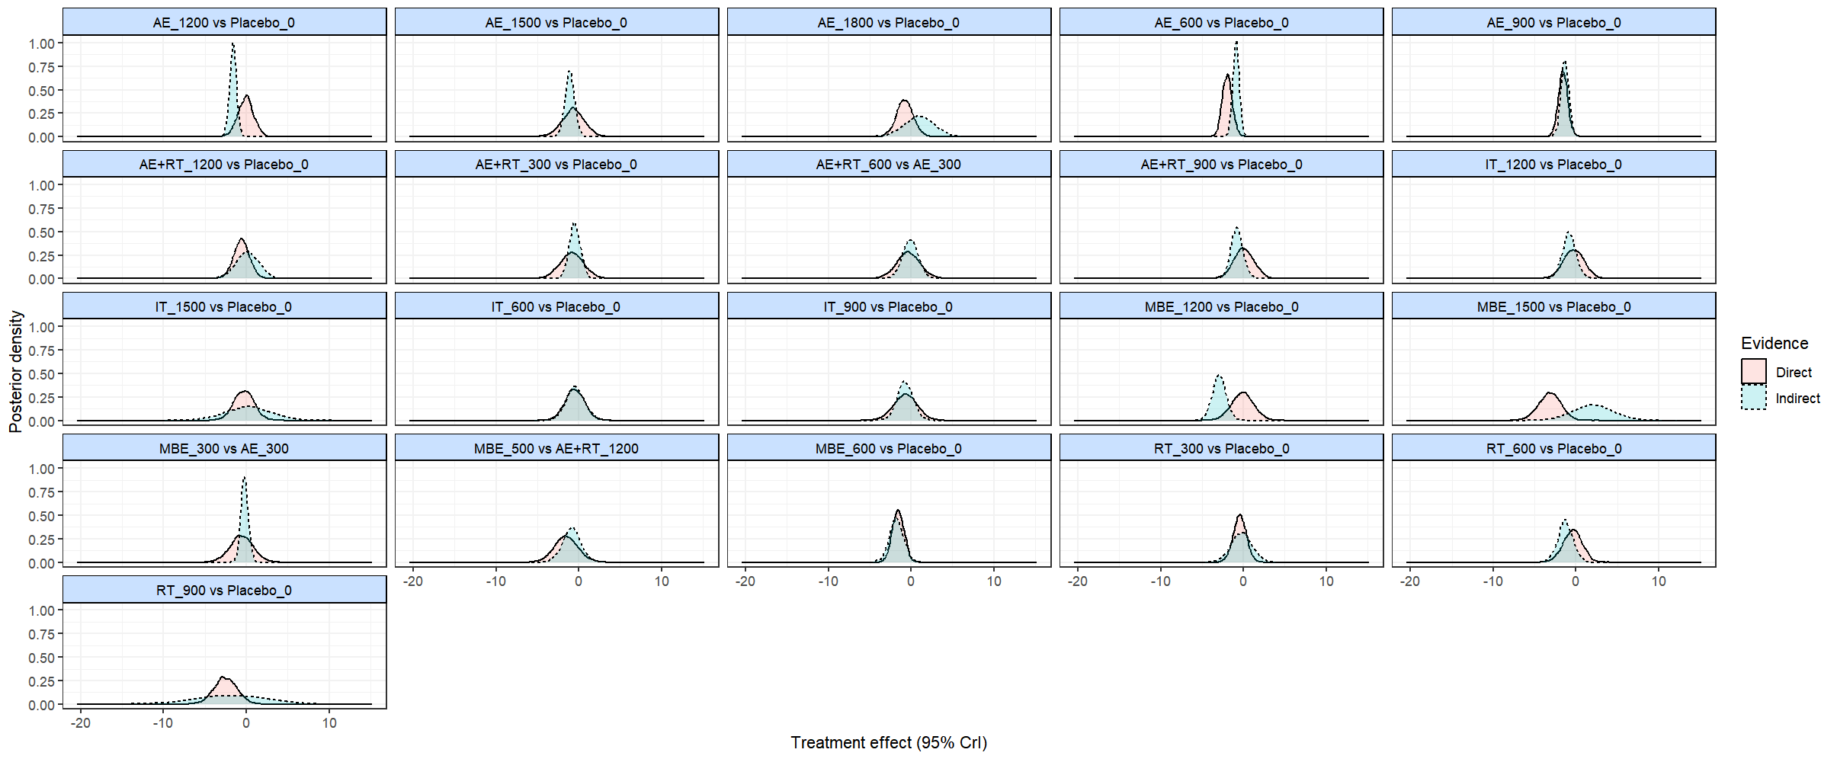

11.Model Selection for Dose-Response Analysis
Models selection
To determine the optimal functional form for modeling the dose–response relationship, we compared several models, including Emax, linear, natural cubic splines, non-parametric monotonic function, and quadratic fractional polynomial models. Based on model fit statistics, the quadratic fractional polynomial model was selected to best represent the nonlinear association (Table 12).
Table 13. Comparison of fit information of different models
Model | Deviance | DIC | pD | SD
Emax (Random) | -61.79 | 24 | 85.7 | 1.3
Emax (Common) | 1368.96 | 1415.4 | 46.7 | NA
Linear (Random) | -61.7 | 24.4 | 86.2 | 1.39
Linear (Common) | 1498.92 | 1545 | 46 | NA
Natural cubic splines (Random) | -61.7 | 24.8 | 86.6 | 1.42
Natural cubic splines (Common) | 1094.51 | 1154.5 | 60.1 | NA
Non-parametric monotonic function (Random) | -62.15 | 26 | 87.6 | 2.74
Non-parametric monotonic function (Common) | 2031.08 | 2073.4 | 42 | NA
Quadratic fractional polynomia (Random) | -61.4 | 23.9 | 85.3 | 1.28
Quadratic fractional polynomia (Common) | 1344.87 | 1395.5 | 50.7 | NA
Fit and deviance plot of quadratic fractional polynomia
In addition, we further plotted fit plots and deviation plots to assess the degree of fit of the model. These plots show that the quadratic fractional polynomial model fits well with the dose-response function for the overall exercise and different exercises.
Supplementary Figure 28. Fit plots at overall exercise level.
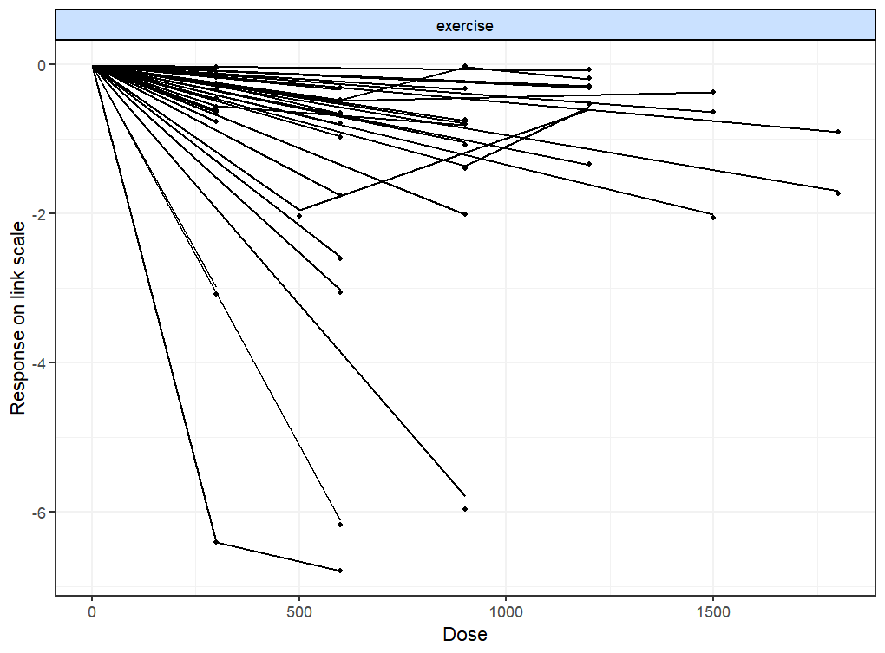
Supplementary Figure 29. Fit plots at agent-level.
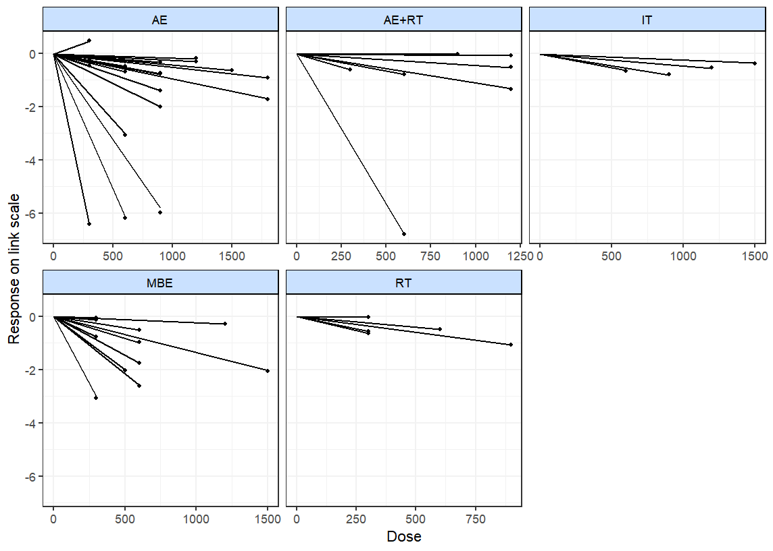
Supplementary Figure 30. Deviance plots at overall exercise level.
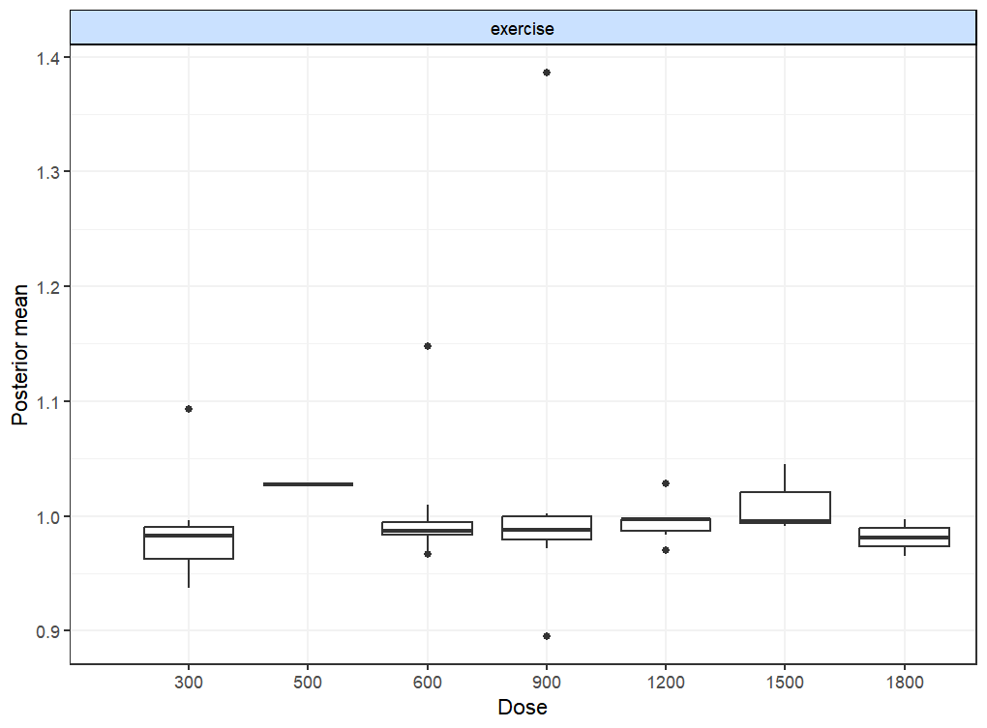

Supplementary Figure 31. Deviance plots at agent-level
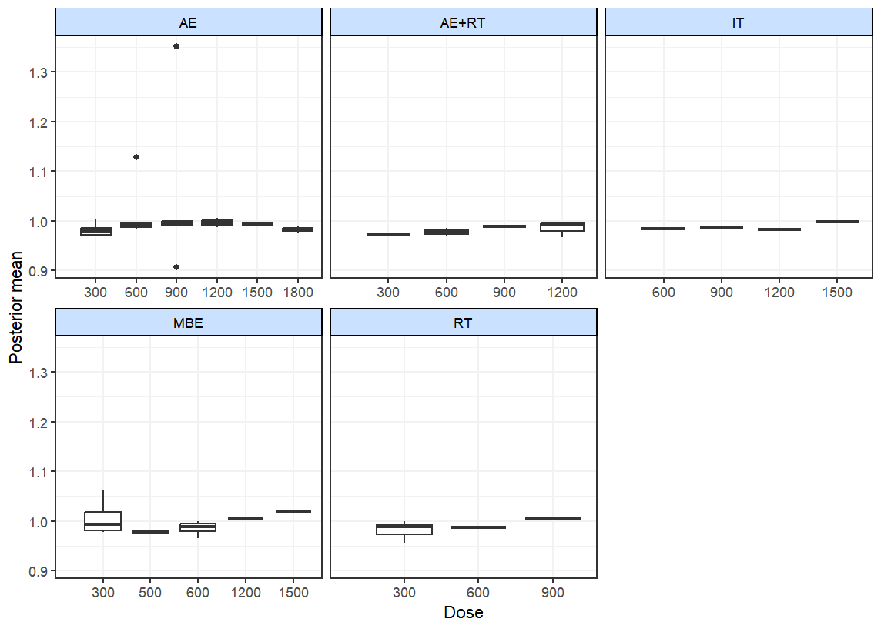
12.Dose-Response Relationship
Supplementary Figure 32. “Split” dose-response network meta-analysis of overall exercise level
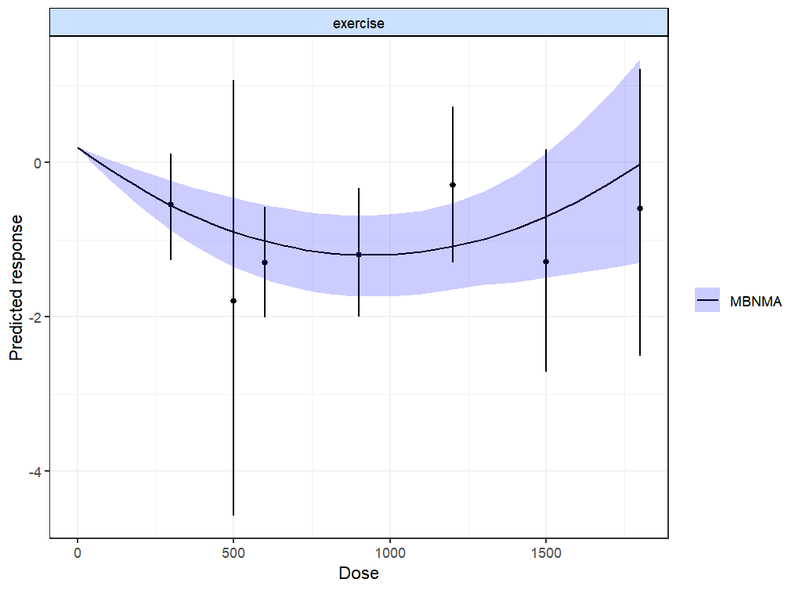
Supplementary Figure 33. “Split” dose-response network meta-analysis of agent-level.
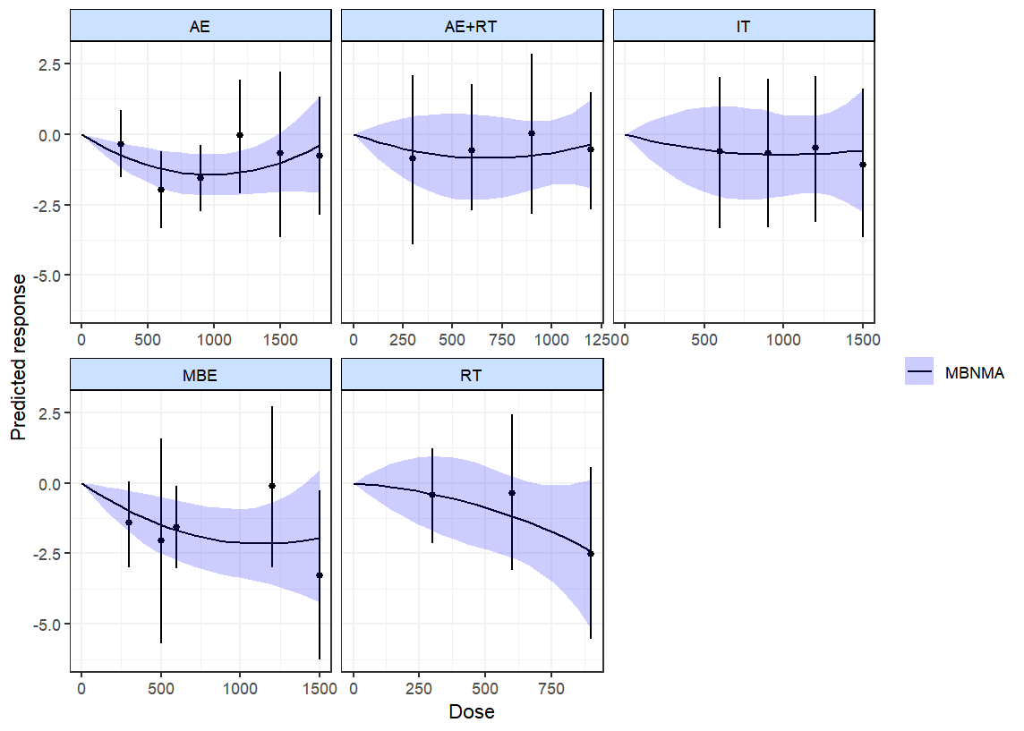
13.GRADE Evidence Quality
Supplementary Table 14. GRADE Evidence Quality Assessment
Comparison | Direct evidence |  | Indirect evidence |  | Network meta-analysis
Comparison | Mean difference  (95% credible interval) | Quality of evidence | Mean difference  (95% credible interval) | Quality  of evidence | Mean difference  (95% credible interval) | Quality of evidence
AE vs. Control | -0.82(-1.22 to -0.45) | ⊕⊕⊕ O  Moderate  Due to Risk of bias¹ | -0.5(-1.88 to 0.92) | ⊕⊕O O  Low  Due to Risk of bias¹ and Inconsistency² | -0.80(-1.2 to -0.43) | ⊕⊕⊕ O  Moderate
AE+RT vs. Control | -0.51(-1.32 to 0.26) | ⊕⊕O O  Low  Due to Risk of bias¹ and Inconsistency² | -0.59(-2.05 to 0.78) | ⊕⊕O O  Low  Due to Risk of bias¹ and Inconsistency² | -0.54(-1.24 to 0.13) | ⊕⊕O O  Low
IT vs. Control | -0.60(-1.43 to 0.24) | ⊕⊕⊕ O  Moderate  Due to Inconsistency² | — | — | -0.60(-1.43 to 0.24) | ⊕⊕⊕ O  Moderate
MBE vs. Control | -1.42(-2.04 to -0.82) | ⊕⊕⊕ O  Moderate  Due to Risk of bias¹ | -1.71(-3.16 to -0.29) | ⊕⊕O O  Low  Due to Risk of bias¹ and Inconsistency² | -1.46(-2 to -0.88) | ⊕⊕⊕ O  Moderate
RT vs. Control | -0.90(-1.68 to -0.14) | ⊕⊕⊕ O  Moderate  Due to Inconsistency² | — | — | -0.9(-1.68 to -0.14) | ⊕⊕⊕ O  Moderate
AE+RT vs. AE | 0.15(-1.01 to 1.34) | ⊕⊕O O  Low  Due to Risk of bias¹ and Inconsistency² | 0.31(-0.67 to 1.25) | ⊕⊕O O  Low  Due to Risk of bias¹ and Inconsistency² | 0.27(-0.47 to 0.99) | ⊕⊕O O  Low
IT vs. AE | 0.3(-0.65 to 1.21) | ⊕⊕O O  Low  Due to Risk of bias¹ and Inconsistency² | -0.14(-1.84 to 1.58) | ⊕⊕O O  Low  Due to Risk of bias¹ and Inconsistency² | 0.21(-0.63 to 1.05) | ⊕⊕ O O  Low
MBE vs. AE | -0.59(-2.42 to 1.27) | ⊕⊕O O  Low  Due to Risk of bias¹ and Inconsistency² | -0.68(-1.4 to 0.02) | ⊕⊕O O  Low  Due to Risk of bias¹ and Inconsistency² | -0.66(-1.29 to 0.01) | ⊕⊕ O O  Low
RT vs. AE | -0.05(-1.55 to 1.47) | ⊕⊕O O  Low  Due to Risk of bias¹ and Inconsistency² | -0.1(-1.06 to 0.85) | ⊕⊕O O  Low  Due to Risk of bias¹ and Inconsistency² | -0.10(-0.93 to 0.75) | ⊕⊕ O O  Low
IT vs. AE+RT | -0.06(-1.1 to 1.02) | ⊕⊕O O  Low  Due to Risk of bias¹ and Inconsistency² | — | — | -0.06(-1.1 to 1.02) | ⊕⊕ O O  Low
MBE vs. AE+RT | -1.53(-3.42 to 0.38) | ⊕⊕O O  Low  Due to Risk of bias¹ and Inconsistency² | -0.82(-1.76 to 0.13) | ⊕⊕O O  Low  Due to Risk of bias¹ and Inconsistency² | -0.92(-1.71 to -0.12) | ⊕⊕O O  Low
RT vs. AE+RT | -0.31(-1.86 to 1.22) | ⊕⊕ O O  Low  Due to Risk of bias¹ and Inconsistency² | -0.36(-1.52 to 0.82) | ⊕⊕ O O  Low  Due to Inconsistency²and Imprecision⁴ | -0.36(-1.33 to 0.62) | ⊕⊕ O O  Low
MBE vs. IT | -0.87(-1.85 to 0.13) | ⊕⊕ O O  Low  Due to Risk of bias¹ and Inconsistency² | — | — | -0.87(-1.85 to 0.13) | ⊕⊕ O O  Low
RT vs. IT | 0.1(-1.58 to 1.81) | ⊕⊕ O O  Low  Due to Risk of bias¹ and Inconsistency² | — | — | -0.3(-1.37 to 0.76) | ⊕⊕ O O  Low
RT vs. MBE | 0.56(-0.36 to 1.49) | ⊕⊕⊕ O  Moderate  Due to Inconsistency² | — | — | 0.56(-0.36 to 1.49) | ⊕⊕⊕ O  Moderate
¹ The included RCTs were at high risk of bias
² The confidence interval for comparison is wide

