Body image disturbance and body dysmorphic symptoms in university students: a Bayesian network analysis
This supplementary file provides additional statistical and Bayesian network analysis results. Supplementary Tables S1–S4 present regression model fit, diagnostic summaries, complete-case information, and missing-data summaries. Supplementary Tables S5–S10 and Supplementary Figures S1–S3 provide additional Bayesian network analysis details, including analytic settings, Markov blanket results, threshold sensitivity analyses, all-node visualization, and split-sample robustness checks.

Supplementary Table S1. Regression model fit
Outcome | N | R² | Adjusted R² | F | Model df | Residual df | p value
Body image disturbance | 1,297 | 0.243 | 0.223 | 11.932 | 34 | 1,262 | <0.001
Body dysmorphic symptoms | 1,297 | 0.214 | 0.193 | 10.113 | 34 | 1,262 | <0.001
Note. R² = coefficient of determination; adjusted R² = adjusted coefficient of determination; df = degrees of freedom. Both regression models were statistically significant.

Supplementary Table S2. Regression diagnostic summary
Model | Shapiro–Wilk p | Breusch–Pagan p | Maximum Cook’s distance | Cases with Cook’s distance >4/N | Maximum leverage | Maximum VIF
Body image disturbance model | <0.001 | <0.001 | 0.0198 | 94 | 0.0732 | 1.626
Body dysmorphic symptoms model | <0.001 | <0.001 | 0.0164 | 87 | 0.0732 | 1.626
Note. Q-Q plots and residual-versus-fitted plots were examined alongside these diagnostic statistics. The Shapiro–Wilk and Breusch–Pagan tests indicated deviations from residual normality and homoscedasticity; therefore, HC3 robust standard errors were used in the main regression models. Multicollinearity was low, as indicated by the maximum VIF values.

Supplementary Table S3. Complete-case summary for regression models
Model | Total sample, N | Complete cases, N | Excluded due to missing data, N | Excluded due to missing data, % | Complete-case rule
Body image disturbance model | 1,401 | 1,297 | 104 | 7.42 | Non-missing body image disturbance total score and all model predictors; individual BIDQ items were not used for exclusion.
Body dysmorphic symptoms model | 1,401 | 1,297 | 104 | 7.42 | Non-missing body dysmorphic symptoms score and all model predictors; individual BDDS-5 items were not used for exclusion.
Note. Complete cases were defined as participants with non-missing data on the relevant total-score outcome and all predictor variables included in the corresponding regression model. Participants were not excluded based on missing individual scale items when the total-score variable was available.

Supplementary Table S4. Missing data summary
Variable | Missing, n | Missing, %
Family type | 41 | 2.93
Cyberbullying | 15 | 1.07
Current smoking | 14 | 1.00
Traditional bullying | 13 | 0.93
Educational year | 11 | 0.79
Mother’s education | 11 | 0.79
Monthly family income | 11 | 0.79
Physical activity | 7 | 0.50
Father’s education | 6 | 0.43
Age | 5 | 0.36
Age group | 5 | 0.36
Gender | 4 | 0.29
ESP total score | 1 | 0.07
Note. Only variables used in the revised analyses are summarized. Missingness was low across study variables and was handled using complete-case analysis in the regression models. Raw scale items were not used to define missingness when total-score variables were available.

Supplementary Table S5. Bayesian network analysis summary

Original N | Complete-case N | Nodes included | Bootstrap replications | Main arc-strength threshold | Direction probability threshold | Main BIC-CG score
1,401 | 1,297 | 23 | 1,000 | 0.5 | 0.7 | -35,585.24
Note. This table summarizes the analytic sample and estimation settings for the conditional Gaussian Bayesian network. The main averaged network retained arcs with bootstrap strength ≥0.50 and direction probability ≥0.70. Continuous variables were retained in their original metric, and naturally categorical variables were retained as categorical nodes.

Supplementary Table S6. Markov blankets of body image disturbance and body dysmorphic symptoms
Target | Node | Role
Body image disturbance | Cyberbullying | Parent
Body image disturbance | Depressive symptoms | Parent
Body image disturbance | Anxiety symptoms | Parent
Body image disturbance | Eating disorder risk | Parent
Body image disturbance | Body dysmorphic symptoms | Child
Body dysmorphic symptoms | Anxiety symptoms | Parent
Body dysmorphic symptoms | Body image disturbance | Parent
Note. The Markov blanket of a target node includes its most locally relevant neighbouring nodes, including parents, children, and co-parents. Given its Markov blanket, a target node is conditionally independent of the remaining nodes in the network. Directional roles are model-supported dependency orientations and should not be interpreted as causal pathways.

Supplementary Table S7. Sensitivity analysis summary
Arc-strength threshold | Direction probability threshold | Arcs retained | BIC-CG score
0.50 | 0.7 | 13 | -35,585.24
0.70 | 0.7 | 9 | -35,620.91
0.85 | 0.7 | 5 | -35,628.28
Note. Sensitivity analyses used stricter arc-strength thresholds while retaining the same direction probability threshold of ≥0.70. The number of retained arcs decreased as the threshold became more conservative. These analyses were conducted to examine whether the main dependency structure was robust to alternative threshold choices.

Supplementary Table S8. Sensitivity Markov blankets

Arc-strength threshold | Body image disturbance Markov blanket | Body dysmorphic symptoms Markov blanket
0.50 | Cyberbullying, depressive symptoms, anxiety symptoms, eating disorder risk, body dysmorphic symptoms | Anxiety symptoms, body image disturbance
0.70 | Cyberbullying, anxiety symptoms, body dysmorphic symptoms | Anxiety symptoms, body image disturbance
0.85 | Cyberbullying, anxiety symptoms, body dysmorphic symptoms | Anxiety symptoms, body image disturbance
Note. This table summarizes how the Markov blankets of body image disturbance and body dysmorphic symptoms changed across stricter arc-strength thresholds. The persistence of cyberbullying, anxiety symptoms, and body dysmorphic symptoms in the Markov blanket of body image disturbance indicates that these local dependencies were retained under more conservative thresholds.

Supplementary Table S9. Split-sample robustness summary

Total complete-case N | Training N | Test N | Training proportion | Full-sample arcs at 0.50 | Training-sample arcs at 0.50 | Full-sample target arcs | Full-sample arcs retained in training
1,297 | 1,037 | 260 | 0.8 | 13 | 14 | 6 | 13

Note. The split-sample robustness check used an 80/20 training-test split. All 13 arcs retained in the full-sample averaged network were also retained in the training-sample network, supporting the robustness of the main averaged network structure.

Supplementary Table S10. Split-sample arc comparison
From | To | Full-sample arc strength | Full-sample direction probability | Training-sample arc strength | Training-sample direction probability | Retained in training network
Body image disturbance | Body dysmorphic symptoms | 1.000 | 1.000 | 1.000 | 1.000 | Yes
Gender | Current smoking | 1.000 | 1.000 | 1.000 | 1.000 | Yes
Cyberbullying | Current smoking | 0.989 | 0.840 | 0.959 | 0.810 | Yes
Cyberbullying | Body image disturbance | 0.930 | 1.000 | 0.902 | 1.000 | Yes
Anxiety symptoms | Body dysmorphic symptoms | 0.905 | 1.000 | 0.911 | 1.000 | Yes
Discomfort with scar marks | Discomfort with hair | 0.838 | 0.726 | 0.807 | 0.735 | Yes
Cyberbullying | Eating disorder risk | 0.817 | 1.000 | 0.648 | 1.000 | Yes
Discomfort with hair | Discomfort with weight | 0.715 | 0.835 | 0.653 | 0.940 | Yes
Discomfort with scar marks | Discomfort with acne | 0.710 | 0.702 | 0.580 | 0.700 | Yes
Eating disorder risk | Body image disturbance | 0.700 | 1.000 | 0.637 | 1.000 | Yes
Anxiety symptoms | Body image disturbance | 0.656 | 1.000 | 0.659 | 1.000 | Yes
Depressive symptoms | Body image disturbance | 0.617 | 1.000 | 0.651 | 1.000 | Yes
Discomfort with acne | Discomfort with weight | 0.561 | 0.889 | 0.954 | 0.884 | Yes
Note. BIDQ, BDDS-5, PHQ-2, GAD-2, and ESP refer to body image disturbance, body dysmorphic symptoms, depressive symptoms, anxiety symptoms, and eating disorder risk, respectively. This table compares arcs retained in the full-sample averaged network with arcs retained in the training-sample network. All full-sample arcs were retained in the training-sample network. Arc strength indicates the proportion of bootstrap networks in which an arc was retained, and direction probability indicates the proportion supporting the displayed direction among networks containing that arc.

Supplementary Figure S1. Averaged conditional Gaussian Bayesian network including all nodes
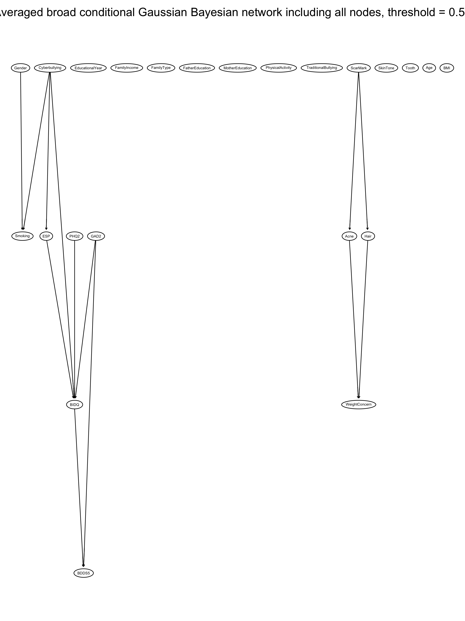
This figure shows all nodes included in the averaged conditional Gaussian Bayesian network, including isolated nodes, retained at arc strength ≥0.50 and direction probability ≥0.70. The connected-node version is presented in the main manuscript for readability.

Supplementary Figure S2. Sensitivity averaged Bayesian network using arc-strength threshold ≥0.70
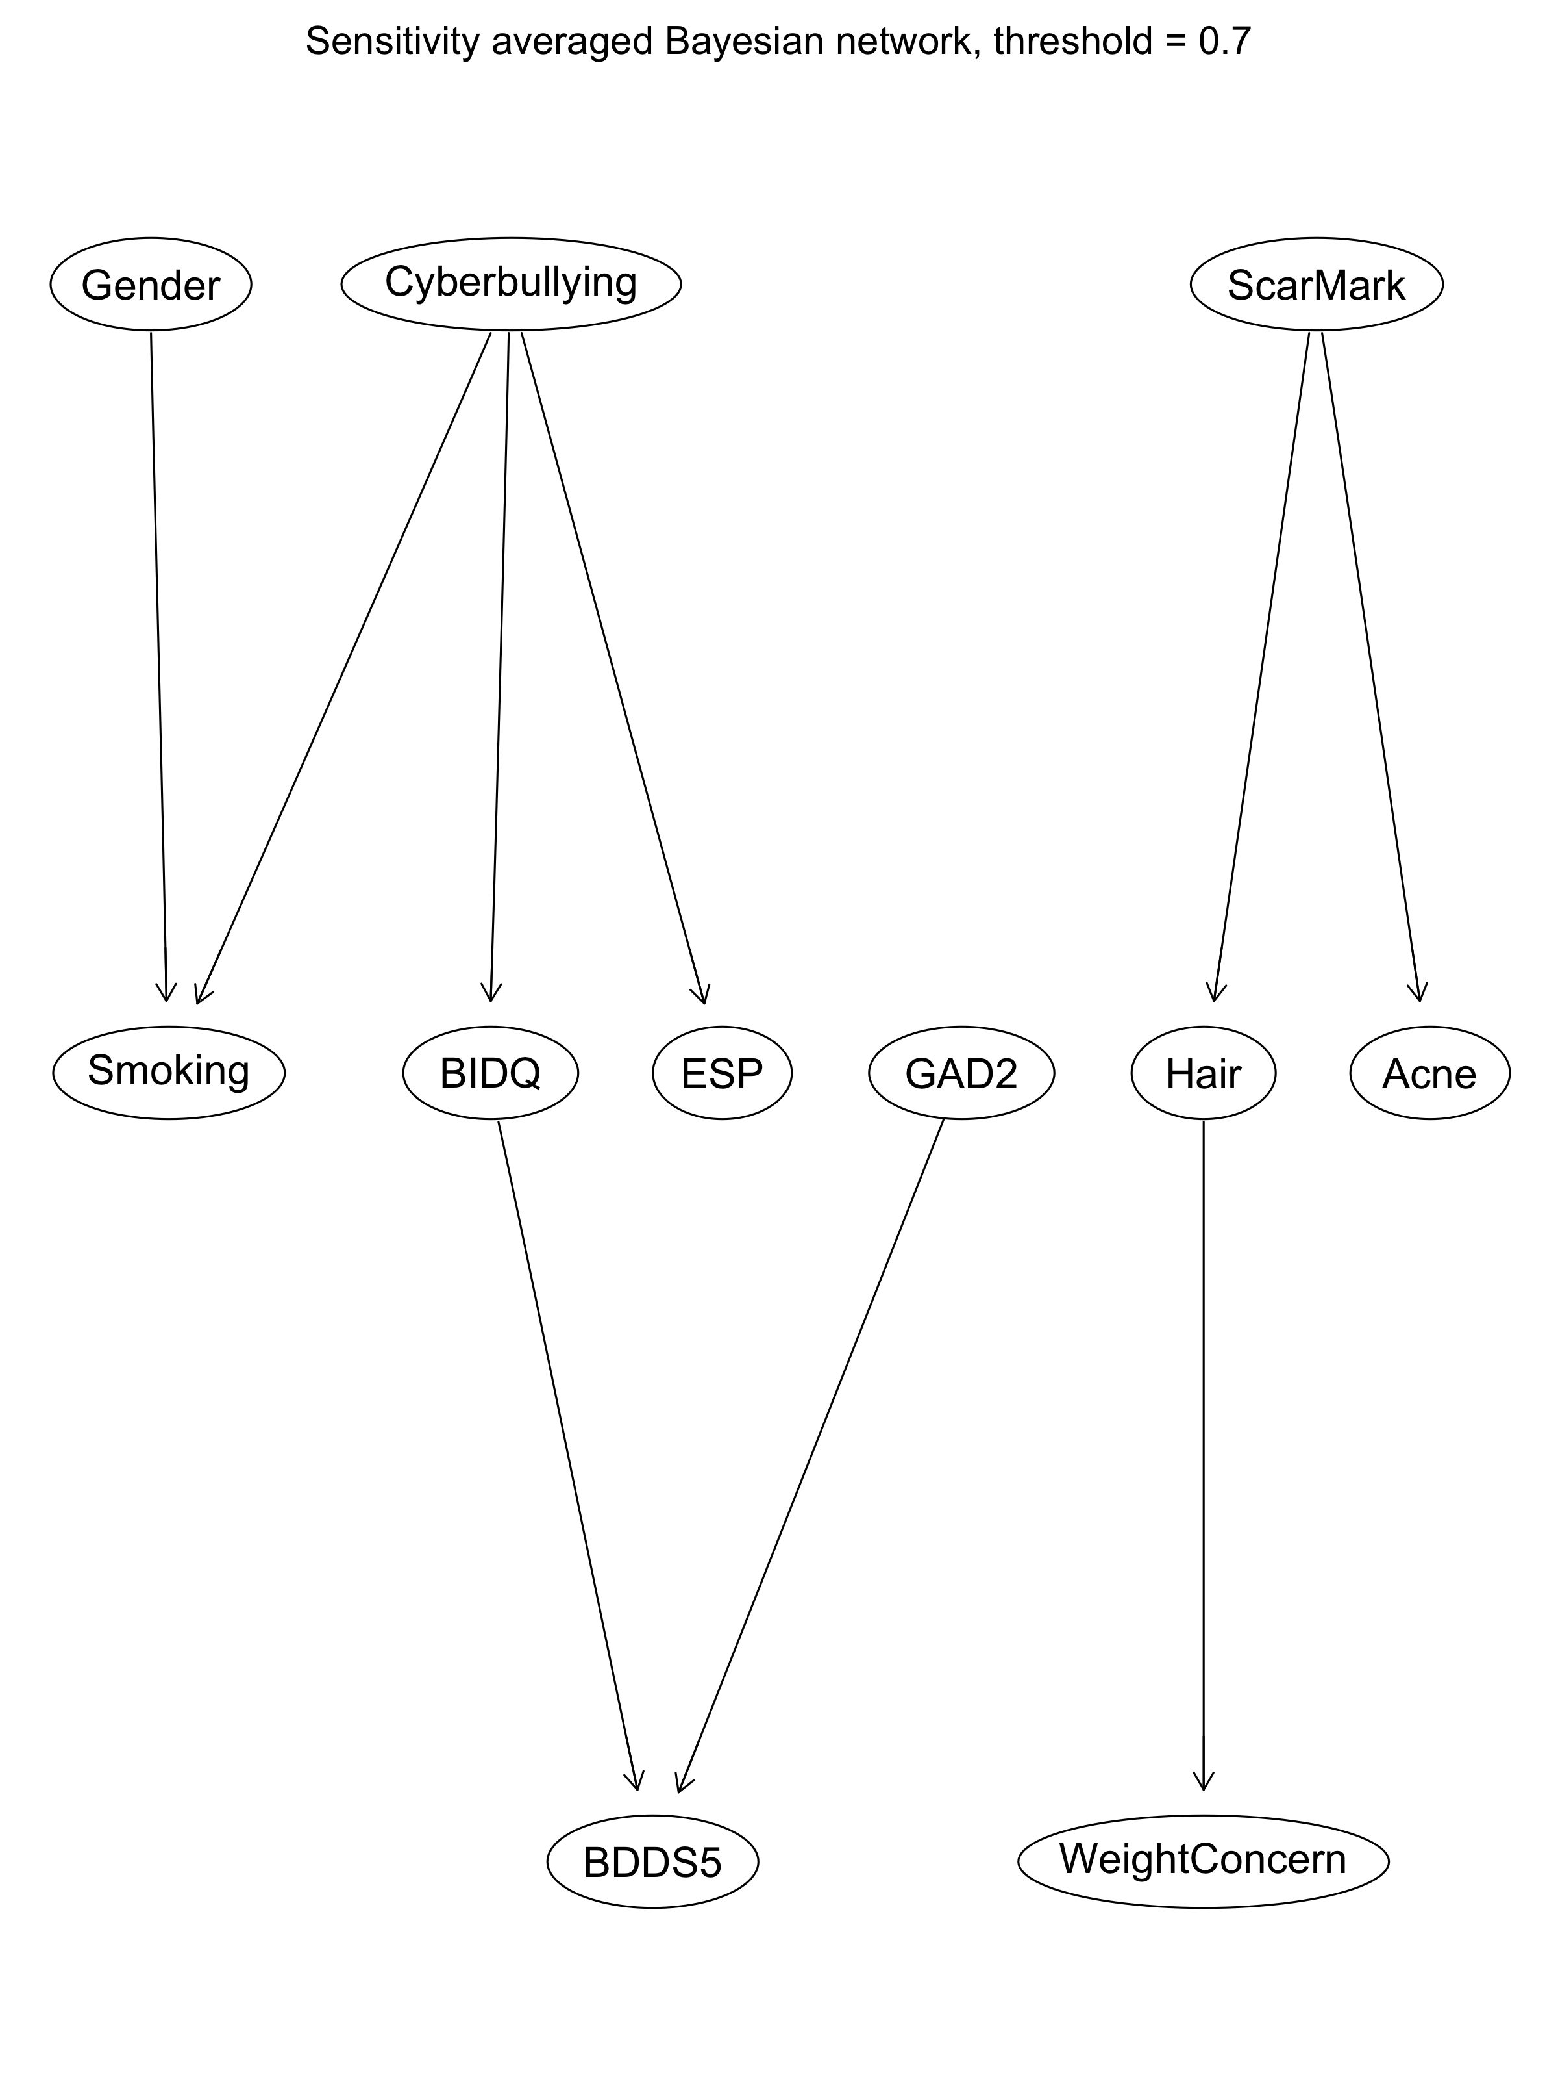
This figure shows the sensitivity averaged conditional Gaussian Bayesian network retained at arc strength ≥0.70 and direction probability ≥0.70. This threshold provides a stricter representation of bootstrap-supported conditional dependencies than the main averaged network.

Supplementary Figure S3. Sensitivity averaged Bayesian network using arc-strength threshold ≥0.85
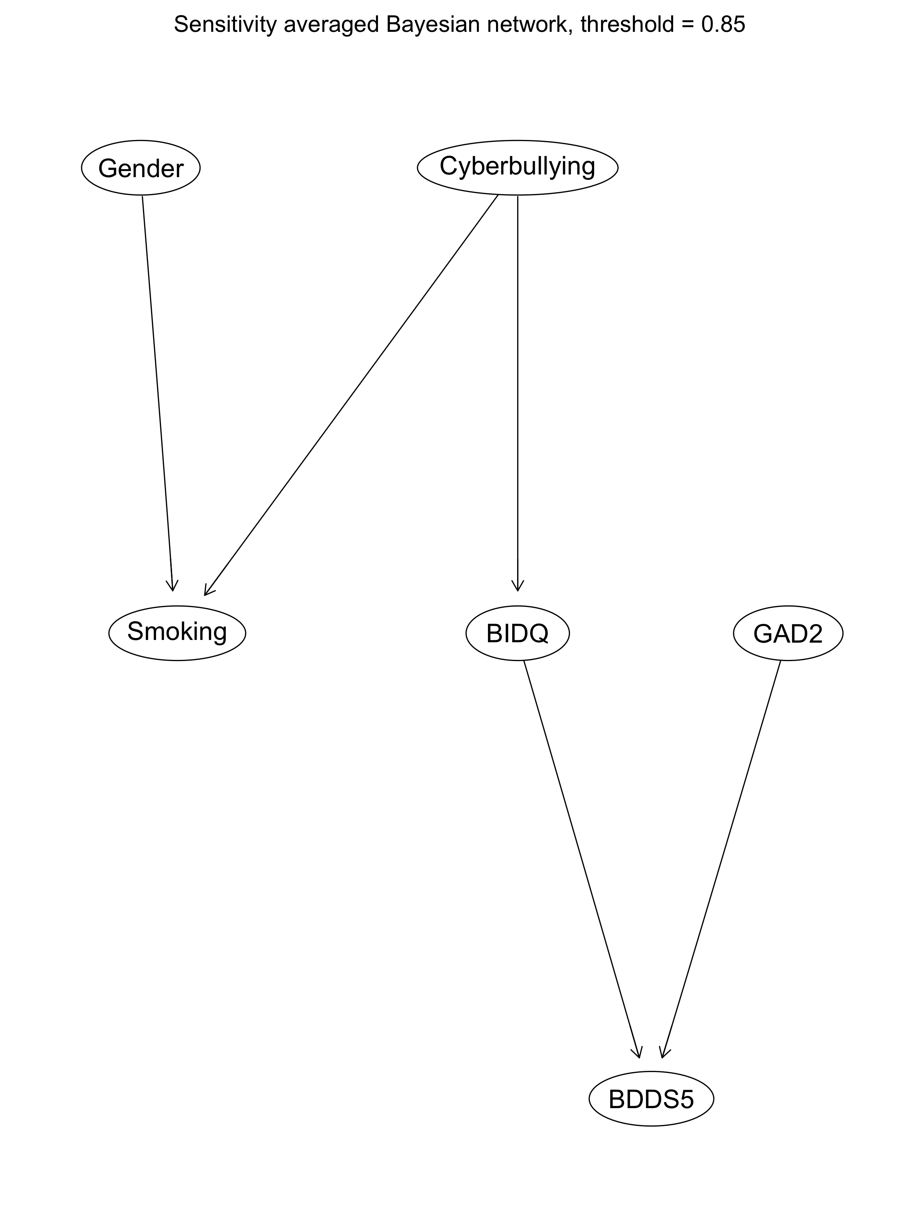
This figure shows the sensitivity averaged conditional Gaussian Bayesian network retained at arc strength ≥0.85 and direction probability ≥0.70. This represents the most conservative threshold used in the sensitivity analyses.

