Supplementary Materials
eFigure 1. Illustration of taVNS and Sham taVNS.
eFigure 2. eFigure 2 Boxplot of Alpha Diversity Indices at the Species Levelc
eFigure 3 Scatter plot of PCoA results.
eFigure 4 Correlation Analysis Between Brain Imaging and Clinical Data.
eFigure 5 Correlation Analysis Between Brain Imaging, Clinical Data, and Core Microbiota

eTable 1. Comparison of Clinical Data between Two Groups
eTable 2. Comparison of Response Rates and Clinical Remission Rates Between the Two Groups
eTable 3. Differences in ALFF and fALFF Between the Two Groups Pre and Post Intervention
eTable 4 Differences in ReHo and DC Between the Two Groups Pre and Post Intervention
eTable 5 Analysis of Alpha Diversity at the Species Level.

This supplemental material has been provided by the authors to give readers
additional information about their work.

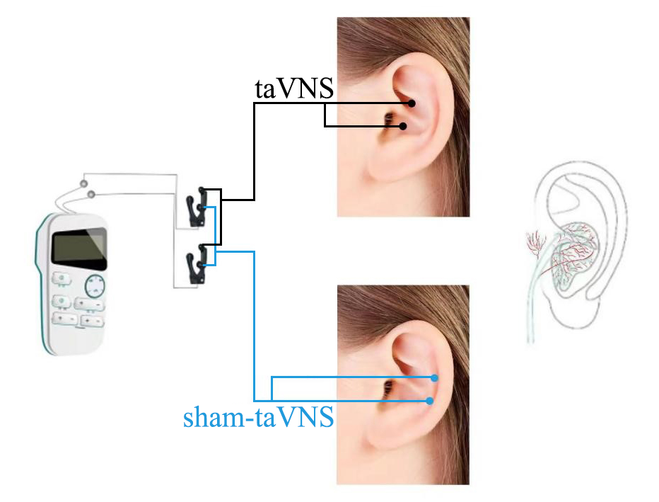
eFigure 1 A diagrammatic view showing taVNS treatment
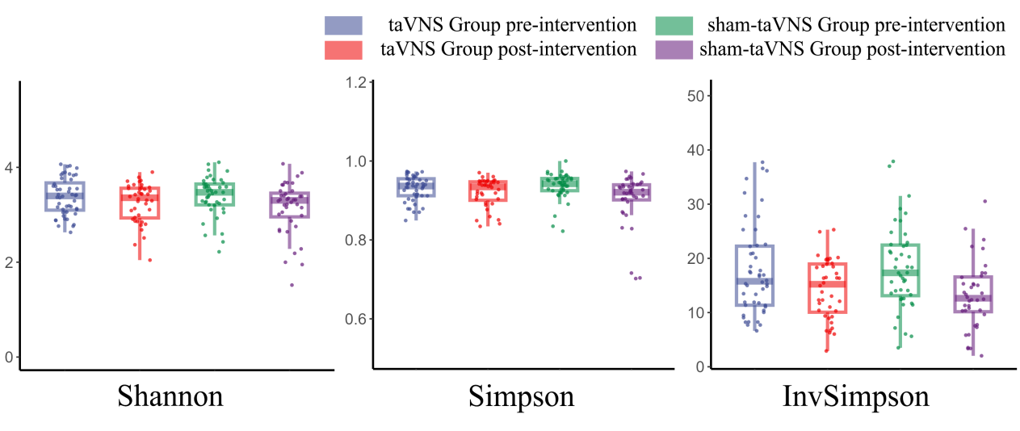
eFigure 2 Boxplot of Alpha Diversity Indices at the Species Level.
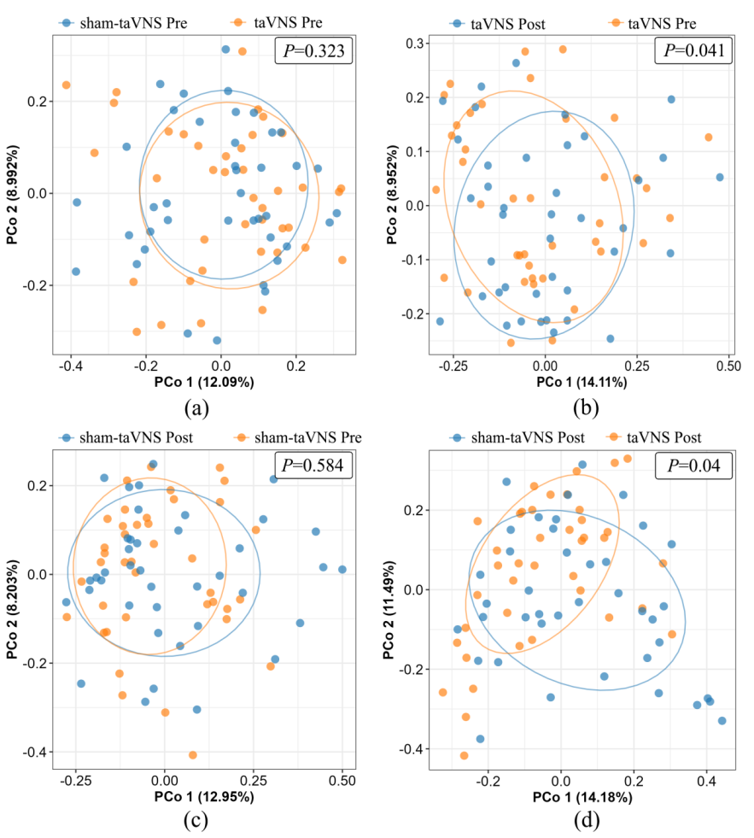
eFigure 3 Scatter plot of PCoA results: (a) taVNS group and sham-taVNS group pre intervention; (b) taVNS group pre and post intervention; (c) sham-taVNS group pre and post intervention; (d) taVNS group and sham-taVNS group post intervention.
Note: Points of the same color represent samples from the same group, and the distance between points indicates the difference in microbial community composition. The axes PCo1 and PCo2 represent the first and second principal coordinates, respectively, with the accompanying percentages indicating the contribution rate of the corresponding principal coordinate to the variance in the sample data.
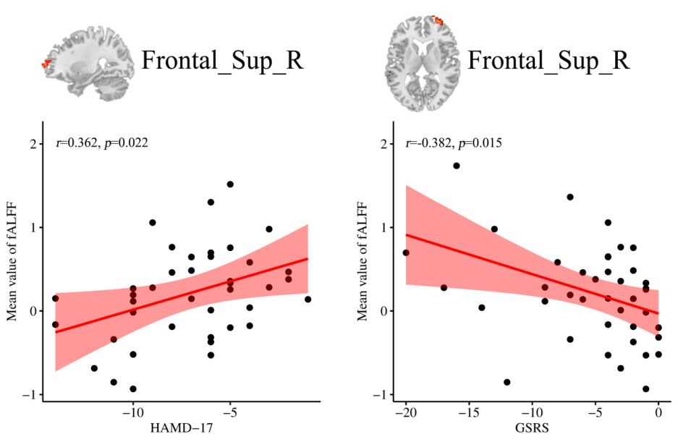
eFigure 4 Correlation Analysis Between Brain Imaging and Clinical Data.

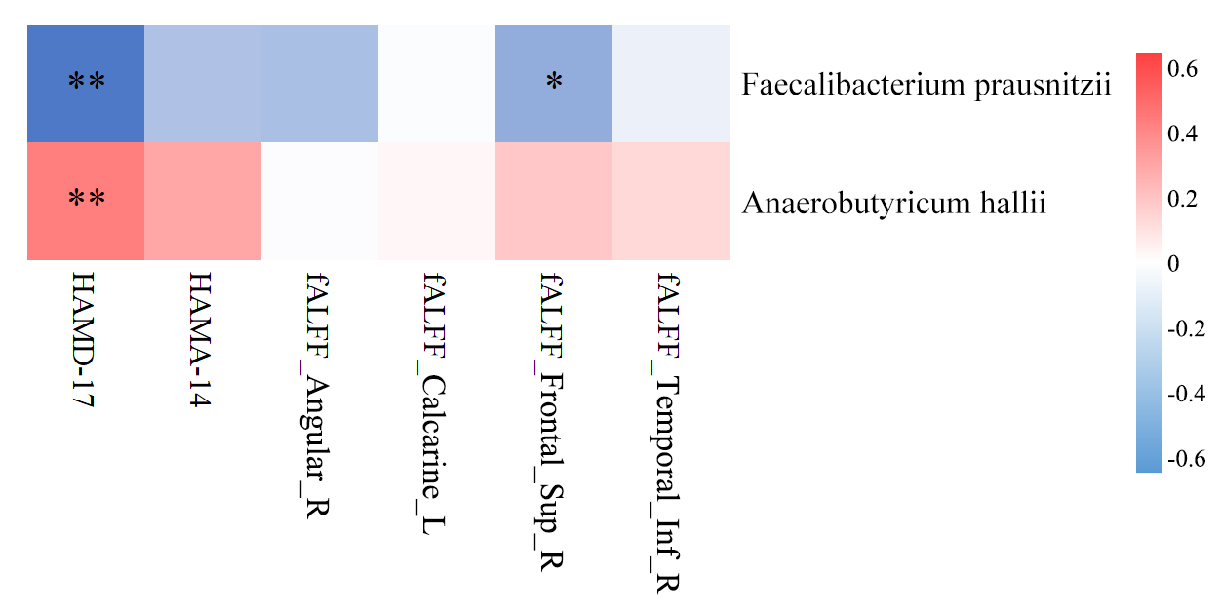
eFigure 5 Correlation Analysis Between Brain Imaging, Clinical Data, and Core Microbiota
Note: * indicates a significant correlation, (*P<0.05; **P<0.01). The color of the heatmap represents the nature of the correlation, with red indicating a positive correlation and blue indicating a negative correlation.

eTable 1 | Comparison of Clinical Data between Two Groups
Variable | Time Point | Group |  | t/Z | P
Variable | Time Point | taVNS(n=40) | sham-taVNS(n=40) | t/Z | P
HAMD-17 | Pre-intervention | 18.92±3.22 | 18.05±3.84 | 1.101 | 0.099
HAMD-17 | Post-intervention | 8.30±2.71ª | 10.95±3.15ª | 4.025 | <0.001^{b}
HAMA-14 | Pre-intervention | 14.90±3.84 | 14.15±3.36 | 0.929 | 0.401
HAMA-14 | Post-intervention | 7.90±2.97ª | 9.42±3.43ª | 2.122 | 0.037^{b}
GSRS | Pre-intervention | 12.0 (8.25-14.75) | 11.0 (8.0-13.75) | -0.903 | 0.367
GSRS | Post-intervention | 7.0 (4.25-9.0)ª | 6.0 (5.0-10.75)ª | 0.271 | 0.787
ªCompared to the pre-intervention within the same group, P < 0.05.
^{b}Compared to the post-intervention in the control group, P < 0.05.

eTable 2 | Comparison of Response Rates and Clinical Remission Rates Between the Two Groups
HAMD-17  response /remission rate | Group |  | X² | P
HAMD-17  response /remission rate | taVNS(n=40) | sham-taVNS(n=40) | X² | P
Response | 25（62.50%） | 12（30.00%） | 8.495 | 0.004
Non-response | 15（37.50%） | 28（70.00%） | 8.495 | 0.004
Remission | 14（35.00%） | 1（2.50%） | 11.815 | 0.001
Non-remission | 26（65.00%） | 39（97.50%） | 11.815 | 0.001

eTable 3 | Differences in ALFF and fALFF Between the Two Groups Pre and Post Intervention
Metric | Functional connectivity | Brodmann Area | MNI Peak |  |  | Voxel Size | F-value
Metric | Functional connectivity | Brodmann Area | X | Y | Z | Voxel Size | F-value
ALFF | Occipital_Inf_R | 19 | 49 | -74 | -16 | 43 | 16.64
fALFF | Temporal_Inf_R | 37 | 42 | -66 | -4 | 54 | 25.69
fALFF | Calcarine_L | 17 | -1 | -93 | -3 | 51 | 14.79
fALFF | Frontal_Sup_R | 10 | 27 | 63 | 9 | 46 | 17.73
fALFF | Angular_R | 7 | 33 | -66 | 45 | 116 | 20.45
F-value of the peak voxel showing functional connectivity differences among the three groups.
MNI Peak, Coordinates of primary peak locations in the Montreal Neurological Institute space.
fMRI results were subjected to GRF correction, with a corrected cluster level established at P < 0.01 (two-tailed). The threshold voxel levels were set at P < 0.005, ensuring the statistical integrity of the finding.

eTable 4 | Differences in ReHo and DC Between the Two Groups Pre and Post Intervention
Metric | Functional connectivity | Brodmann Area | MNI Peak |  |  | Voxel Size | F
Metric | Functional connectivity | Brodmann Area | X | Y | Z | Voxel Size | F
ReHo | Occipital_Inf_R | 19 | 48 | -72 | -15 | 38 | 20.30
ReHo | Insula_R | 48 | 36 | 9 | 6 | 66 | 13.18
ReHo | Insula_L | 48 | -39 | 9 | 6 | 50 | 13.80
DC | Caudate_R | 39 | 18 | 24 | 12 | 70 | 10.95
DC | ACC_L | 34 | -5 | 8 | 12 | 18 | 20.45
F-value of the peak voxel showing functional connectivity differences among the three groups.
MNI Peak, Coordinates of primary peak locations in the Montreal Neurological Institute space.
fMRI results were subjected to GRF correction, with a corrected cluster level established at P < 0.01 (two-tailed). The threshold voxel levels were set at P < 0.005, ensuring the statistical integrity of the finding.

eTable 5 | Analysis of Alpha Diversity at the Species Level.
Group | N | Time Point | Shannon's Diversity Index | Simpson's Diversity Index | InvSimpson's Diversity Index
taVNS | 40 | Pre | 3.38±0.42 | 0.92±0.03 | 17.94±9.18
taVNS | 40 | Post | 3.33±0.42 | 0.92±0.05 | 17.11±7.65
sham-taVNS | 40 | Pre | 3.30±0.41 | 0.91±0.05 | 17.34±6.67
sham-taVNS | 40 | Post | 3.19±0.60 | 0.90±0.09 | 17.49±7.70

