Supplementary Material 1

Additional Table S1. Discontinuations by treatment arm: reasons and treatment exposure
 | DMPFC (n = 9) | L-DLPFC (n = 5) | Sham (n = 5) | Total (n = 19)
Insufficient effect or worsening | 5 | 3 | 1 | 9
— MADRS above baseline at last visit | 4 | 2 | 1 | 7
— increase ≥ 6 points | 2 | 2 | 0 | 4
Patient's decision | 2 | 2 | 4 | 8
Intolerance / side effects | 2 | 0 | 0 | 2
Received all 20 rTMS sessions | 5 | 4 | 2 | 11
Withdrew during the stimulation phase (<20 rTMS sessions) | 4 | 1 | 3 | 8
Time in study, median days (range) | 28 (7–38) | 28 (14–32) | 21 (14–36) | 28 (7–38)
Post-baseline assessment (1 / 2 / 3) | 1 / 4 / 4 | 0 / 1 / 4 | 0 / 3 / 2 | 1 / 8 / 10

Abbreviations: groups: DMPFC, DMPFC-rTMS + SSRI; L-DLPFC, HF-rTMS over the left DLPFC + SSRI; Sham, sham rTMS + SSRI; DLPFC, dorsolateral prefrontal cortex; DMPFC-rTMS, dorsomedial prefrontal repetitive transcranial magnetic stimulation; HF-rTMS, high-frequency repetitive transcranial magnetic stimulation; MADRS, Montgomery and Åsberg Depression Rating Scale; SSRI, Selective serotonin reuptake inhibitor

Additional Table S2. Comparison of completers and non-completers
Characteristic | Non-completers (n = 19) | Completers (n = 41) | p-value
Age (years) | 44.6 ± 13.6 | 44.3 ± 12.5 | 0.94
Female/ Male | 7/12 | 27/14 | 0.051
Baseline MADRS | 27.8 ± 3.7 | 27.9 ± 3.9 | 0.97
Duration of current episode (weeks) | 26.3 ± 16.3 | 27.4 ± 15.1 | 0.81
Fluoxetine-equivalent dose (last visit; mg) | 53.6 ± 16.2 | 54.1 ± 16.9 | 0.92
TMS acute side-effects (last visit) | 12.4 ± 2.8 | 11.2 ± 2.6 | 0.10
ASEC antidepressant side-effects (last visit) | 11.6 ± 9.0 | 7.8 ± 6.6 | 0.07

Values are mean ± SD unless otherwise indicated. p-values: two-sample t-test (continuous variables) and Fisher's exact test (sex). Last visit denotes each patient's final available rating.

Additional Figure S1. Individual MADRS trajectories by treatment arm

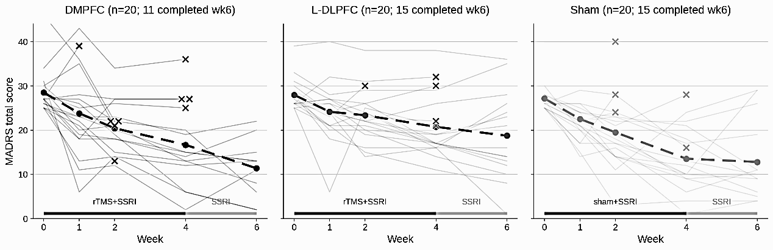
Thin grey lines show individual patient trajectories; the dashed line with circles shows the observed group means at each visit (weeks 0, 1, 2, 4, and 6). Crosses (×) mark the last available MADRS score for patients who discontinued before the week-6 assessment
Abbreviations: groups: DMPFC, DMPFC-rTMS + SSRI; L-DLPFC, HF-rTMS over the left DLPFC + SSRI; Sham, sham rTMS + SSRI; DLPFC, dorsolateral prefrontal cortex; DMPFC-rTMS, dorsomedial prefrontal repetitive transcranial magnetic stimulation; HF-rTMS, high-frequency repetitive transcranial magnetic stimulation; MADRS, Montgomery and Åsberg Depression Rating Scale; SSRI, Selective serotonin reuptake inhibitor

