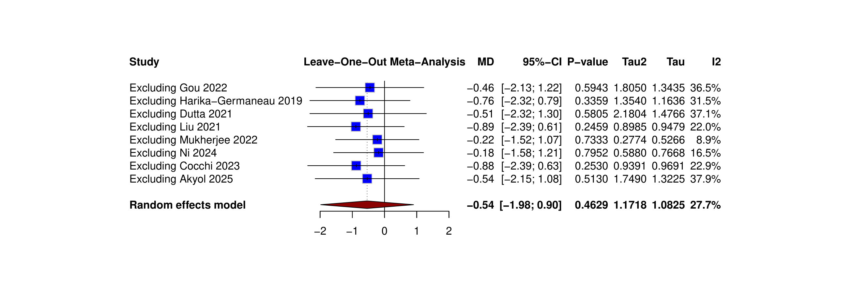
Online supplementary materials

Figure S1. Leave-one-out sensitivity analysis of TBS effect on Y-BCOS scale at the primary endpoint.
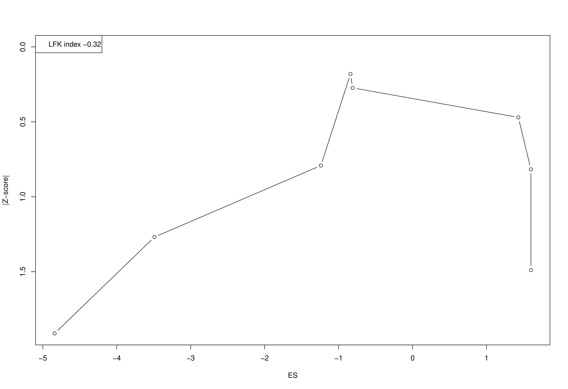
Figure S2. DOI plot of TBS and Y-BCOS score reduction with LFX index.
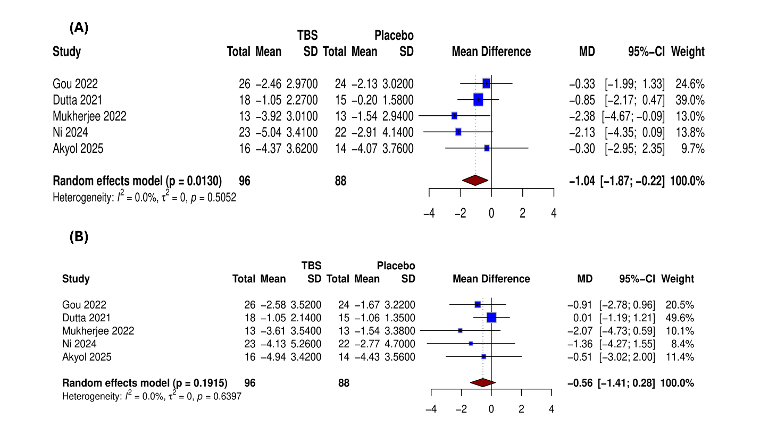
Figure S3. (A) Forest plot of HAM-D scores, (B) Leave-one-out sensitivity analysis of HAM-D scores.

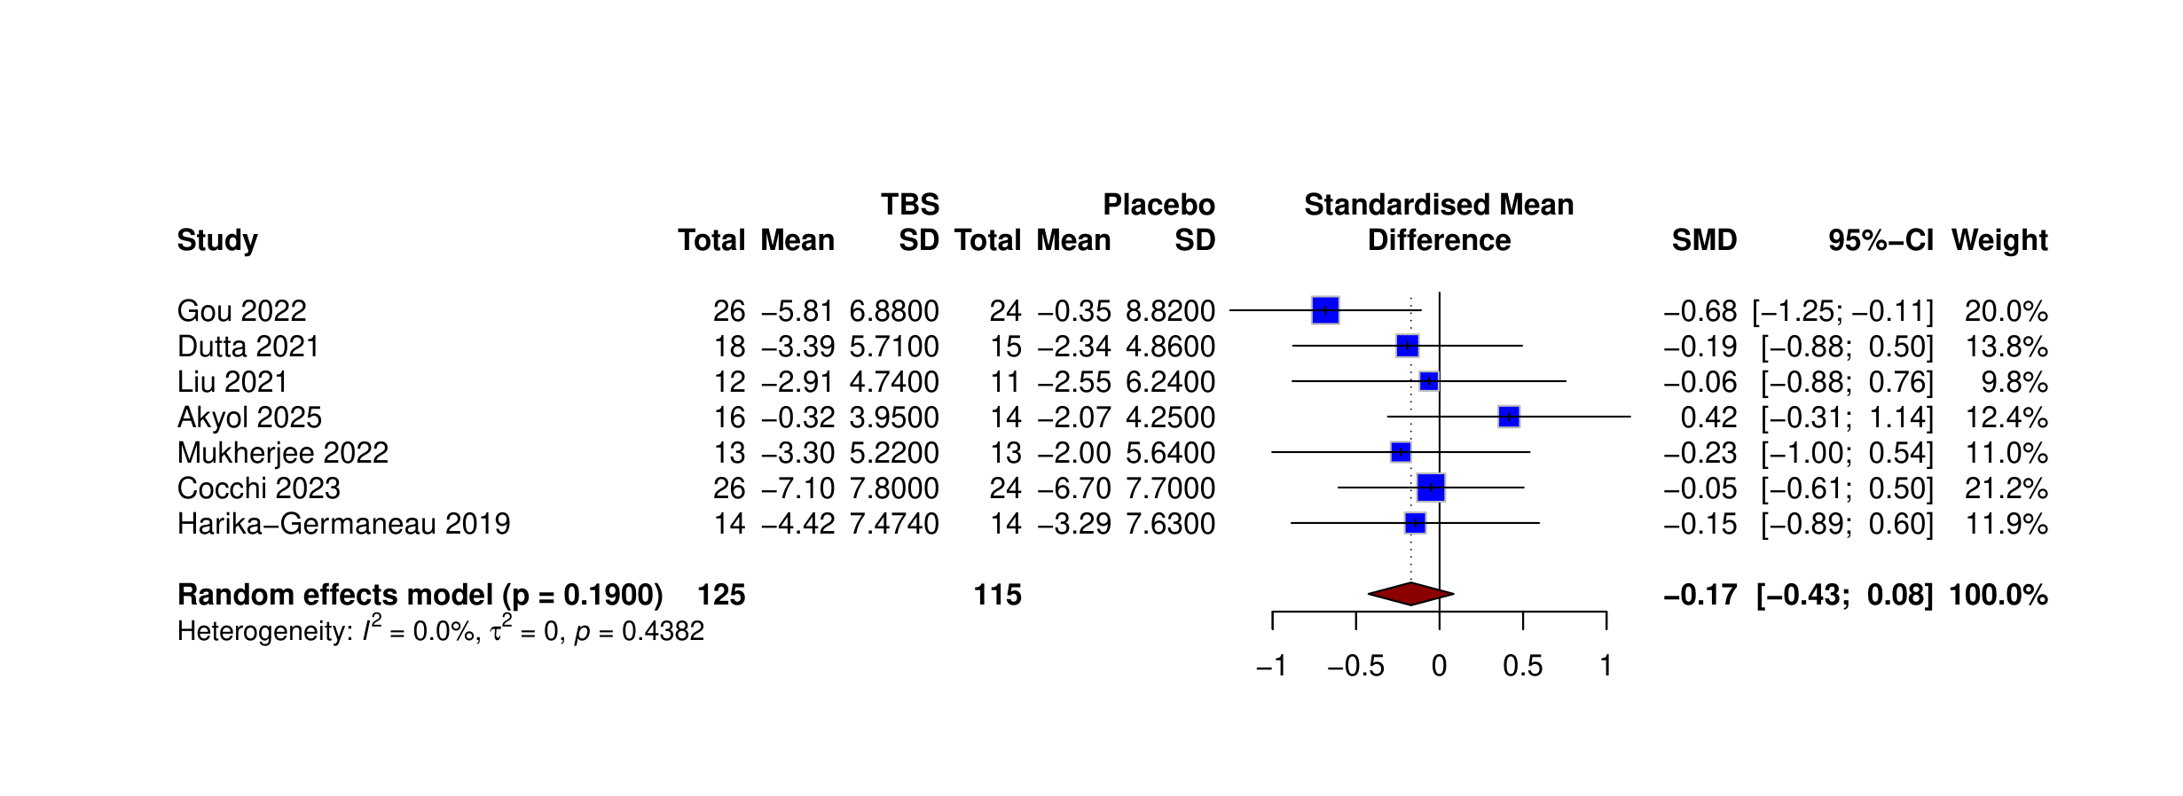Figure S4. Forest plot of TBS effect on anxiety at the primary endpoint.

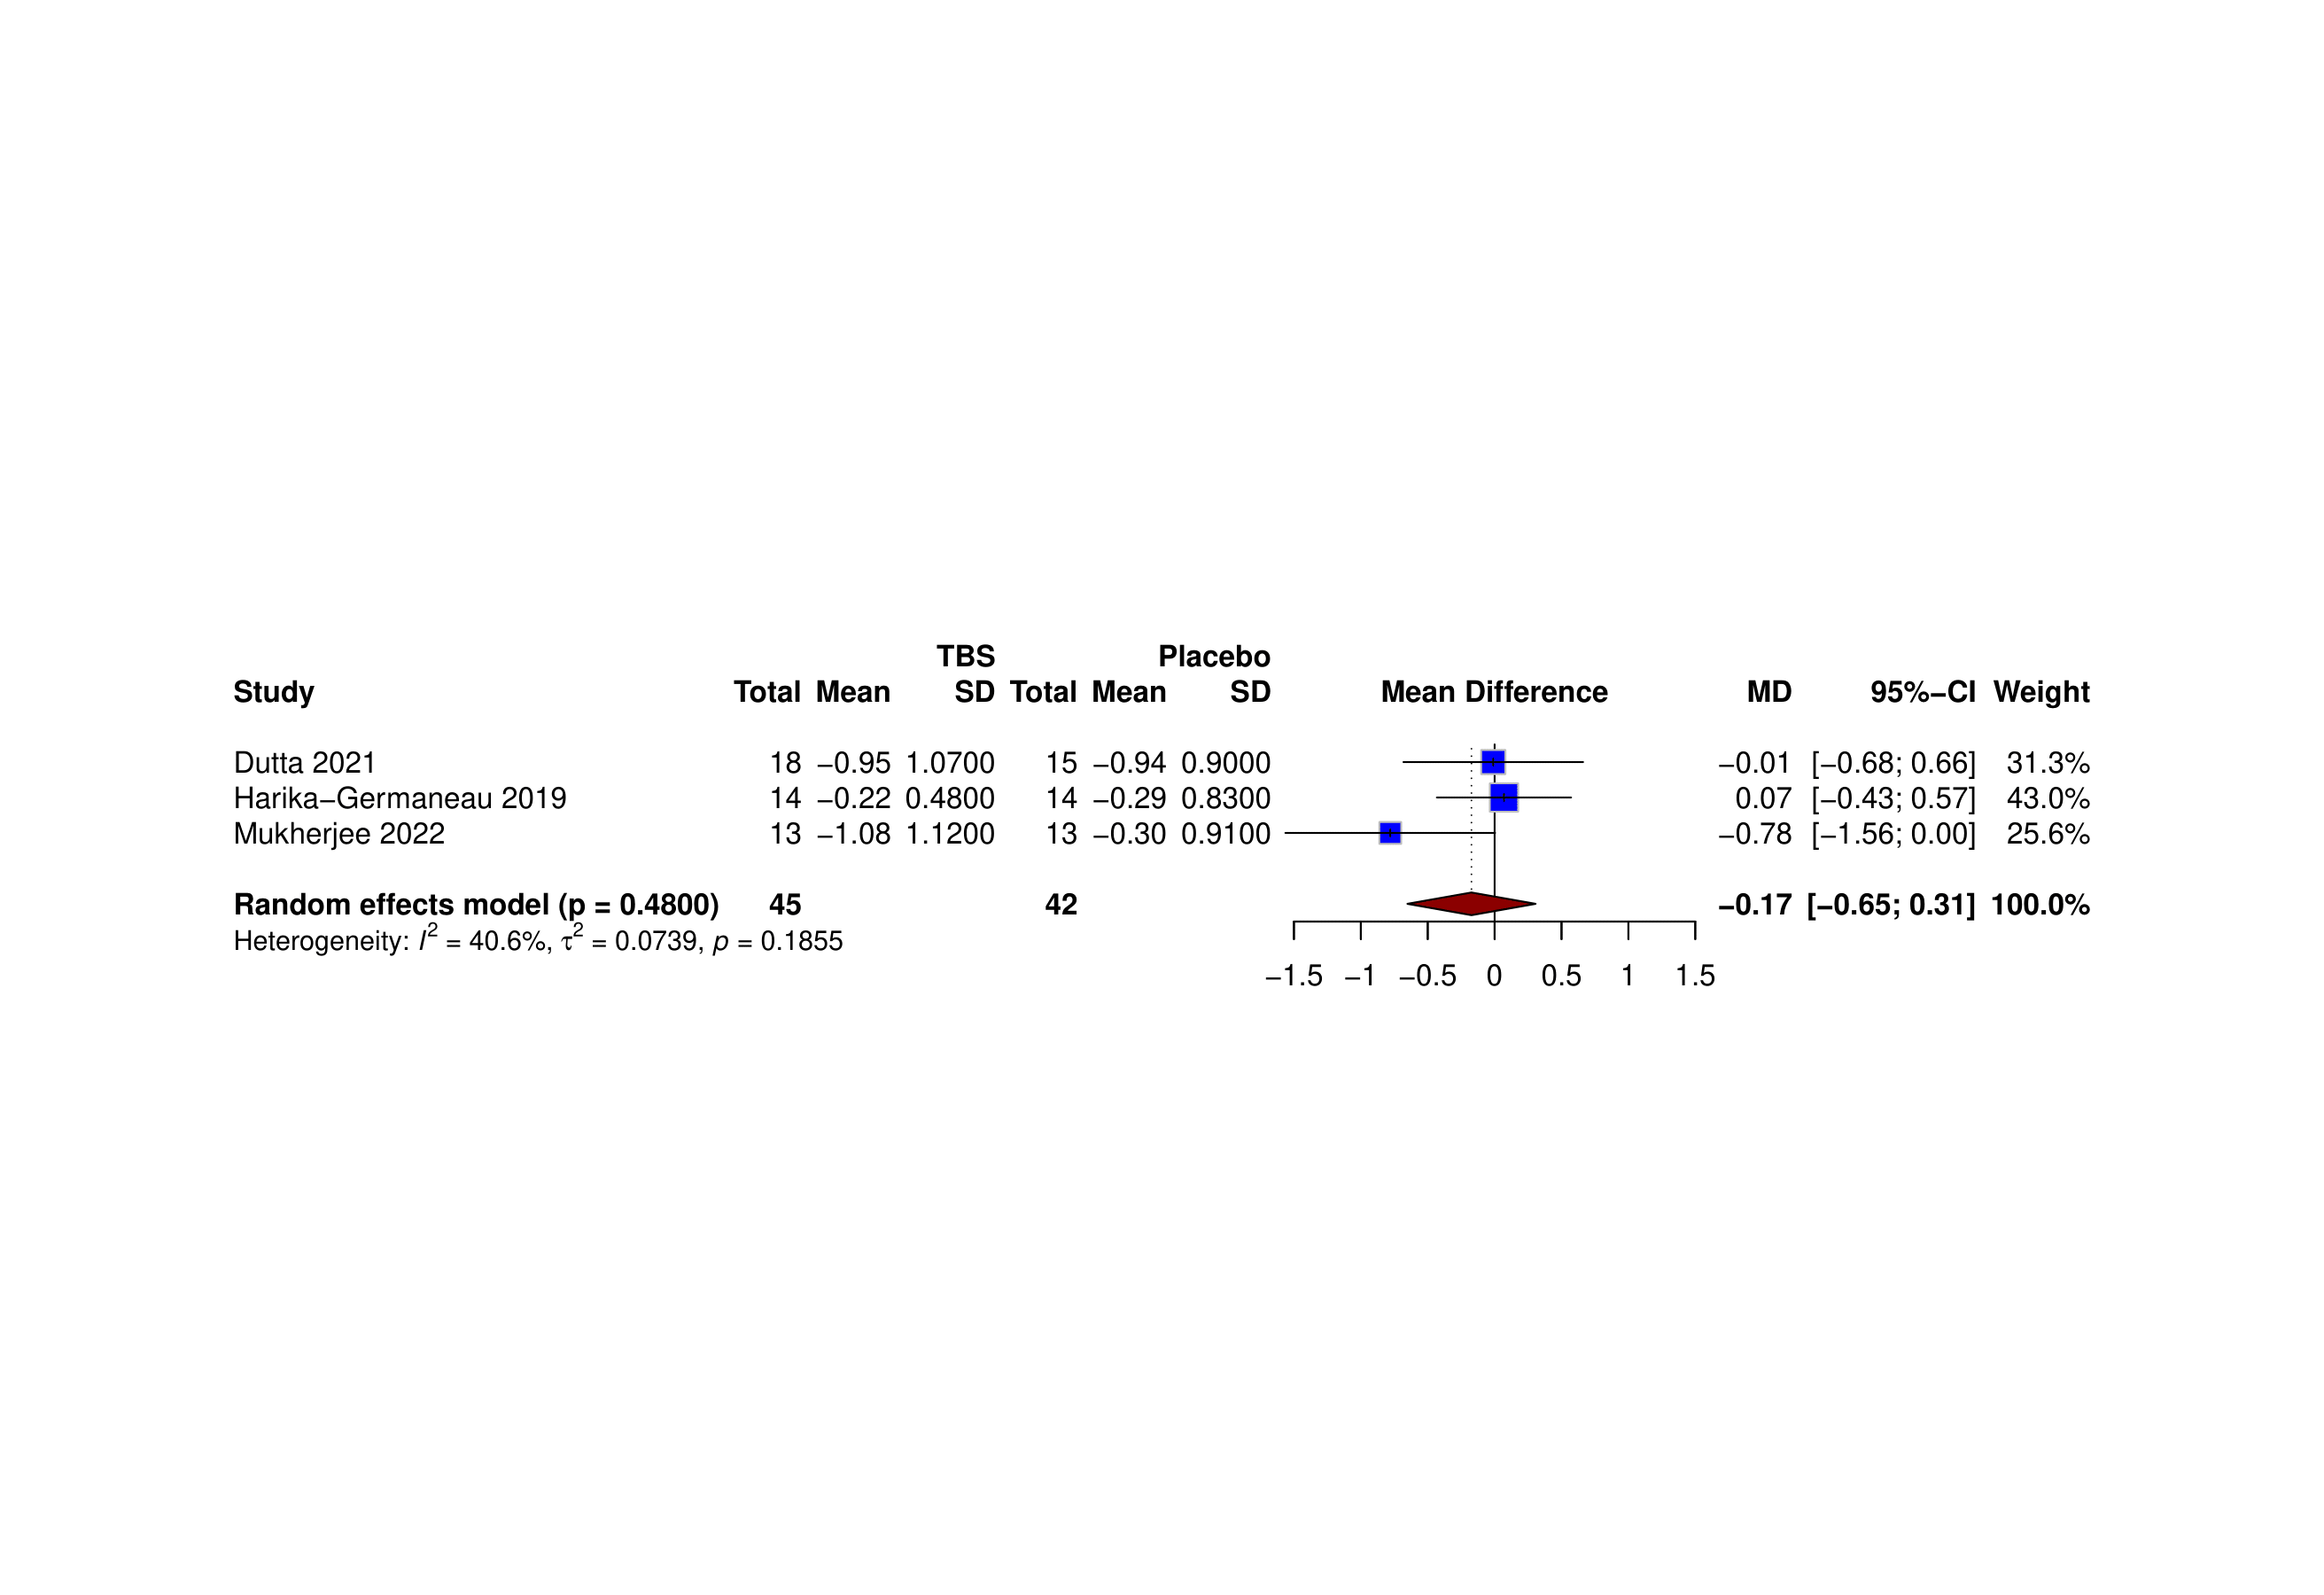Figure S5. Forest plot of TBS effect on CGI-S score at the primary endpoint.

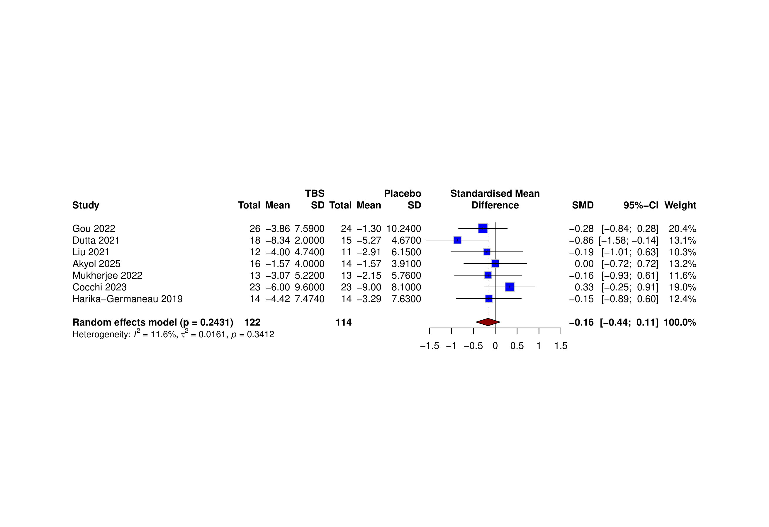Figure S6. Forest plot of anxiety improvement at follow-up.

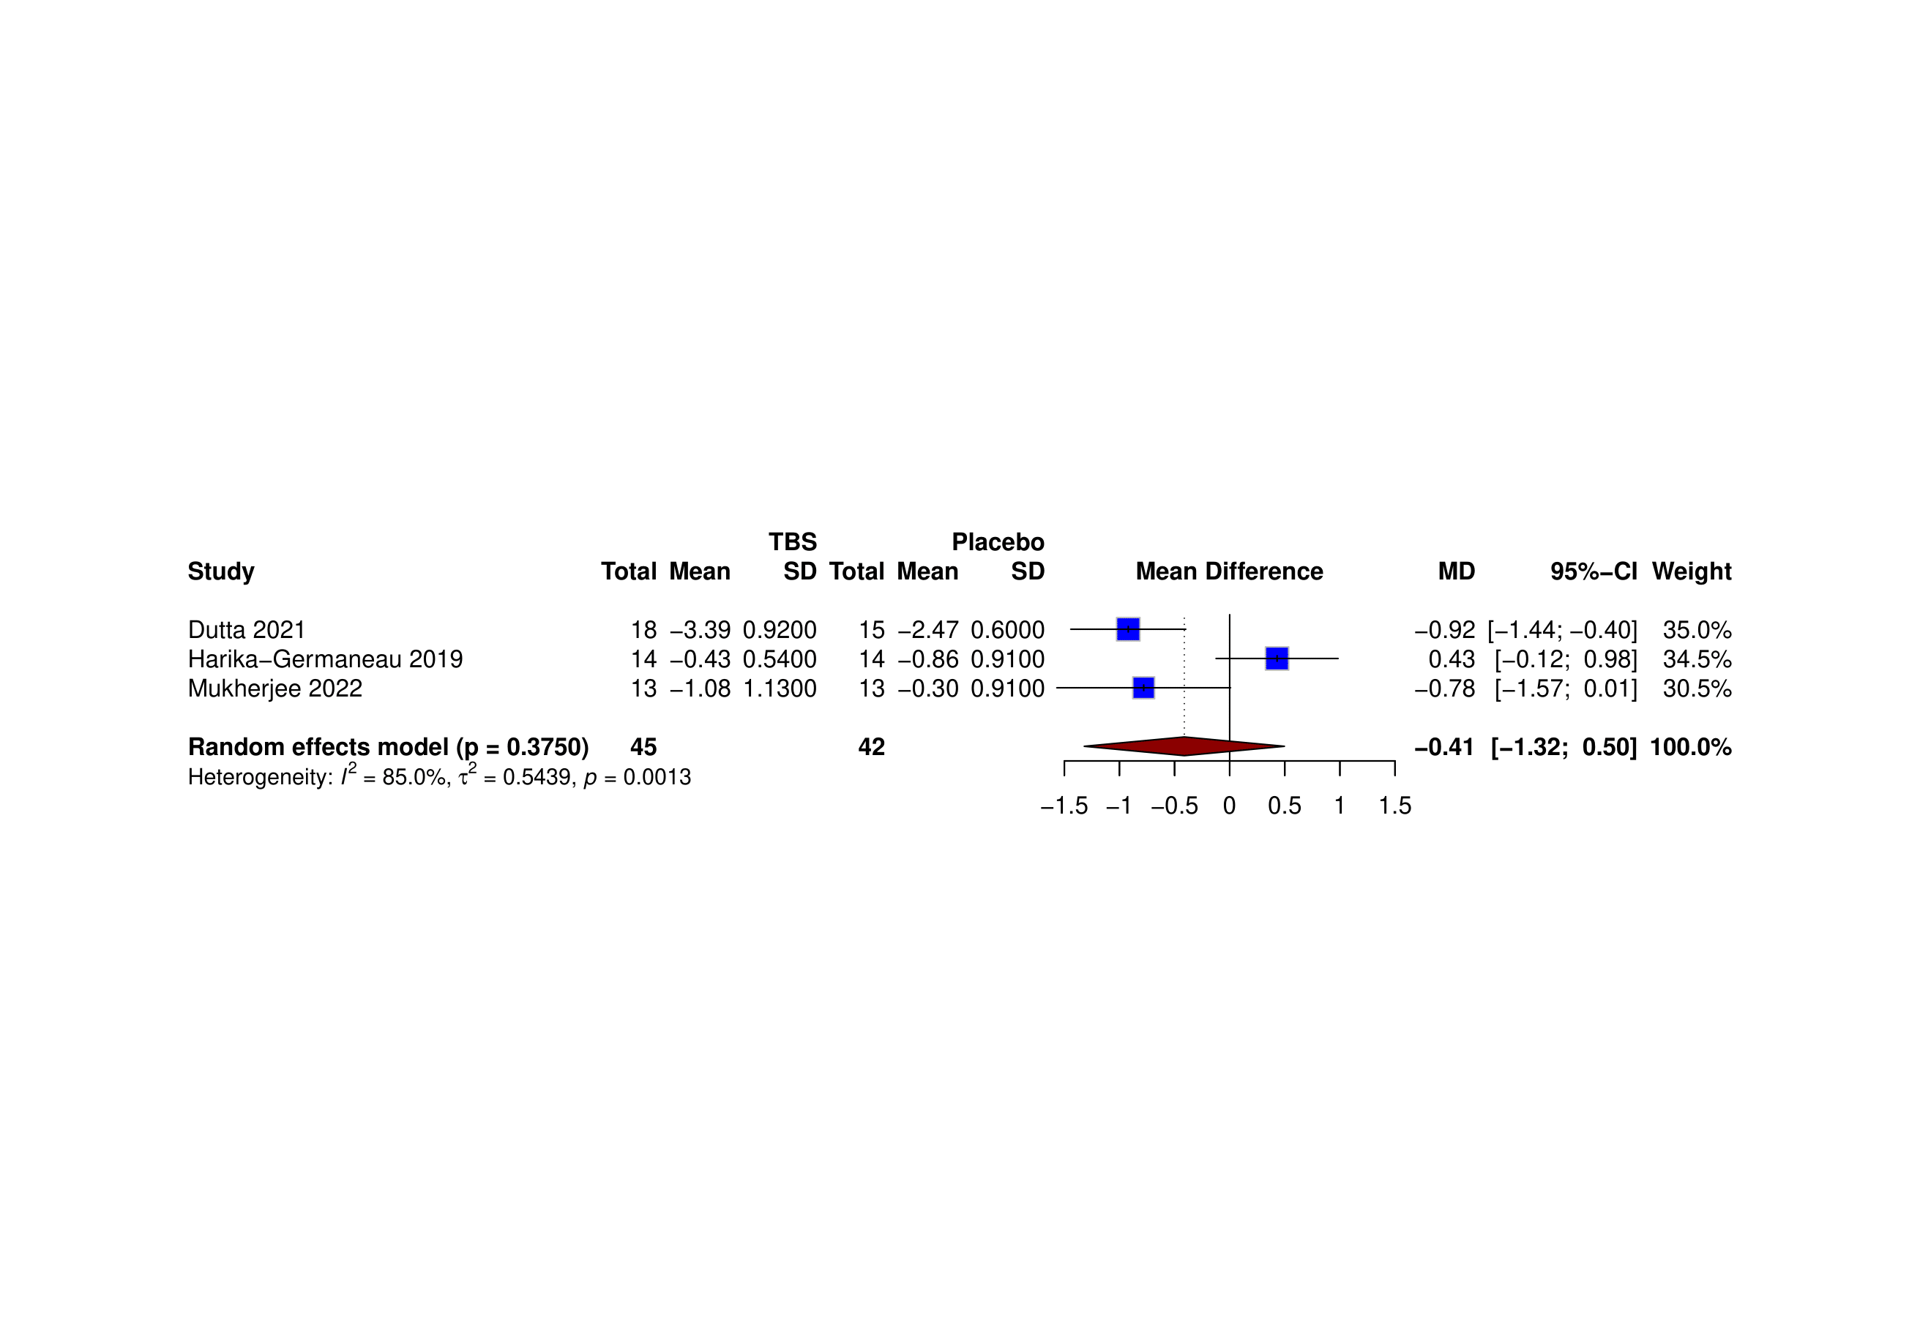Figure S7. Forest plot of the CGI-S score at follow-up.
Certainty assessment
Outcome | Participants  (studies) Follow-up | Risk of bias | Inconsistency | Indirectness | Imprecision | Publication bias | Overall certainty of evidence
Y-BOCS  (Immediate effect) | 255  (8 RCTs) | seriousª | not serious | not serious | serious^{b} | none | ⨁⨁◯◯  Low
Y-BOCS  (Long term effect) | 255  (7 RCTs) | seriousª | not serious | not serious | serious^{b} | none | ⨁⨁◯◯  Low
‘Obsession’  (Immediate effect) | 154  (5 RCTs) | seriousª | not serious | not serious | not serious | none | ⨁⨁⨁◯  Moderate
‘Obsession’  (Long term effect) | 154  (5 RCTs) | seriousª | not serious | not serious | not serious | none | ⨁⨁⨁◯  Moderate
‘Compulsion’  (Immediate effect) | 154  (5 RCTs) | seriousª | not serious | not serious | serious^{b} | none | ⨁⨁◯◯  Low
‘Compulsion’  (Long term effect) | 154  (5 RCTs) | seriousª | not serious | not serious | not serious | none | ⨁⨁⨁◯  Moderate
HAM-D  (Immediate effect) | 132  (5 RCTs) | seriousª | not serious | not serious | not serious | none | ⨁⨁⨁◯  Moderate
HAM-D  (Long term effect) | 132  (5 RCTs) | seriousª | not serious | not serious | not serious | none | ⨁⨁⨁◯  Moderate
MADRS  (Immediate effect) | 78  (2 RCTs) | seriousª | not serious | not serious | serious^{b} | none | ⨁⨁◯◯  Low
MADRS  (Long term effect) | 78  (2 RCTs) | seriousª | not serious | not serious | serious^{b} | none | ⨁⨁◯◯  Low
Anxiety  (Immediate & Long-term effects) | 210  (7 RCTs) | seriousª | not serious | not serious | serious^{b} | none | ⨁⨁◯◯  Low
CGI-S  (Immediate & Long-term effects) | 87  (3 RCTs) | seriousª | not serious | not serious | serious^{b} | none | ⨁⨁◯◯  Low
Explanations:
a. All included RCTs were assessed as having a high risk of bias.
b. The CI was wide, including significant and non-significant result

Supplementary Table 1. GRADE assessment for the outcomes

