Supplemental Online Content
Methods
Table S1. Details of participants’ medication usage during the study period
Table S2. Distribution of antipsychotic medication use among study participants
Table S3. The 16 final FCs selected by the predictive model
Table S4. Demographic and clinical scale characteristics between responders and non-responders
Table S5. Comparison of baseline FCs selected by the model between responders and non-responders
Figure S1 Results of the permutation test.
References

Methods

Study Subjects and Endpoints for Individualized Prediction
A total of 45 patients with schizophrenia who received ECT treatment at Xi’an Mental Health Center in China were included in this study. These patients were part of our previously published dataset (n = 57)[1], from which 12 individuals were excluded due to missing resting state functional magnetic resonance imaging (rs-fMRI) data (n = 6) or excessive head motion (n = 6).

Electroconvulsive therapy
Participants received ECT using the spECTrum 5000Q device (MECTA, Tualatin, OR, USA) in combination with standard antipsychotic medication over a 4-week period. A standard treatment schedule was followed, consisting of three sessions per week for four weeks, and the total number of ECT sessions for each patient was determined by the treating psychiatrists based on individual clinical conditions. The ECT procedure was conducted as follows: one circular flat electrodes (diameter: 5 cm) was placed on either side of the head with the location approximately 2.5 cm above the center of a line connecting the tragus and the external canthus. The stimulus current was 800 mA, and the stimulus duration arranged from 3 to 5 seconds. When the electroencephalogram monitors the spike-and-slow wave, the electrode stimulation is stopped and the spike-and-slow wave lasts for 25 to 75 seconds, which is considered to be a characteristic indicator of the complete of ECT. Stimulus frequency was adapted due to different seizure threshold varied for individuals. Blood pressure, and oxygen saturation were monitored for all patients. The dosages of anesthetic (propofol and etomidate) and a muscle relaxant (succinylcholine) were calculated based on the body weight of each patient.

Image acquisition
All participants underwent MRI scanning using a 3.0T GE MR750 scanner (GE Healthcare, Milwaukee, WI, USA) one day before the initiation of ECT and one day after the final ECT session. Imaging protocols included high-resolution T1-weighted structural imaging, diffusion tensor imaging, and rs-fMRI. The present study focused on the analysis of pre-ECT T1-weighted structural imaging and resting state functional magnetic resonance imaging (rs-fMRI) data. High-resolution T1-weighted structural images were acquired using a three-dimensional fast spoiled gradient echo sequence with the following parameters: repetition time/echo time (TR/TE) = 8.2/3.2 ms; flip angle (FA) = 12°; field of view (FOV) = 256×256 mm²; matrix = 256×256; slice thickness = 1 mm; 196 contiguous sagittal slices. rs-fMRI were obtained using a single-shot gradient echo-planar imaging sequence with the following parameters: TR/TE = 2000/30 ms; flip angle = 90°; FOV = 240×240 mm²; matrix = 64×64; in-plane resolution = 3.75×3.75 mm²; slice thickness = 3.5 mm with no gap; 45 axial slices; 210 volumes were acquired for each participant. During scanning, participants were instructed to relax, keep still, refrain from engaging in active thought, remain awake, and keep their eyes closed. A customized head cushion was used to minimize head motion and reduce artifacts during image acquisition.

Imaging data preprocessing and feature extraction
Data preprocessing
The first five volumes of each rs-fMRI scan were discarded to allow signal stabilization. Subsequent preprocessing was performed using the default pipeline in the CONN toolbox[2] (version 21a, running on MATLAB R2022a), comprising the following steps: 1) Realignment (motion correction): subjects with head motion exceeding 2 mm in translation or 2° in rotation were excluded to minimize motion-related artifacts. 2) Functional centering: functional images were realigned to center at the (0, 0, 0) coordinate. 3) Timing correction: functional slices were temporally realigned according to their acquisition order. 4) Detection of functional images outliers: Artifact Detection Tools (ART; https://www.nitrc.org/projects/artifact_detect/) were used to identify artifacts and motion-related outliers in the functional scans, and to remove contaminated time points. The procedure applied the default threshold settings (based on the 97th percentile of the normative sample), flagging time points as outliers if global blood oxygen level dependent (BOLD) signal changes exceeded 5 standard deviations or if framewise displacement exceeded 0.9 mm. 5) Segmentation and normalization of functional images[3]: slice-time corrected functional data were segmented into gray matter, white matter, and cerebrospinal fluid (CSF), and normalized to montreal neurological institute space using default tissue probability maps (target resolution: 2×2×2 mm³ for functional data; 1×1×1 mm³ for structural data). 6) Structural centering: high-resolution T1-weighted structural images were centered at (0, 0, 0). 7) Segmentation and normalization of structural images: structural data were segmented and normalized using procedures analogous to those for functional data. 8) Spatial smoothing: to improve the signal-to-noise ratio of the BOLD signal, a Gaussian kernel with a full width at half maximum of 8 mm was applied to the functional data. Subsequently, denoising was performed to remove potential confounding factors in the BOLD signal. This included removal of 10 noise components (5 from white matter and 5 from CSF) using principal component analysis, 12 motion-related parameters (3 translations, 3 rotations, and their first-order derivatives), and scrubbing regressors from ART outlier detection. A temporal bandpass filter (0.008-0.09 Hz) was applied to isolate low-frequency fluctuations while minimizing physiological and motion-related noise[4]. Additionally, linear detrending and global signal regression were conducted to further control for signal fluctuations associated with motion artifacts. Functional connectivity analysis employed an ROI-to-ROI approach. The time series for each ROI was defined as the average BOLD signal across all voxels within the respective region. A Pearson correlation coefficient matrix was computed for all possible pairs among the 154 ROIs (totaling 11,781 unique pairs), quantifying inter-regional connectivity strength. Subsequently, correlation coefficients underwent Fisher’s z-transformation to generate normally distributed whole-brain connectivity matrices at the individual subject level.

Establishment of a predictive model
Data Preprocessing
Considering the relatively small sample size of this study and the presence of outliers as well as deviations from normal distribution among certain features, a systematic data preprocessing strategy was implemented to enhance the robustness and generalization ability of the predictive model. First, the RobustScaler was employed to standardize the feature set[5], scaling values based on the median and interquartile range. This approach effectively reduces the influence of extreme values, thereby improving model stability under small-sample conditions. Second, to address the non-normal distributions of both features and target variables, the PowerTransformer (method = “yeo-johnson”) was applied to perform nonlinear transformations on the feature data and the target variable. The Yeo-Johnson transformation[6] can handle both positive and negative values, making feature distributions closer to Gaussian and enhancing the model’s ability to capture complex, asymmetric data patterns.
To ensure reproducibility and prevent data leakage, the entire data preprocessing and modeling process was encapsulated within a unified Pipeline framework[7,8]. This integrated design combines standardization, distribution transformation, and subsequent modeling procedures within a single workflow, ensuring a consistent and traceable training process. The pipeline structure enhances the robustness and interpretability of the modeling procedure while facilitating hyperparameter optimization and deployment. Through these systematic preprocessing and integration strategies, the model achieved improved data consistency, enhanced generalization capability, and greater reproducibility across different training configurations.
Feature selection
To mitigate the impact of high-dimensional features on the predictive model, we employed an elastic net-based feature selection method[9,10]. This method combines the sparsity of L1 regularization (Lasso) with the stability of L2 regularization (Ridge)[11,12]. effectively reducing multicollinearity-related interference on model performance while retaining key predictive features. We first performed five-fold cross-validation on the feature set and independently applied elastic net regression on the training set of each fold to select the most predictive features. In this process, to further assess the stability and robustness of feature selection, leave-one-out cross-validation (LOOCV) was applied within each training fold[13]. During training, the indices of features selected by the elastic net model in each iteration were recorded. The objective function of the elastic net regression is as follows:
$$\min_{β}\left\{\sum_{i=1}^{n}{(y_{i}-x_{i}β)^{2}+α\left[\left(1-λ\right){\left\|β\right\|}_{2}^{2}+λ{\left\|β\right\|}_{1}\right]}\right\}$$
In the objective function above, α is a hyperparameter that controls the overall strength of regularization, while λ determines the relative contribution of L1 and L2 regularization. When λ is set to 1, the model simplifies to Lasso regression, applying only L1 regularization. Conversely, when λ is set to 0, the model reduces to Ridge regression, applying only L2 regularization. In the present study, α was set to 0.01 to ensure a moderate level of regularization, and λ was set to 0.8 to retain the primary characteristics of L1 regularization while simultaneously reducing instability caused by high-dimensional data.
During five-fold cross-validation, we recorded the selection frequency of each feature across folds. Features selected in at least three out of five folds were retained as the final subset. This strategy enhances the robustness of feature selection, reduces variability due to data partitioning, and ensures better model generalizability. The resulting feature subset was used for subsequent model training and optimization.

Table and Figure
Table S1. Details of participants’ medication usage during the study period
Number (1-25) | AP dose ª | Antipsychotic drug names | Number (26-45) | AP dose ª | Antipsychotic drug names
1 | 20 | Olanzapine | 24 | 10 | Amisulpride
2 | 20 | Olanzapine | 25 | 8 | Risperidone
3 | 11.7 | Clozapine, Quetiapine | 26 | 7.5 | Quetiapine
4 | 20 | Olanzapine | 27 | 10 | Ziprasidone
5 | 8.3 | Clozapine, Quetiapine | 28 | 15 | Ziprasidone, Olanzapine
6 | 20 | Olanzapine | 29 | 26.7 | Aripiprazole, Quetiapine, Clozapine
7 | 27.5 | Ziprasidone, Haloperidol | 30 | 20 | Ziprasidone, Olanzapine
8 | 8 | Risperidone | 31 | 10 | Clozapine
9 | 10 | Olanzapine | 32 | 15 | Ziprasidone, Olanzapine
10 | 10 | Amisulpride | 33 | 11.7 | Clozapine, Quetiapine
11 | 20 | Risperidone, Amisulpride | 34 | 20 | Ziprasidone
12 | 20 | Ziprasidone | 35 | 10 | Olanzapine
13 | 20 | Risperidone, Amisulpride | 36 | 20 | Olanzapine, Amisulpride
14 | 11.25 | Clozapine, Haloperidol | 37 | 20 | Ziprasidone, Quetiapine
15 | 23.3 | Olanzapine, Clozapine | 38 | 18.3 | Olanzapine, Clozapine
16 | 10 | Olanzapine | 39 | 7.5 | Olanzapine
17 | 10 | Olanzapine | 40 | 7.5 | Olanzapine
18 | 20 | Aripiprazole | 41 | 8.3 | Clozapine, Quetiapine
19 | 18.3 | Olanzapine, Clozapine | 42 | 20 | Olanzapine
20 | 12.5 | Haloperidol | 43 | 18.3 | Olanzapine, Clozapine
21 | 20 | Olanzapine | 44 | 11.25 | Clozapine, Haloperidol
22 | 12 | Risperidone | 45 | 16.25 | Olanzapine, Haloperidol
23 | 26.7 | Olanzapine, Clozapine | NA | NA | NA
ª Antipsychotic (AP) doses were converted to equivalents to olanzapine.

Table S2. Distribution of antipsychotic medication use among study participants
Antipsychotic | Number of patients (N=45) | Percentage (%)
Olanzapine | 22 | 48.89
Clozapine | 13 | 28.89
Ziprasidone | 8 | 17.78
Quetiapine | 7 | 15.56
Risperidone | 5 | 11.11
Haloperidol | 5 | 11.11
Amisulpride | 5 | 11.11
Aripiprazole | 2 | 4.44

Table S3. The 16 final FCs selected by the predictive model.
Num | Seed | ROI | Voxel Count | coordinate(1:3)’
 |  |  |  | x | y | z
1 | PI.L | ACCsub.L | 168 | -4 | 31 | -6
2 | PI.L | LING.R | 2300 | 16 | -68 | -5
3 | PI.L | MFG.R | 4507 | 39 | 33 | 29
4 | PI.L | PCUN.R | 3265 | 10 | -57 | 42
5 | PI.L | SFGmedial.L | 2992 | -5 | 48 | 30
6 | PI.R | OFCmed.R | 621 | 16 | 37 | -21
7 | PI.R | PreCG.L | 3526 | -39 | -7 | 50
8 | vAI.L | ACCsub.L | 168 | -4 | 31 | -6
9 | vAI.L | CERCRU2.L | 1894 | -28 | -75 | -39
10 | vAI.L | OFClat.R | 188 | 48 | 37 | -16
11 | vAI.L | OFCpost.R | 561 | 33 | 25 | -19
12 | vAI.L | tMGN.R | 14 | 15 | -24 | -5
13 | vAI.R | CER8.R | 2308 | 26 | -58 | -51
14 | vAI.R | HES.R | 249 | 46 | -18 | 9
15 | vAI.R | IOG.R | 989 | 38 | -83 | -9
16 | vAI.R | tVPL.R | 160 | 17 | -20 | 6
Abbreviations: vAI, ventral anterior insula; PI, posterior insula; ACCsub, subgenual anterior cingulate cortex; LING, lingual gyrus; MFG, middle frontal gyrus; PCUN, precuneus; SFGmedial, medial superior frontal gyrus; OFCmed, medial orbital gyrus; PreCG, precentral gyrus; CERCRU2, crus II of the cerebellar hemisphere; OFClat, lateral orbital gyrus; OFCpost, posterior orbital gyrus; tMGN, medial geniculate nucleus; CER8, lobule VIII of the cerebellar hemisphere; HES, Heschl’s gyrus; IOG, inferior occipital gyrus; tVPL, ventral posterolateral.
Table S4. Demographic and clinical scale characteristics between responders and non-responders.
Characteristic | Group, Mean±SD |  | t/χ2 | p values ^{b}
Characteristic | Responders (n=21) | Non-responders (n=24) | t/χ2 | p values ^{b}
Age, y | 33.19±9.76 | 28.96±9.04 | 1.51 | 0.865
Sex (M/F) | 15/6 | 17/7 | <0.001 | 1.000
Years of study | 11.10±3.51 | 11.04±4.01 | 0.05 | 1.000
Duration of disease, y | 6.65±6.86 | 6.34±6.71 | 0.15 | 1.000
Antipsychotic drug equivalent ª | 16.15±6.05 | 14. 65±5.68 | 0.86 | 1.000
ECT sessions | 10.33±1.96 | 9.46±2.25 | 1.38 | 1.000
Scale score (baseline)
PANSS Positive symptoms | 29.62±6.54 | 27.13±7.67 | 1.16 | 1.000
PANSS Negative symptoms | 20.95±11.62 | 28.96±10.62 | -2.41 | 0.219
PANSS General symptoms | 42.90±10.00 | 41.13±10.27 | 0.59 | 1.000
PANSS Total symptoms | 93.48±19.47 | 97.21±20.90 | -0.62 | 1.000
CGI | 5.48±1.21 | 5.58±0.65 | -0.38 | 1.000
Scale score (post-treatment)
PANSS Positive symptoms | 9.52±1.63 | 15.42±3.62 | -6.86 | <0.001
PANSS Negative symptoms | 11.29±6.05 | 20.00±8.76 | -3.83 | 0.003
PANSS General symptoms | 19.86±3.73 | 27.92±6.98 | -4.73 | <0.001
PANSS Total symptoms | 40.67±8.93 | 63.33±14.98 | -6.05 | <0.001
CGI | 2.57±0.68 | 3.67±0.87 | -4.67 | <0.001
PANSS (%) | 0.84±0.10 | 0.51±0.12 | 9.67 | <0.001
Abbreviations: ECT, electroconvulsive therapy; APs, antipsychotics; PANSS, Positive and Negative Syndrome Scale scores; CGI, Clinical Global Impression; TRS, treatment resistance.
ª Antipsychotic doses were converted to equivalents to olanzapine.
^{b} Calculated using Bonferroni correction.

Table S5. Comparison of baseline FCs selected by the model between responders and non-responders
Seed | ROI | Group, Mean±SD |  | t | p values
Seed | ROI | Responders (n=21) | Non-responders (n=24) | t | p values
PI.L | ACCsub.L | 0.16±0.24 | 0.02±0.19 | 2.04 | 0.047
PI.L | LING.R | -0.036±0.13 | -0.10±0.19 | 1.46 | 0.151
PI.L | MFG.R | -0.09±0.20 | 0.01±0.19 | -1.88 | 0.065
PI.L | PCUN.R | -0.12±0.13 | -0.01±0.19 | -2.11 | 0.039
PI.L | SFGmedial.L | -0.08±0.20 | -0.12±0.20 | 0.79 | 0.435
PI.R | OFCmed.R | -0.15±0.18 | -0.08±0.21 | -1.26 | 0.212
PI.R | PreCG.L | 0.06±0.24 | -0.01±0.17 | 1.11 | 0.274
vAI.L | ACCsub.L | 0.18±0.19 | 0.03±0.15 | 3.06 | 0.003
vAI.L | CERCRU2.L | -0.21±0.18 | -0.08±0.18 | -2.52 | 0.017
vAI.L | OFClat.R | -0.03±0.17 | -0.08±0.15 | 1.07 | 0.291
vAI.L | OFCpost.R | 0.33±0.17 | 0.24±0.22 | 1.52 | 0.137
vAI.L | tMGN.R | 0.02±0.21 | 0.07±0.17 | -0.94 | 0.355
vAI.R | CER8.R | -0.00±0.15 | -0.04±0.15 | 0.92 | 0.357
vAI.R | HES.R | 0.15±0.17 | -0.01±0.19 | 2.95 | 0.005
vAI.R | IOG.R | -0.03±0.17 | 0.03±0.17 | -1.14 | 0.258
vAI.R | tVPL.R | -0.00±0.19 | -0.03±0.21 | 0.44 | 0.667
Abbreviations: vAI, ventral anterior insula; PI, posterior insula; ACCsub, subgenual anterior cingulate cortex; LING, lingual gyrus; MFG, middle frontal gyrus; PCUN, precuneus; SFGmedial, medial superior frontal gyrus; OFCmed, medial orbital gyrus; PreCG, precentral gyrus; CERCRU2, crus II of the cerebellar hemisphere; OFClat, lateral orbital gyrus; OFCpost, posterior orbital gyrus; tMGN, medial geniculate nucleus; CER8, lobule VIII of the cerebellar hemisphere; HES, Heschl’s gyrus; IOG, inferior occipital gyrus; tVPL, ventral posterolateral.
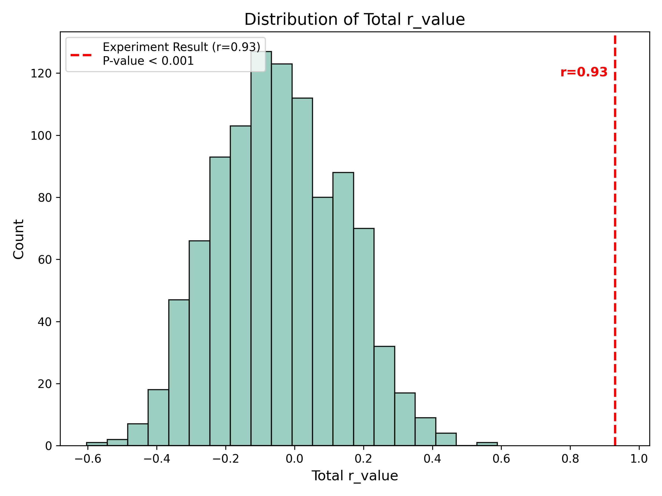
Figure S1. Results of the permutation test.

References
[1] Gong J, Cui L-B, Xi Y-B, Zhao Y-S, Yang X-J, Xu Z-L, et al. Predicting response to electroconvulsive therapy combined with antipsychotics in schizophrenia using multi-parametric magnetic resonance imaging. Schizophr Res 2020;216:262–71. https://doi.org/10.1016/j.schres.2019.11.046.
[2] Whitfield-Gabrieli S, Nieto-Castanon A. Conn: a functional connectivity toolbox for correlated and anticorrelated brain networks. Brain Connect 2012;2:125–41. https://doi.org/10.1089/brain.2012.0073.
[3] Ashburner J, Friston KJ. Unified segmentation. Neuroimage 2005;26:839–51. https://doi.org/10.1016/j.neuroimage.2005.02.018.
[4] D C, Vm H, K A, Jd C, Pa T, Ch M, et al. Frequencies contributing to functional connectivity in the cerebral cortex in “resting-state” data. AJNR American Journal of Neuroradiology 2001;22.
[5] Piepel GF. Robust Regression and Outlier Detection. Technometrics 1989;31:260–1. https://doi.org/10.1080/00401706.1989.10488524.
[6] Yeo I-K. A new family of power transformations to improve normality or symmetry. Biometrika 2000;87:954–9. https://doi.org/10.1093/biomet/87.4.954.
[7] Pedregosa F, Varoquaux G, Gramfort A, Michel V, Thirion B, Grisel O, et al. Scikit-learn: Machine Learning in Python. MACHINE LEARNING IN PYTHON n.d.
[8] Varoquaux G, Cheplygina V. Machine learning for medical imaging: methodological failures and recommendations for the future. NPJ Digit Med 2022;5:48. https://doi.org/10.1038/s41746-022-00592-y.
[9] Guyon I, Elisseeff A. An Introduction to Variable and Feature Selection n.d.
[10] Zou H, Hastie T. Regularization and Variable Selection Via the Elastic Net. Journal of the Royal Statistical Society Series B: Statistical Methodology 2005;67:301–20. https://doi.org/10.1111/j.1467-9868.2005.00503.x.
[11] Hoerl AE, Kennard RW. Ridge Regression: Biased Estimation for Nonorthogonal Problems n.d.
[12] Tibshirani R. Regression Shrinkage and Selection Via the Lasso. Journal of the Royal Statistical Society Series B: Statistical Methodology 1996;58:267–88. https://doi.org/10.1111/j.2517-6161.1996.tb02080.x.
[13] Fan Y, Liu Y, Wu H, Hao Y, Liu H, Liu Z, et al. Discriminant analysis of functional connectivity patterns on Grassmann manifold. Neuroimage 2011;56:2058–67. https://doi.org/10.1016/j.neuroimage.2011.03.051.

